

GeO- iPlatform

Set UAC for Vista

Appurtenance of IIS Setup

Version 4.9.1
Release Date: April 2008

© Copyrights 2007-2008. iPlatform Corporation.
All rights reserved. No part of this manual may be reproduced in any form or by any means without the express written permission of iPlatform Corporation.

Business forms – invoices, checks, sales orders, etc – displayed in this manual are for illustration purposes only. They are not to be used for producing actual business forms for your business and iPlatform Corporation assumes no responsibility if they are.

This document may contain technical inaccuracies or typographical errors. Any documentation with respect to iPlatform Corporation software products is provided for informational purposed only and does not extend or modify the limited warranty extended to the licensee of iPlatform Corporation software products.

Trademark Acknowledgments
All products mentioned in this text are registered trademarks of their respective corporation in the United States and/or other countries.

Set UAC for Vista

1. Enter Start- Control Panel- User Accounts and Family Safety. Select User Account.
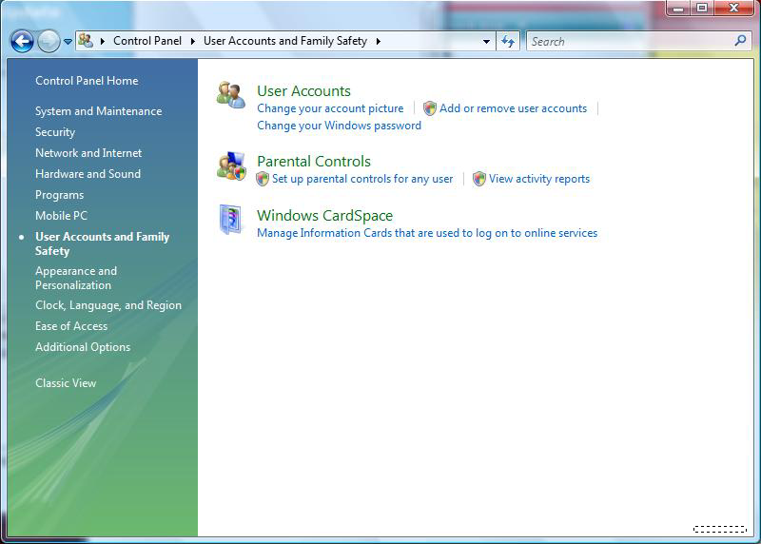

2. Check Turn User Account Control on or off.
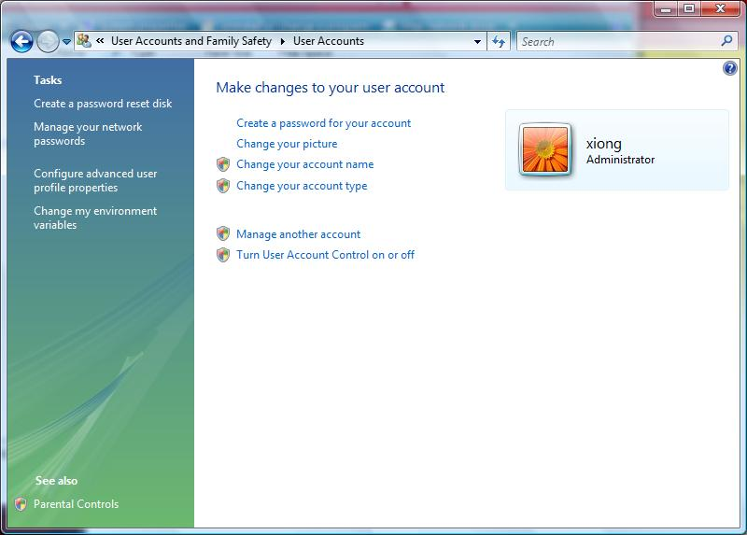
3. Unselect option of Use User Account Control(UAC) to help protect your computer. Click ‘OK’.
