EPBrowserRelease Notes
Version 8.65

EPBrowserRelease Notes Version 8.65
Last Revision, 8 May 2018

©Copyright 2018. Enterprise Browser Pte Ltd.
All rights reserved.

No part of this manual may be reproduced in any form or by any means without the express written authorization from EPB. Business forms—which include but are not limited to invoices, checks, sales orders—displayed in this manual are for illustration purposes only and are not to be used for producing actual business forms. Enterprise Browser Pte Ltd. assumes no responsibility.
This document may contain technical inaccuracies or typographical errors and may change without prior notice. Any documentation with respect to EPB software products is provided for informational purposes only and does not extend or modify the limited warranty extended to the licensee of EPB software products.

Enterprise Browser Pte Ltd (EPB)
33Ubi Avenue 3, #07-65, Vertex Tower A, Singapore 408868
Tel: (65)-6509-4065
Fax: (65)-6509-4089

Document Location
EPBSH

Contents
1. Featured 4
2. New Interface 4
2.1 Added new module: 180BNIA Material Return Requisition Enquiry. 26686-(865) 4
3. Enhancements 4
3.1 Privilege 4
3.2 Setting 4
3.2.1 010CA System Settings:Added setting ‘Enable User Change Password’. (26810)-865 4
3.2.2 090D POSN: Setting changed ‘Enable Collection Function’ and ‘Enable [A] Copy Function [B] Topup’. (26667)-865 4
3.2.3 200CC Debit Note: Added settings’ Keep Our Ref when copying from Source Document’. (26706)-865 5
3.2.4 200FE Account Balance Book:Added setting’ Enable Cross ORG enquiry’. (26740)-865 5
3.3 Improve 6
3.3.1 020BLB Official Invoice: System will prompt message if ‘Date To’ is earlier than ‘Date From’. (26675)-865 6
3.3.2 020BI Supplier:Added columns’Acc Close Day’.(26797)-865 6
3.3.3 0015 Trace:Added columns’Acc ID’ and ‘Acc Name’. (26786)-865 7
3.3.4 060HA Sales Order Enquiry:Added columns’Dattn To’. (26691)-865 7
3.3.5 060HJ Customer DO/RNC Summary Enquiry:Added columns’CRN QTY’.(26753)-865 7
3.3.6 System will not insert print log if user just view the report and doesn’t send to the printer by clicking the print button in the preview screen.(26702)-865 8
3.3.7 090CaP Shop Sales Enquiry:Added ‘print’ button. (26744)-865 8
3.3.8 Triangle Trading, System will prompt message when generating document to another Org and Emp ID doesn’t exist in that org.(26723)-865 9
3.3.9 060CBA Sales Agreement: System will update Sales Agreement to ‘Inactive’ if user change the Qty to zero by creating a Sales Agreement Change Note.(26748)-865 9
3.3.10 140ED Stock Transaction: Added option ‘POSN’ for search criteria ‘Src Code’.(26743)-865 9
3.3.11 200BF GL Transaction:Added columns’LastUpdate User ID’ and ‘LastUpdate’(26680)-865 10
3.3.12 200BX Journal Entry Batch:Added function ‘Transfer From Prepay’.(26794)-865 10
3.3.13 800DA Distribution Analysis:Added columns ‘CUSTCAT1_ID’,’CUSTCAT2_ID’…’ CUSTCAT8_ID’ .(26823)-865 10
4. Fixes 10

1. Featured

2. New Interface

2.1 Added new module: 180BNIA Material Return Requisition Enquiry. 26686-(865)
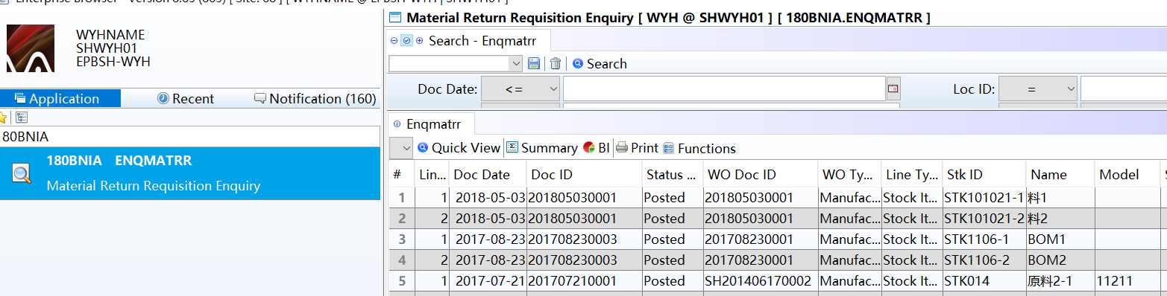

3. Enhancements

3.1 Privilege

3.2 Setting

3.2.1 010CA System Settings:Added setting ‘Enable User Change Password’. (26810)-865
Set to ‘Y’,
Enable User Change Password;
Set to ‘N’,
Don't display 'Enable User Change Password'function.
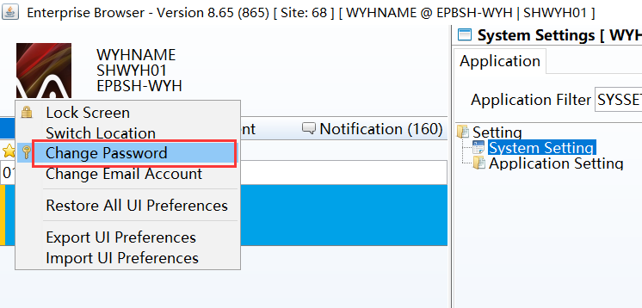

3.2.2 090D POSN: Setting changed ‘Enable Collection Function’ and ‘Enable [A] Copy Function [B] Topup’. (26667)-865
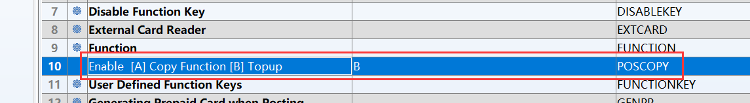
Set to ‘B’:
POS interface display 'Topup' button;

Set to ‘A’:
POS interface display 'Copy' button.
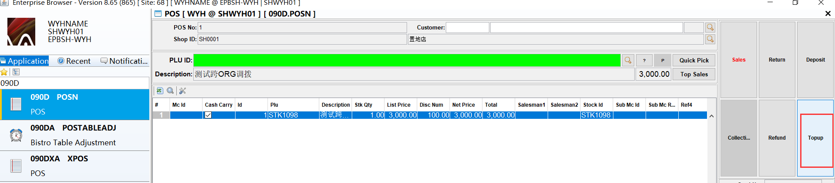

3.2.3 200CC Debit Note: Added settings’ Keep Our Ref when copying from Source Document’. (26706)-865
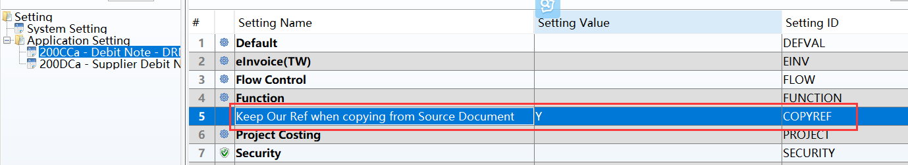
Set to ‘Y’:
Keep Our Ref when copying from Source Document.

Set to ‘N’:
Keeping the original logic.

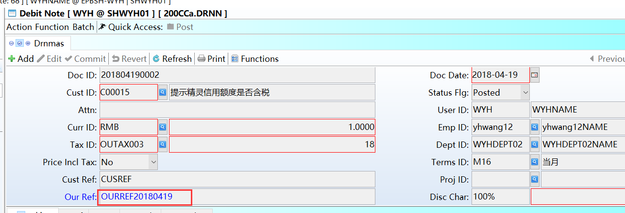

3.2.4 200FE Account Balance Book:Added setting’ Enable Cross ORG enquiry’. (26740)-865
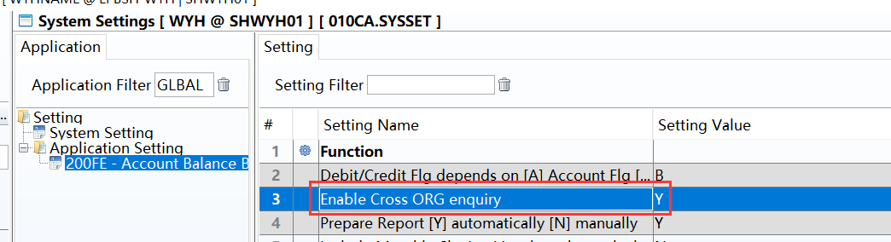
if setting =Y, User can view multiple organizations’ data,
search condition ‘org_id’ can be used;

if setting =N, only own org, regardless search condition ‘org_id’.
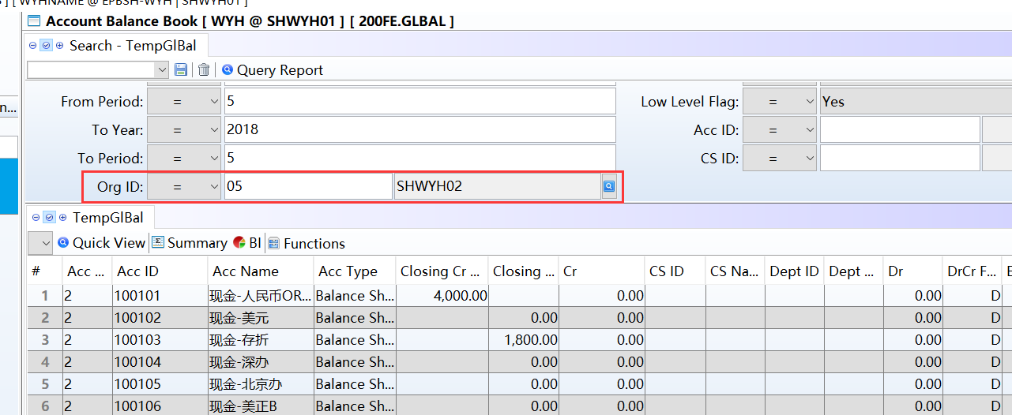

3.3 Improve

3.3.1 020BLB Official Invoice: System will prompt message if ‘Date To’ is earlier than ‘Date From’. (26675)-865
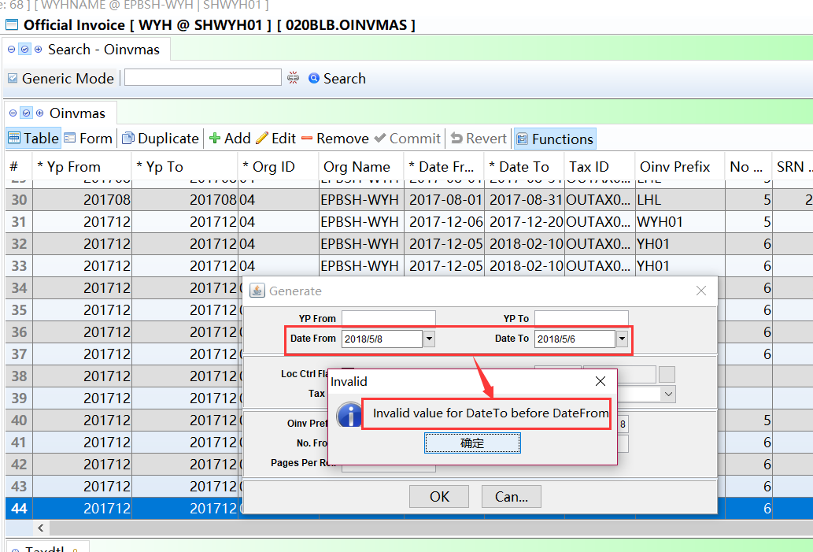
if ‘Date To’ is earlier than ‘Date From’, prompt information will pop up.

3.3.2 020BI Supplier:Added columns’Acc Close Day’.(26797)-865
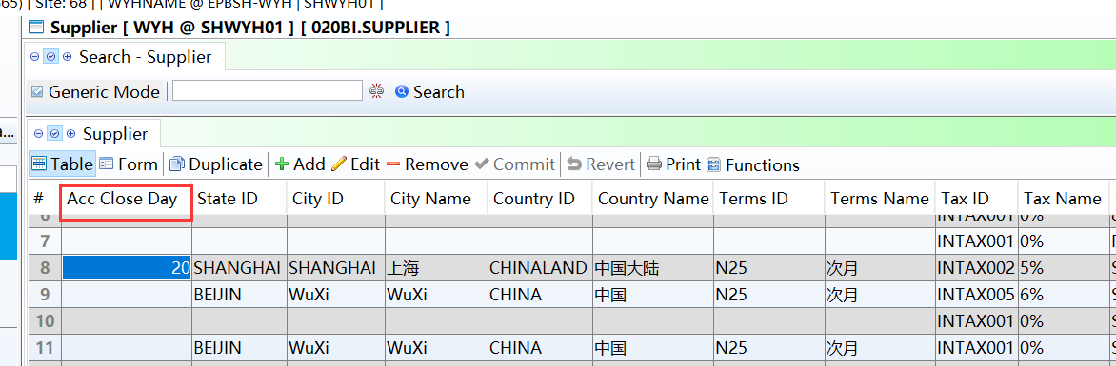
According to the 'Acc Close Day' and 'Term_ID' automatic computing ' Dly Date'.
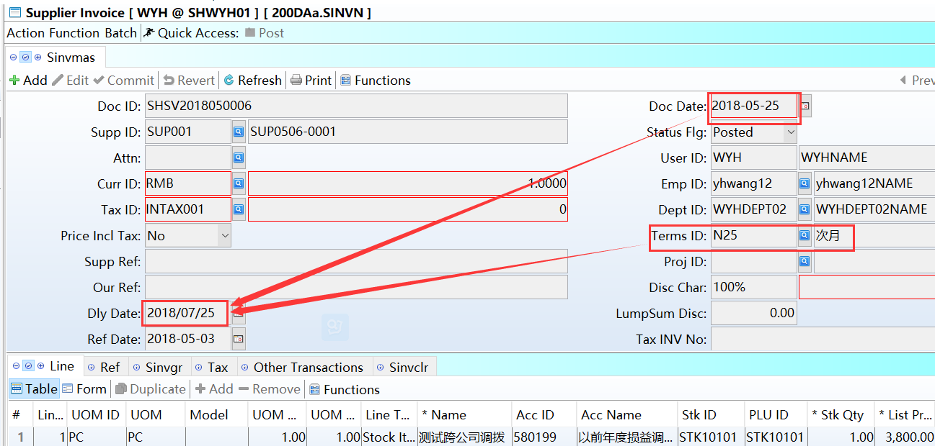

3.3.3 0015 Trace:Added columns’Acc ID’ and ‘Acc Name’. (26786)-865
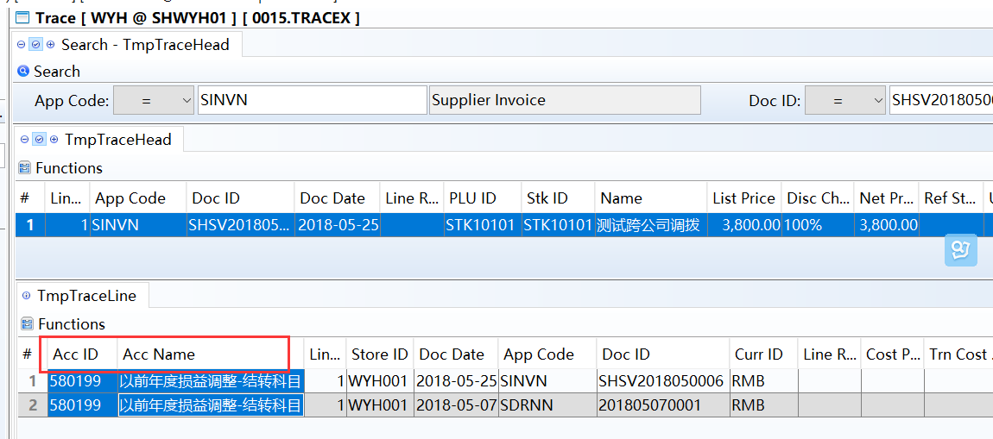

3.3.4 060HA Sales Order Enquiry:Added columns’Dattn To’. (26691)-865
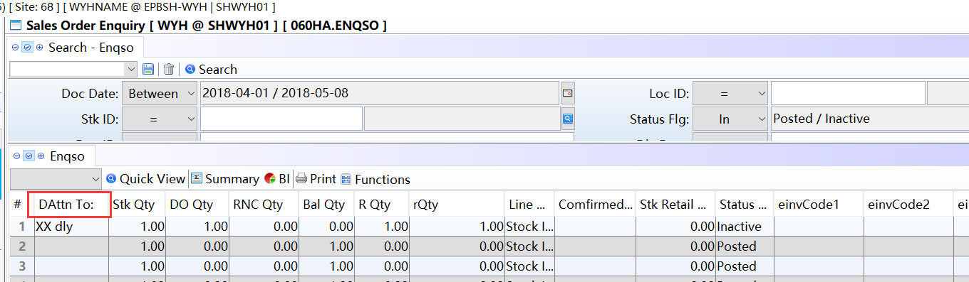

3.3.5 060HJ Customer DO/RNC Summary Enquiry:Added columns’CRN QTY’.(26753)-865
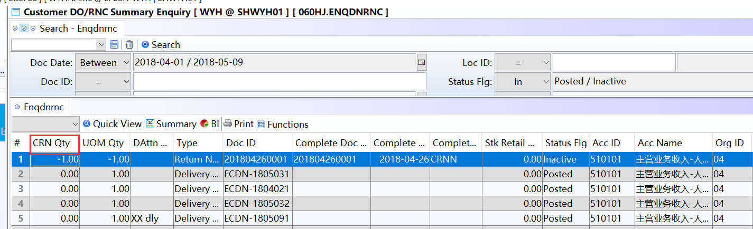

3.3.6 System will not insert print log if user just view the report and doesn’t send to the printer by clicking the print button in the preview screen.(26702)-865
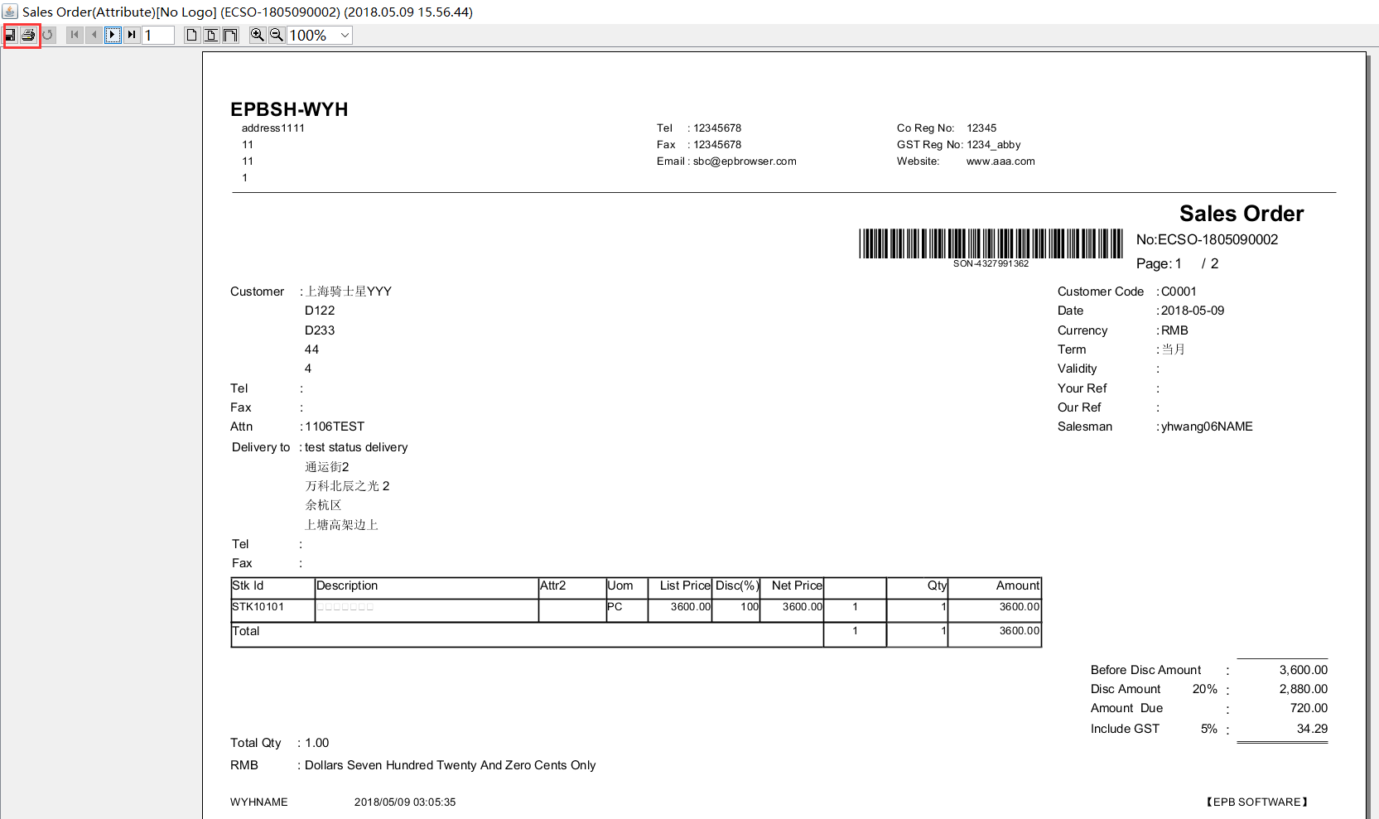
Just click on these buttons in the preview screen, ‘Even Viewer’ will insert print log.
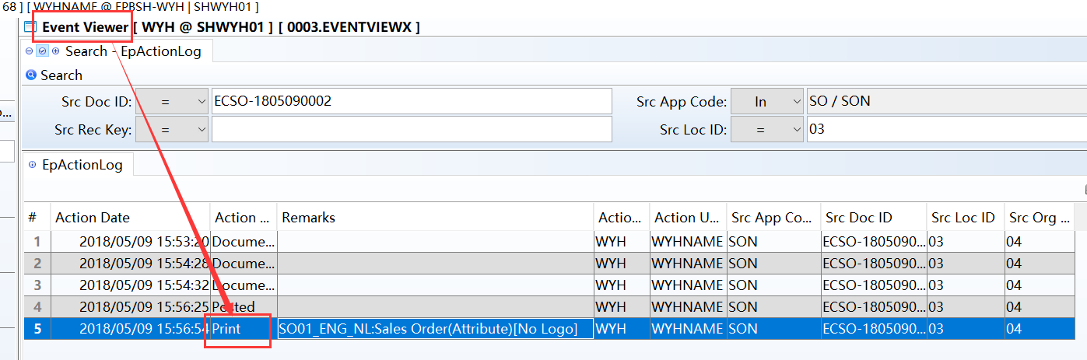

3.3.7 090CaP Shop Sales Enquiry:Added ‘print’ button. (26744)-865
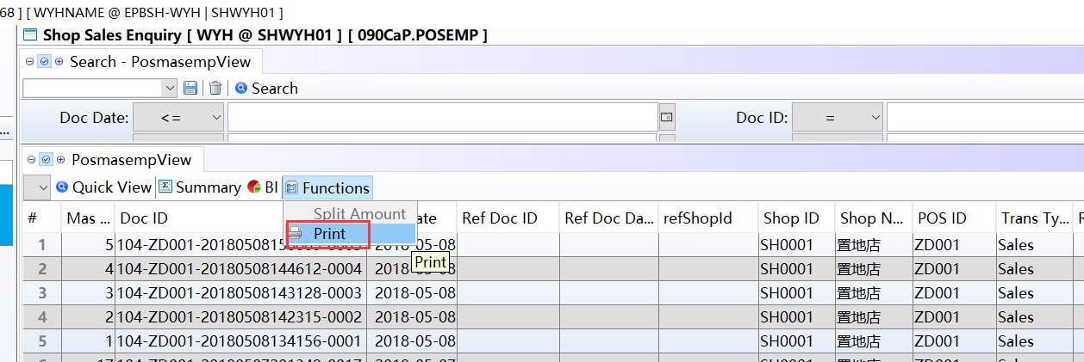

3.3.8 Triangle Trading, System will prompt message when generating document to another Org and Emp ID doesn’t exist in that org.(26723)-865
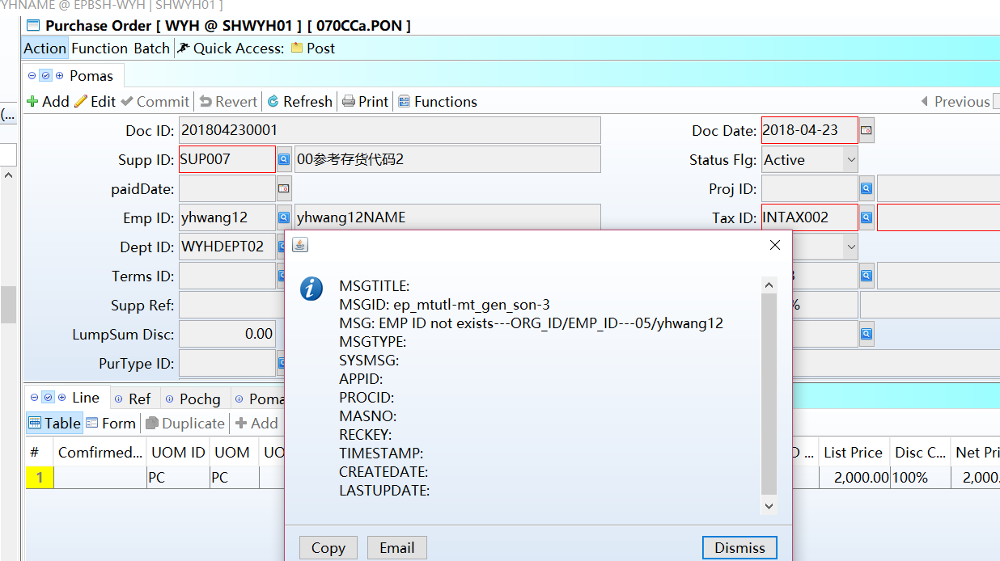
If another organization haven't the employee code, system will prompt message 'emp_id not exists'.

3.3.9 060CBA Sales Agreement: System will update Sales Agreement to ‘Inactive’ if user change the Qty to zero by creating a Sales Agreement Change Note.(26748)-865
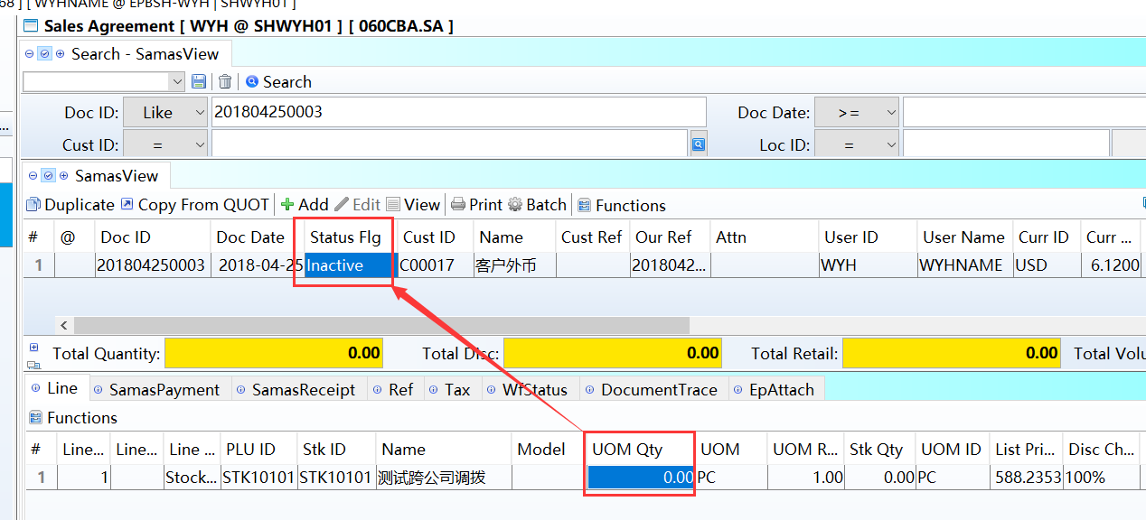

3.3.10 140ED Stock Transaction: Added option ‘POSN’ for search criteria ‘Src Code’.(26743)-865
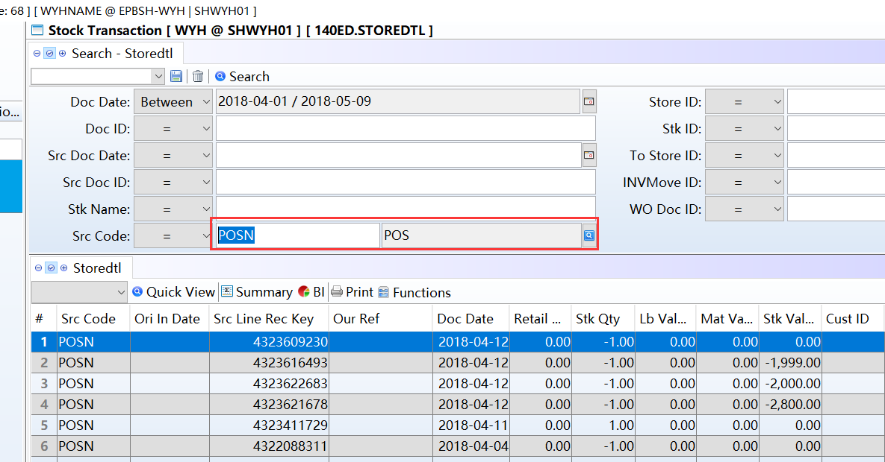

3.3.11 200BF GL Transaction:Added columns’LastUpdate User ID’ and ‘LastUpdate’(26680)-865
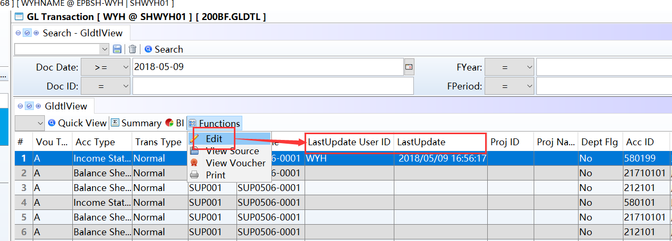
System will update these two columns when user changing GL transactions by using function ‘Edit’.

3.3.12 200BX Journal Entry Batch:Added function ‘Transfer From Prepay’.(26794)-865
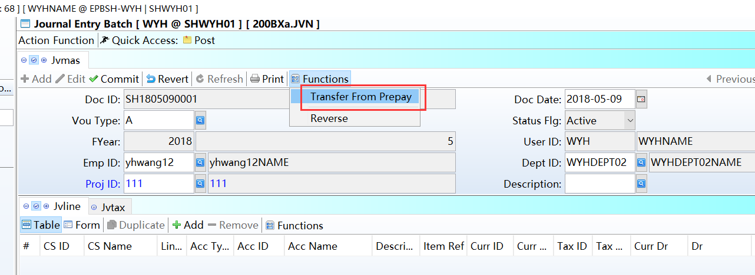

3.3.13 800DA Distribution Analysis:Added columns ‘CUSTCAT1_ID’,’CUSTCAT2_ID’…’ CUSTCAT8_ID’ .(26823)-865
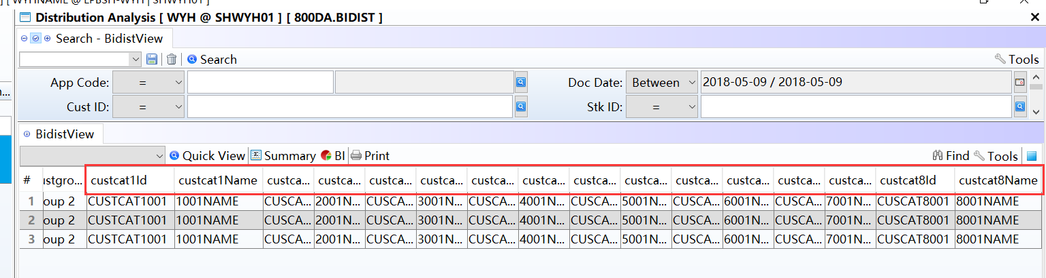

4. Fixes

