EPBrowserRelease Notes
Version 8.66

EPBrowserRelease Notes Version 8.66
Last Revision, 12 June 2018

©Copyright 2018. Enterprise Browser Pte Ltd.
All rights reserved.

No part of this manual may be reproduced in any form or by any means without the express written authorization from EPB. Business forms—which include but are not limited to invoices, checks, sales orders—displayed in this manual are for illustration purposes only and are not to be used for producing actual business forms. Enterprise Browser Pte Ltd. assumes no responsibility.
This document may contain technical inaccuracies or typographical errors and may change without prior notice. Any documentation with respect to EPB software products is provided for informational purposes only and does not extend or modify the limited warranty extended to the licensee of EPB software products.

Enterprise Browser Pte Ltd (EPB)
33Ubi Avenue 3, #07-65, Vertex Tower A, Singapore 408868
Tel: (65)-6509-4065
Fax: (65)-6509-4089

Document Location
EPBSH

Contents
1. Featured 4
2. New Interface 4
2.1 Added new module: 090CaY Shop Campaign Overview. 26679-(866) 4
3. Enhancements 4
3.1 Privilege 4
3.2 Setting 4
3.2.1 020BF Customer: Added setting ‘Include Outstanding S/A when calculating Credit Limit’. (26995)-866 4
3.2.2 060CM Packing List: Added settings ’Allow over-transferring from Delivery Order’ and ’Allow over-transferring from Sales Agreement’. (26997)-866 4
3.2.3 060CBD Sales Agreement Change Note: Added setting ’Disallow Lock/Post if Payment not tally with total amount’. (27050)-866 5
3.2.4 200CD Official Receipt: Added setting’ Disallow duplicate Cheque ID’ .(26894)-866 5
3.2.5 200DD Payment Voucher: Added setting ’Default SUM AP Flag’ to set default value for column ‘sumFlg’.(26891)-866 6
3.2.6 200DDA AP Payment Batch: Added settings ‘Enable Direct Print by Document’ and ’Direct Print by Document Report File’. (26808)-866 6
3.3 Improve 7
3.3.1 010CZ Application Package:Added columns: ‘docnoprefix’ and ‘docnotype’ and ‘docnolth’.(26930)-866: 7
3.3.2 030H WFNODE: Added two system nodes 'Inform' and ‘InformInitiator’.(26922)-866 7
3.3.3 070HH Supplier GR/RNS Summary Enquiry: Added columns ‘Scrn Qty’ and ‘Scrnr Qty’. (26992)-866 8
3.3.4 090CaB Payment Enquiry: Added column and BI column ‘Round Amt’(26829)-866 8
3.3.5 090D POS: Added criteria ‘Ref No’ when doing collection and added columns ‘Ref No’ in Reference input screen and added columns ‘line ref1’…’line ref4’ in S/N input screen.(27011)-866 9
3.3.6 140BA Stock Items: Allow batch delete function.(27017)-866 10
3.3.7 140BA Stock Items: Added Tabs ‘StkmasAttr3’ and ‘StkmasAttr4’ and allow input attr3 in Interactive Input Screen. (27008)-866 10
3.3.8 140BF PLU Master: Added settings ‘Enable Auto Generate PLU ID’ and ‘Running Number Length’. (27004)-866 10
3.3.9 140FG Inventory Issue Enquiry: Added columns and search criteria ‘AnaID1’…’AnaID10’ . (27049)-866 11
3.3.10 180BL Outsource Goods Receive: Added function ‘Change Store ID’. (26776)-866 11
3.3.11 200CA Invoice: System will consider Term ID start with W which means next 7 months when calculating DueDate. (25405)-866 11
3.3.12 200CB Credit Note: Added option ‘Cancelled’ for Crn Type. (26970)-866 11
3.3.13 070HH/200DXA…200DXD: Added columns ‘Country ID’, ’State ID’ and ‘City ID’. (26832)-866 12
3.3.14 200DXD Supplier SINV/SCRN/SDRN Summary Enquiry: Added column ‘Crn Type’.(27024)-866 12
3.3.15 200FE Account Balance Book: Added search criteria ‘inclMthclose’ . (26863)-866 12
4. Fixes 12

1. Featured

2. New Interface

2.1 Added new module: 090CaY Shop Campaign Overview. 26679-(866)
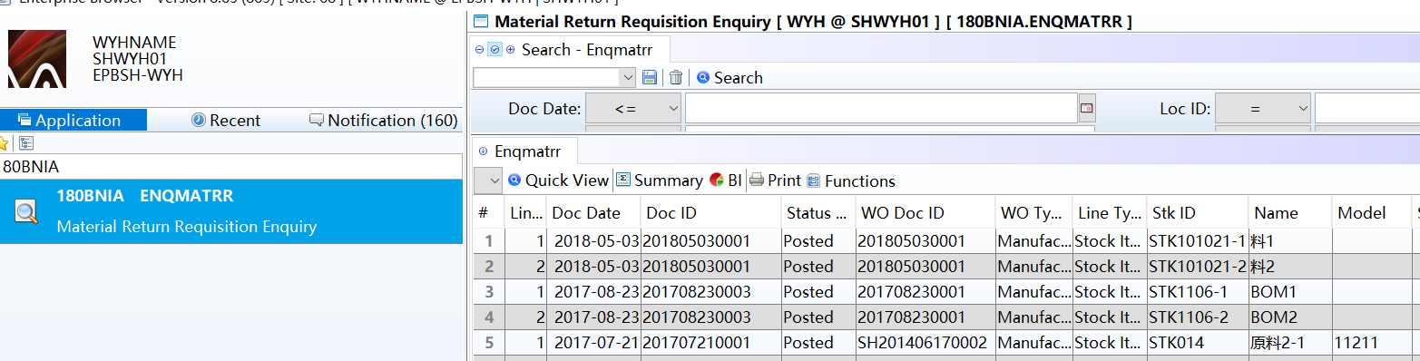

3. Enhancements

3.1 Privilege

3.2 Setting

3.2.1 020BF Customer: Added setting ‘Include Outstanding S/A when calculating Credit Limit’. (26995)-866
Set to ‘Y’：System will consider outstanding Sales Agreement when calculating Credit Limit.
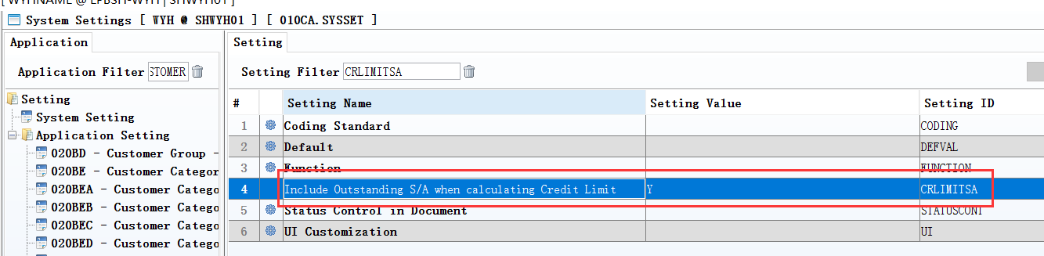

3.2.2 060CM Packing List: Added settings ’Allow over-transferring from Delivery Order’ and ’Allow over-transferring from Sales Agreement’. (26997)-866
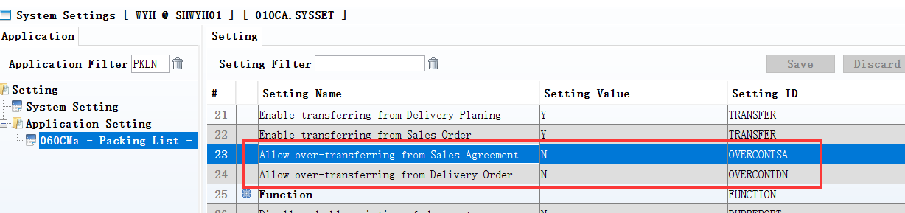

3.2.3 060CBD Sales Agreement Change Note: Added setting ’Disallow Lock/Post if Payment not tally with total amount’. (27050)-866
Set to Y: System will prompt error message if payment amount not tally with total amount when posting or locking.
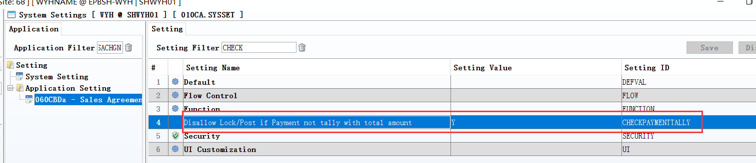
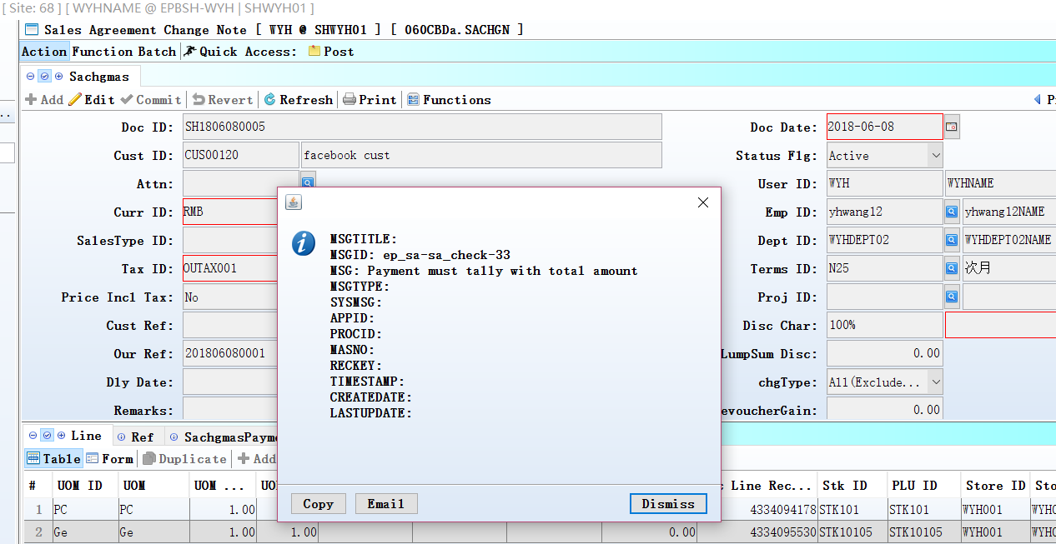
Set to Y;
If payment not tally with total amount, there will be a pop-up message when posting documents.

3.2.4 200CD Official Receipt: Added setting’ Disallow duplicate Cheque ID’ .(26894)-866
System will prompt error message if same Cheque ID already exist in GL Transaction when posting.
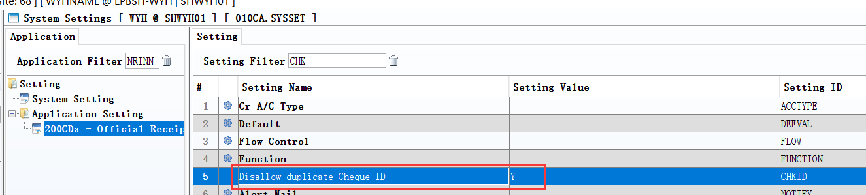
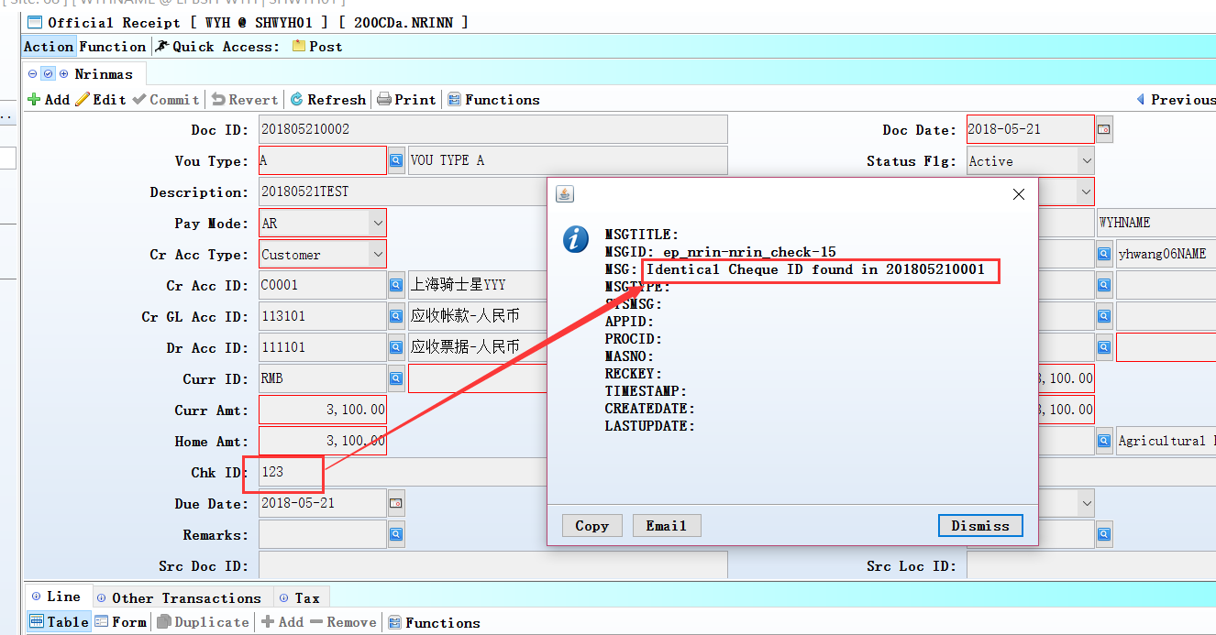

3.2.5 200DD Payment Voucher: Added setting ’Default SUM AP Flag’ to set default value for column ‘sumFlg’.(26891)-866
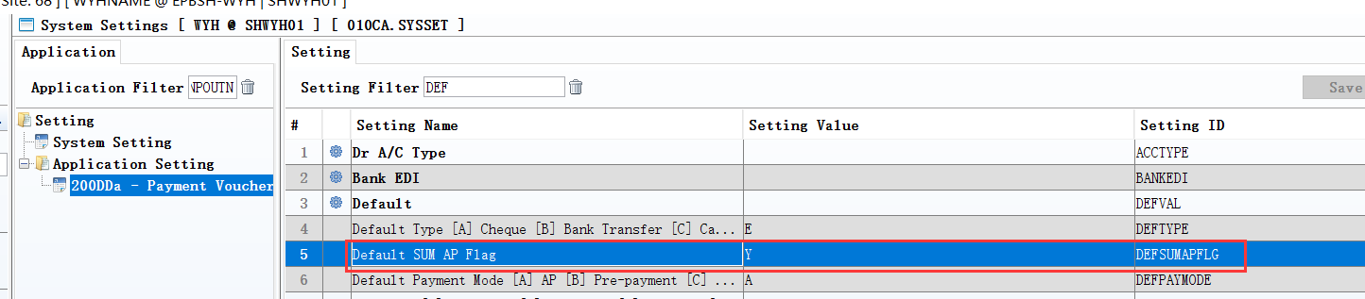
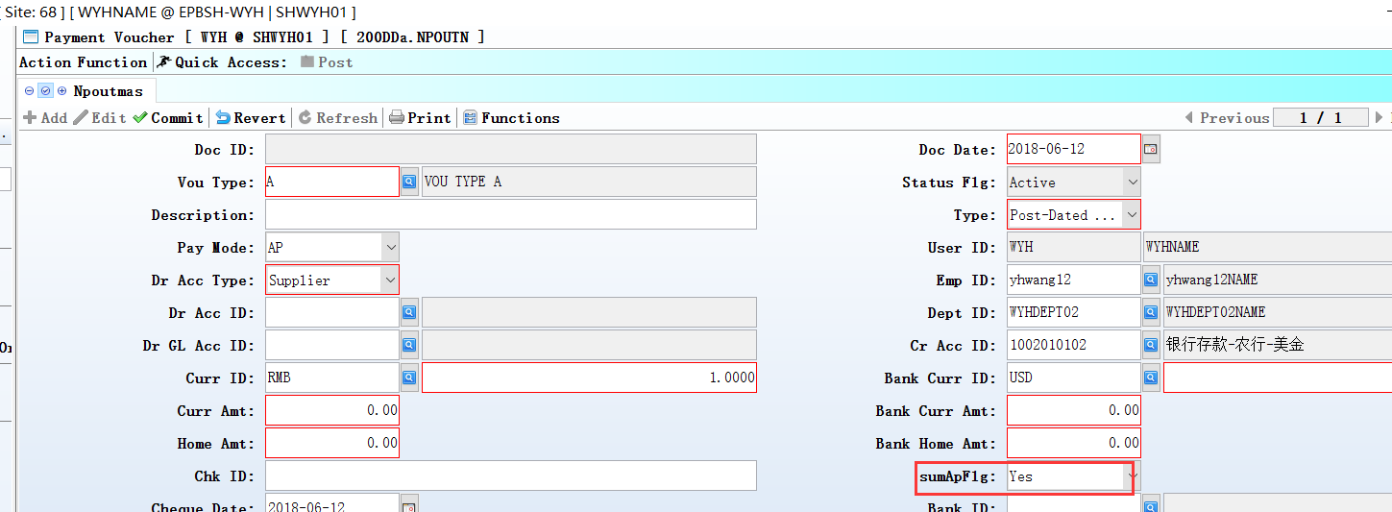

3.2.6 200DDA AP Payment Batch: Added settings ‘Enable Direct Print by Document’ and ’Direct Print by Document Report File’. (26808)-866
‘Enable Direct Print by Document’ set to Y and ‘Direct Print by Document Report File’ set to iReport file name,system will generate mutiple PDF files by Doc ID and directly to printer when using function ‘Direct Print By Document’.
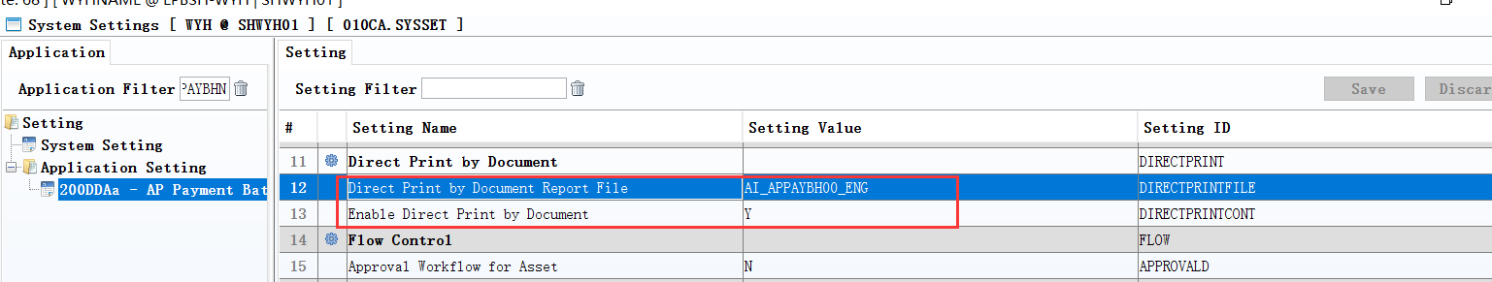
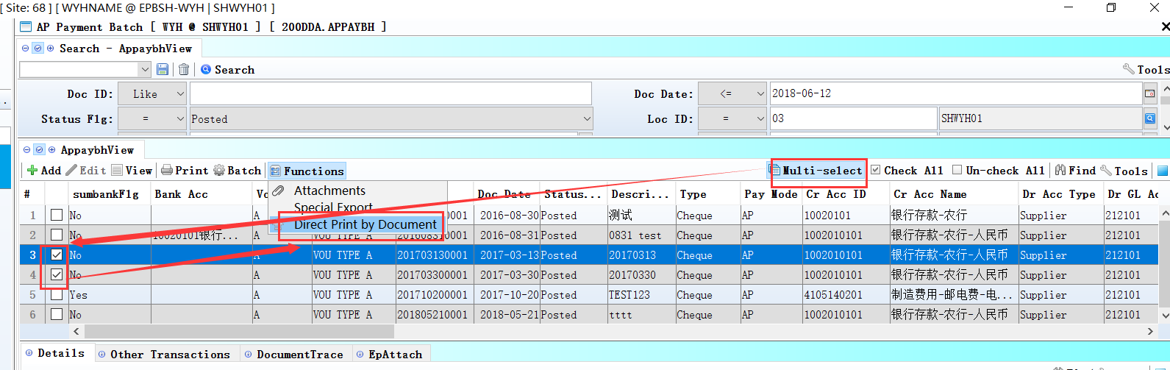

3.3 Improve

3.3.1 010CZ Application Package:Added columns: ‘docnoprefix’ and ‘docnotype’ and ‘docnolth’.(26930)-866:
Set these columns;
Added new location;
Added new documents In the new location, According to the rule automatically generated document number.

Note:If you set error,change it by ‘Reset document number’ in the doucument.
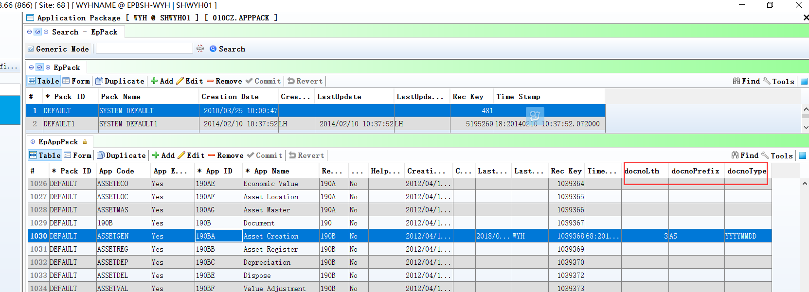
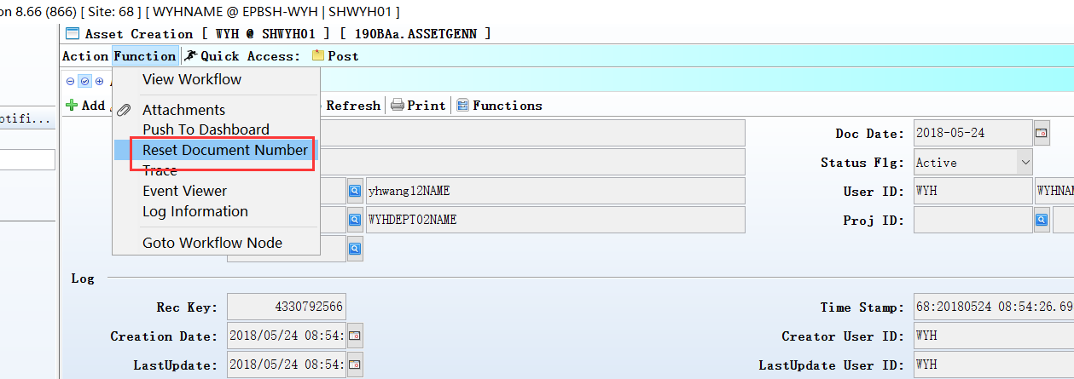

3.3.2 030H WFNODE: Added two system nodes 'Inform' and ‘InformInitiator’.(26922)-866
These two nodes are different with other customize node, system will not stop at these two nodes.
System will send to-do record to users defined on these two nodes and the flow will go on no matter the related users complete the node or not.
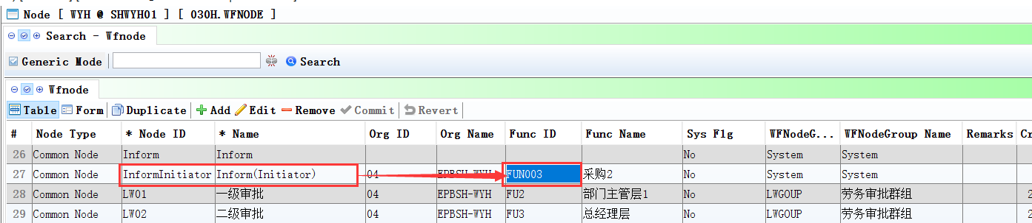

3.3.3 070HH Supplier GR/RNS Summary Enquiry: Added columns ‘Scrn Qty’ and ‘Scrnr Qty’. (26992)-866
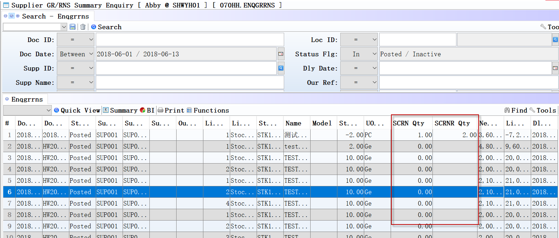

3.3.4 090CaB Payment Enquiry: Added column and BI column ‘Round Amt’(26829)-866
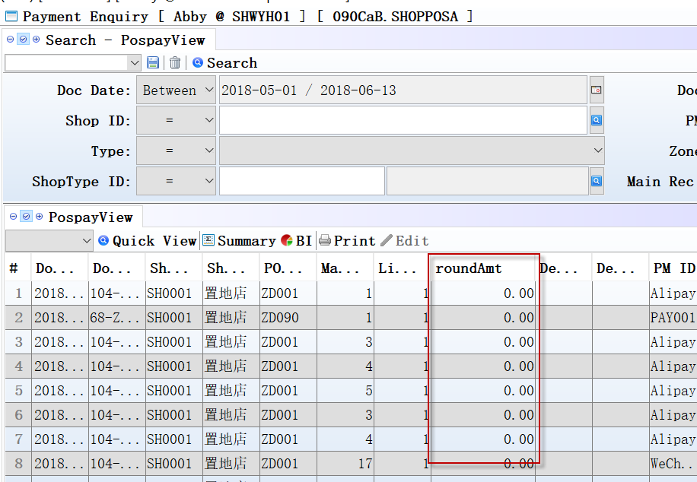

3.3.5 090D POS: Added criteria ‘Ref No’ when doing collection and added columns ‘Ref No’ in Reference input screen and added columns ‘line ref1’…’line ref4’ in S/N input screen.(27011)-866
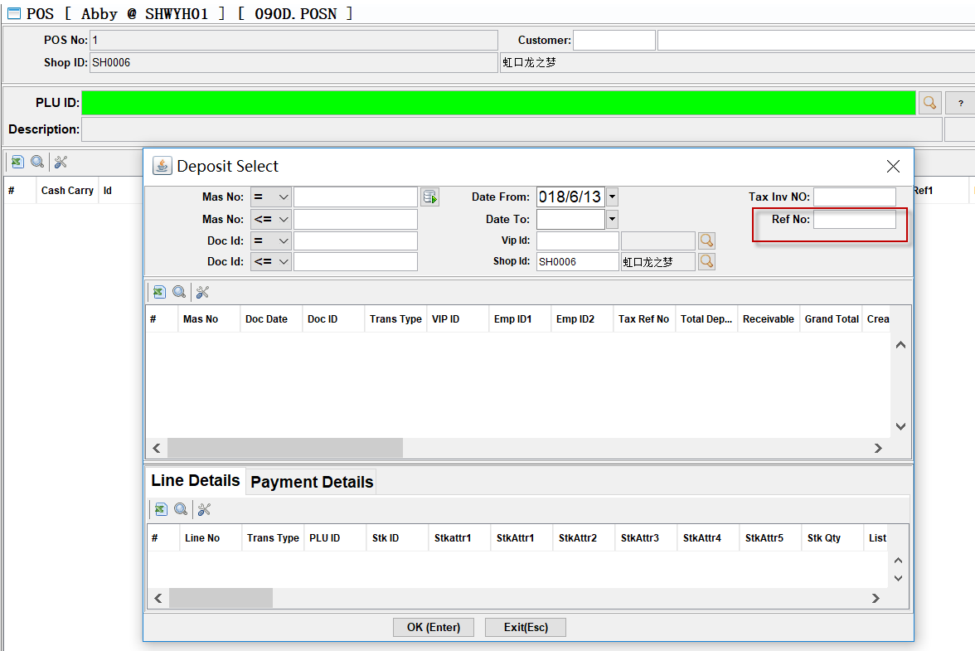

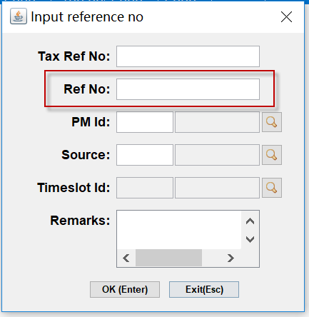

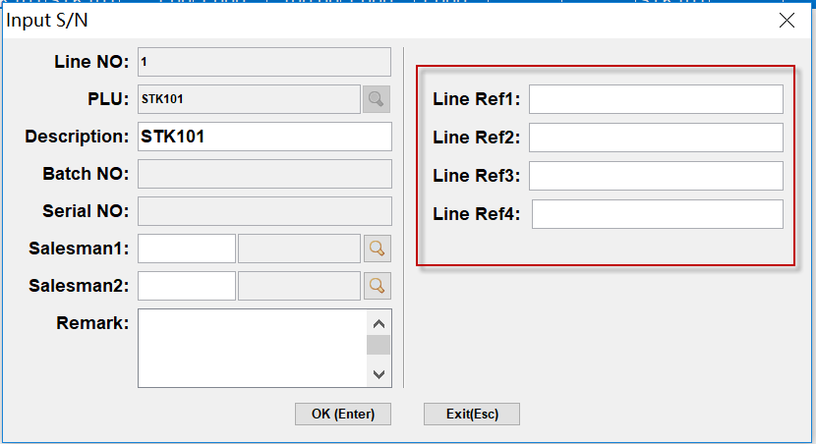

3.3.6 140BA Stock Items: Allow batch delete function.(27017)-866
Step1:Click Muti-Select
Step2:Check items need to delete
Step3:Click Function - Delete

3.3.7 140BA Stock Items: Added Tabs ‘StkmasAttr3’ and ‘StkmasAttr4’ and allow input attr3 in Interactive Input Screen. (27008)-866
How to select item with 3 Attribute in Interactive Input Screen:
Step1:select stkattr1 and stkattr2
Step2:click ‘Confirm’
Step3:select stkattr3
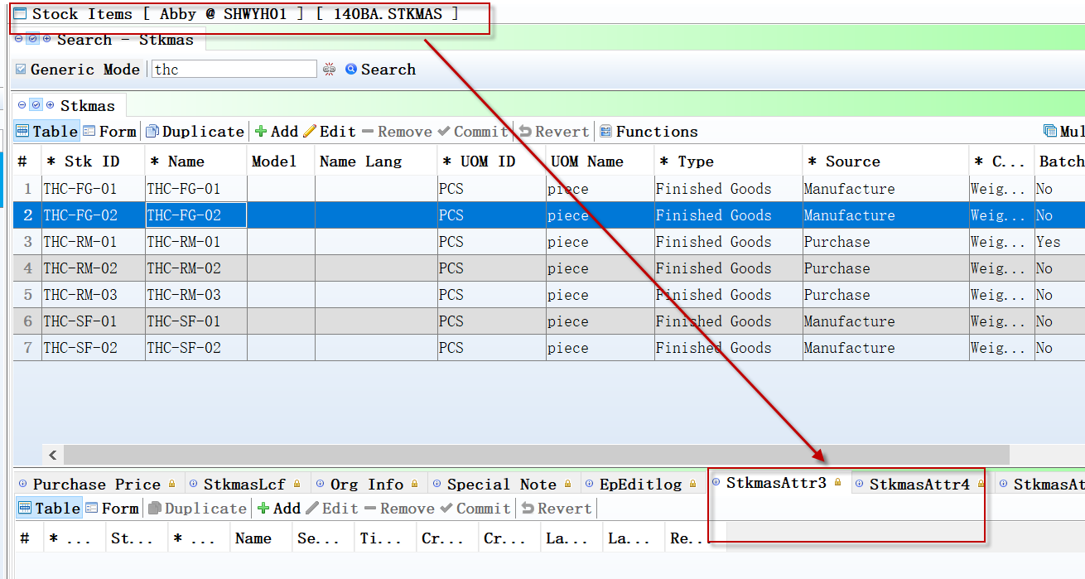

3.3.8 140BF PLU Master: Added settings ‘Enable Auto Generate PLU ID’ and ‘Running Number Length’. (27004)-866
System will generate Plu Master base on settings when ‘Enable Auto Generate PLU ID’ set to Y.

3.3.9 140FG Inventory Issue Enquiry: Added columns and search criteria ‘AnaID1’…’AnaID10’ . (27049)-866
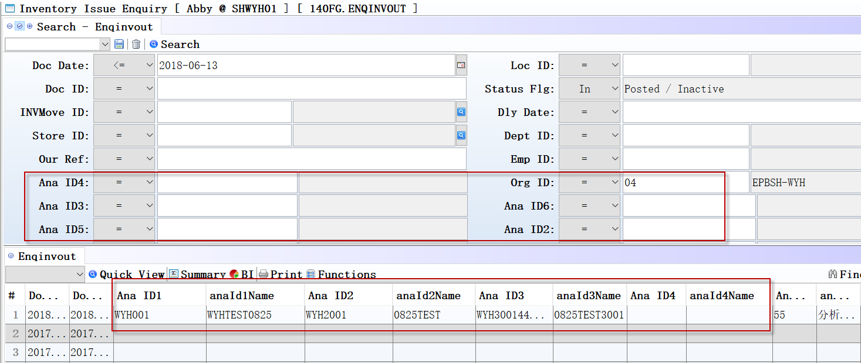

3.3.10 180BL Outsource Goods Receive: Added function ‘Change Store ID’. (26776)-866
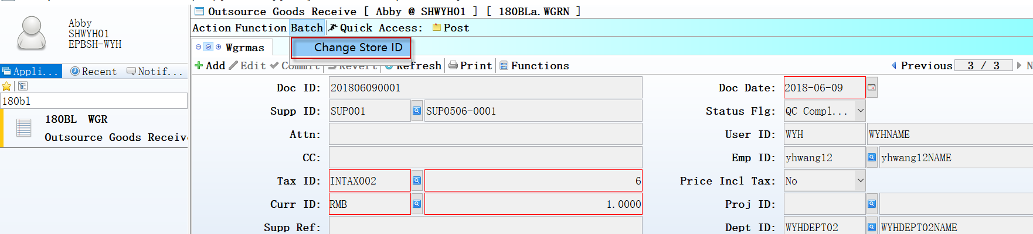

3.3.11 200CA Invoice: System will consider Term ID start with W which means next 7 months when calculating DueDate. (25405)-866

3.3.12 200CB Credit Note: Added option ‘Cancelled’ for Crn Type. (26970)-866
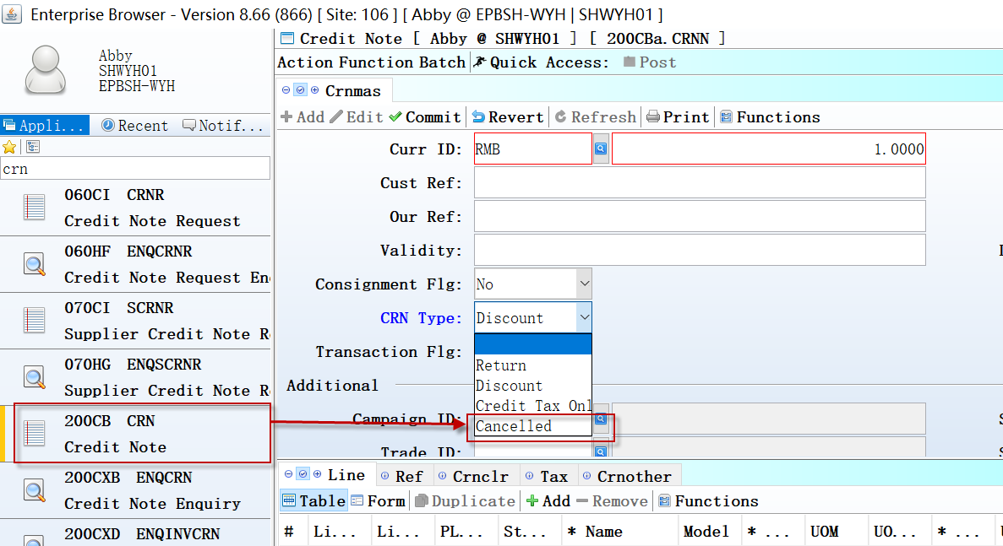

3.3.13 070HH/200DXA…200DXD: Added columns ‘Country ID’, ’State ID’ and ‘City ID’. (26832)-866
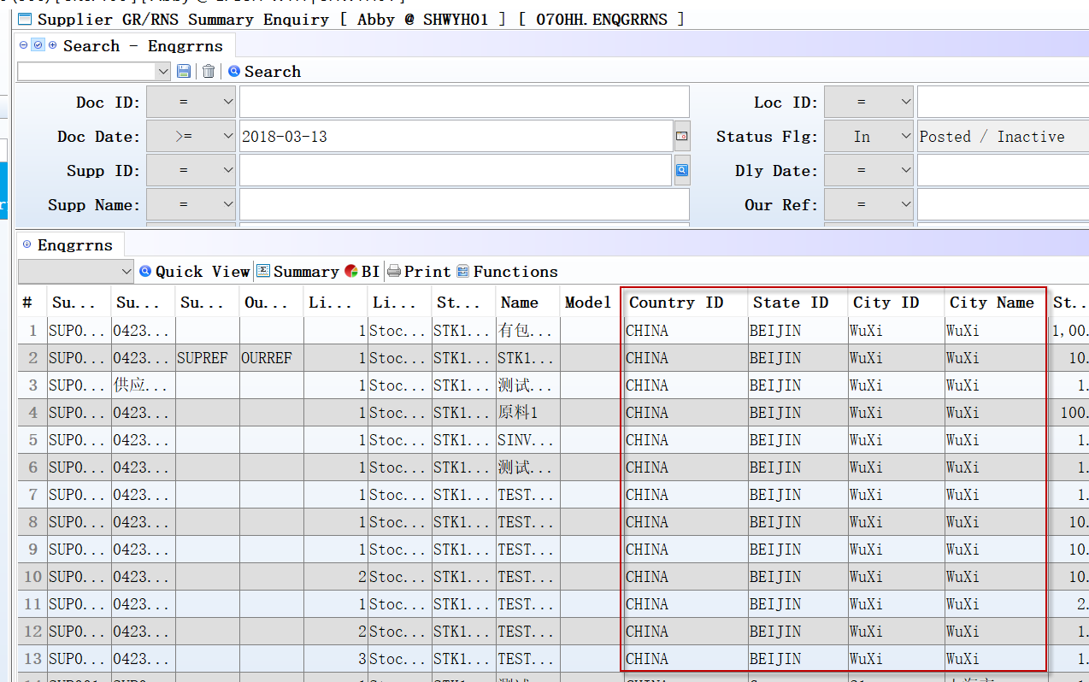

3.3.14 200DXD Supplier SINV/SCRN/SDRN Summary Enquiry: Added column ‘Crn Type’.(27024)-866

3.3.15 200FE Account Balance Book: Added search criteria ‘inclMthclose’ . (26863)-866
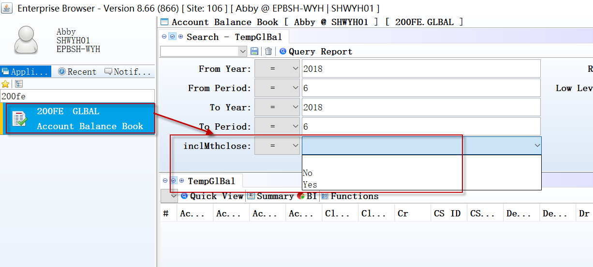

4. Fixes

