EPBrowserRelease Notes
Version 8.70~8.71

EPBrowserRelease Notes Version 8.70~8.71
Last Revision, 18 September 2018

©Copyright 2018. Enterprise Browser Pte Ltd.
All rights reserved.

No part of this manual may be reproduced in any form or by any means without the express written authorization from EPB. Business forms—which include but are not limited to invoices, checks, sales orders—displayed in this manual are for illustration purposes only and are not to be used for producing actual business forms. Enterprise Browser Pte Ltd. assumes no responsibility.
This document may contain technical inaccuracies or typographical errors and may change without prior notice. Any documentation with respect to EPB software products is provided for informational purposes only and does not extend or modify the limited warranty extended to the licensee of EPB software products.

Enterprise Browser Pte Ltd (EPB)
33Ubi Avenue 3, #07-65, Vertex Tower A, Singapore 408868
Tel: (65)-6509-4065
Fax: (65)-6509-4089

Document Location
EPBSH

Contents
1. Featured 4
2. New Interface 4
3. Enhancements 4
3.1 Privilege 4
3.2 Setting 4
3.2.1 060CB Sales Order:Added setting D' Generate Picklist for [A] Reserved Stock Item [B] Stock Item [C] All items [D] Stock Item(Separate by Cat3) '.(27354)-870 4
3.2.2 090CeX :Prepaid Card Transaction:Added setting'Search Control by accessible Location'.(27490)-870 5
3.2.3 098CA eCommerce Order:Added setting'Generate IQC when posting'.(27424)-870 5
3.2.4 200CEE AR Ageing by Salesmas:Added setting'User Access Control [A] by Dept [B] by Emp Group'. (27408)-870 5
3.2.5 010CA System Settings:Added setting'Line Total rounding [N] Currency Round [0] [2] [4] [6]'. (27678)-871 6
3.2.6 060CE Delivery Order:Added setting'Allow copying or tranferring of inactive Document'. (27616)-871 6
3.2.7 070CC Purchase Order:Added setting'User Access Control [A] by Dept [B] by Emp Group'. (27617)-871 6
3.2.8 090D POS:Added setting'Prepaid Card Return must transfer from original receipt'. (27633)-871 7
3.2.9 090D POS:Added setting'Force key in Batch ID/SRN ID if batch/srn control flag is Y'. (27676)-871 7
3.2.10 140CJ Stock Take:Added setting'Take Method [A] Full Stock Take [B] Partial Stock Take'. (27682)-871 7
3.2.11 180BE Work Order Reporting:Added setting'Enable transferring from Work Order ' and 'Enable transferring from Work Order Reporting'. (27538)-871 8
3.2.12 800DA Distribution Analysis etc module:Added setting'Allow Cross Org Enquiry'. (27561)-871 8
3.2.13 800FA Sales Analysis:Added setting'User Access Control [A] by Dept [B] by Emp Group'. (25868)-870 9
3.3 Improve 9
3.3.1 070CD Purchase Order Change Note:Added column'PAID_DATE'. (27406)-870 9
3.3.2 090BH Campaign(Buy and Get Discount):Added function'Buy any number, price discount is N%'. (24091)-871 10
3.3.3 090DXC ZPOS:Added function'order by emp_id ' and ' allow input emp_id '.(27604)-870 10
3.3.4 140CH Inventory Transfer Issue:Added button'commit'. (27388)-870 10
3.3.5 140EJF Stock Value Summary(Valuation Area):Added columns'SAMPLEIN_QTY'and'SAMPLEIN_VALUE'and'SAMPLEOUT_QTY'and'SAMPLEOUT_VALUE'. (27438)-870 11
3.3.6 180BNO Work Order Reporting Enquiry:Added column'open qty'. (27464)-870 11
3.3.7 180CA Forecast:Added columns'repUserId'and'FGR Qty'.(27383)-870 11
3.3.8 140EJF Stock Value Summary(Valuation Area):Added columns'SAMPLEW_QTY'and'SAMPLEW_VALUE'. (27558)-871 12
3.3.9 150F Picklist:Added function'Batch Change BIN '. (27603)-871 12
3.3.10 200CD Official Receipt:Added lov for description. (27602)-871 12
3.3.11 BI field can fuzzy query.(25198)-871 13
3.3.12 Remove the system setting 'Allow copying or tranferring of inactive Document', moved to each module.(27619)-871 13
4. Fixes 13

1. Featured

2. New Interface

3. Enhancements

3.1 Privilege

3.2 Setting

3.2.1 060CB Sales Order:Added setting D' Generate Picklist for [A] Reserved Stock Item [B] Stock Item [C] All items [D] Stock Item(Separate by Cat3) '.(27354)-870
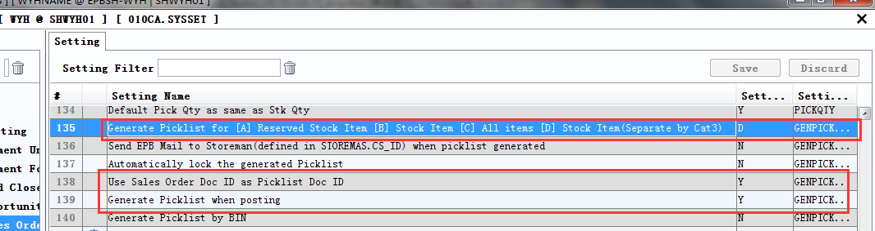
1、Set to 'D';
2、Set ‘Use Sales Order Doc ID as Picklist Doc ID’to 'Y';
3、The picklist of doucument number,Separate by Cat3.
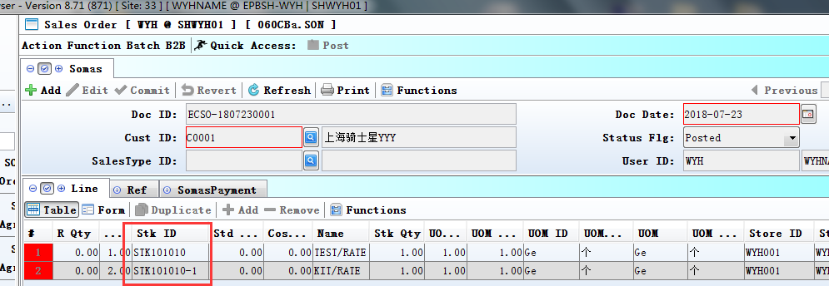
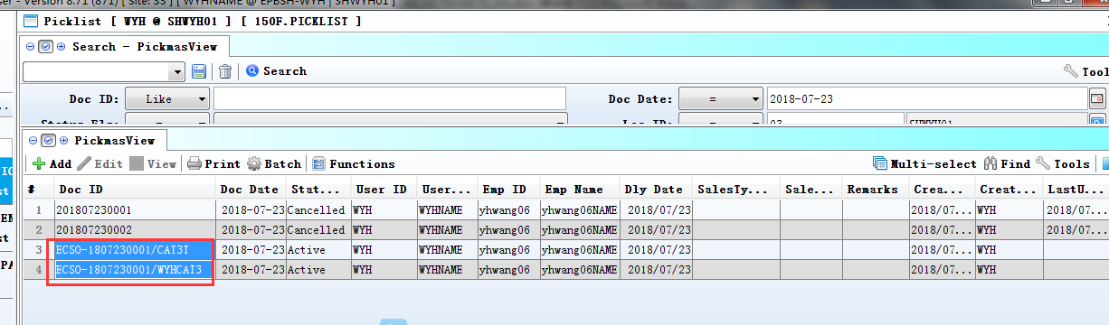

3.2.2 090CeX :Prepaid Card Transaction:Added setting'Search Control by accessible Location'.(27490)-870
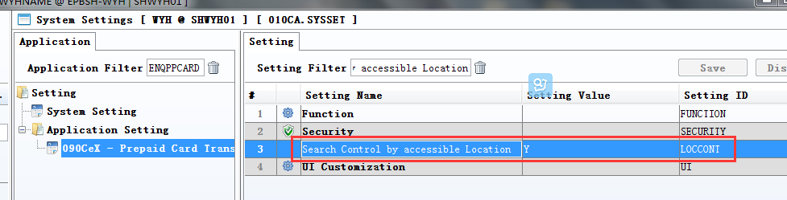
1、Set to Y;
2、Don't assign permissions: 'view all records'；
3、In the assigned location,user can see the prepaid card transaction.
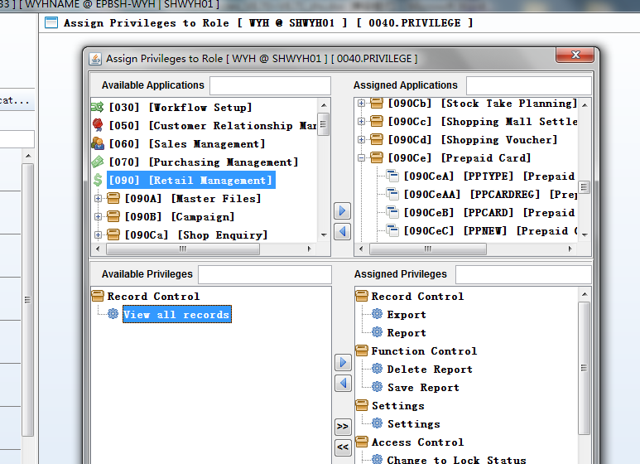

3.2.3 098CA eCommerce Order:Added setting'Generate IQC when posting'.(27424)-870
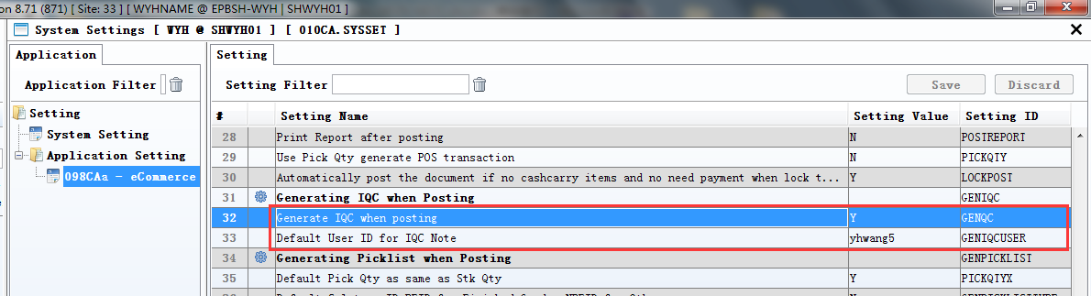

3.2.4 200CEE AR Ageing by Salesmas:Added setting'User Access Control [A] by Dept [B] by Emp Group'. (27408)-870
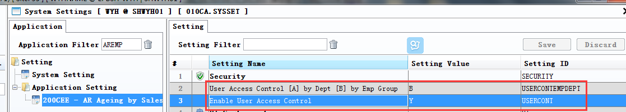

3.2.5 010CA System Settings:Added setting'Line Total rounding [N] Currency Round [0] [2] [4] [6]'. (27678)-871
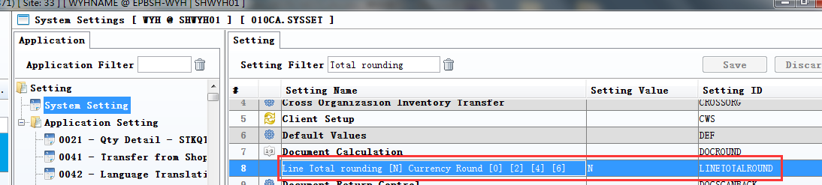

3.2.6 060CE Delivery Order:Added setting'Allow copying or tranferring of inactive Document'. (27616)-871
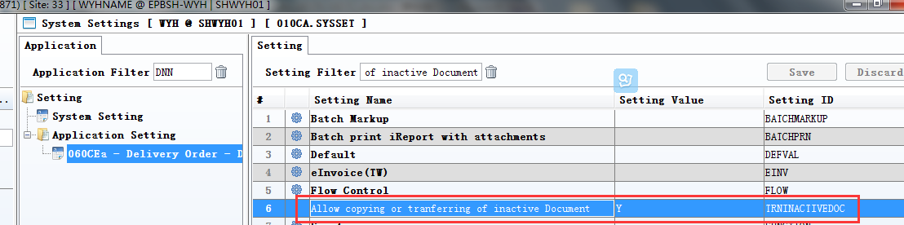

3.2.7 070CC Purchase Order:Added setting'User Access Control [A] by Dept [B] by Emp Group'. (27617)-871
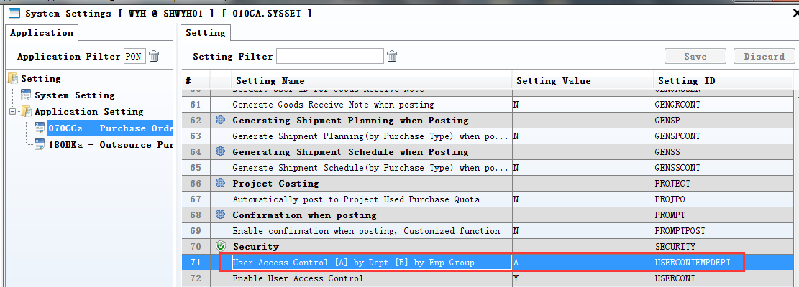

3.2.8 090D POS:Added setting'Prepaid Card Return must transfer from original receipt'. (27633)-871
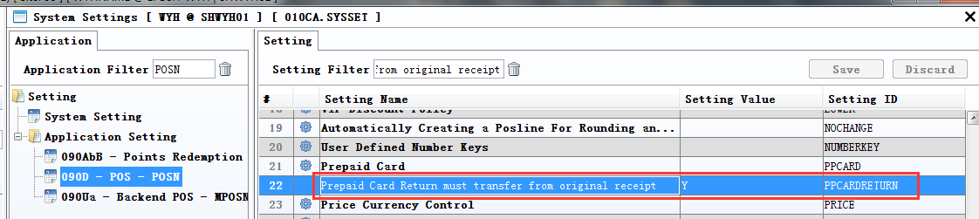
Set to Y: Not allowed to edit the price and discount.

3.2.9 090D POS:Added setting'Force key in Batch ID/SRN ID if batch/srn control flag is Y'. (27676)-871
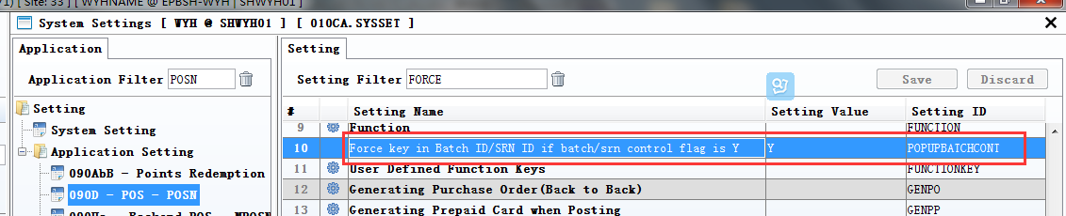
1、set to Y;
2、If batch/srn control flag is Y in the stkmas,then force input key in Batch ID/SRN ID in the pos.
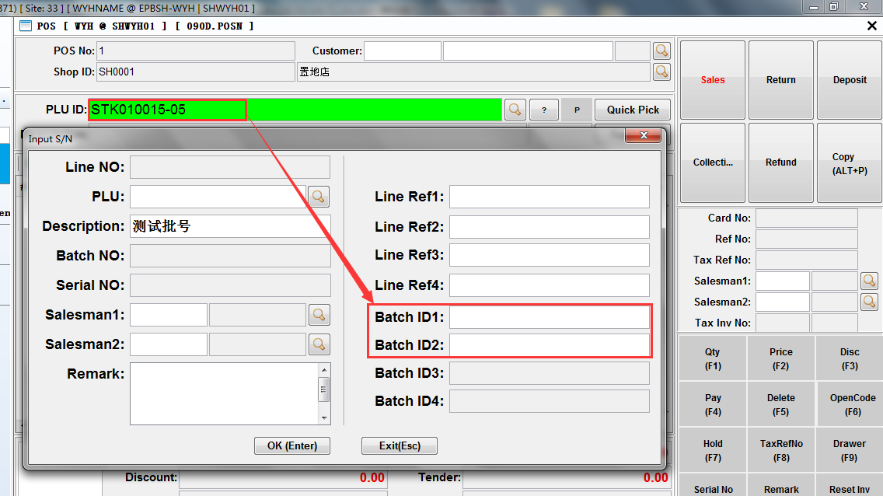

3.2.10 140CJ Stock Take:Added setting'Take Method [A] Full Stock Take [B] Partial Stock Take'. (27682)-871
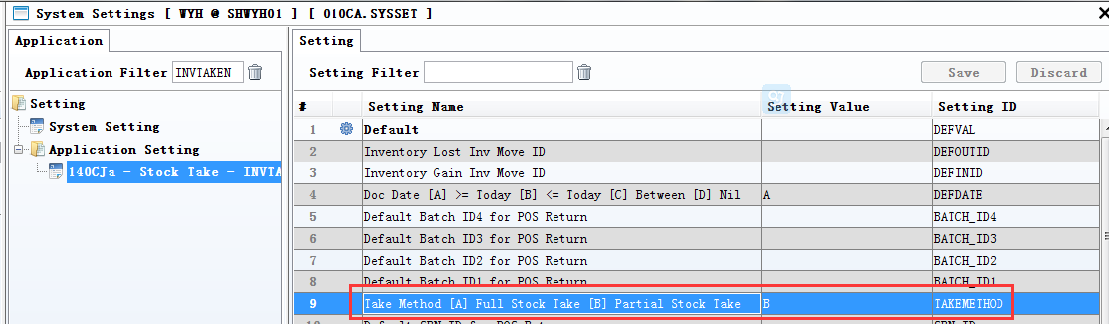
1、According to the set, automatic take out of the default values;
2、When user change take_id, system will use choose takeplan overwrite it .

3.2.11 180BE Work Order Reporting:Added setting'Enable transferring from Work Order ' and 'Enable transferring from Work Order Reporting'. (27538)-871
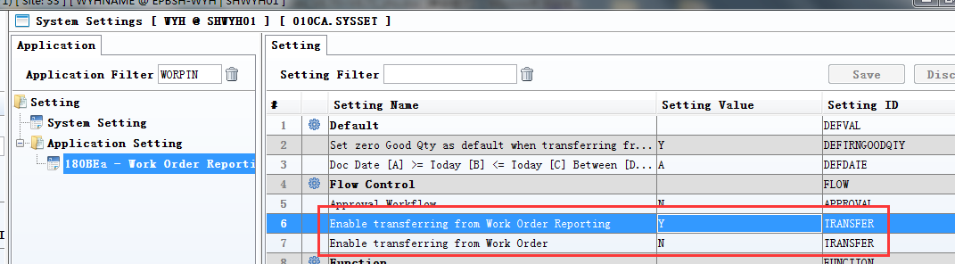
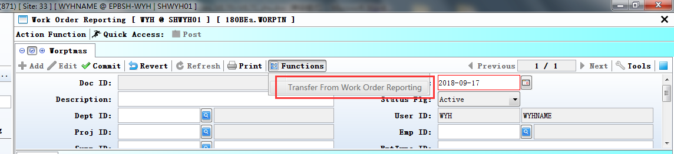

3.2.12 800DA Distribution Analysis etc module:Added setting'Allow Cross Org Enquiry'. (27561)-871
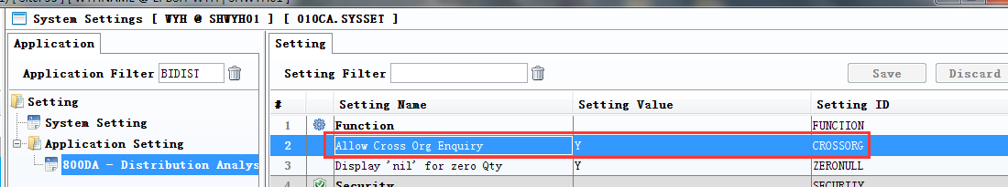
The setting be added in other module,Such as'140EB、140EA、800BA、800AB、800CB' etc module.
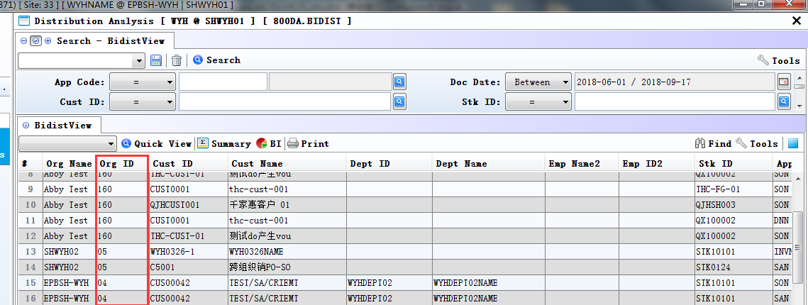

3.2.13 800FA Sales Analysis:Added setting'User Access Control [A] by Dept [B] by Emp Group'. (25868)-870
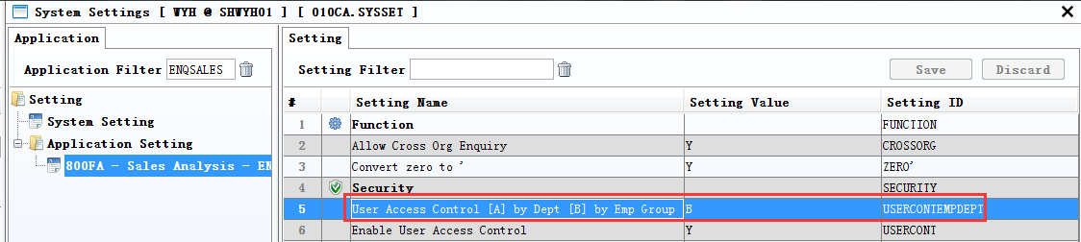
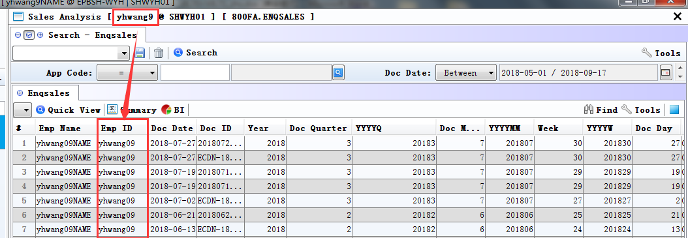

3.3 Improve

3.3.1 070CD Purchase Order Change Note:Added column'PAID_DATE'. (27406)-870
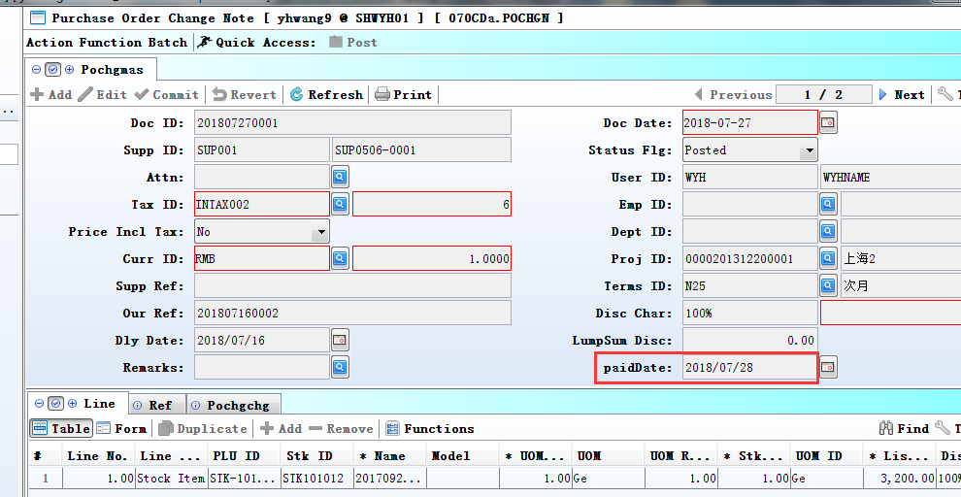
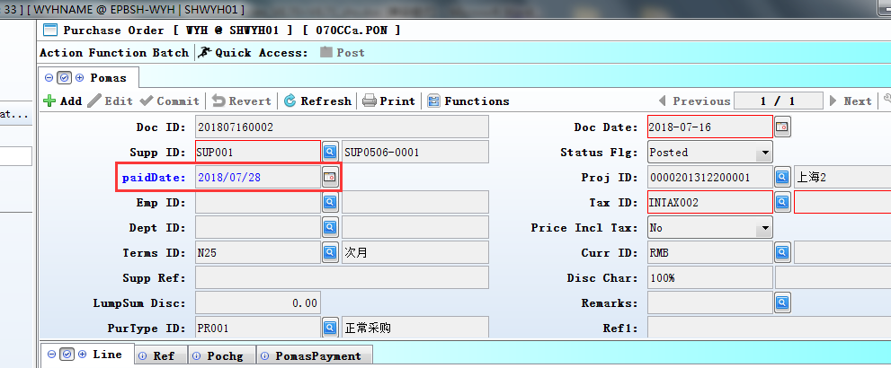

3.3.2 090BH Campaign(Buy and Get Discount):Added function'Buy any number, price discount is N%'. (24091)-871
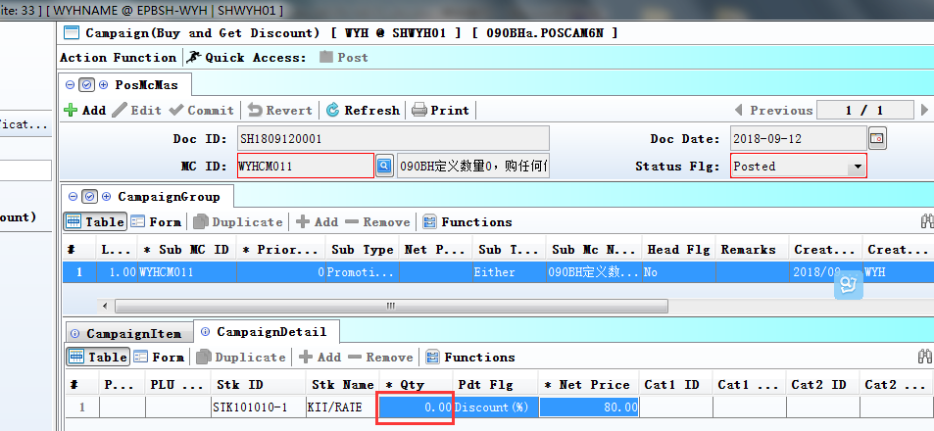
Note: Qty must be defined as zero.

3.3.3 090DXC ZPOS:Added function'order by emp_id ' and ' allow input emp_id '.(27604)-870
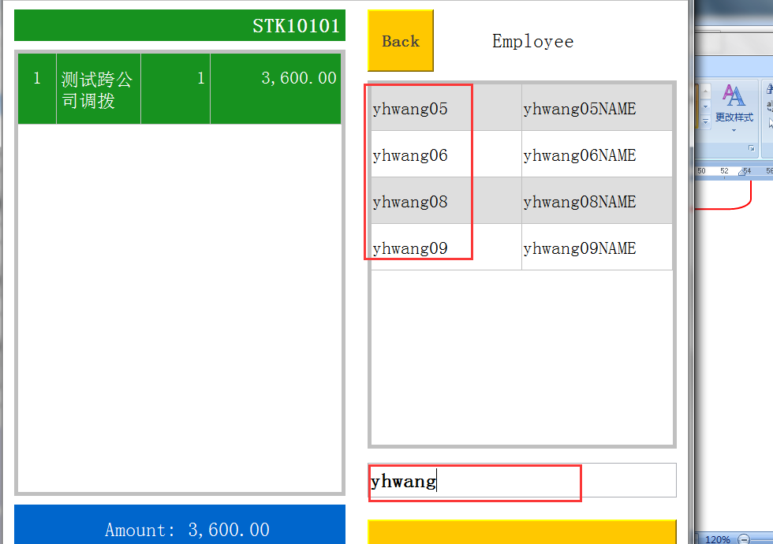

3.3.4 140CH Inventory Transfer Issue:Added button'commit'. (27388)-870
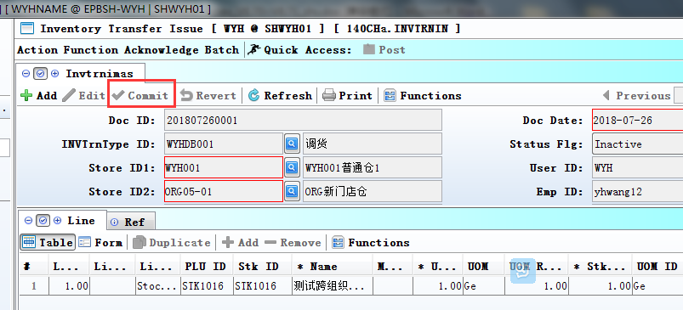

3.3.5 140EJF Stock Value Summary(Valuation Area):Added columns'SAMPLEIN_QTY'and'SAMPLEIN_VALUE'and'SAMPLEOUT_QTY'and'SAMPLEOUT_VALUE'. (27438)-870
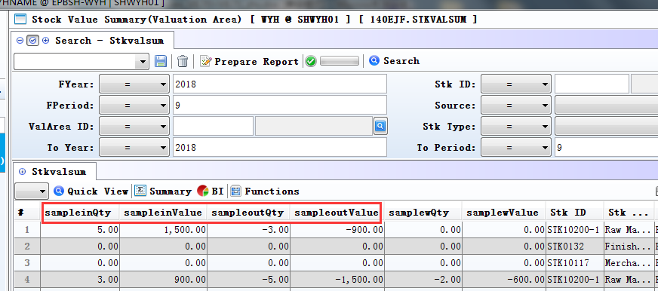

3.3.6 180BNO Work Order Reporting Enquiry:Added column'open qty'. (27464)-870
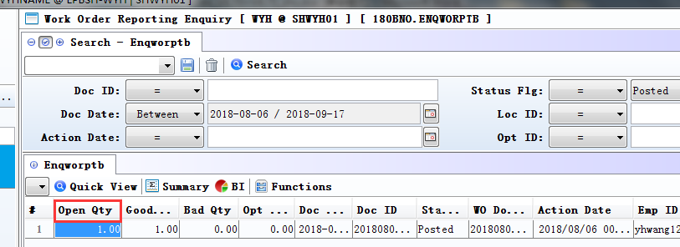

3.3.7 180CA Forecast:Added columns'repUserId'and'FGR Qty'.(27383)-870
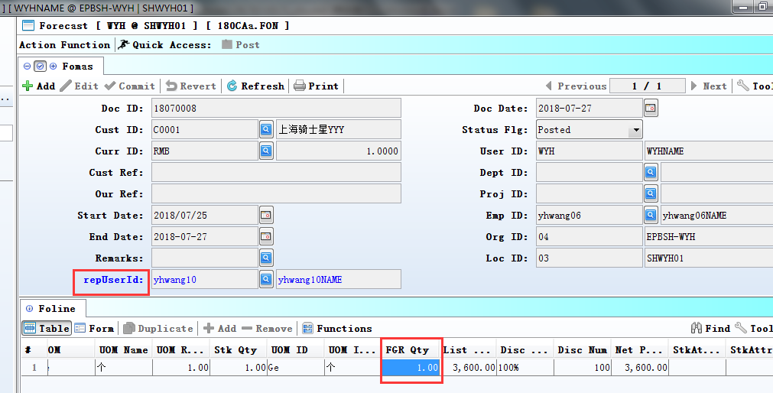
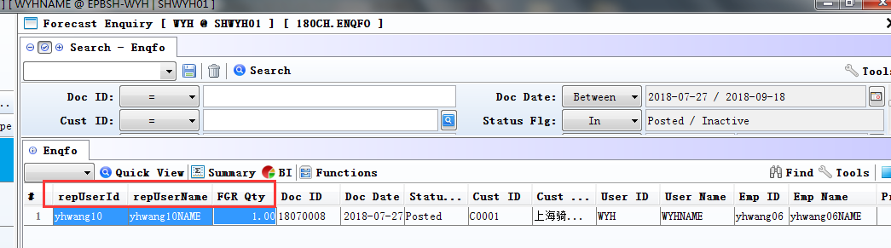
180CH module also added these fields.

3.3.8 140EJF Stock Value Summary(Valuation Area):Added columns'SAMPLEW_QTY'and'SAMPLEW_VALUE'. (27558)-871
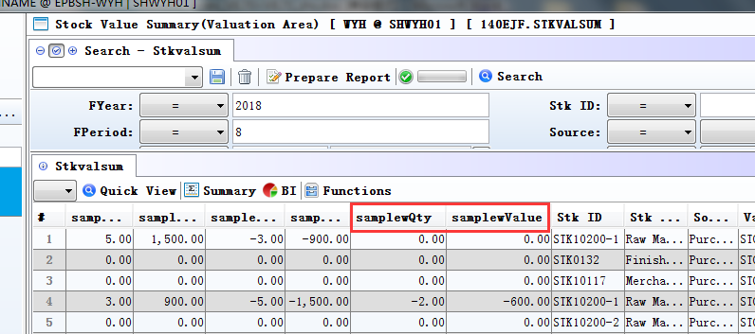

3.3.9 150F Picklist:Added function'Batch Change BIN '. (27603)-871
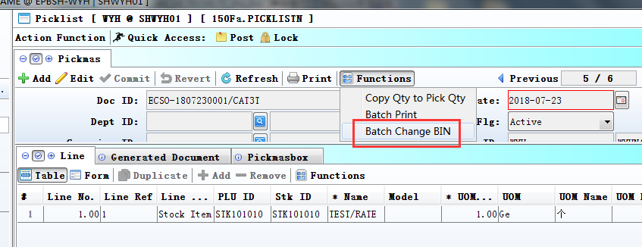

3.3.10 200CD Official Receipt:Added lov for description. (27602)-871
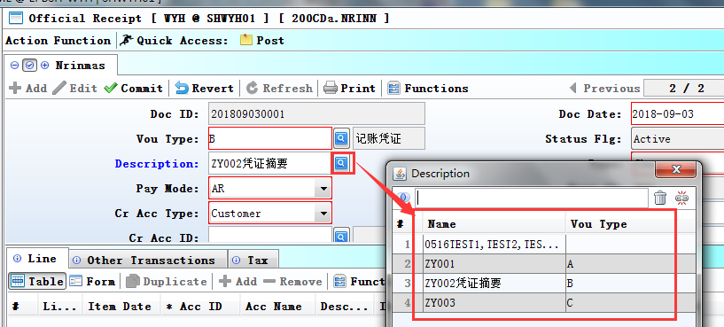
1、200DD module also added these function.
2、'Enable lov for Description' is set to Y in 200BA module,lov can be choose.

3.3.11 BI field can fuzzy query.(25198)-871
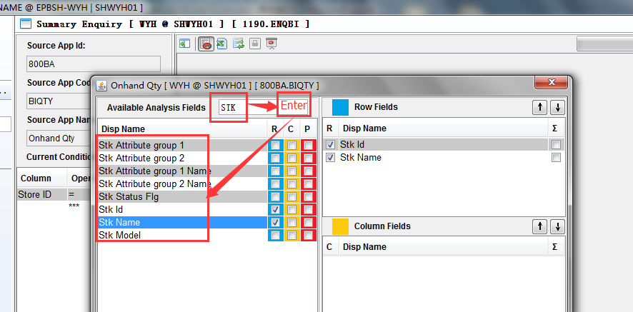
Note:
After inputting words' in the Available Analysis Fields', need to press the enter key.

3.3.12 Remove the system setting 'Allow copying or tranferring of inactive Document', moved to each module.(27619)-871
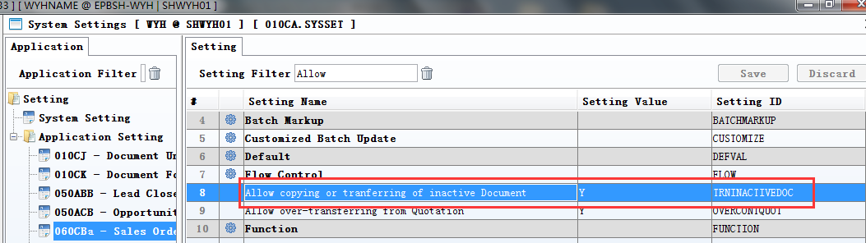

4. Fixes

