EPBrowserRelease Notes
Version 8.72

EPBrowserRelease Notes Version 8.72
Last Revision, 16 October 2018

©Copyright 2018. Enterprise Browser Pte Ltd.
All rights reserved.

No part of this manual may be reproduced in any form or by any means without the express written authorization from EPB. Business forms—which include but are not limited to invoices, checks, sales orders—displayed in this manual are for illustration purposes only and are not to be used for producing actual business forms. Enterprise Browser Pte Ltd. assumes no responsibility.
This document may contain technical inaccuracies or typographical errors and may change without prior notice. Any documentation with respect to EPB software products is provided for informational purposes only and does not extend or modify the limited warranty extended to the licensee of EPB software products.

Enterprise Browser Pte Ltd (EPB)
33Ubi Avenue 3, #07-65, Vertex Tower A, Singapore 408868
Tel: (65)-6509-4065
Fax: (65)-6509-4089

Document Location
EPBSH

Contents
1. Featured 4
2. New Interface 4
3. Enhancements 4
3.1 Privilege 4
3.2 Setting 4
3.2.1 060CB Sales Order:Added setting’Automatically refresh purchase price when batch apply price book’. (27824)-872 4
3.2.2 060CJ Sample Request:Added setting’ Enable copying from Sales Quotation’. (27747)-872 4
3.2.3 060EB Delivery Scheduling Planning:Added setting’ [D] Partial by Distibute Rate’. (27773)-872 5
3.2.4 060EB Delivery Scheduling Planning:Added setting’ Generate Document group by Customer’ .(27848)-872 5
3.2.5 070CF Goods Receive:Added setting’ Use Price with Tax as Transfer Price when stock in’.(27776)-872 6
3.2.6 098CA eCommerce Order:Added setting’ Use [A] Doc Date [B] Posting Date when generate POSMAS’.(27700)-872 6
3.2.7 200CP AR Accrual:Added setting’ [A] Summary without Tax [B] Details with Tax’.(27724)-872 6
3.3 Improve 7
3.3.1 0021 Qty Detail: Added column’Remarks’ in ‘trace’ tabele.(27815)-872 7
3.3.2 010BZ User Access Rights Enquiry:Added column’ pri name’. (27742)-872 7
3.3.3 0021 Qty Detail:Added column’Ref Stk Id’.(27814)-872 8
3.3.4 020BF Customer: 'ecuserPwd' field increase control: length must be greater than or equal to 8. (27788)-872 8
3.3.5 060CT Customer Credit Review Process:the credit limit will be updated to all org.(26413)-872 8
3.3.6 070BZ Purchase Price Book Enquiry:Added column’LastUpdate’.(27823)-872 9
3.3.7 070CJ Shipment Scheduling:Added fields’Cat1_ID’~’Cat8_ID’and’Brand_ID’ at the search in the transfer window.(27775)-872 9
3.3.8 140BX Item Profile Creation:Added control to show which table .(27726)-872 9
3.3.9 140EX Onhand Stock Qty Enquiry:Added columns’ ori_in_date’and’ org_age’.(27698)-872 10
3.3.10 150CC Bin Enquiry:Added Replenishment function. (27762)-872 10
3.3.11 180EH WIP Summary:Added column’ COMPLETE_DATE’.(27813)-872 10
3.3.12 200BA General Accounting voucher:Added control’ line number duplicate of documents don't allow Posting’.(27706)-872 11
4. Fixes 11

1. Featured

2. New Interface

3. Enhancements

3.1 Privilege

3.2 Setting

3.2.1 060CB Sales Order:Added setting’Automatically refresh purchase price when batch apply price book’. (27824)-872
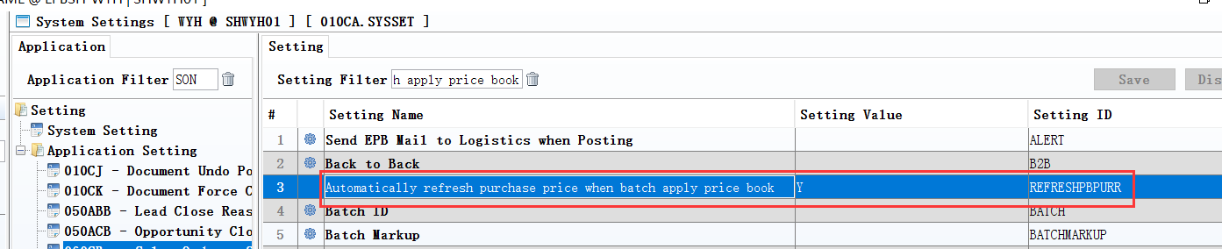
Set to Y;
Purchase price also will be updated automatically.
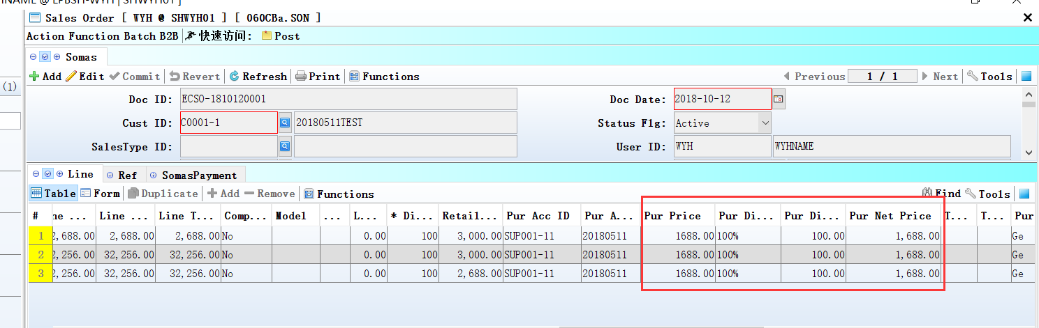

3.2.2 060CJ Sample Request:Added setting’ Enable copying from Sales Quotation’. (27747)-872
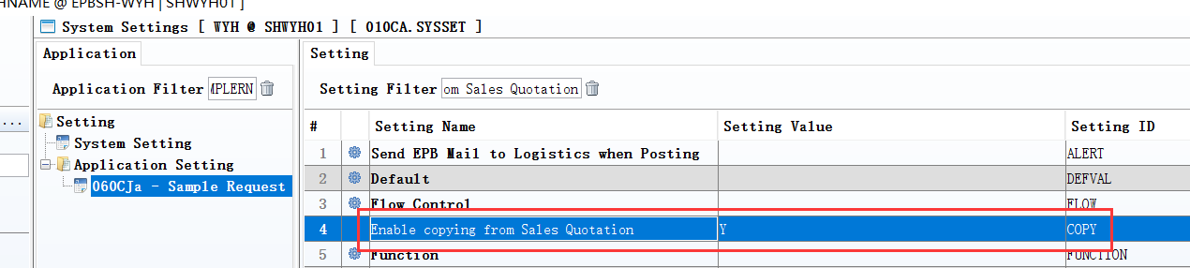
Set to Y;
Can copy from quot.
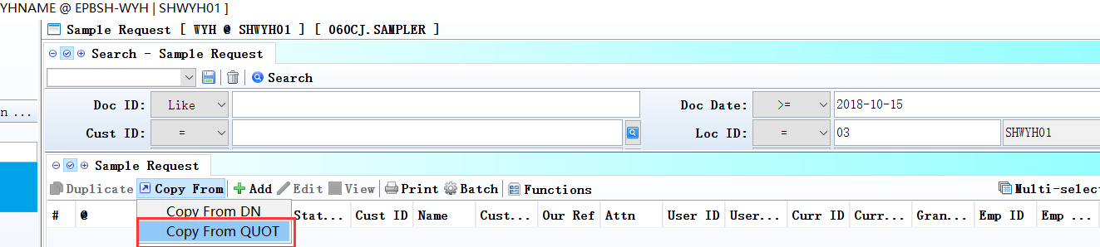

3.2.3 060EB Delivery Scheduling Planning:Added setting’ [D] Partial by Distibute Rate’. (27773)-872
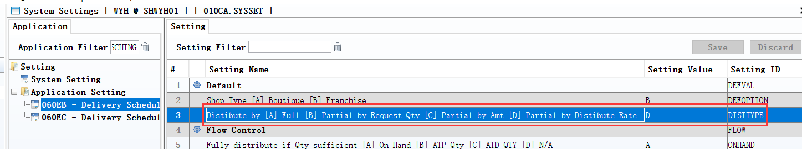
Define ‘Dist_rate’ in Customer module;
060EB:Set to D;
Automatically assigned to generate DP.
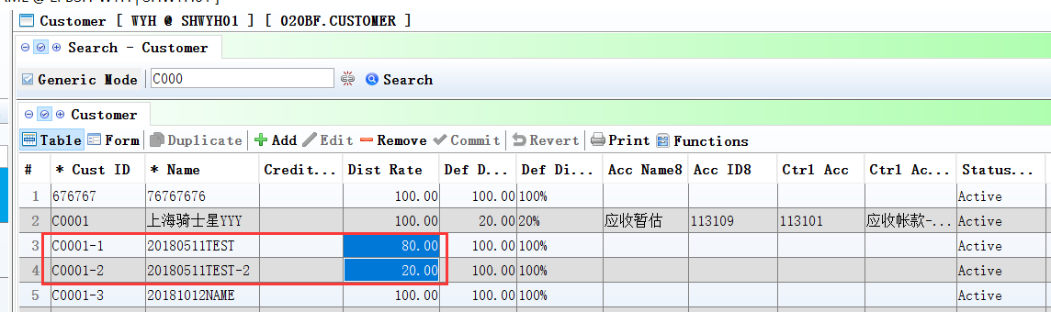
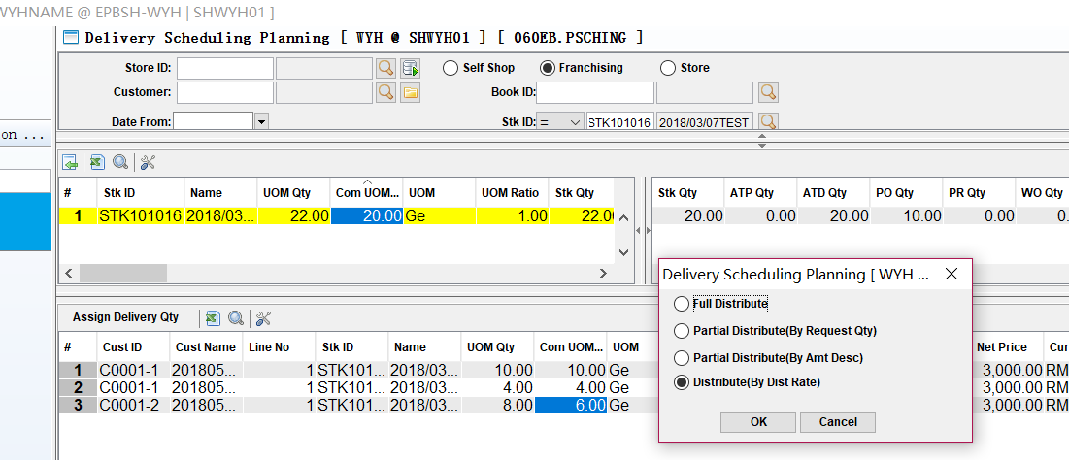

3.2.4 060EB Delivery Scheduling Planning:Added setting’ Generate Document group by Customer’ .(27848)-872
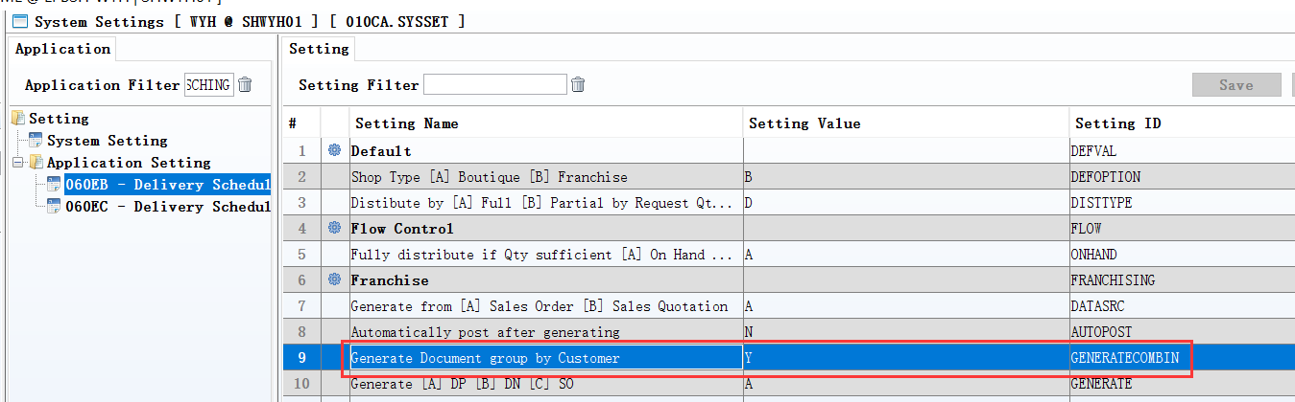
1、Set to Y;
2、Generate Document group by Customer.
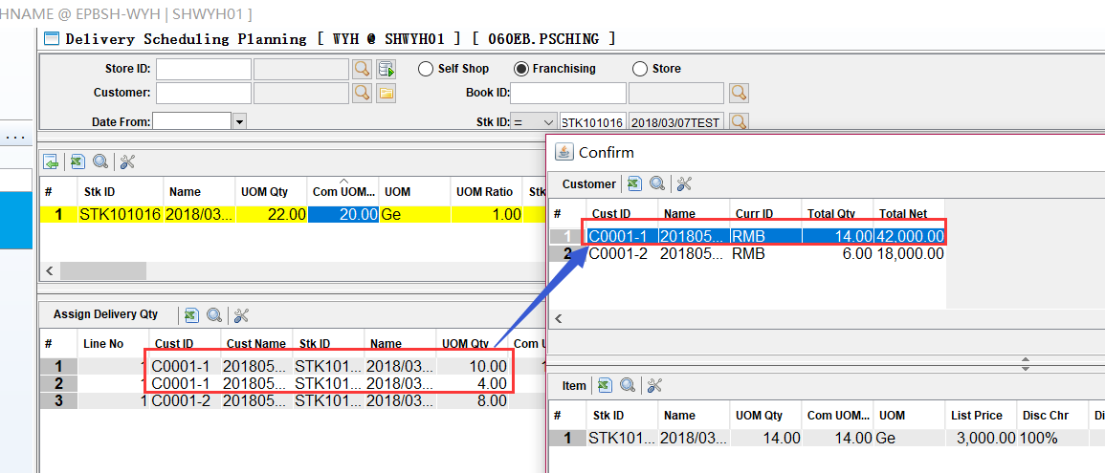

3.2.5 070CF Goods Receive:Added setting’ Use Price with Tax as Transfer Price when stock in’.(27776)-872
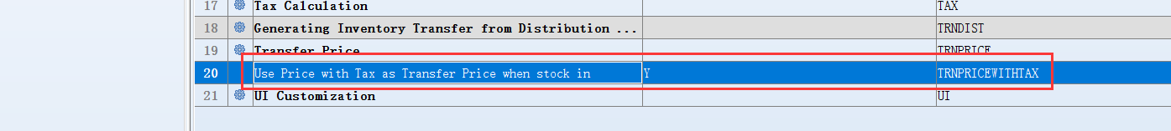
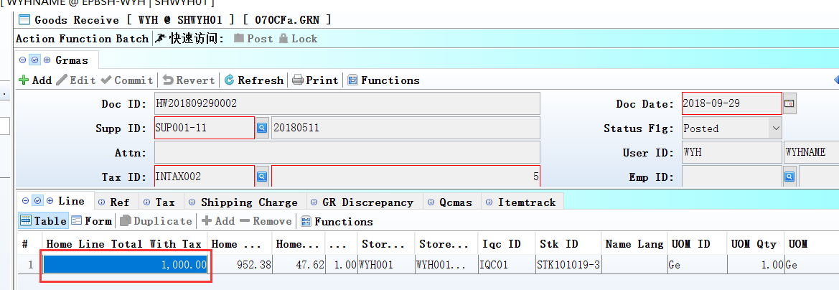
Set to Y;
Trn cost Price=Price with tax (in GR)
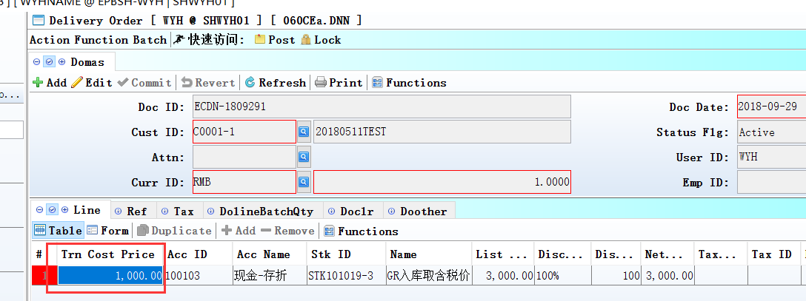

3.2.6 098CA eCommerce Order:Added setting’ Use [A] Doc Date [B] Posting Date when generate POSMAS’.(27700)-872
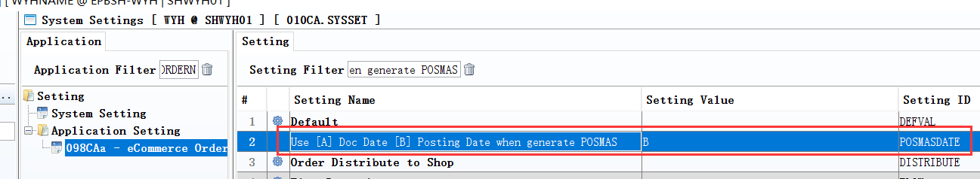

3.2.7 200CP AR Accrual:Added setting’ [A] Summary without Tax [B] Details with Tax’.(27724)-872
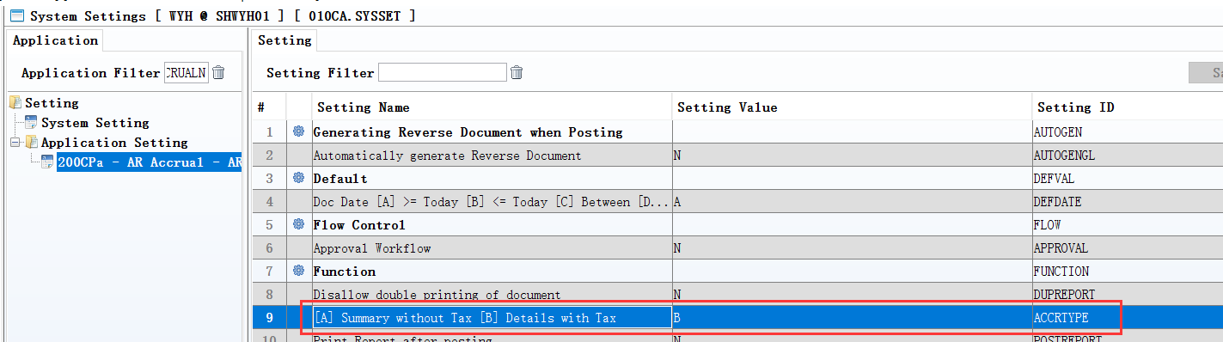
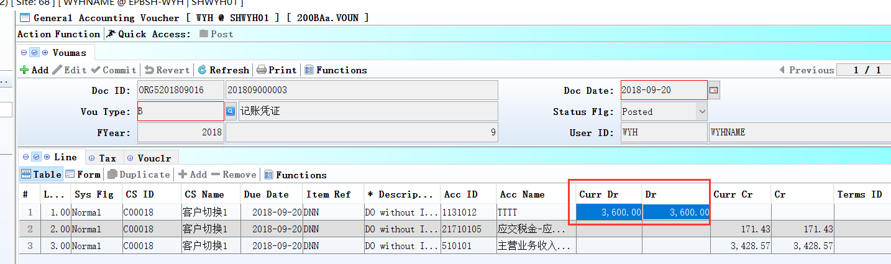
Set to B;
‘Curr Dr’ include tax .

3.3 Improve

3.3.1 0021 Qty Detail: Added column’Remarks’ in ‘trace’ tabele.(27815)-872
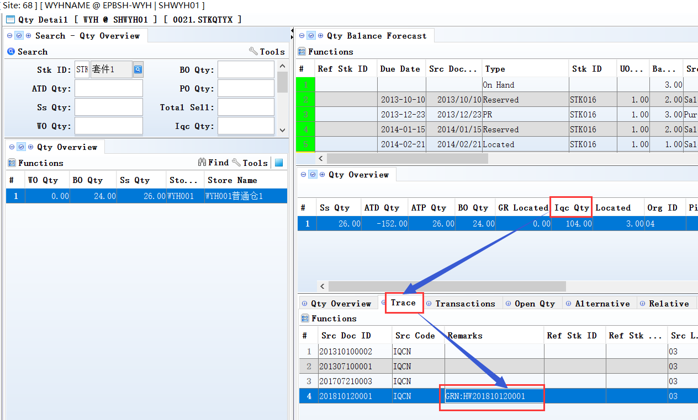
In the QCMAS of 'SRC_CODE' and 'SRC_DOC_ID' were incorporated in the 'Remark' field.

3.3.2 010BZ User Access Rights Enquiry:Added column’ pri name’. (27742)-872
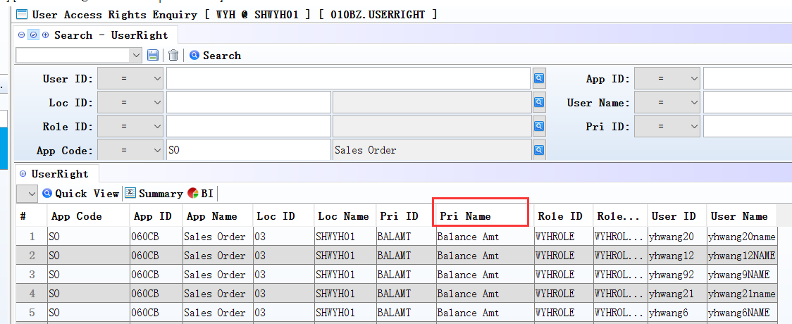

3.3.3 0021 Qty Detail:Added column’Ref Stk Id’.(27814)-872
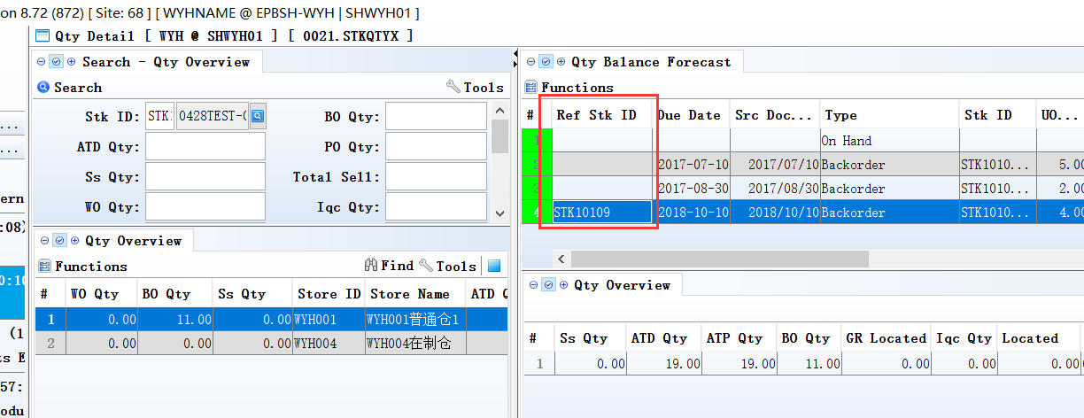
Note:
Use mat_id to search, RefStkId=WOMAS.STK_ID.

3.3.4 020BF Customer: 'ecuserPwd' field increase control: length must be greater than or equal to 8. (27788)-872
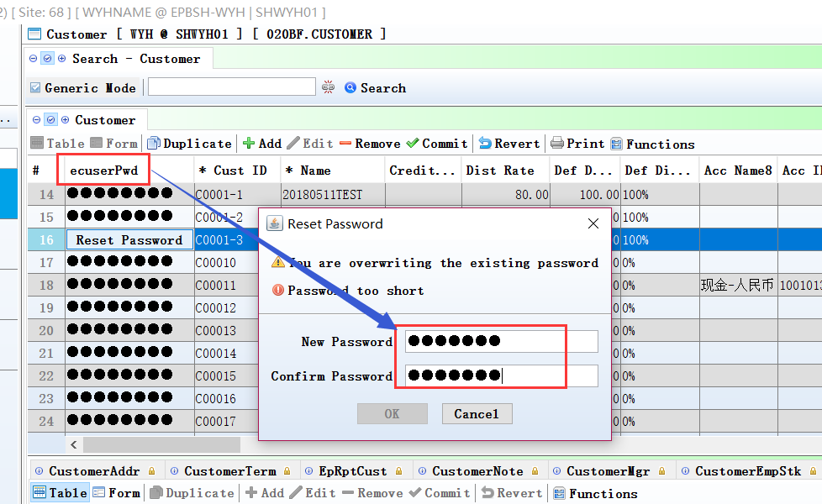

3.3.5 060CT Customer Credit Review Process:the credit limit will be updated to all org.(26413)-872
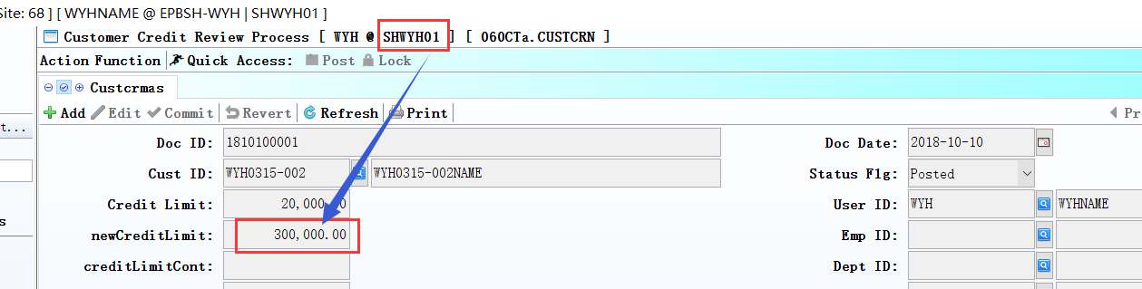
If customer code is same in all org,the credit limit will be updated to all org.
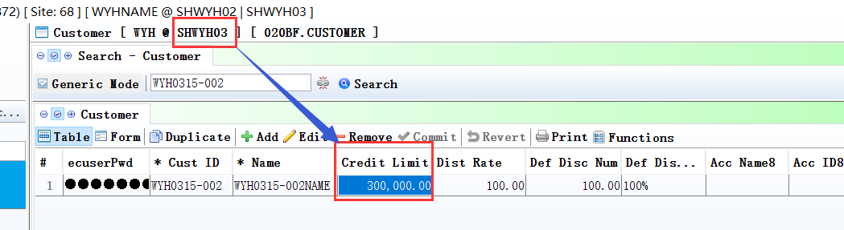

3.3.6 070BZ Purchase Price Book Enquiry:Added column’LastUpdate’.(27823)-872
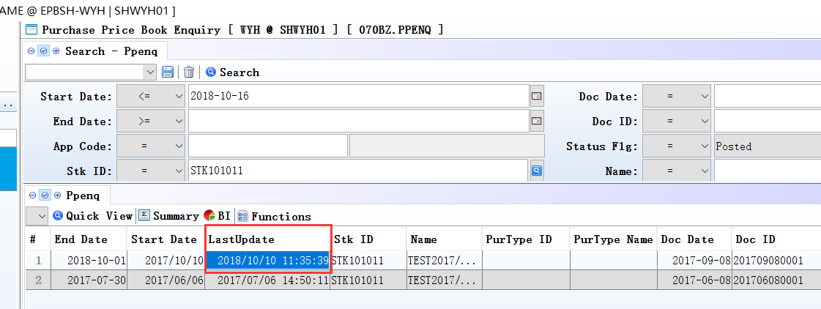
If there are Purchase Price changes,the ‘LastUpdat’ will be updated, inorder to let the buyer know when the Purchase Price has been modified.

3.3.7 070CJ Shipment Scheduling:Added fields’Cat1_ID’~’Cat8_ID’and’Brand_ID’ at the search in the transfer window.(27775)-872
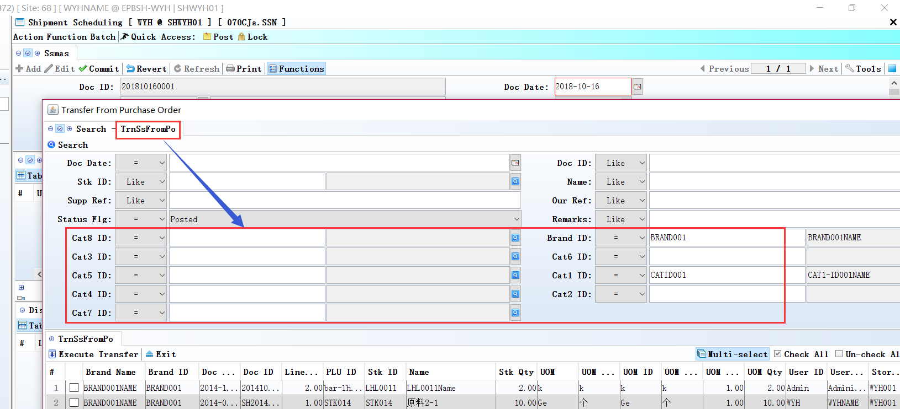

3.3.8 140BX Item Profile Creation:Added control to show which table .(27726)-872
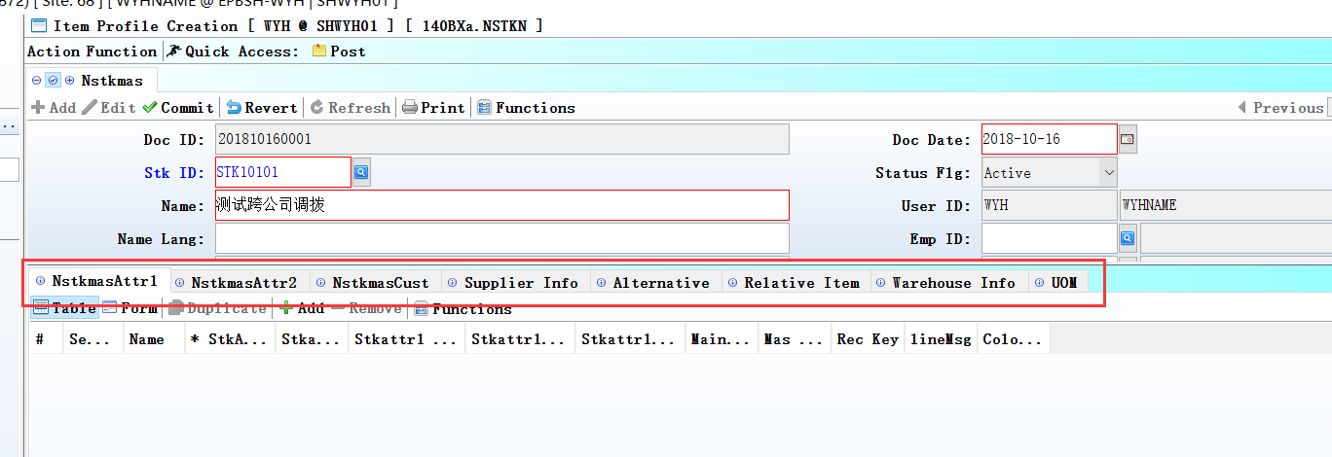
By stkmas Settings to control, whether need to display table.

3.3.9 140EX Onhand Stock Qty Enquiry:Added columns’ ori_in_date’and’ org_age’.(27698)-872
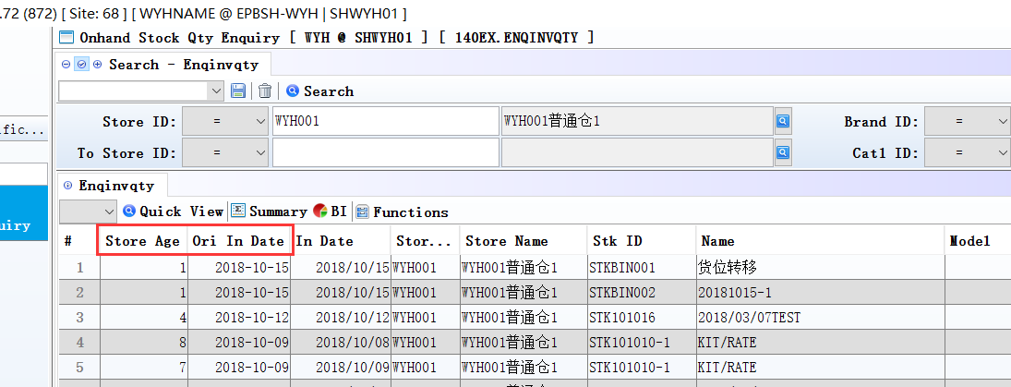

3.3.10 150CC Bin Enquiry:Added Replenishment function. (27762)-872
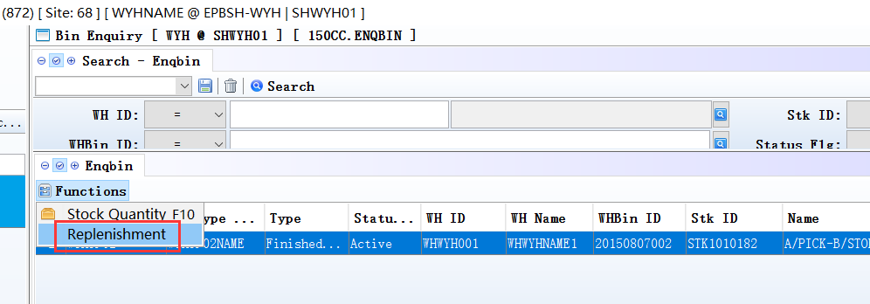
140ADC-Storemas:define ‘def_whbin_id’;
150AE-Bintype:define’ pick/storage 'A'/'B'’;
140BA-STKMAS-WH:define’ MAX_QTY/MIN_QTY’;
150CC-Enqbin: IN ENQBIN HAVE FUNCTION "BIN REPLENISHMENT",WHEN CLICK, SYSTEM WILL CHECK ALL ITEM IN BINTYPE_ID = 'A' ITEM < MIN_QTY,AND CREATE WHBINTRN FOR THOSE ITEM AND FROM BINTYPE_ID = 'B'
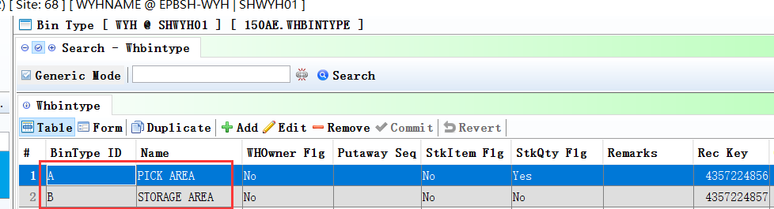

3.3.11 180EH WIP Summary:Added column’ COMPLETE_DATE’.(27813)-872
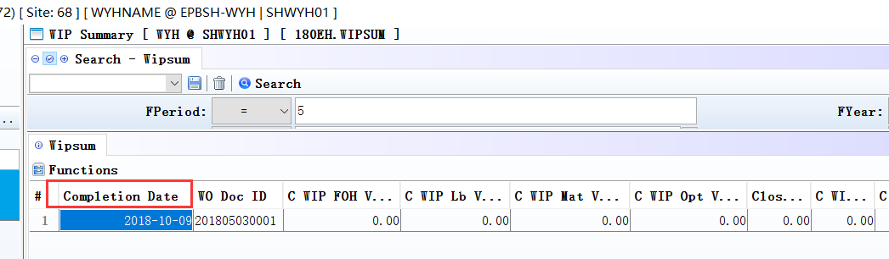

3.3.12 200BA General Accounting voucher:Added control’ line number duplicate of documents don't allow Posting’.(27706)-872
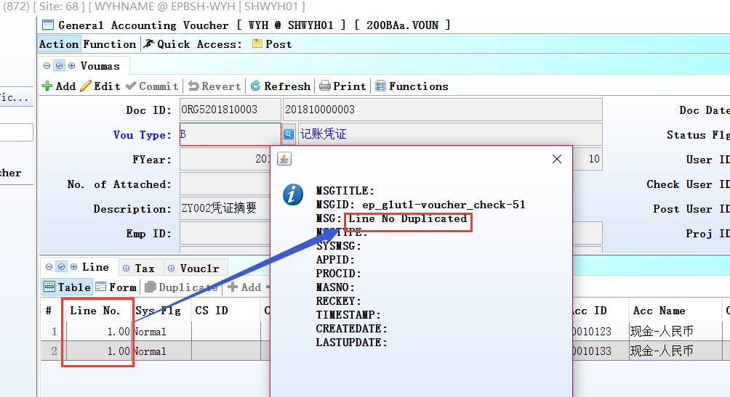
If the line number is duplicated, there will be a pop-up message when posting documents.

4. Fixes

