EPBrowserRelease Notes
Version 8.73

EPBrowserRelease Notes Version 8.73
Last Revision, 20 November 2018

©Copyright 2018. Enterprise Browser Pte Ltd.
All rights reserved.

No part of this manual may be reproduced in any form or by any means without the express written authorization from EPB. Business forms—which include but are not limited to invoices, checks, sales orders—displayed in this manual are for illustration purposes only and are not to be used for producing actual business forms. Enterprise Browser Pte Ltd. assumes no responsibility.
This document may contain technical inaccuracies or typographical errors and may change without prior notice. Any documentation with respect to EPB software products is provided for informational purposes only and does not extend or modify the limited warranty extended to the licensee of EPB software products.

Enterprise Browser Pte Ltd (EPB)
33Ubi Avenue 3, #07-65, Vertex Tower A, Singapore 408868
Tel: (65)-6509-4065
Fax: (65)-6509-4089

Document Location
EPBSH

Contents
1. Featured 5
2. New Interface 5
2.1 Added new module: 091AL Menu Folder.(27872)-873 5
2.2 Added new module:030K Workflow Node & 030L Workflow Task.(28099)-873 5
3. Enhancements 5
3.1 Privilege 5
3.1.1 140UA Unicode:Added Privilege’ Delete’and’ Import’. (27260)-873 5
3.1.2 200CEB AR Ageing:Added Privilege’ Cross Org’(28047)-873 5
3.2 Setting 6
3.2.1 020BX Customer Profile Creation: Added setting ‘Define Workflow by Customer Category’. (28026)-873 6
3.2.2 070CH Supplier Return:Added setting’ Force complete related Supplier Return Request when posting’.(27877)-873 6
3.2.3 070DA Procurement Preparation(Purchase Requisition): Added setting’ Use PR location as PO location if stock item is delivery to site’. (27943)-873 7
3.2.4 140CF Inventory Transfer:Added setting’ Enable transferring from Sales Order’.(28079)-873 7
3.2.5 140CI Inventory Transfer Receive:Added setting’ Header column cursor focus [colName example docId]’. (27884)-873 7
3.2.6 150AB Warehouse:Added setting’ Allow negative Qty’. (27916)-873 8
3.2.7 150BB Bin Transfer:Added setting’ Automatically Generate INVTRN when BIN Transfer across bintype_id A,B,C to D’. (27915)-873 8
3.2.8 180BFA Batch Generate Work Order:Added setting‘Enable transferring from Inventory Transfer Request’. (28044)-873 8
3.2.9 180BL Outsource Goods Receive:Added setting’ Generate FGRR For all WO Stk’. (27942)-873 8
3.2.10 200DDA AP Payment Batch:Added setting ‘Default Dr Acc Type [G] GL Account [C] Customer [S] Supplier [E] Employee’. (27899)-873 8
3.2.11 200DDA AP Payment Batch:Added setting’ Enable paying to Custome’、’ Enable paying to Supplier’、’ Enable paying to Employee’、’ Enable paying to Other GL’. (27932)-873 9
3.2.12 800CB Inventory Analysis:Added setting’ Use Transfer Cost as Stock Value’.(28050)-873 9
3.3 Improve 10
3.3.1 060CE Delivery Order:Added function’ if saletype_id = 'SAMPLEX' or 'GIFTX', invmove_id = 'SAMPLEX' or 'GIFTX',then not consider in credit limit calculation’. (27732)-873 10
3.3.2 060HA Sales Order Enquiry:Added column’ DEPOSIT_AMT’.(27917)-873 10
3.3.3 070CC Purchase Order:Added column’ totalWeight’. (27870)-873 10
3.3.4 070CC Purchase Order:Added column’ production_date’.(27939)-873 10
3.3.5 070CZ Goods Distribution Planning:Added column’ packqty’. (28020)-873 11
3.3.6 070HP Goods Receive Shipping Charges Enquiry:Added column’ orgname’.(28135)-873 11
3.3.7 140EB Stock Summary:Added columns’Total Volume’and’Total Weight’and’ unit_weight’and’Volume’.(28076)-873 11
3.3.8 150F Picklist:Added function’ complete/undo complete’.(27862)-873 12
3.3.9 150BB Bin Transfer:Added column’bintrnType’. (27861)-873 12
3.3.10 160DA Application Form Setup:Added column’prefix’.(27912)-873 12
3.3.11 160DA Application Form Setup :Added function ‘Copy’.(27911)-873 13
3.3.12 180BA Work Order:Added function’ refresh bulk_flg from stkmas’.(27903)-873 13
3.3.13 180BFA Batch Generate Work Order:Added columns’ATP Qty’and’ATD Qty’and’Onhand Qty’ .(28086)-873 13
3.3.14 180BNO Work Order Reporting Enquiry:Added columns’ cust_id’and’ cust_name’.(28072)-873 14
3.3.15 180BNX Outsource Price Book Enquiry:Added columns’LastUpdate’and’ LastUpdate_User_ID’and’ LastUpdate_UserName’.(28088)-873 14
3.3.16 180CA Forecast:Added control’ if have non cancelled po/wo not allow undo post’.(27894)-873 14
3.3.17 180EI Finished Goods Costing:Added columns’Volume’and’Unit Weight’and’Unit Weight UOM’.(28077)-873 14
3.3.18 200BX Journal Entry Batch:Added function’ Use the remark of documents automatically refresh the remark of voucher’. (27891)-873 15
3.3.19 200DA Supplier Invoice:Added column’ PO_DOC_ID’ in TrnSinvFromGr interface.(27940)-873 15
3.3.20 140EBA Stock Summary As At, etc module:Added column’Retail List Price’ . (28038)-873 15
4. Fixes 15

1. Featured

2. New Interface

2.1 Added new module: 091AL Menu Folder.(27872)-873

2.2 Added new module:030K Workflow Node & 030L Workflow Task.(28099)-873

3. Enhancements

3.1 Privilege

3.1.1 140UA Unicode:Added Privilege’ Delete’and’ Import’. (27260)-873
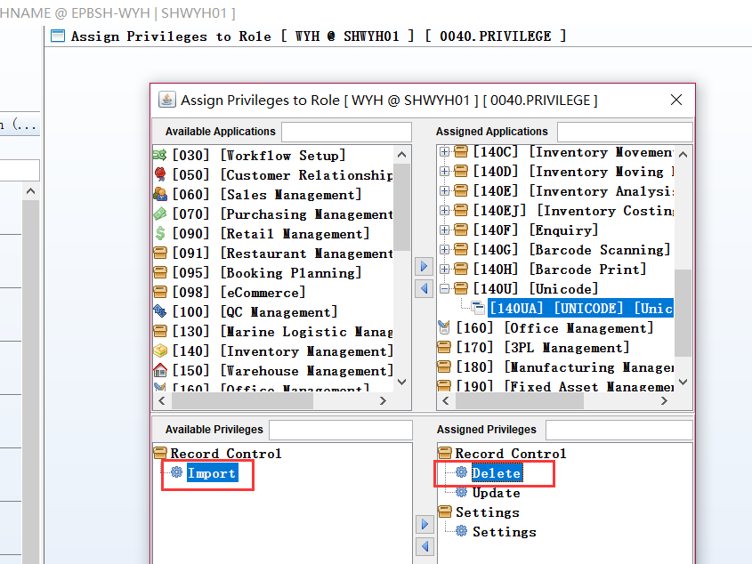

3.1.2 200CEB AR Ageing:Added Privilege’ Cross Org’(28047)-873
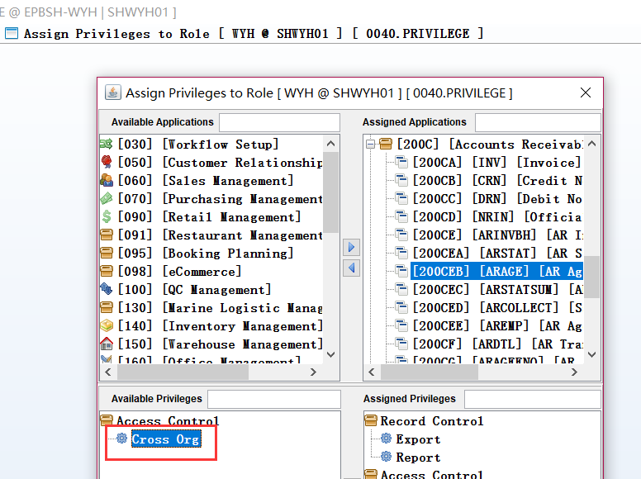
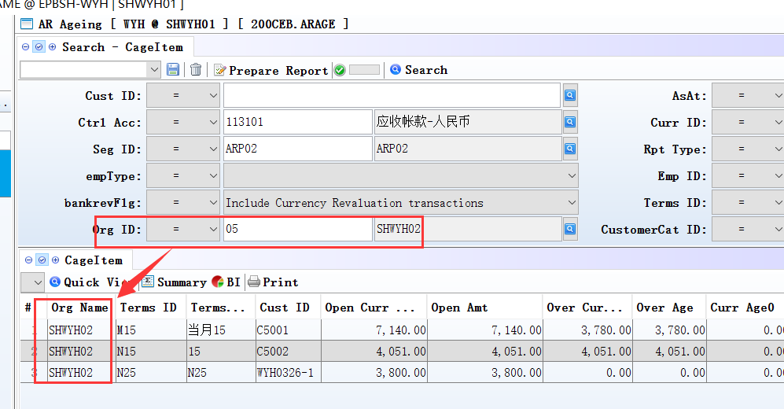
The user is not admin can’t choose own org_id.
Add the function:
Apage\bankbal\openitembal etc module.

3.2 Setting

3.2.1 020BX Customer Profile Creation: Added setting ‘Define Workflow by Customer Category’. (28026)-873
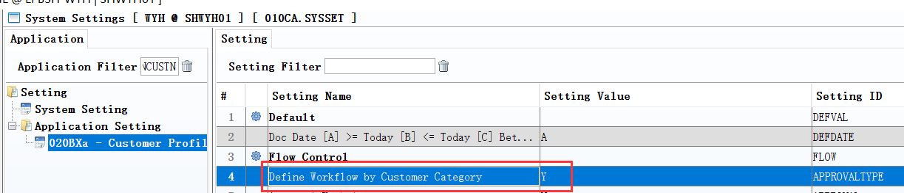
1、020BE:define WF_ID;
2、020BX: ‘Define Workflow by Customer Category’=Y;
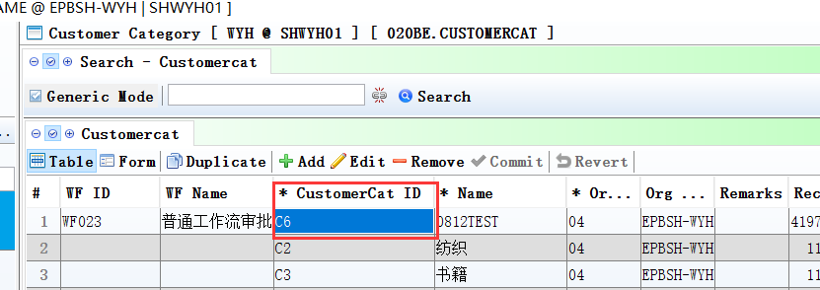
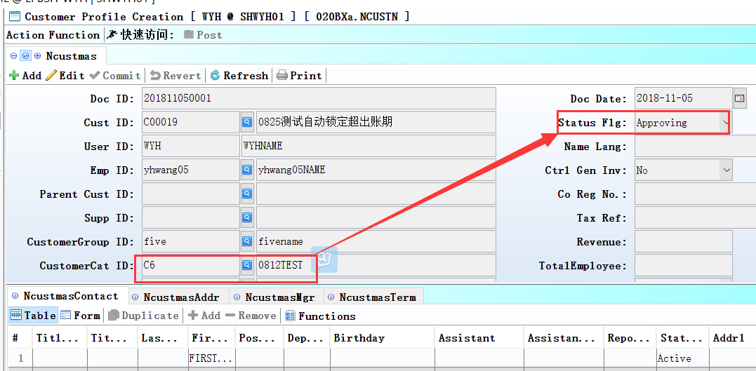

3.2.2 070CH Supplier Return:Added setting’ Force complete related Supplier Return Request when posting’.(27877)-873
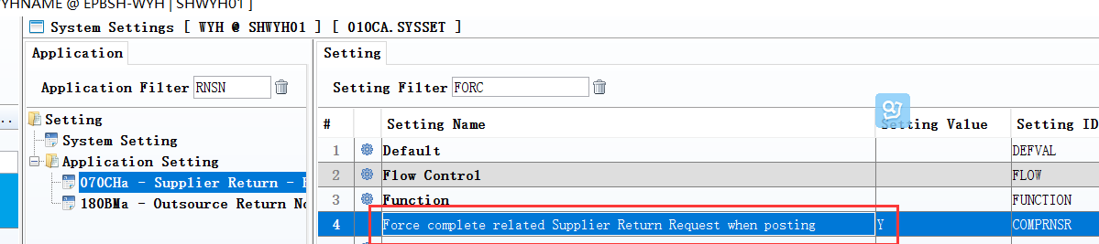

3.2.3 070DA Procurement Preparation(Purchase Requisition): Added setting’ Use PR location as PO location if stock item is delivery to site’. (27943)-873
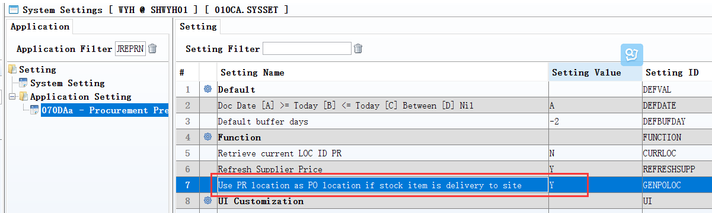

3.2.4 140CF Inventory Transfer:Added setting’ Enable transferring from Sales Order’.(28079)-873
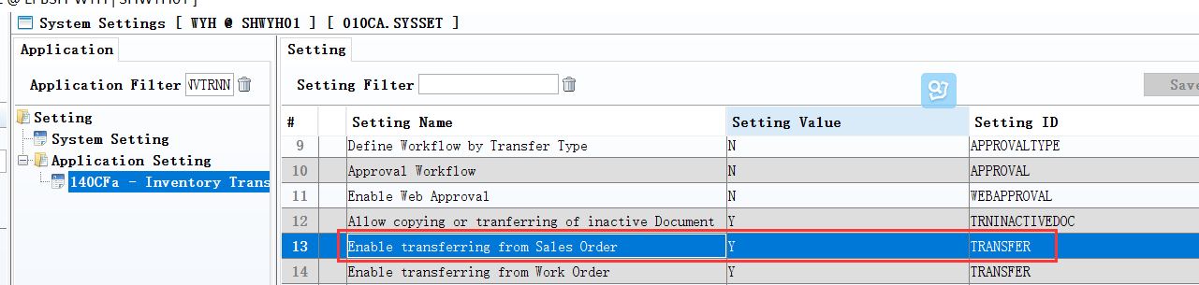
Note: must input cus_id, in the head;
otherwise can't transferring from So.
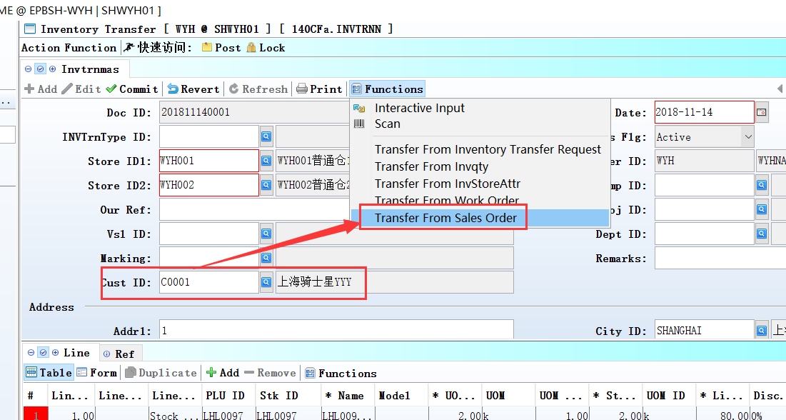

3.2.5 140CI Inventory Transfer Receive:Added setting’ Header column cursor focus [colName example docId]’. (27884)-873
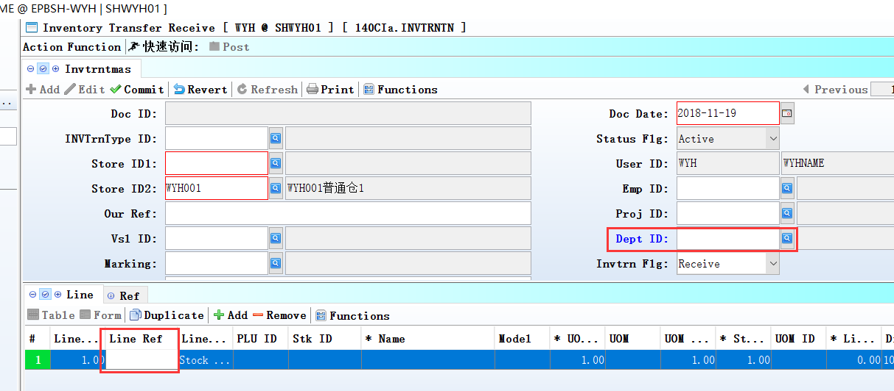
Added new doucument, the cursor point to set of columns.

3.2.6 150AB Warehouse:Added setting’ Allow negative Qty’. (27916)-873
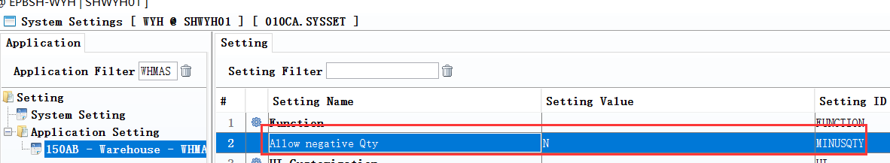

3.2.7 150BB Bin Transfer:Added setting’ Automatically Generate INVTRN when BIN Transfer across bintype_id A,B,C to D’. (27915)-873

3.2.8 180BFA Batch Generate Work Order:Added setting‘Enable transferring from Inventory Transfer Request’. (28044)-873
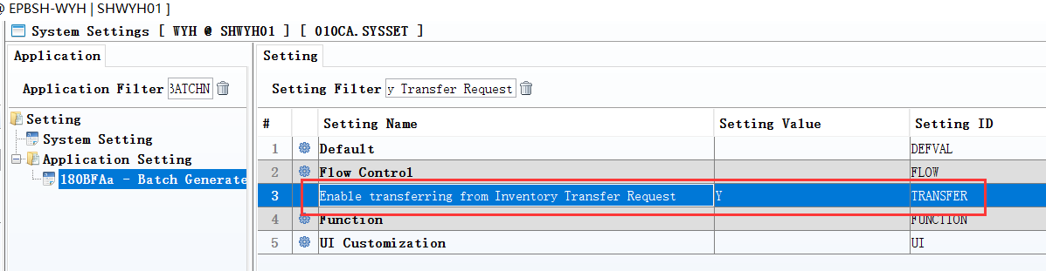
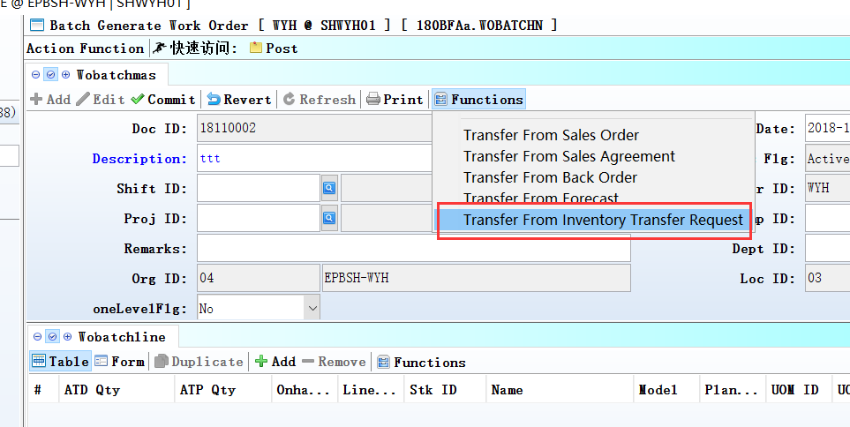

3.2.9 180BL Outsource Goods Receive:Added setting’ Generate FGRR For all WO Stk’. (27942)-873
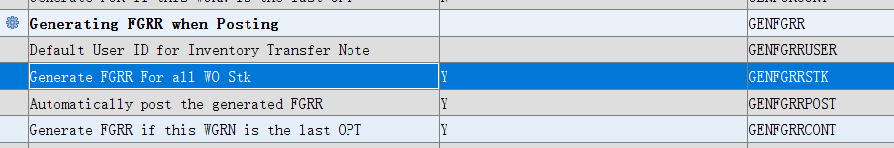

3.2.10 200DDA AP Payment Batch:Added setting ‘Default Dr Acc Type [G] GL Account [C] Customer [S] Supplier [E] Employee’. (27899)-873
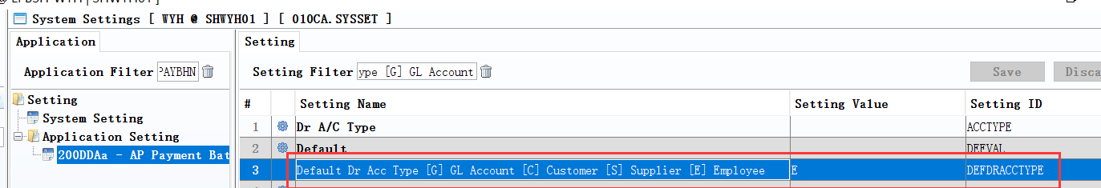

3.2.11 200DDA AP Payment Batch:Added setting’ Enable paying to Custome’、’ Enable paying to Supplier’、’ Enable paying to Employee’、’ Enable paying to Other GL’. (27932)-873
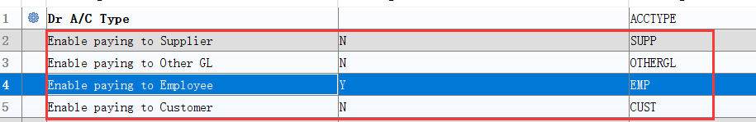
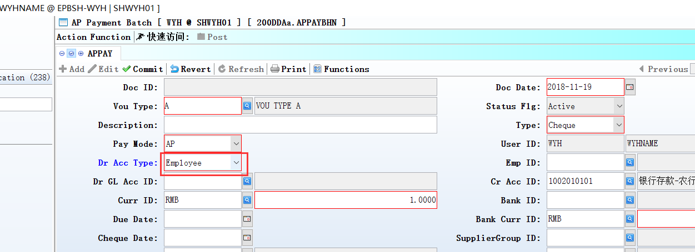
Set to Y;
‘Dr Acc Type’ can be selected.

3.2.12 800CB Inventory Analysis:Added setting’ Use Transfer Cost as Stock Value’.(28050)-873
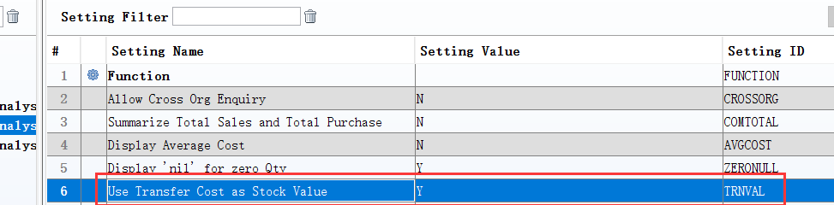
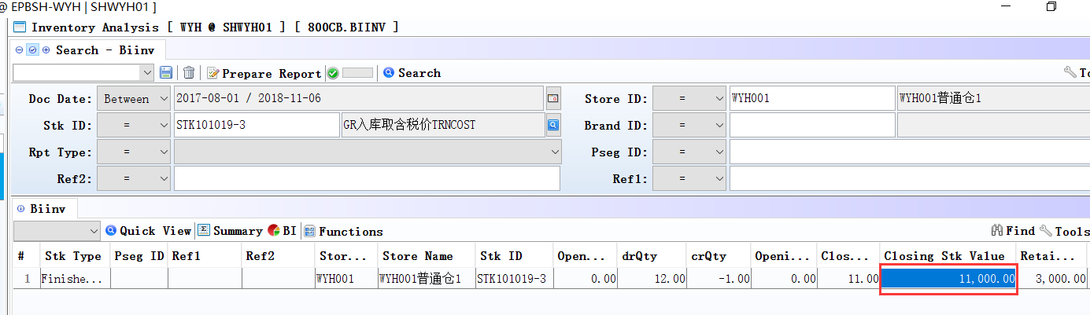

3.3 Improve

3.3.1 060CE Delivery Order:Added function’ if saletype_id = 'SAMPLEX' or 'GIFTX', invmove_id = 'SAMPLEX' or 'GIFTX',then not consider in credit limit calculation’. (27732)-873

3.3.2 060HA Sales Order Enquiry:Added column’ DEPOSIT_AMT’.(27917)-873
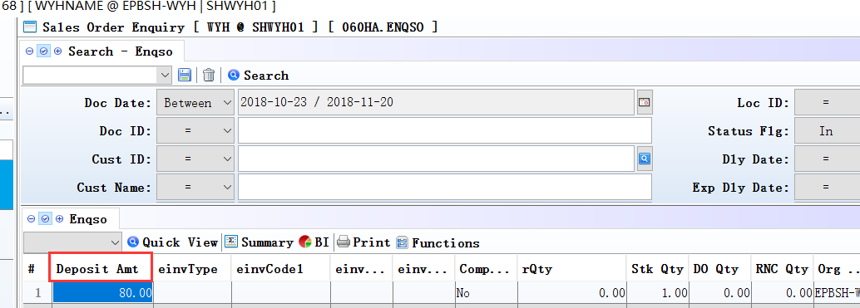

3.3.3 070CC Purchase Order:Added column’ totalWeight’. (27870)-873
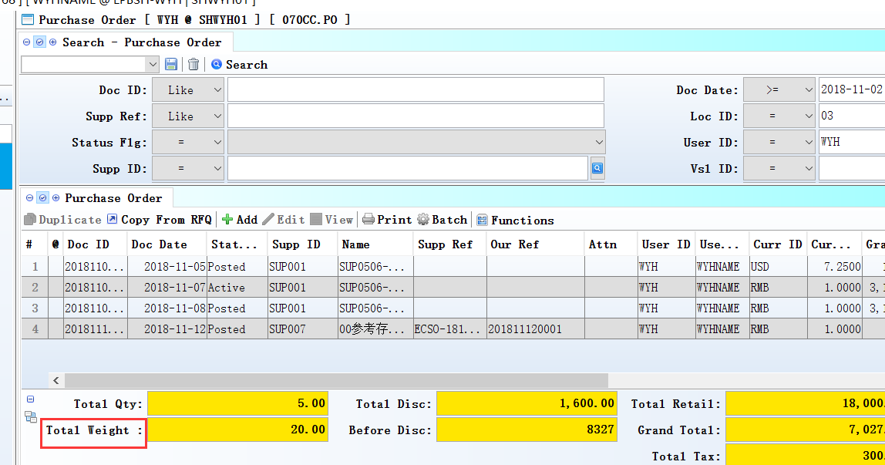

3.3.4 070CC Purchase Order:Added column’ production_date’.(27939)-873
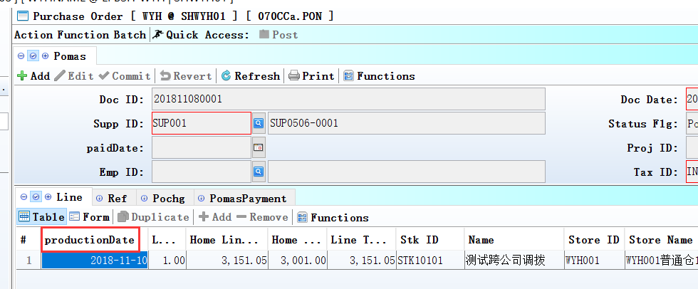

3.3.5 070CZ Goods Distribution Planning:Added column’ packqty’. (28020)-873
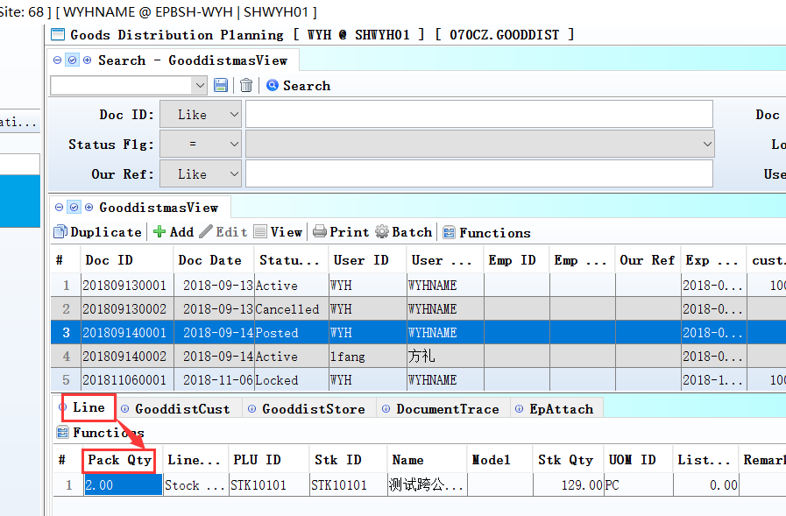
Added column in table QtyDtl.

3.3.6 070HP Goods Receive Shipping Charges Enquiry:Added column’ orgname’.(28135)-873
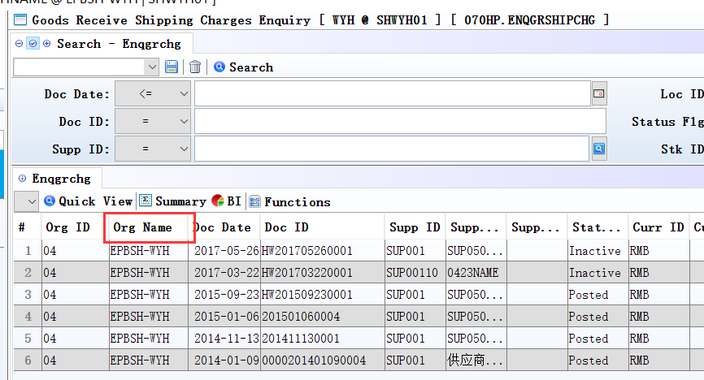

3.3.7 140EB Stock Summary:Added columns’Total Volume’and’Total Weight’and’ unit_weight’and’Volume’.(28076)-873
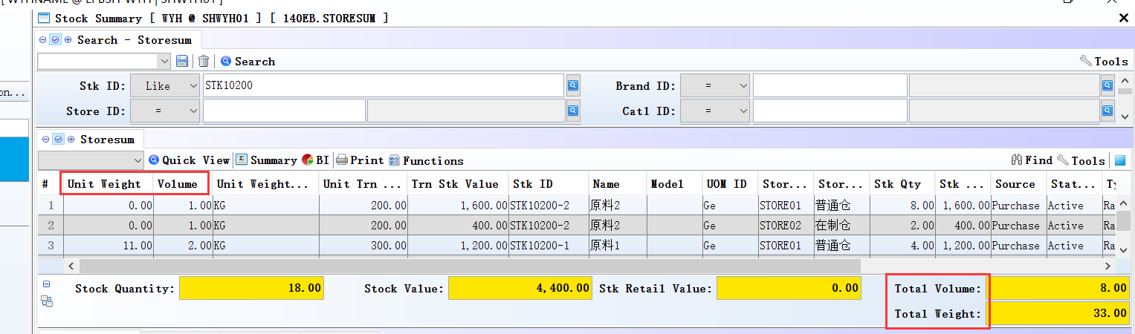

3.3.8 150F Picklist:Added function’ complete/undo complete’.(27862)-873
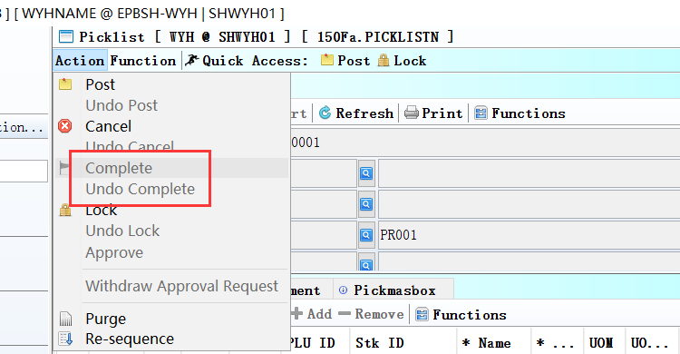

3.3.9 150BB Bin Transfer:Added column’bintrnType’. (27861)-873
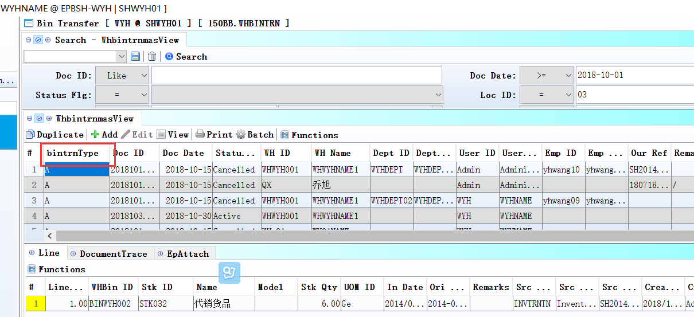
The default is A.
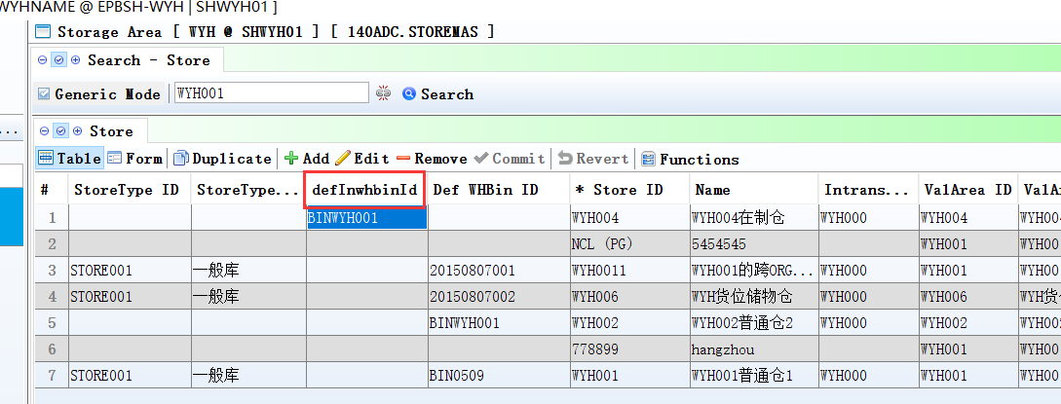
1、140ADC Storage Area: Added column’defInwhbinId’.

2、If DEF_INWHBIN_ID is not null and DEF_WHBIN_ID is not null, then into DEF_INWHBIN_ID

3.3.10 160DA Application Form Setup:Added column’prefix’.(27912)-873
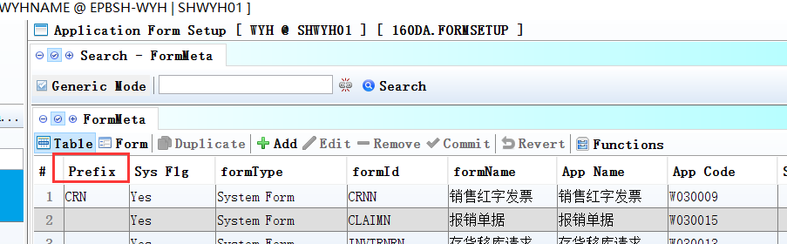

3.3.11 160DA Application Form Setup :Added function ‘Copy’.(27911)-873
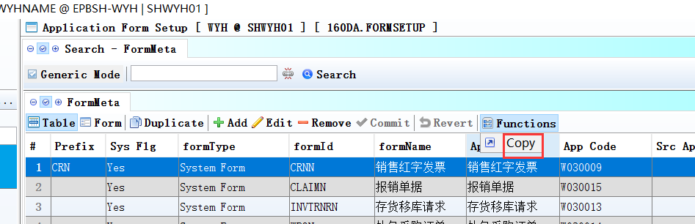

3.3.12 180BA Work Order:Added function’ refresh bulk_flg from stkmas’.(27903)-873
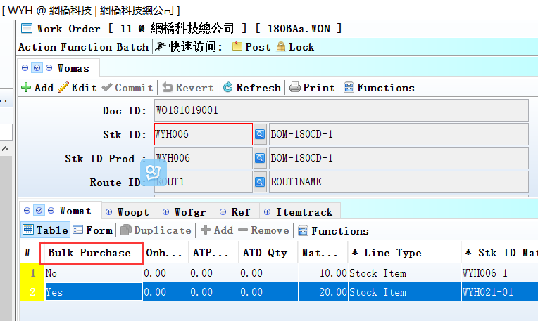
When save w/o, system refresh bulk_flg from stkmas, regardless bommat.bulk_flg.

3.3.13 180BFA Batch Generate Work Order:Added columns’ATP Qty’and’ATD Qty’and’Onhand Qty’ .(28086)-873
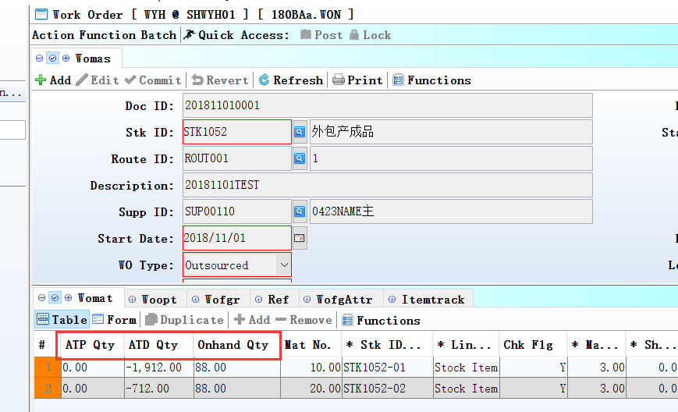

3.3.14 180BNO Work Order Reporting Enquiry:Added columns’ cust_id’and’ cust_name’.(28072)-873
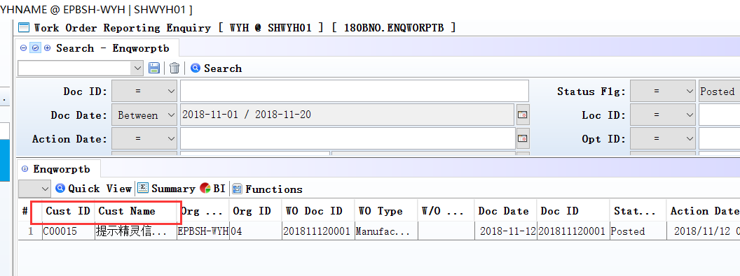

3.3.15 180BNX Outsource Price Book Enquiry:Added columns’LastUpdate’and’ LastUpdate_User_ID’and’ LastUpdate_UserName’.(28088)-873
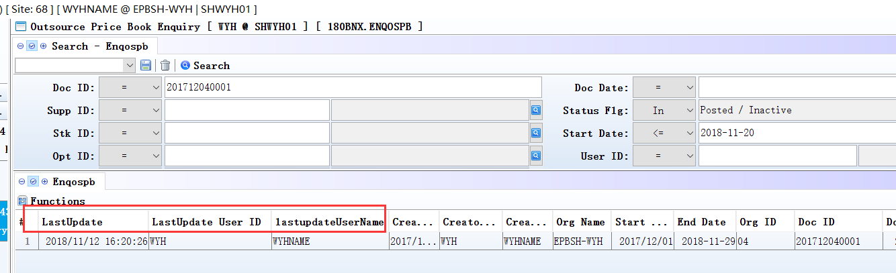

3.3.16 180CA Forecast:Added control’ if have non cancelled po/wo not allow undo post’.(27894)-873

3.3.17 180EI Finished Goods Costing:Added columns’Volume’and’Unit Weight’and’Unit Weight UOM’.(28077)-873
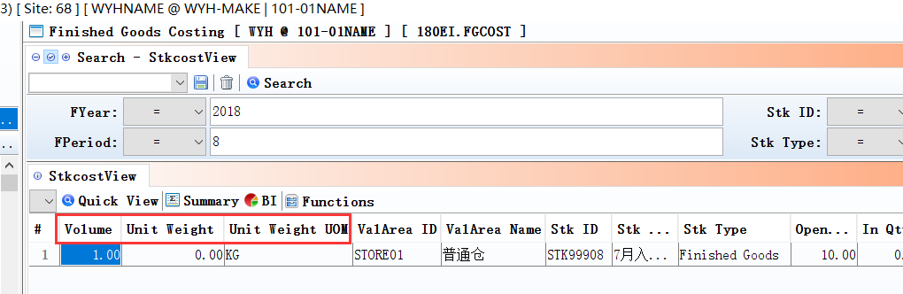

3.3.18 200BX Journal Entry Batch:Added function’ Use the remark of documents automatically refresh the remark of voucher’. (27891)-873
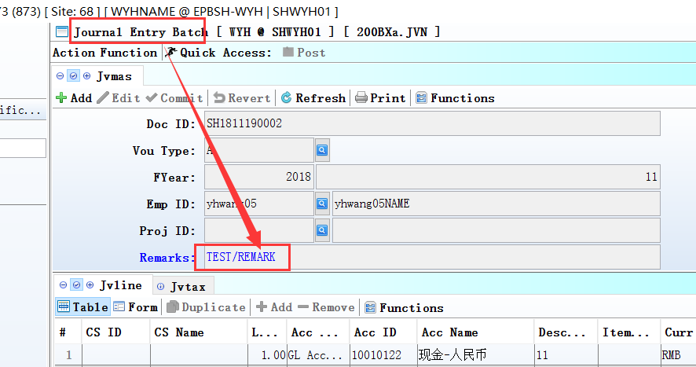
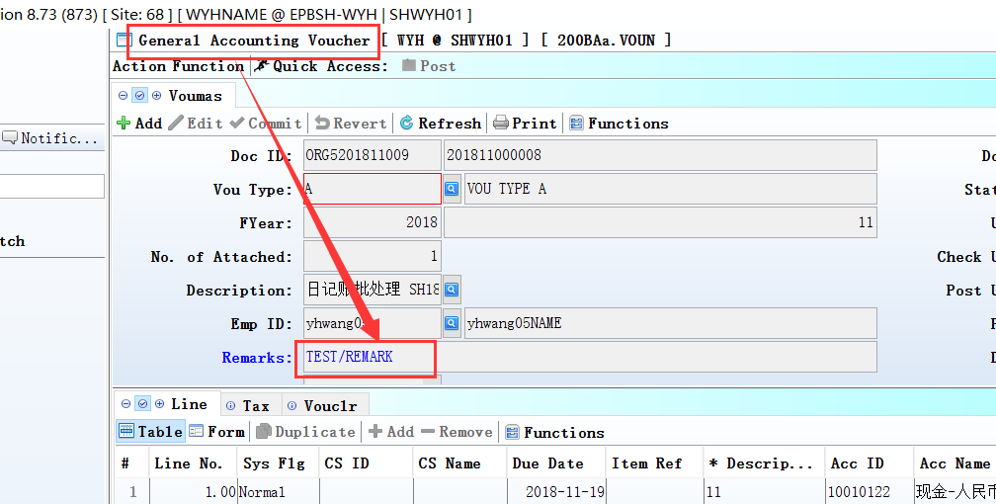

3.3.19 200DA Supplier Invoice:Added column’ PO_DOC_ID’ in TrnSinvFromGr interface.(27940)-873
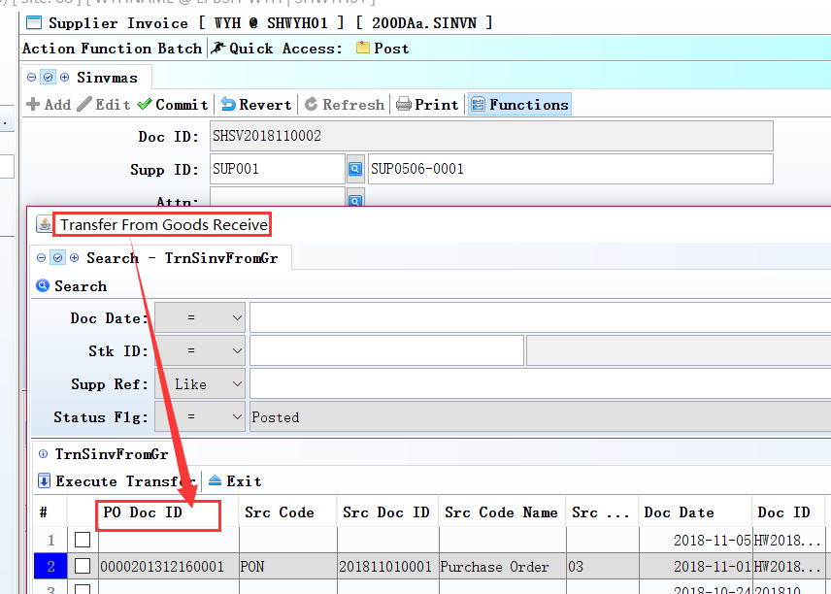

3.3.20 140EBA Stock Summary As At, etc module:Added column’Retail List Price’ . (28038)-873
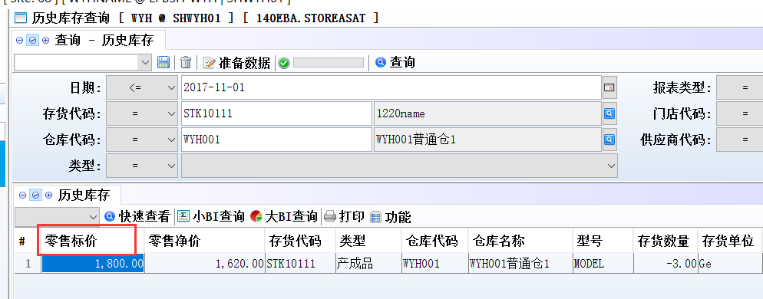

4. Fixes

