EPBrowserRelease Notes
Version 8.74~8.75

EPBrowserRelease Notes Version 8.74~8.75
Last Revision, 3 January 2019

©Copyright 2019. Enterprise Browser Pte Ltd.
All rights reserved.

No part of this manual may be reproduced in any form or by any means without the express written authorization from EPB. Business forms—which include but are not limited to invoices, checks, sales orders—displayed in this manual are for illustration purposes only and are not to be used for producing actual business forms. Enterprise Browser Pte Ltd. assumes no responsibility.
This document may contain technical inaccuracies or typographical errors and may change without prior notice. Any documentation with respect to EPB software products is provided for informational purposes only and does not extend or modify the limited warranty extended to the licensee of EPB software products.

Enterprise Browser Pte Ltd (EPB)
33Ubi Avenue 3, #07-65, Vertex Tower A, Singapore 408868
Tel: (65)-6509-4065
Fax: (65)-6509-4089

Document Location
EPBSH

Contents
1. Featured 4
2. New Interface 4
2.1 Added new module: 180BNS Work Order Change Note Enquiry (27910)-874 4
2.2 Added new module: 200DDE Payment Requisition (28143)-875 4
3. Enhancements 4
3.1 Privilege 4
3.2 Setting 4
3.2.1 010AA Organization Added setting ‘Retrieve from PLU Master Location’. (28196)-874 4
3.2.2 060CE Delivery Order:Added setting’ Allow edit currency exchange rate’. (28168)-874 5
3.2.3 140BA Stock Items:Added setting’ Unit Weight’.(28212)-874 5
3.2.4 060CB Sales Order:Added setting’ Generating Inventory Transfer Request when Posting’.(28229)-P875 6
3.2.5 140CG/140CF module changed setting’ Enable transferring from INVQTY [Y]Transferred and exit [N]Disable [T]Execute Transfer’.(28409)-875 6
3.2.6 180BZ Work Order Complete Note:Adde setting’ Do not allow w/o clearing for Back Flush items’ .(28337)-875 6
3.2.7 070CD Purchase Order Change Note:Added setting’ Split line when changing price but items have been received [Y] Split Line [U] Split line and Update Price [N] No’.(28151)-875 7
3.3 Improve 7
3.3.1 060IA Trangle Trading Setup:Added ‘MtNodeProfit Table’. (28048)-874 7
3.3.2 090CaC Item Enquiry:Added column ‘PLU Name’.(28166)-874 8
3.3.3 Interactive Input:Added ‘the two-dimensional QTY details’. (18761)-874 8
3.3.4 060HB Delivery Planning Enquiry: BI export also includes the title bar.(28177)-874 8
3.3.5 140FH Inventory Transfer Enquiry:Added ‘Batch’ Table.(28198)-874 8
3.3.6 180BNJ Finished Goods Receive Enquiry:Added ‘Batch’ Table.(28197)-874 9
3.3.7 200DD Payment Voucher:Added columns‘payBankAcc’、 ’payBankId’、 ‘payBankAccName’、’paySubBankId’.(28227)-874 9
3.3.8 Interactive Input:Adde column’Storename’.(28353)-875 9
3.3.9 030I Workflow:Added ‘scroll bar’in the design of interface.(28317)-875 10
3.3.10 060CN Debit Note Request:Added column’Ctrl Acc ID’.(28401)-875 10
3.3.11 090CcE Shopping Mall Settlement:Added function’when select shop_id,automaticly bring out dept_id’.(28282)-875 11
3.3.12 090CcEa Shopping Mall Settlement:Added columns’ total revAmt’、’ total Amt’.(28347)-875 11
3.3.13 140FC Inventory Transfer Request Enquiry:Added columns’Addr1’、’Ref4’、’Phone’、’Zone ID’、’Cat1 Id’etc.(28350)-875 11
3.3.14 140FI Inventory Transfer Receive Enquiry;Added ‘Batch’ table. (28462)-875 12
3.3.15 150G Truck Note:Added columns’Acc ID’、’Acc Name’ 、’DPhone’、’DZone ID’、’Daddress 1’.(28232)-875 12
3.3.16 180BNS Order Change Note Enquiry:Added BI function.(28333)-875 12
3.3.17 180BFA Batch Generate Work Order:Added columns’combineWoFlg’、‘ingorSfAtpqtyFlg’.(28109)-875 13
3.3.18 180BE Work Order Reporting:Added function’ When transfer from batch,combined the same batch number’.(28425)-875 13
4. Fixes 13

1. Featured

2. New Interface

2.1 Added new module: 180BNS Work Order Change Note Enquiry (27910)-874

2.2 Added new module: 200DDE Payment Requisition (28143)-875

3. Enhancements

3.1 Privilege

3.2 Setting

3.2.1 010AA Organization :Added setting ‘Retrieve from PLU Master Location’. (28196)-874

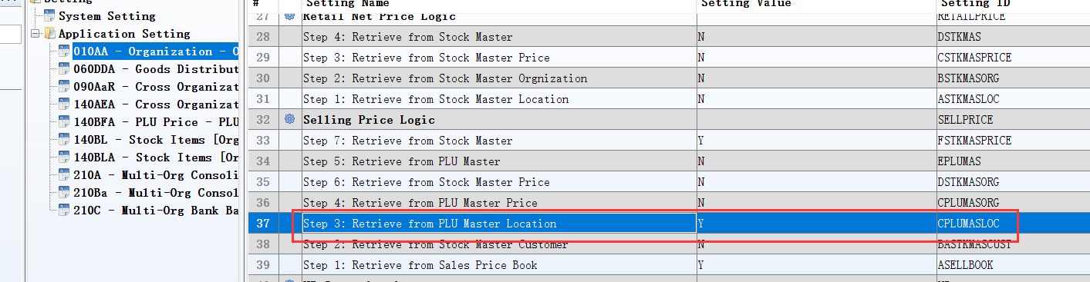
Added new setting: ‘Setp 3’;
Changed setting:’Step 4\ Step 5\ Step 6\ Step 7’
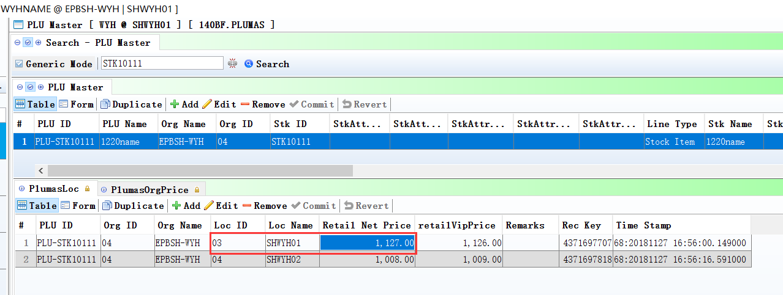
3、140BF：define price by location。
4、The price should be according by location in POS.
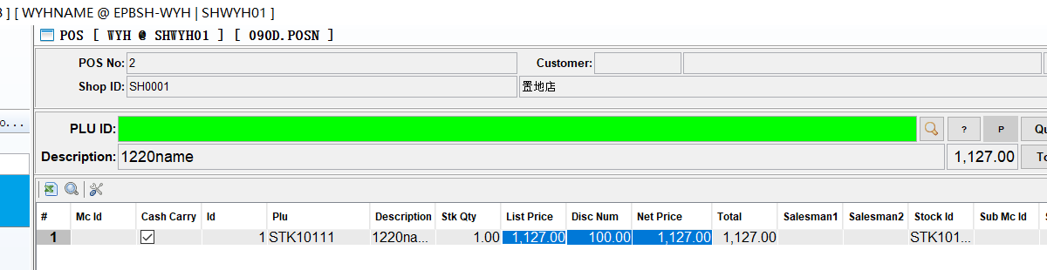

3.2.2 060CE Delivery Order:Added setting’ Allow edit currency exchange rate’. (28168)-874
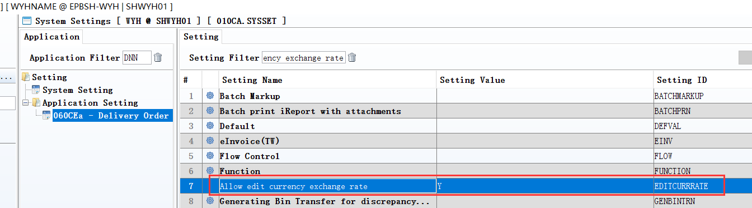
060CG RNC ：Added the same setting.
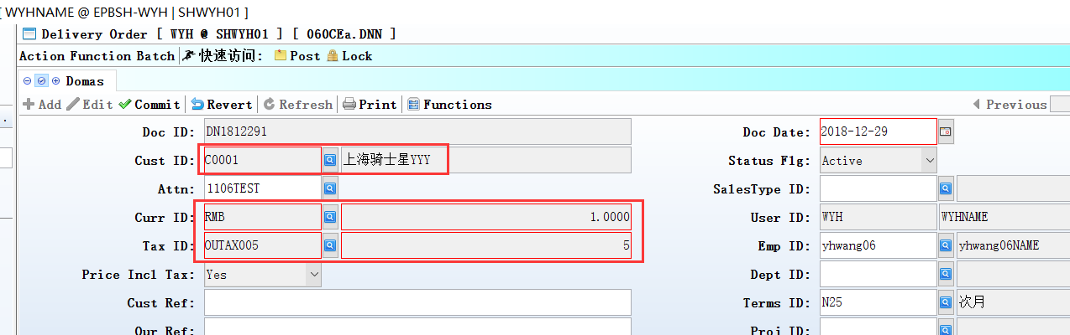
Set to N: cann't edit for custId/ currId/ currRate / taxId/ taxFlg/taxRate/ name etc column.

3.2.3 140BA Stock Items:Added setting’ Unit Weight’.(28212)-874
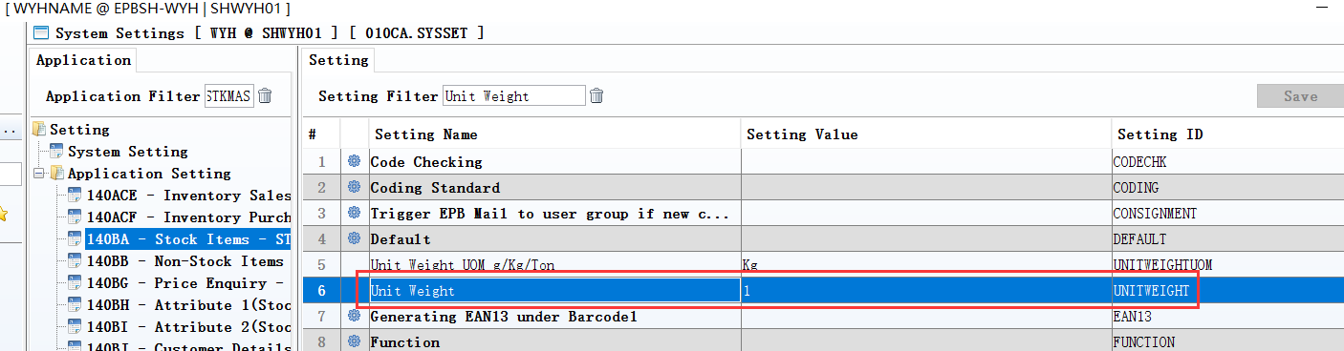
140BA/140BX:Added new stock Id, Unit Weight default setting value.

3.2.4 060CB Sales Order:Added setting’ Generating Inventory Transfer Request when Posting’.(28229)-P875
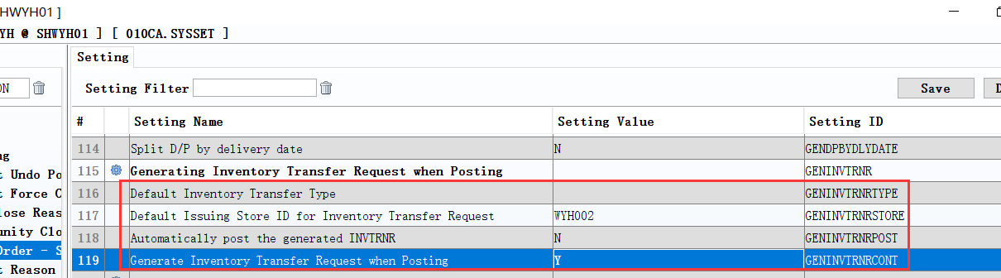

3.2.5 140CG/140CF module: changed setting’ Enable transferring from INVQTY [Y]Transferred and exit [N]Disable [T]Execute Transfer’.(28409)-875
Set to T: After transfer ,don't close the transmission interface.
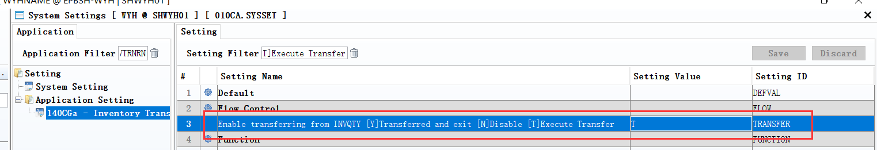

3.2.6 180BZ Work Order Complete Note:Adde setting’ Do not allow w/o clearing for Back Flush items’ .(28337)-875
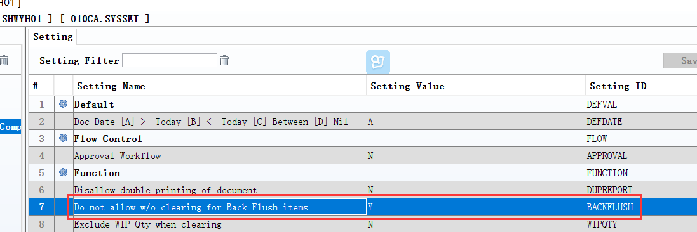
Set to Y: If there are back Flush items, The document does not allow Posting.
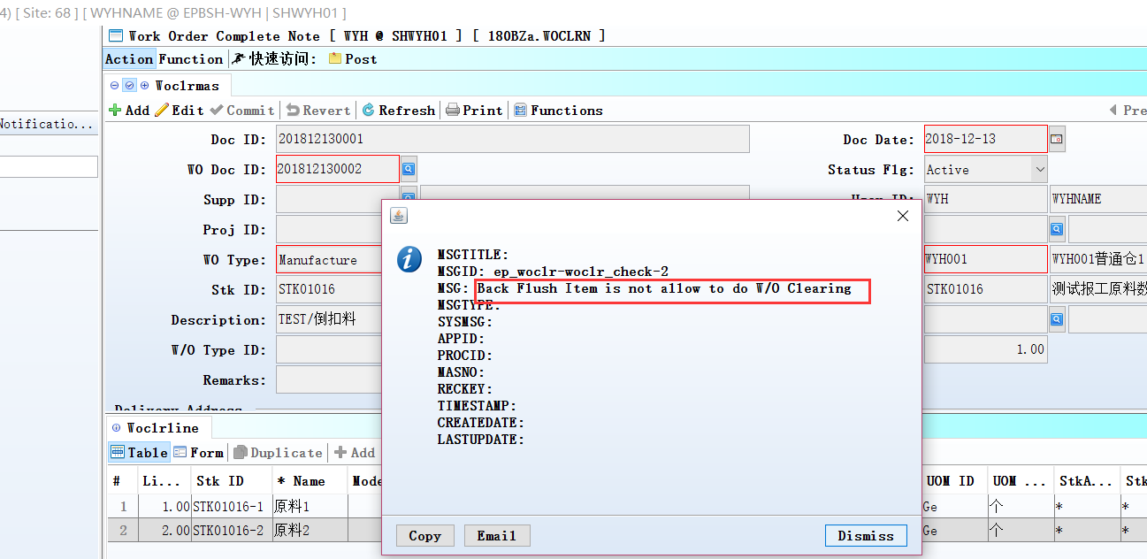

3.2.7 070CD Purchase Order Change Note:Added setting’ Split line when changing price but items have been received [Y] Split Line [U] Split line and Update Price [N] No’.(28151)-875
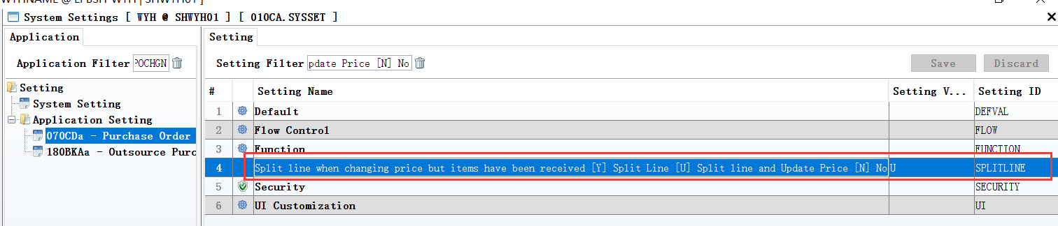

3.3 Improve

3.3.1 060IA Trangle Trading Setup:Added ‘MtNodeProfit Table’. (28048)-874
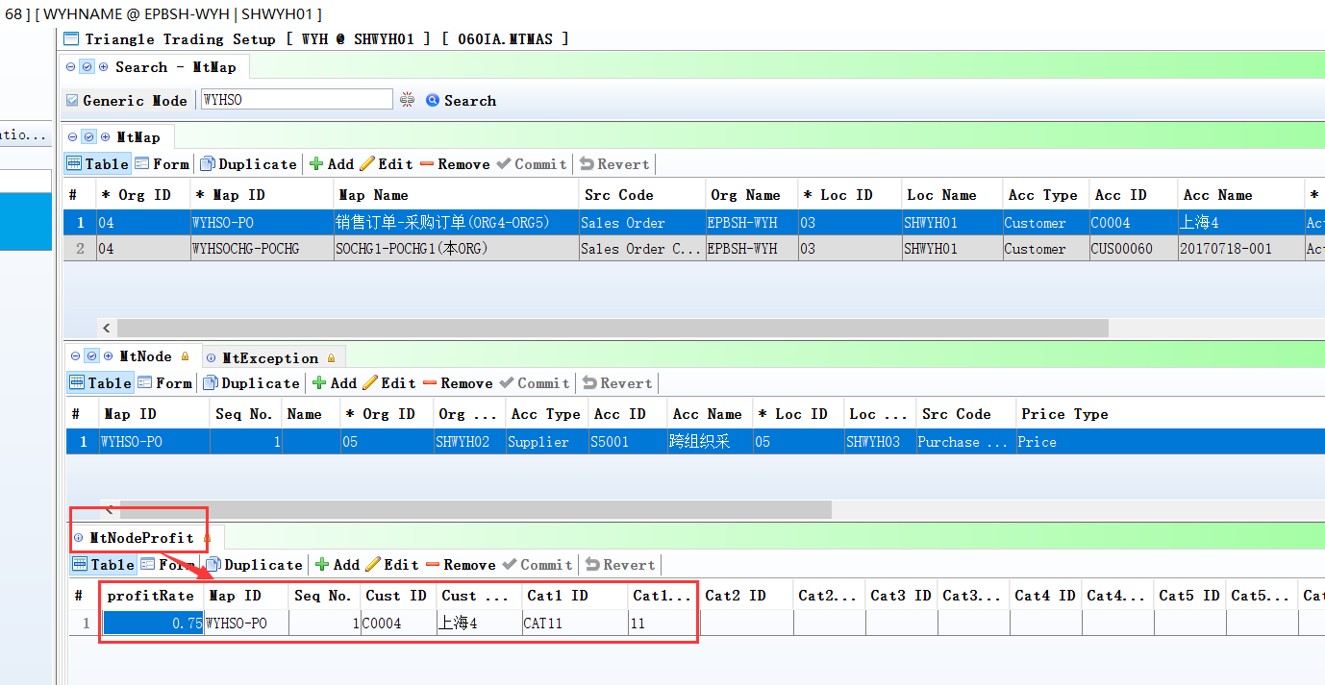
1、060IA:define the profitRate ;
2、Posted SO，Generated PO;
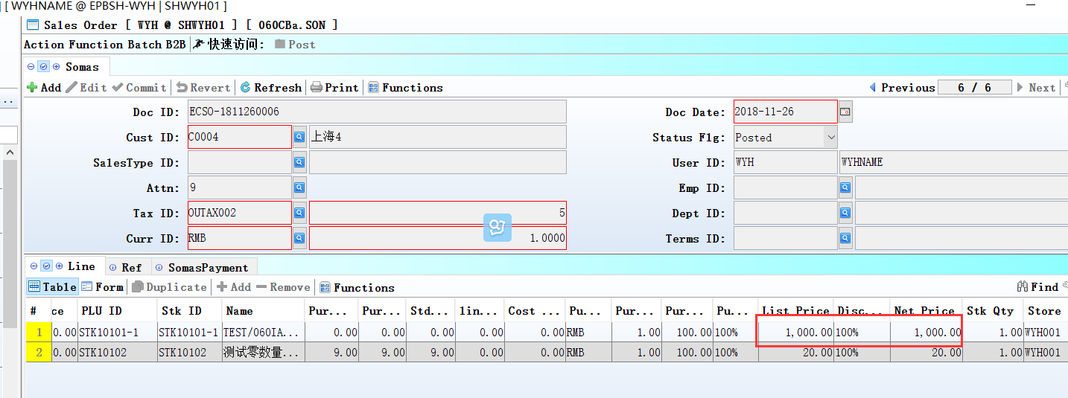
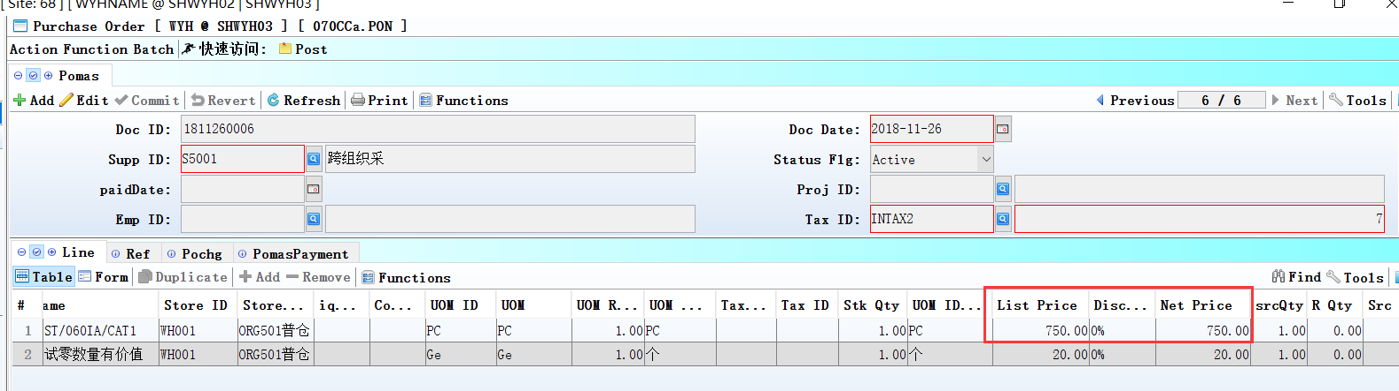
3、po.price = so.price * MT_NODE_PROFIT.PROFIT_RATE；

3.3.2 090CaC Item Enquiry:Added column ‘PLU Name’.(28166)-874
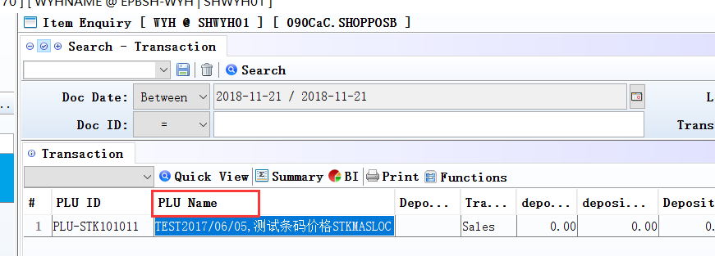

3.3.3 Interactive Input:Added ‘the two-dimensional QTY details’. (18761)-874
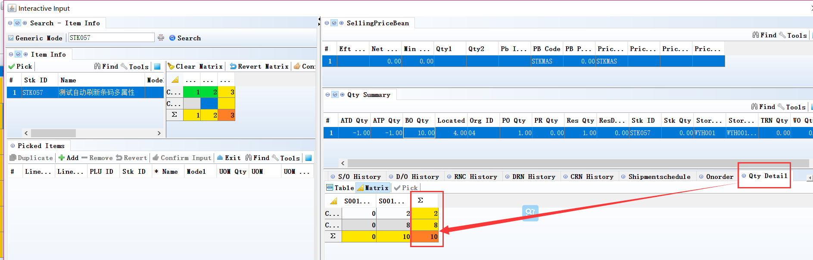
Select the Qty Summary a line of a number of fields, Qty Detail will bring out the two-dimensional QTY details：
For example, select the Stk QTY, QTY Detail will be out of the two-dimensional Stk QTY,
If there is no stkattr1 and stkattr2 STK ID, Qty Detail never data。

3.3.4 060HB Delivery Planning Enquiry: BI export also includes the title bar.(28177)-874
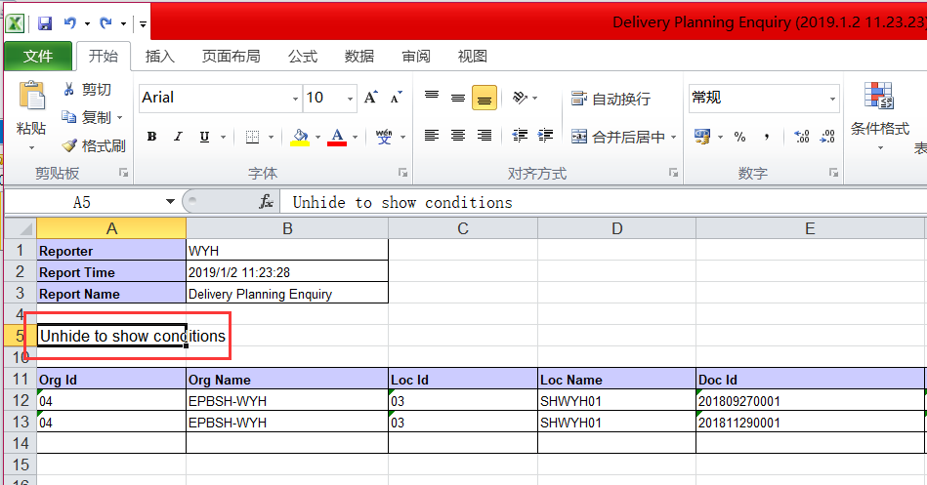

3.3.5 140FH Inventory Transfer Enquiry:Added ‘Batch’ Table.(28198)-874
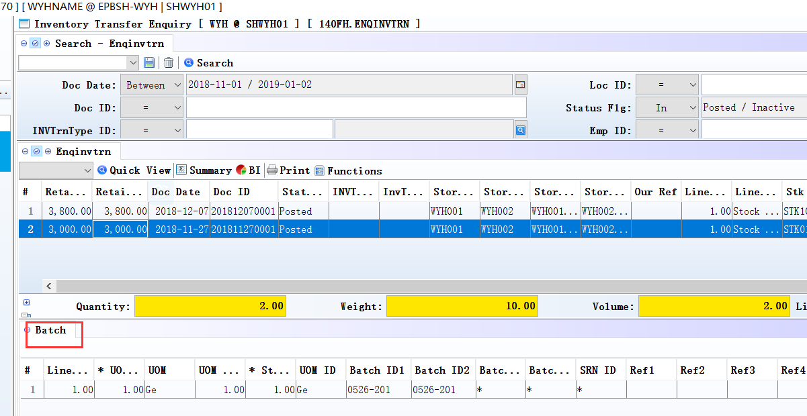

3.3.6 180BNJ Finished Goods Receive Enquiry:Added ‘Batch’ Table.(28197)-874
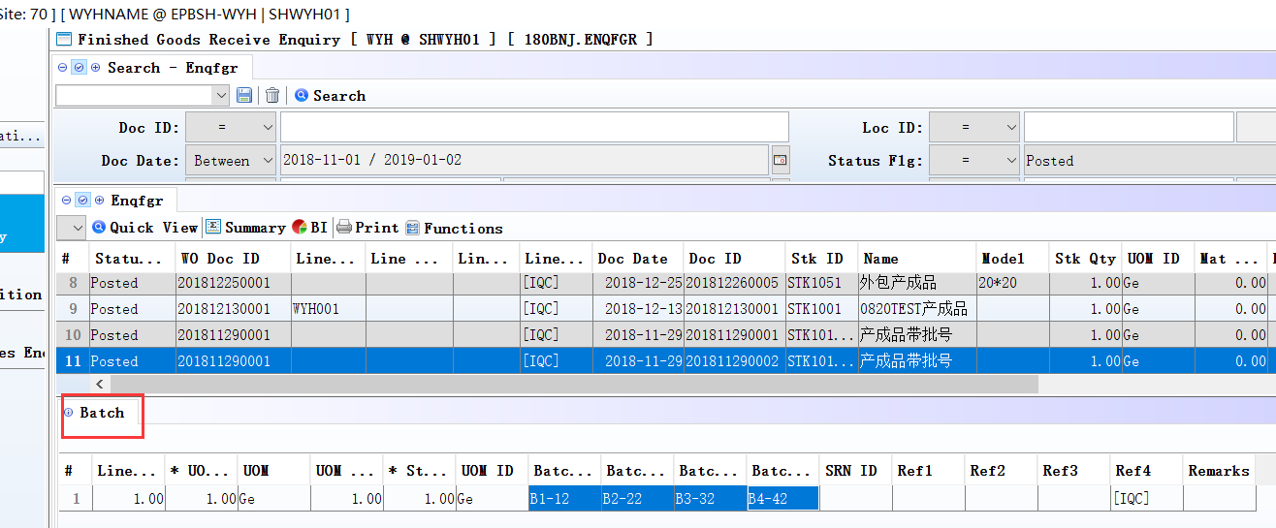

3.3.7 200DD Payment Voucher:Added columns‘payBankAcc’、 ’payBankId’、 ‘payBankAccName’、’paySubBankId’.(28227)-874
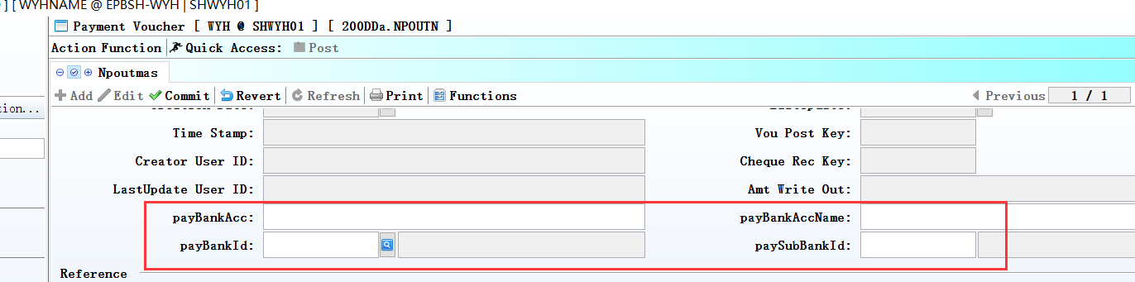

3.3.8 Interactive Input:Adde column’Storename’.(28353)-875
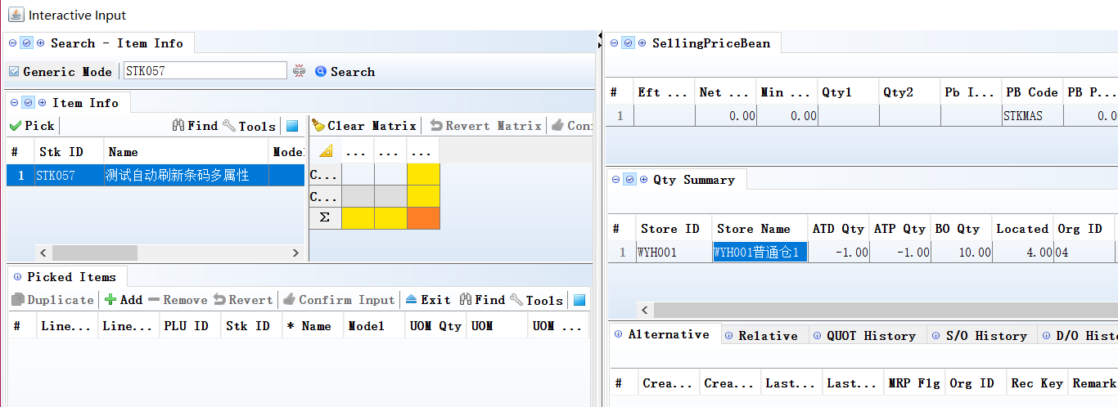

3.3.9 030I Workflow:Added ‘scroll bar’in the design of interface.(28317)-875
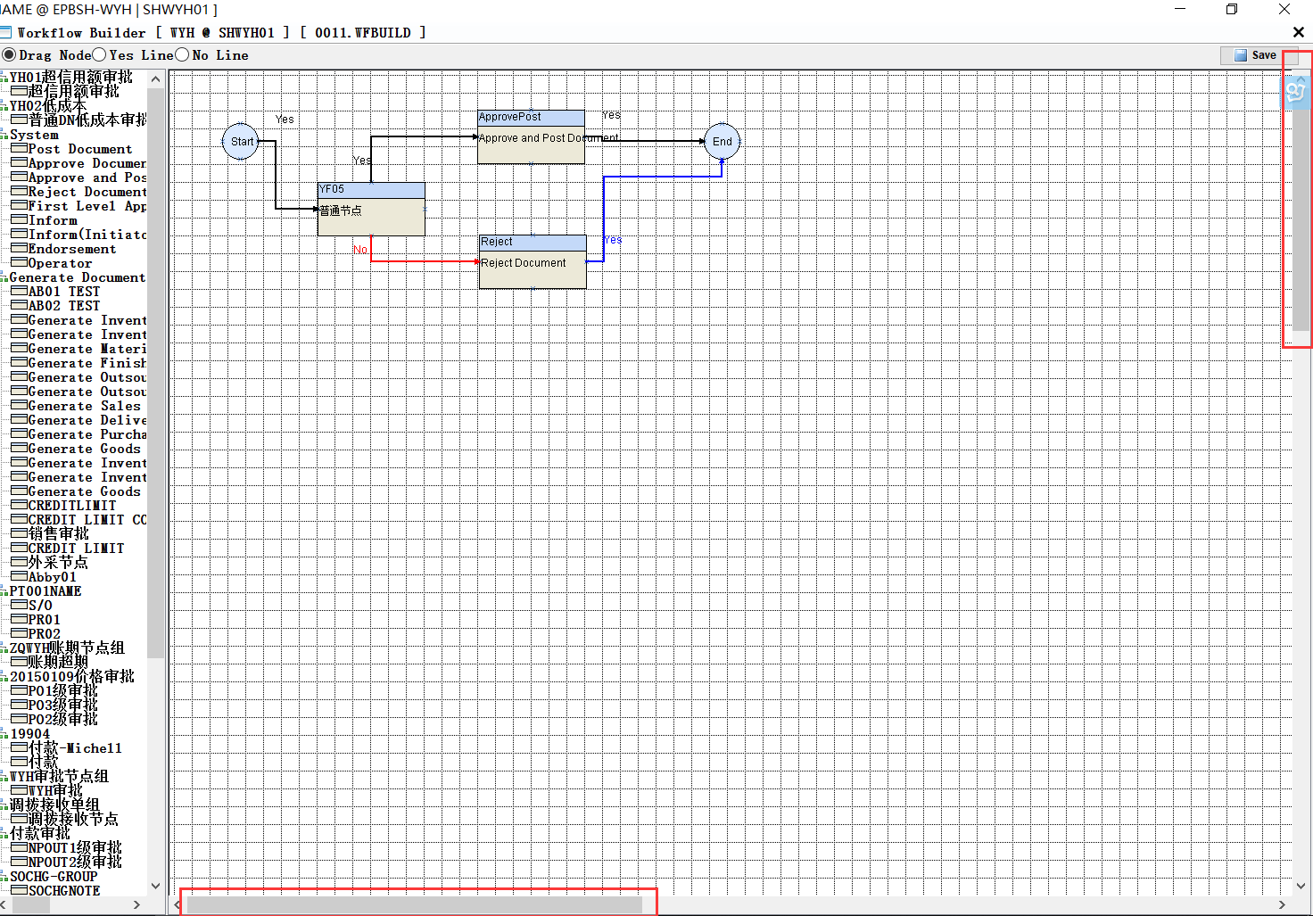

3.3.10 060CN Debit Note Request:Added column’Ctrl Acc ID’.(28401)-875
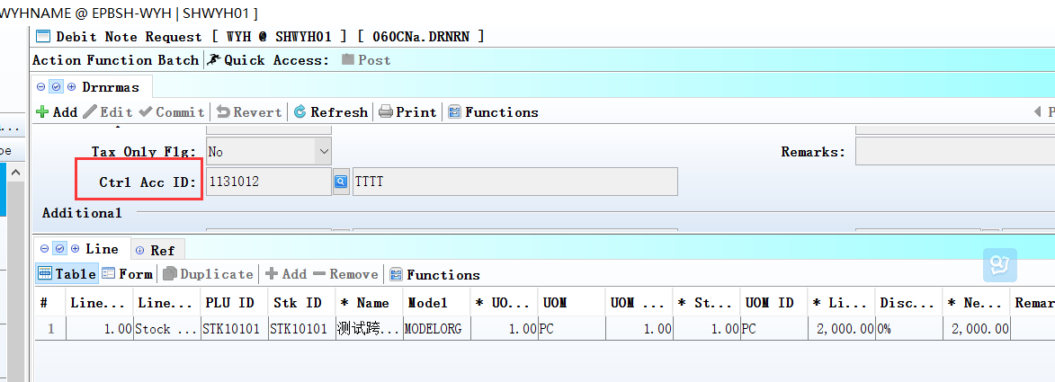
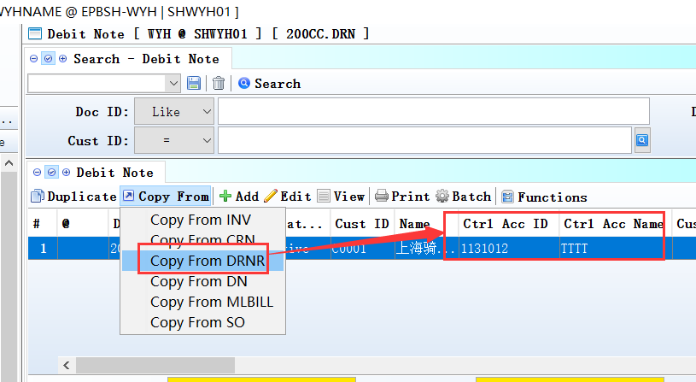
When 200CC copy from drnr, Ctrl Acc ID will Automaticly bring out.

3.3.11 090CcE Shopping Mall Settlement:Added function’when select shop_id,automaticly bring out dept_id’.(28282)-875
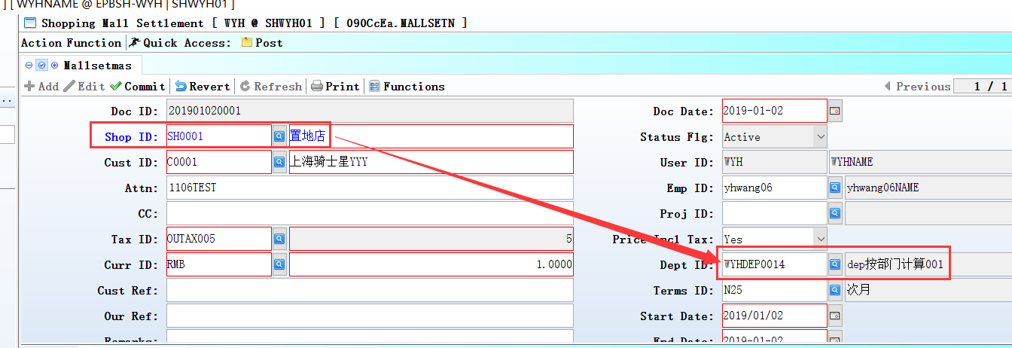
when validate shop_id
bring over pos_shop_mas.dept_id to mallsetmas.dept_id.

3.3.12 090CcEa Shopping Mall Settlement:Added columns’ total revAmt’、’ total Amt’.(28347)-875
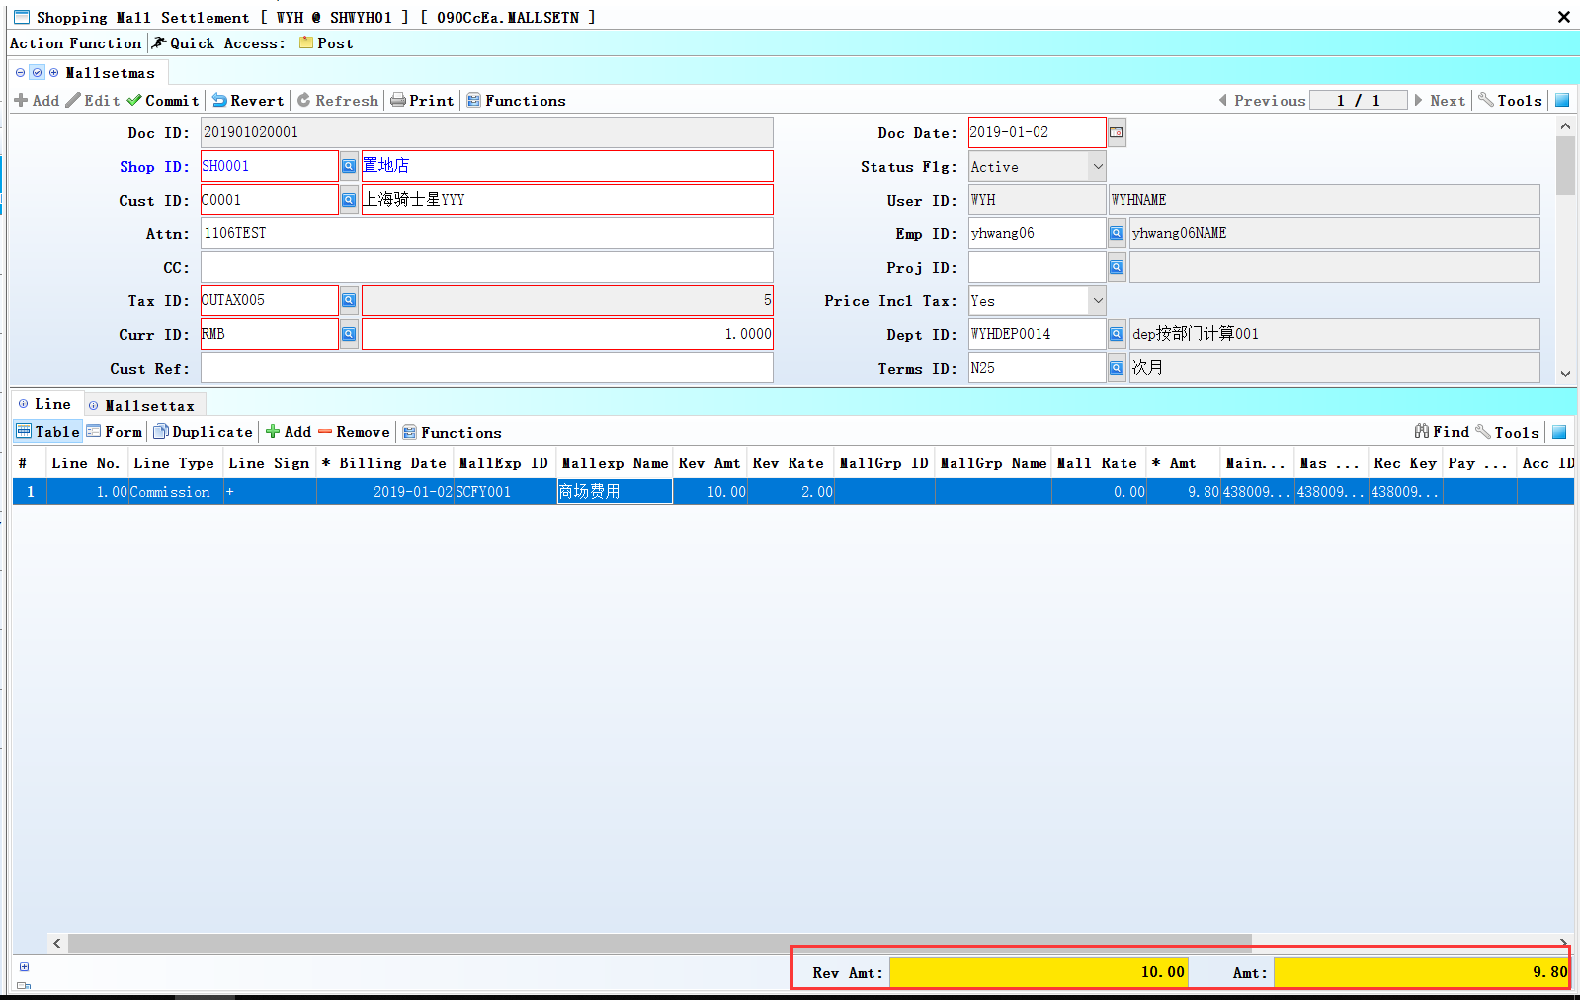

3.3.13 140FC Inventory Transfer Request Enquiry:Added columns’Addr1’、’Ref4’、’Phone’、’Zone ID’、’Cat1 Id’etc.(28350)-875
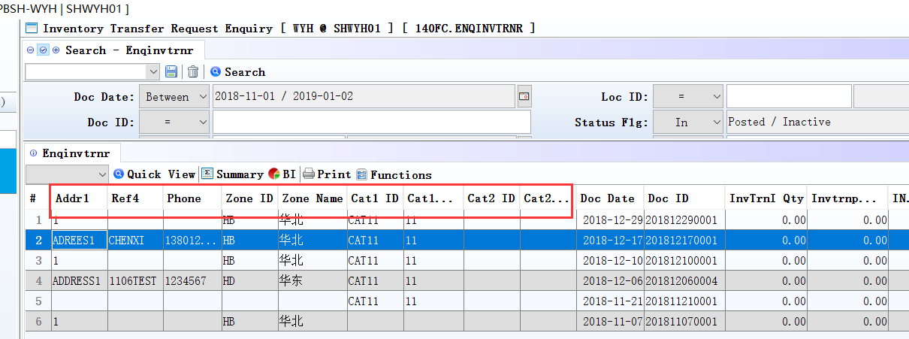

3.3.14 140FI Inventory Transfer Receive Enquiry;Added ‘Batch’ table. (28462)-875
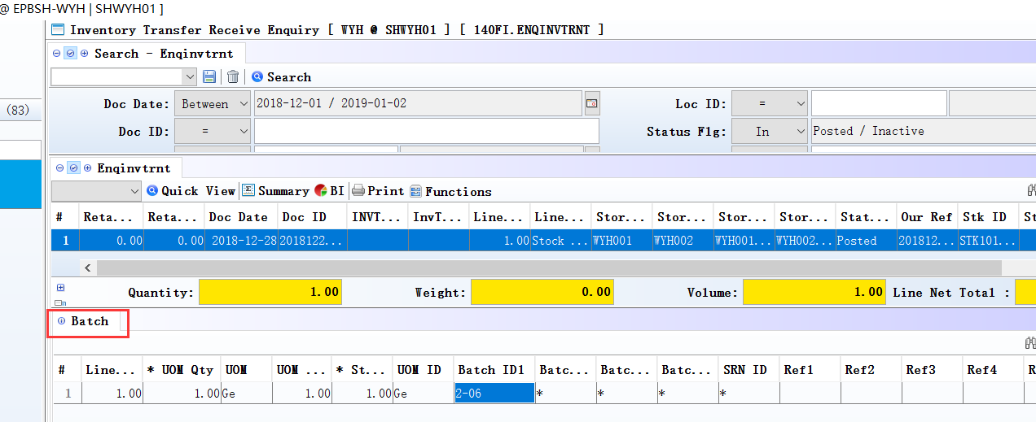
140FD :added the same function.

3.3.15 150G Truck Note:Added columns’Acc ID’、’Acc Name’ 、’DPhone’、’DZone ID’、’Daddress 1’.(28232)-875
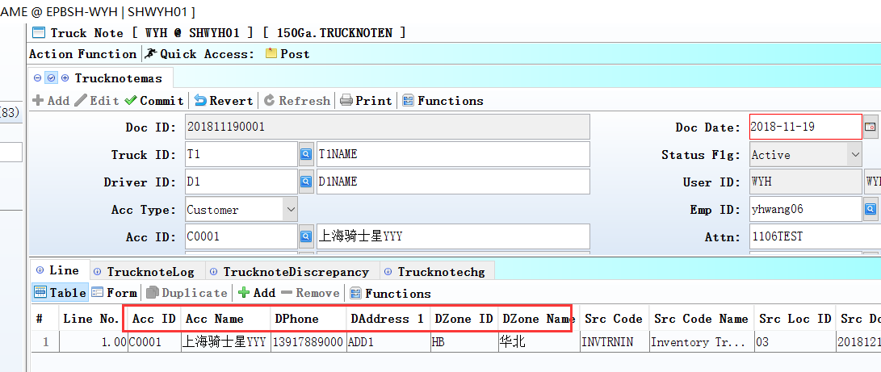

3.3.16 180BNS Order Change Note Enquiry:Added BI function.(28333)-875
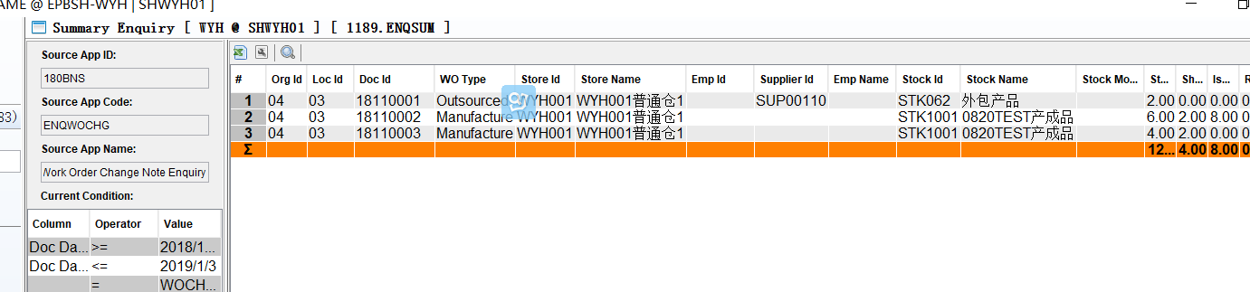

3.3.17 180BFA Batch Generate Work Order:Added columns’combineWoFlg’、‘ingorSfAtpqtyFlg’.(28109)-875
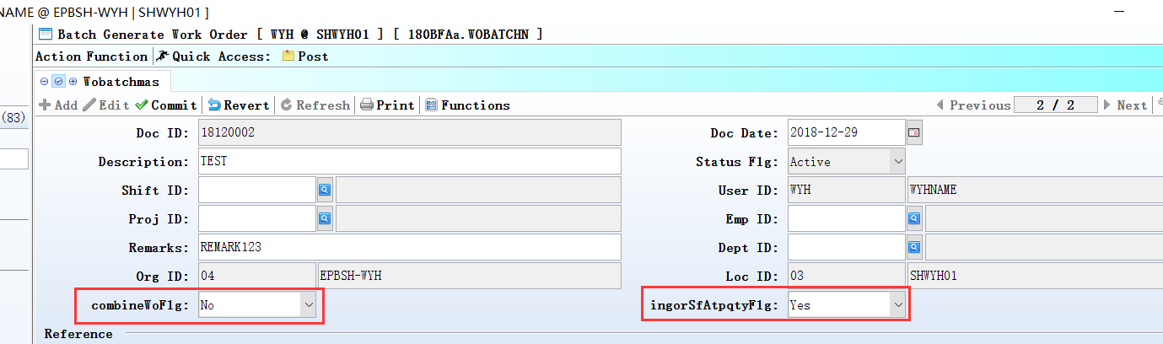

3.3.18 180BE Work Order Reporting:Added function’ When transfer from batch,combined the same batch number’.(28425)-875
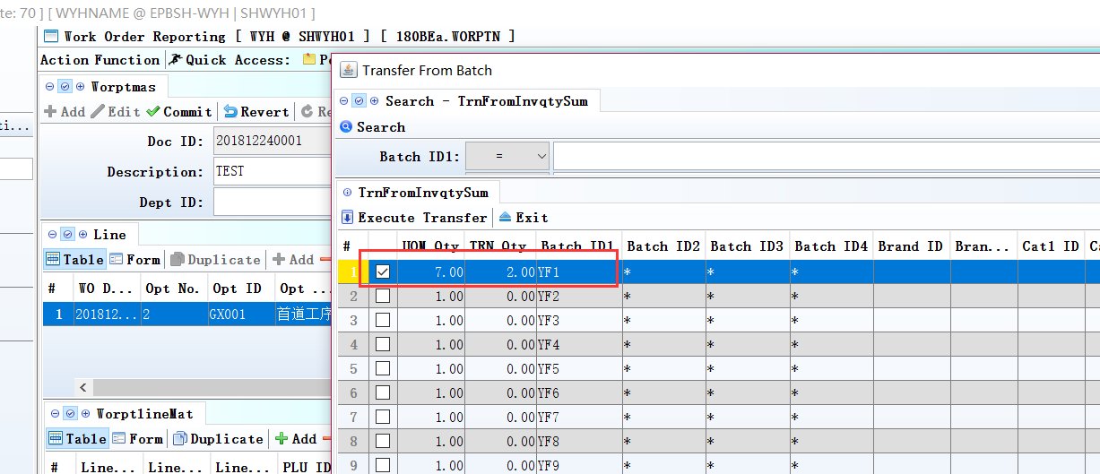

4. Fixes

