EPBrowserRelease Notes
Version 8.79

EPBrowserRelease Notes Version 8.79
Last Revision, 10 March 2019

©Copyright 2019. Enterprise Browser Pte Ltd.
All rights reserved.

No part of this manual may be reproduced in any form or by any means without the express written authorization from EPB. Business forms—which include but are not limited to invoices, checks, sales orders—displayed in this manual are for illustration purposes only and are not to be used for producing actual business forms. Enterprise Browser Pte Ltd. assumes no responsibility.
This document may contain technical inaccuracies or typographical errors and may change without prior notice. Any documentation with respect to EPB software products is provided for informational purposes only and does not extend or modify the limited warranty extended to the licensee of EPB software products.

Enterprise Browser Pte Ltd (EPB)
33Ubi Avenue 3, #07-65, Vertex Tower A, Singapore 408868
Tel: (65)-6509-4065
Fax: (65)-6509-4089

Document Location
EPBSH

Contents
1. Featured 4
2. New Interface 4
2.1 Added new module: 140CW Inventory Transfer Import.(28854)-879 4
2.2 Added new module:200AQ Payment Voucher Type Setup/200AP Official Receipt Setup (28773)-879 4
3. Enhancements 4
3.1 Privilege 4
3.1.1 Use 'Purchase price' privilege in GR or PO module,control the 'net price' in G/R History or P/O History table that in EPB(Interactive Input (Back-to-back)) .(28783)-879 4
3.1.2 090CaC Item Enquiry:Use the ‘VIP Phone’ privilege control the ‘DPhone’ and ‘Phone’ (28736)-879 5
3.1.3 180BD Finished Goods Receive：Added privilege’ Edit EXP Price’(28800)-879 6
3.2 Setting 6
3.2.1 010CA System Setting:Added setting’ Matrix view column width’.(28742)-879 6
3.2.2 010CA System Setting:Added setting’ Automatically Lock Screen when you leave your computer after n Mins’.(28807)-879 6
3.2.3 010CA System Setting:Added setting ‘Require Reason ID for cancel Document’(28842)-879 7
3.2.4 070CD Purchase Order Change Note:Use PO setting’ Disallow posting if Net Price and Price Book mismatch’.(28826)-879 7
3.2.5 070CH Supplier Return:Added setting’ Disallow duplicate Supplier Reference’.(28866)-879 7
3.2.6 180BFA Batch Generate Work Order:Added setting’ Combine Semi-finished Item when generating WO’.(28931)-879 7
3.2.7 190BA Asset Creation:Added setting’ utomatically generate Asset ID using Asset [Y] Category [A] Category 1 [B] Category 2 [C] Category 3 [N] Nil as prefix’.(28946)-879 8
3.2.8 200FE Account Balance Book:Added setting’ Display GL Balance Details Tab’and’ Display GL Balance by Dept Tab’and’ Display GL Balance by CS Tab’and’ Display GL Balance by Emp Tab’.(28841)-879 8
3.3 Improve 8
3.3.1 010CJ Document Undo Post Reason:Added column’actionType’.(28842)-879 8
3.3.2 060AZ Piece Rate Commision Setup: The Import LOC_ID according to the data of EXCEL.(28868)-879 9
3.3.3 060HB Delivery Planning Enquiry:BI Added columns’Ref1~ref4’and ‘Remark’.(28730)-879 9
3.3.4 ‘POS PRINT METHOD CHANGE’.090AE POS Machine Setup: Added table ‘POS_REG_IO’.(28746)-879 9
3.3.5 090CeC Prepaid Card Creation:Added columns’ ANA_ID1~ANA_ID10’.(28847)-879 9
3.3.6 010CH Wizard Settings:Added setting’ Total shop amount’ .(28834)-879 10
3.3.7 130AC Charged Item:Added table’ MLCHG_OWNER’.(28886)-879 10
3.3.8 160AB Expenses:Added control’ Select supplier, according to the supplier master file Settings’.(28864)-879 11
3.3.9 180AG BOM:Added column’ stkMat StatusFLg’ and delete ‘STATUS_FLG’ in table’Bommat’.(28901)-879 11
3.3.10 180BNJ Finished Goods Receive Enquiry:Added columns’ UNIT_WEIGHT,UNIT_WEIGHT_UOM, VOLUMN’.(28715)-879 12
3.3.11 200CD Official Receipt: the ’Doc DATE’ in ‘transfer form ar’ interface take out by document’s date.(28848)-879 12
3.3.12 200FE Account Balance Book:Added table’ TEMP_GL_BAL_EMP’.(28841)-879 12
4. Fixes 12

1. Featured

2. New Interface

2.1 Added new module: 140CW Inventory Transfer Import.(28854)-879
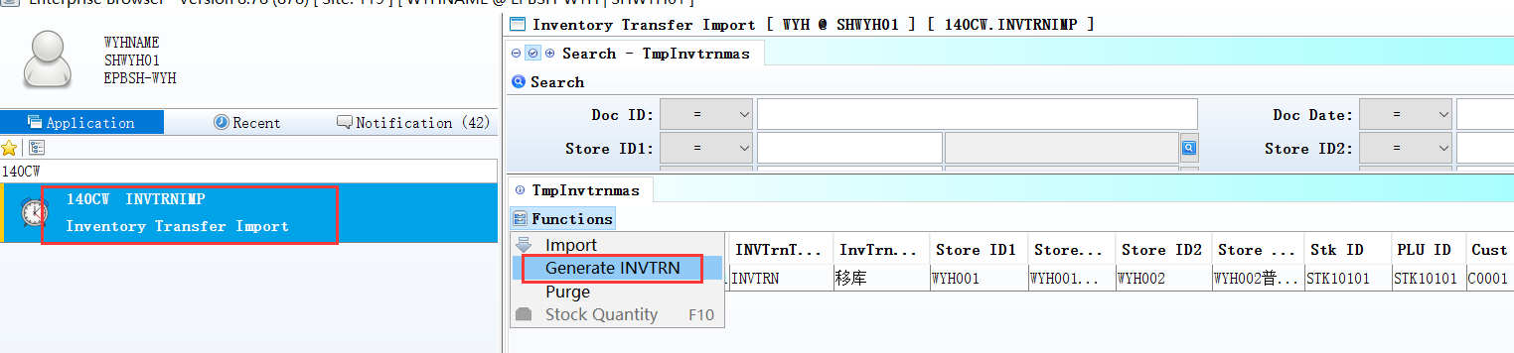
After imported datas,Click the button ‘Generated INVTRN’.

2.2 Added new module:200AQ Payment Voucher Type Setup/200AP Official Receipt Setup (28773)-879
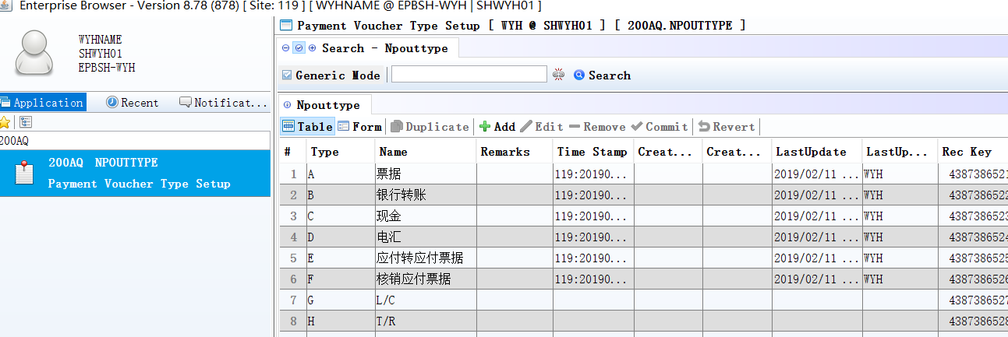

3. Enhancements

3.1 Privilege

3.1.1 Use 'Purchase price' privilege in GR or PO module,control the 'net price' in G/R History or P/O History table that in EPB(Interactive Input (Back-to-back)) .(28783)-879
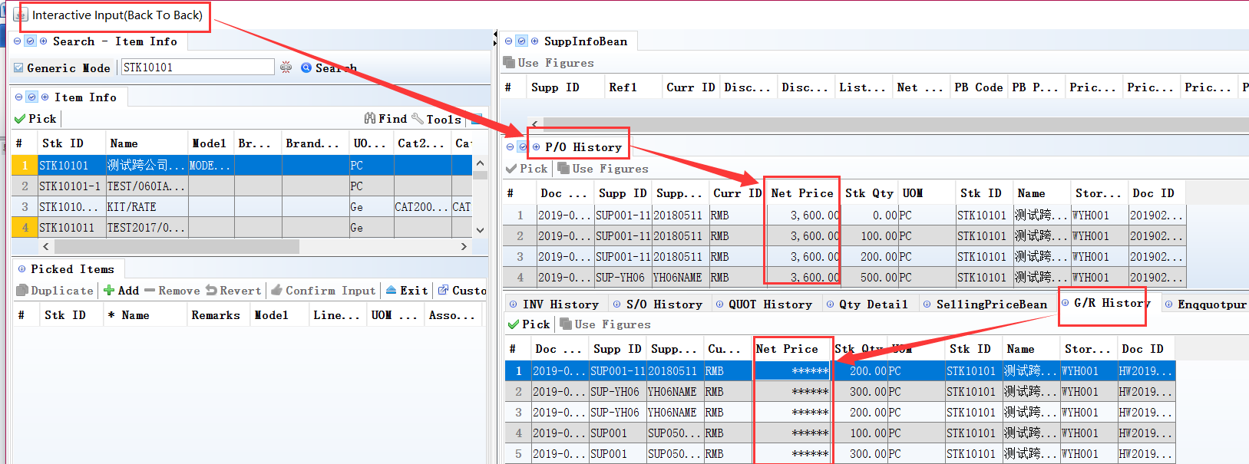
In QUOT/SO/SOCHG module. Added the function.
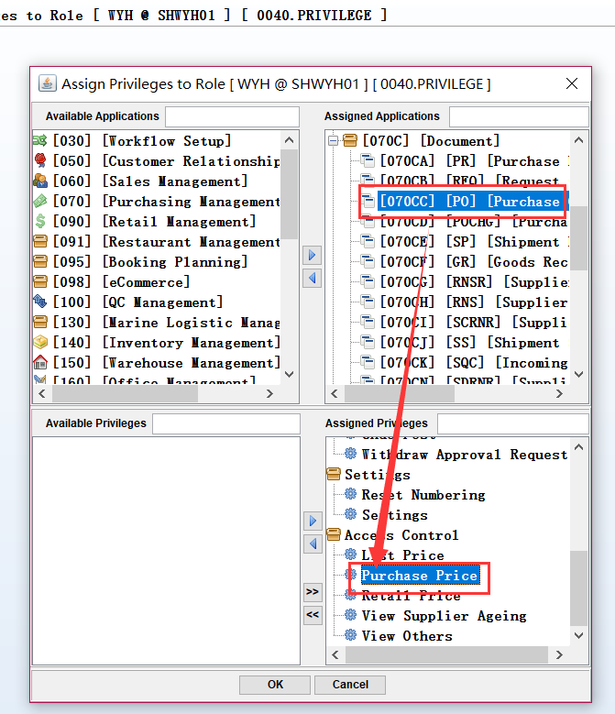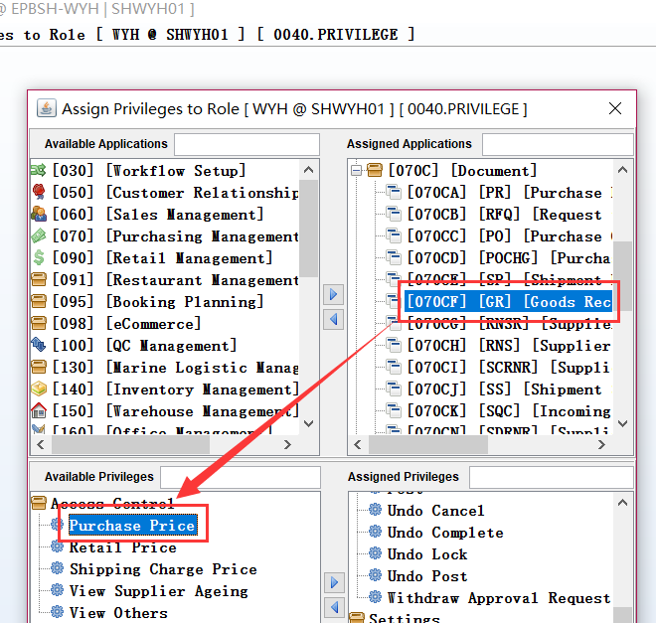

3.1.2 090CaC Item Enquiry:Use the ‘VIP Phone’ privilege control the ‘DPhone’ and ‘Phone’ (28736)-879
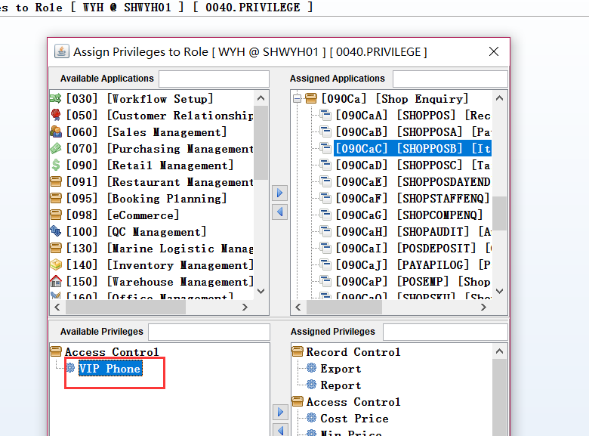
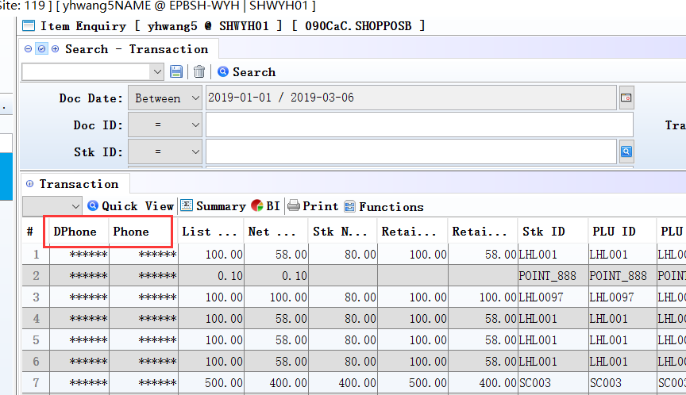

3.1.3 180BD Finished Goods Receive：Added privilege’ Edit EXP Price’(28800)-879
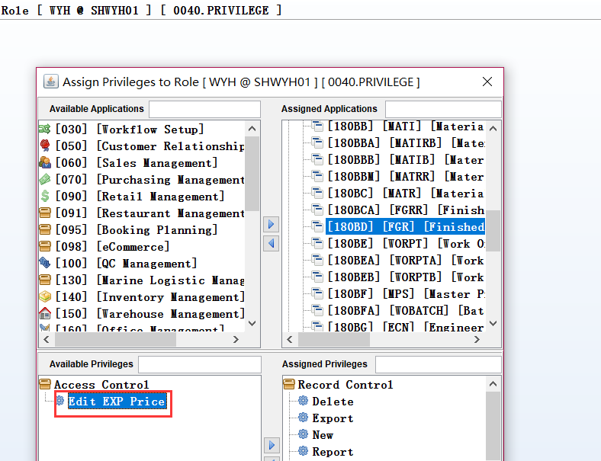
If the user haven't' Edit EXP Price ' privilege and is not Admin,then cannot edit ‘listprice / charChr / netprice’.
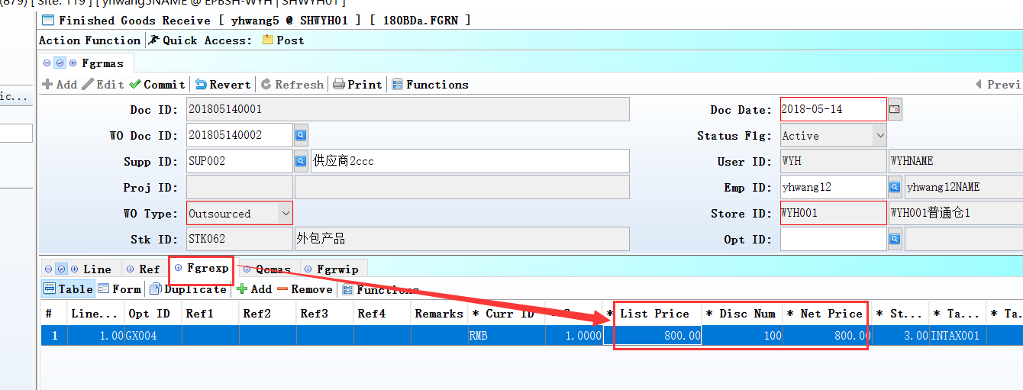

3.2 Setting

3.2.1 010CA System Setting:Added setting’ Matrix view column width’.(28742)-879
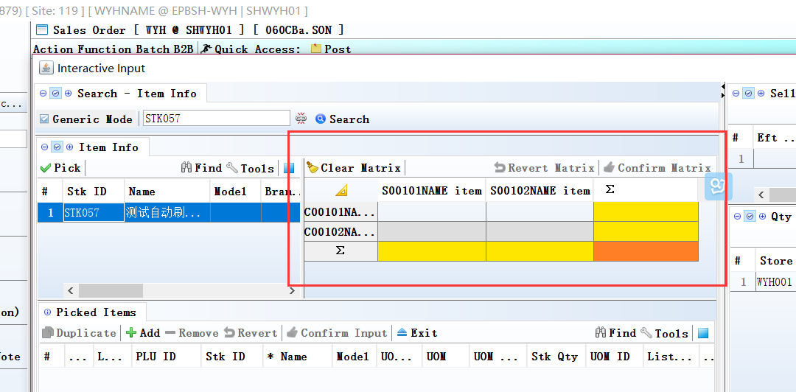
According to the setting of values, automatically adjust the column width.

3.2.2 010CA System Setting:Added setting’ Automatically Lock Screen when you leave your computer after n Mins’.(28807)-879
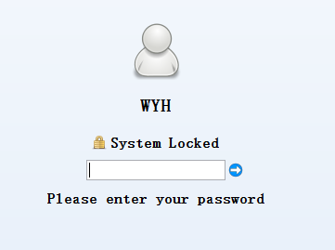
1, The mouse did not move in a set time, EPB lock screen automatically, when the setting is not set for a few minutes, EPB default lock screen time for 30 minutes, when the EPB set is less than 3 minutes, forcing lock screen for 3 minutes;
2, In the lock screen interface, the user can directly input current login user's password to unlock, or according to face images to switch to unlock new users back to login;

3.2.3 010CA System Setting:Added setting ‘Require Reason ID for cancel Document’(28842)-879

3.2.4 070CD Purchase Order Change Note:Use the setting of the PO ’ Disallow posting if Net Price and Price Book mismatch’.(28826)-879
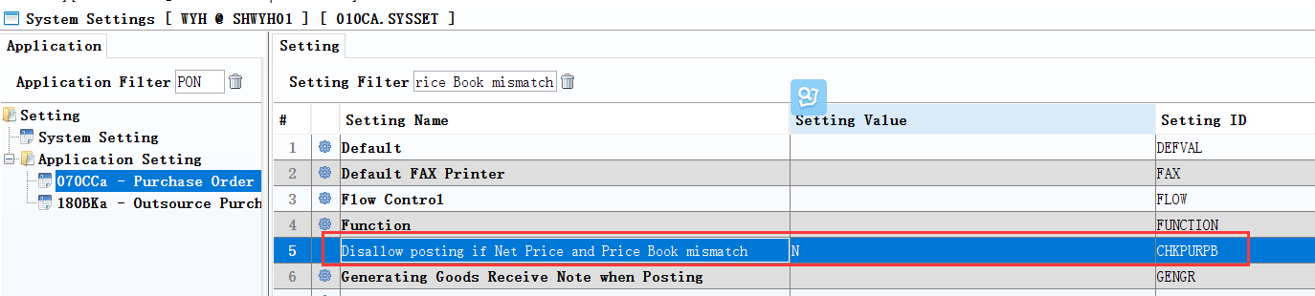

3.2.5 070CH Supplier Return:Added setting’ Disallow duplicate Supplier Reference’.(28866)-879
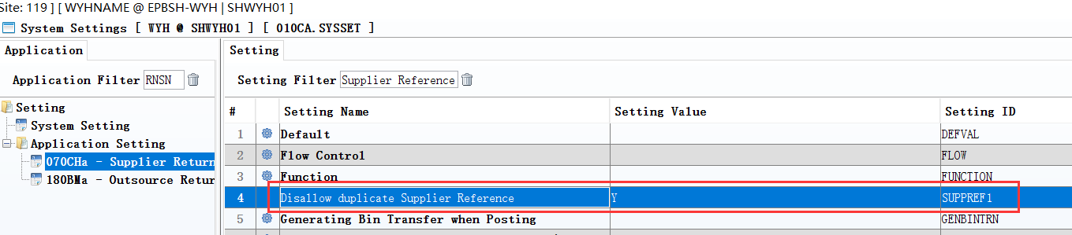

3.2.6 180BFA Batch Generate Work Order:Added setting’ Combine Semi-finished Item when generating WO’.(28931)-879
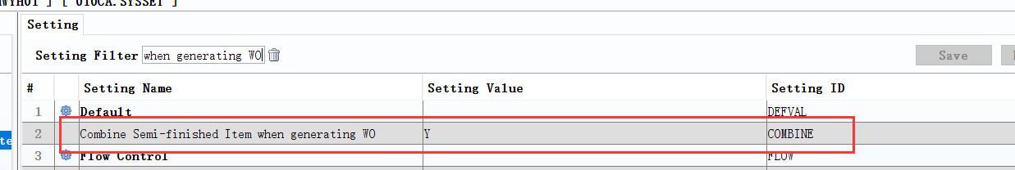
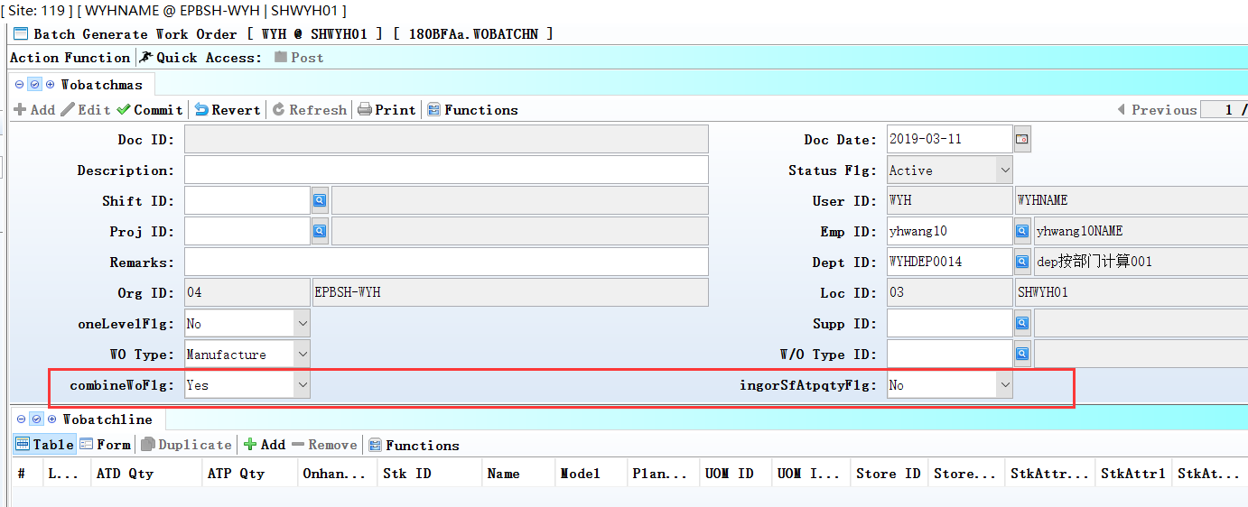

3.2.7 190BA Asset Creation:Added setting’ utomatically generate Asset ID using Asset [Y] Category [A] Category 1 [B] Category 2 [C] Category 3 [N] Nil as prefix’.(28946)-879
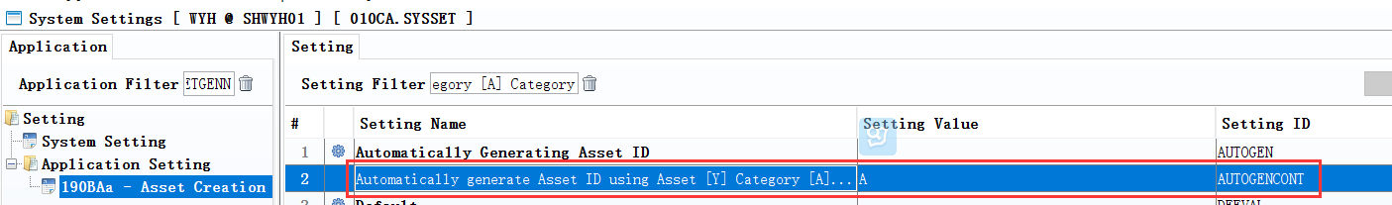

3.2.8 200FE Account Balance Book:Added setting’ Display GL Balance Details Tab’and’ Display GL Balance by Dept Tab’and’ Display GL Balance by CS Tab’and’ Display GL Balance by Emp Tab’.(28841)-879
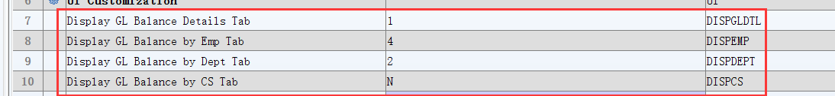

3.3 Improve

3.3.1 010CJ Document Undo Post Reason:Added column’actionType’.(28842)-879
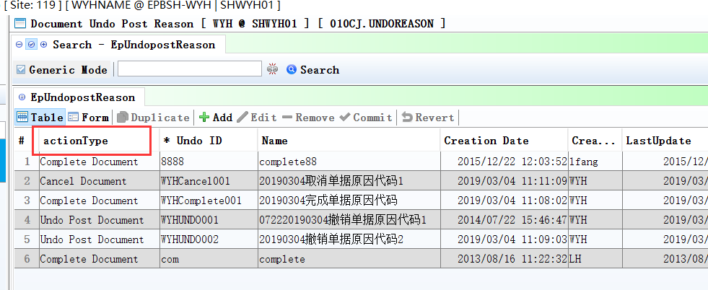
delete 010CK module;
010CJ Module:define reason Id ,include’ Cancel Document/Complete Document/Undo Post Document’

3.3.2 060AZ Piece Rate Commision Setup: The Import LOC_ID according to the data of EXCEL.(28868)-879
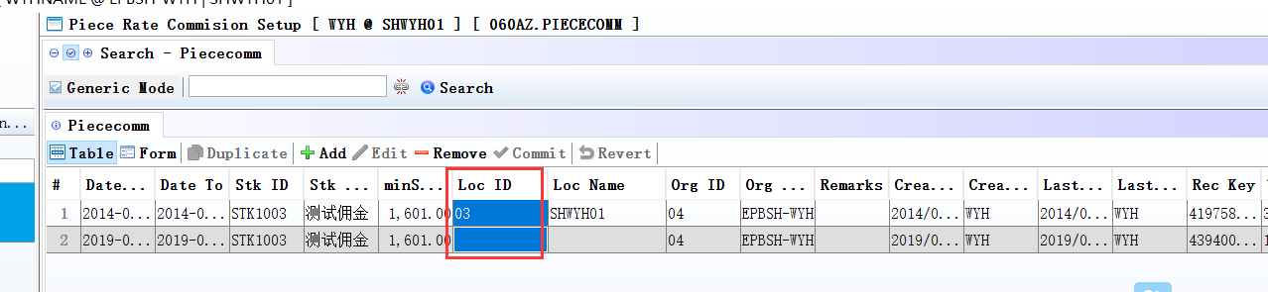
If LOC_ID is null in EXCEL, then after import it is null.

3.3.3 060HB Delivery Planning Enquiry:BI Added columns’Ref1~ref4’and ‘Remark’.(28730)-879
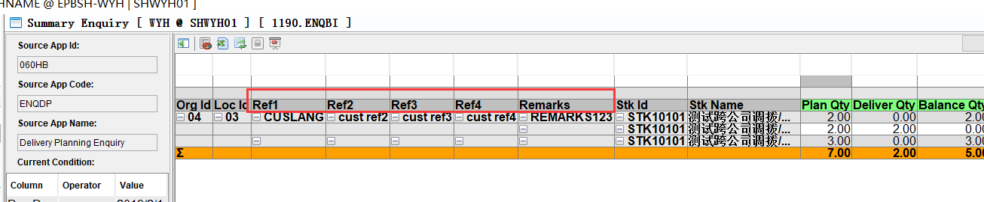

3.3.4 ‘POS PRINT METHOD CHANGE’.090AE POS Machine Setup: Added table ‘POS_REG_IO’.(28746)-879
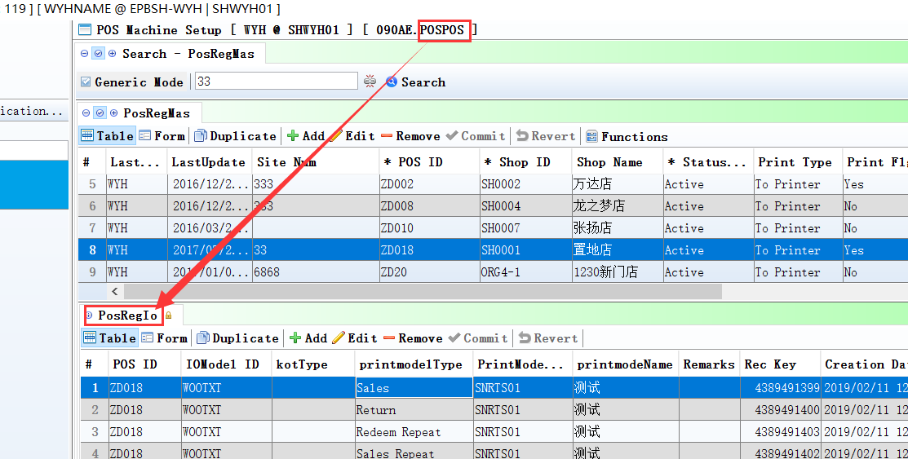

3.3.5 090CeC Prepaid Card Creation:Added columns’ ANA_ID1~ANA_ID10’.(28847)-879
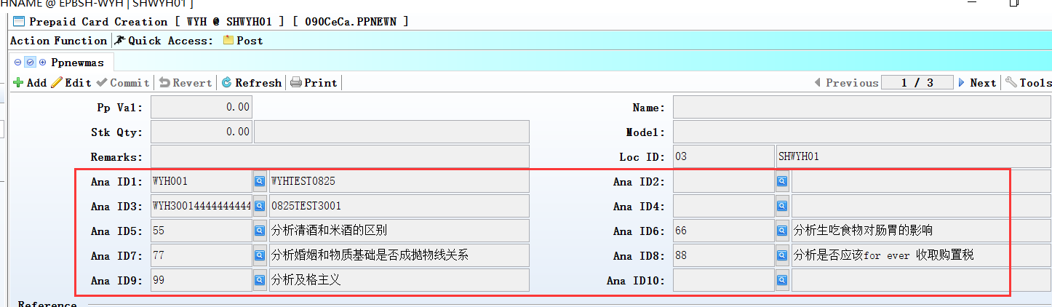

3.3.6 010CH Wizard Settings:Added setting’ Total shop amount’ .(28834)-879
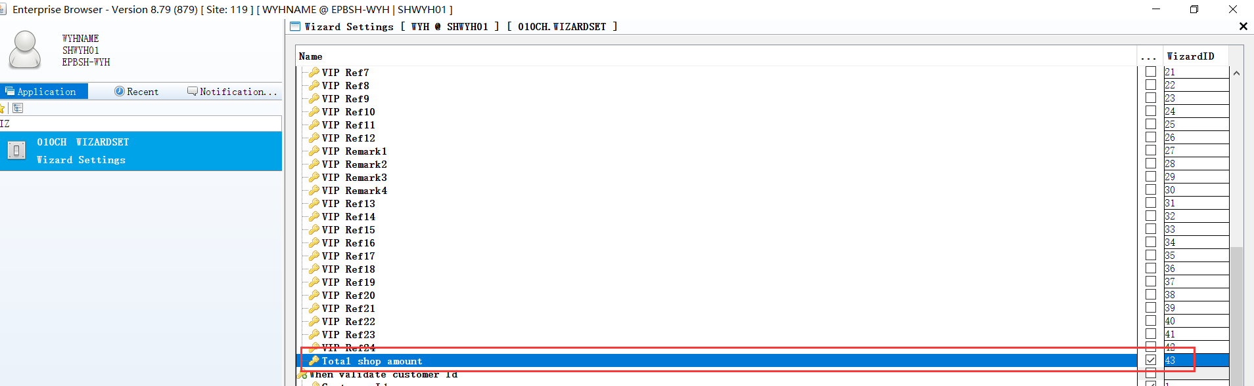
1、010CH ：Checked‘Total shop amount’；

2、090D: When after select VIP_ID,then display ‘Total Purchase’ in Info.
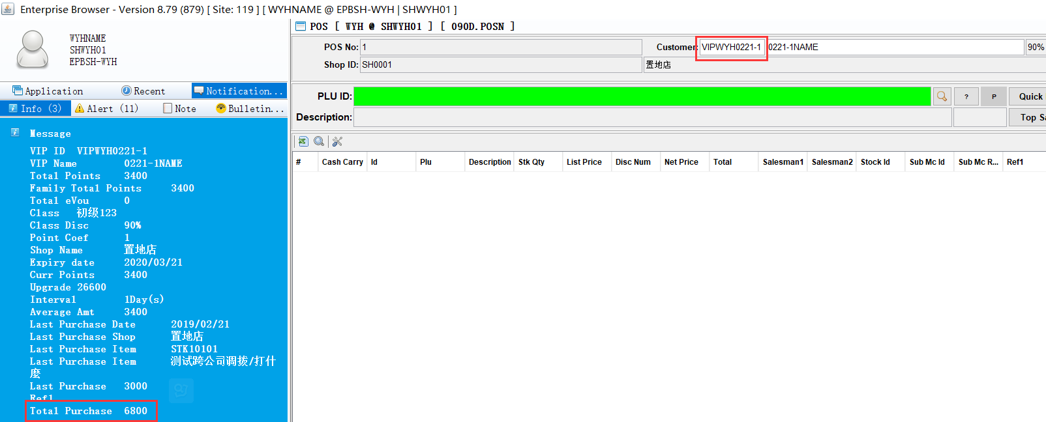

3.3.7 130AC Charged Item:Added table’ MLCHG_OWNER’.(28886)-879
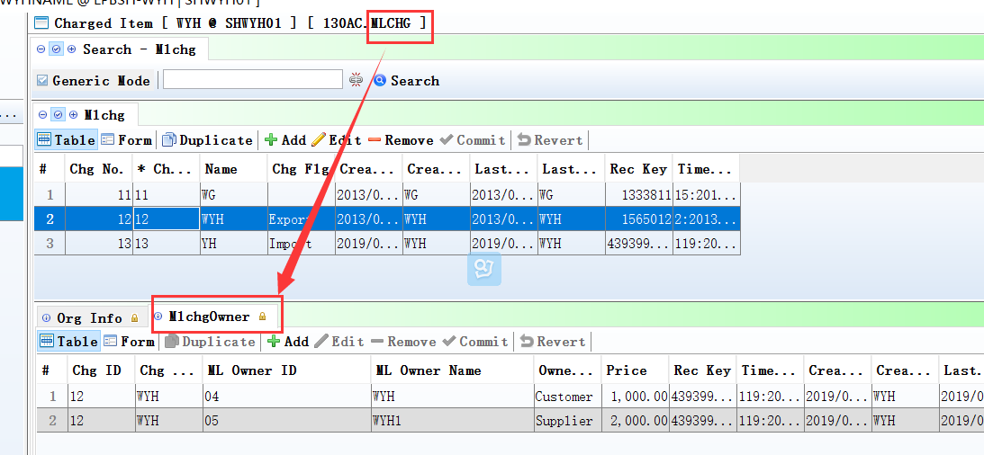
1、130AC:define price by Owner_Id;

2、130B: Select owner, take out the price automatically
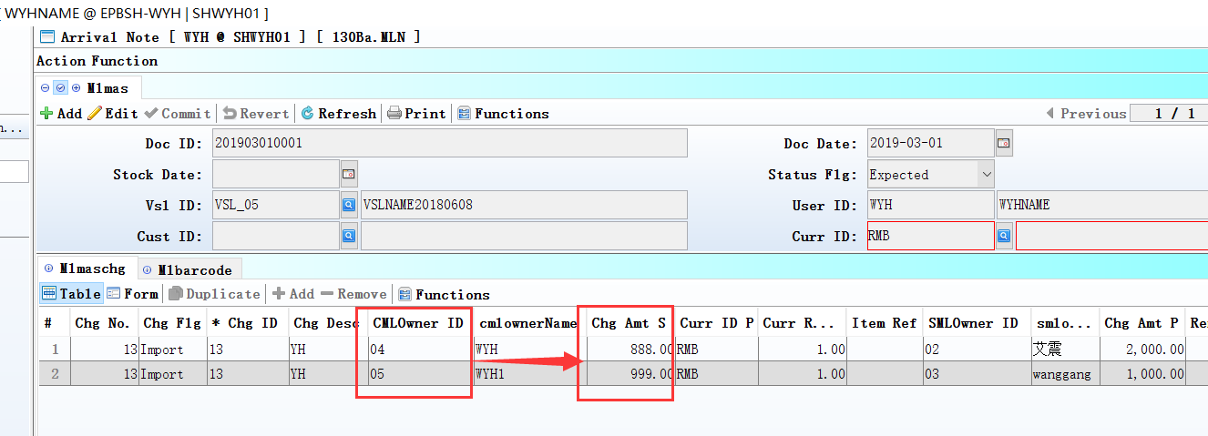

3.3.8 160AB Expenses:Added control’ Select supplier, according to the supplier master file Settings’.(28864)-879
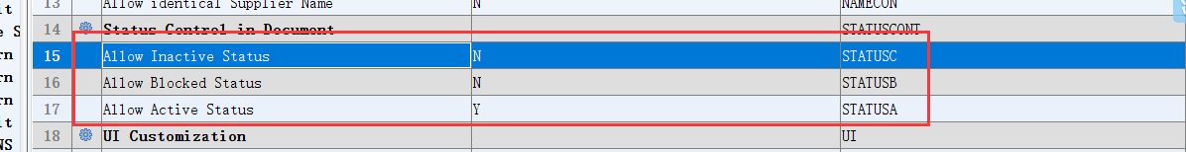
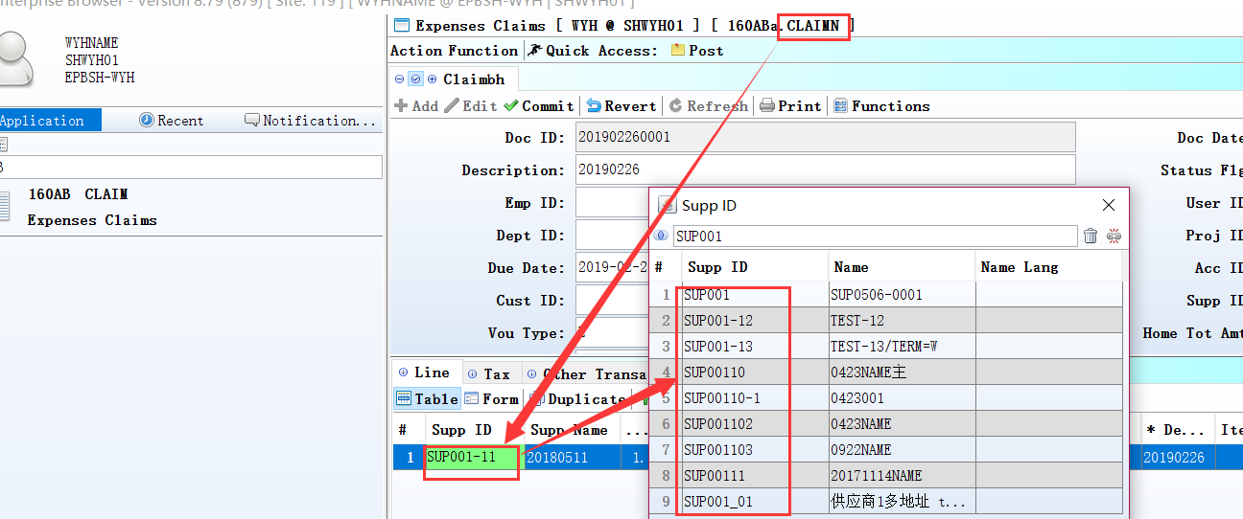

3.3.9 180AG BOM:Added column’ stkMat StatusFLg’ and delete ‘STATUS_FLG’ in table’Bommat’.(28901)-879
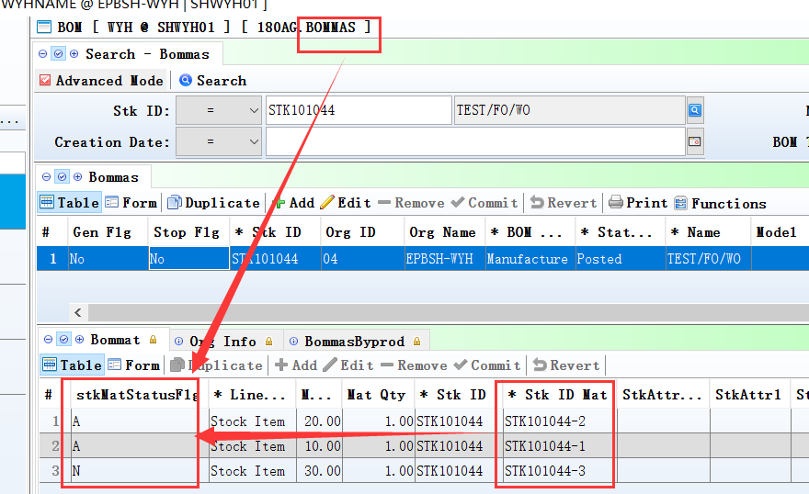
The ‘stkMat StatusFLg’
value according to the 'status_flg' in STKMAS module.

3.3.10 180BNJ Finished Goods Receive Enquiry:Added columns’ UNIT_WEIGHT,UNIT_WEIGHT_UOM, VOLUMN’.(28715)-879
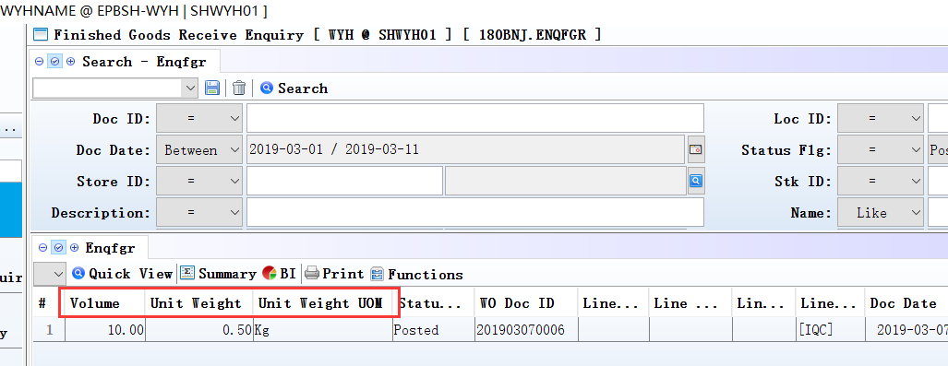

3.3.11 200CD Official Receipt: the ’Doc DATE’ in ‘transfer form ar’ interface take out by document’s date.(28848)-879
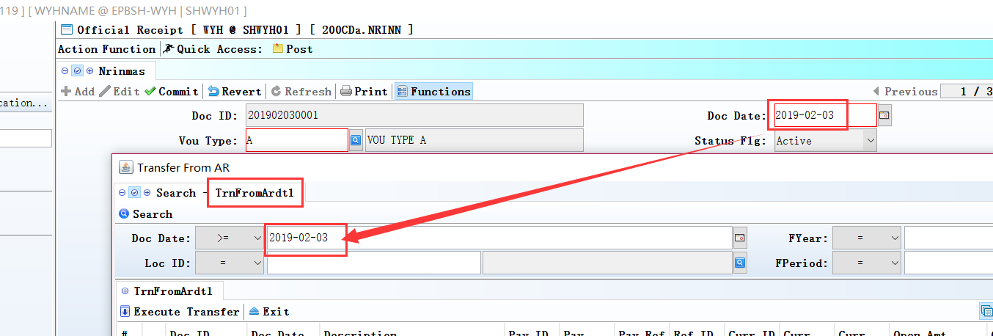

3.3.12 200FE Account Balance Book:Added table’ TEMP_GL_BAL_EMP’.(28841)-879
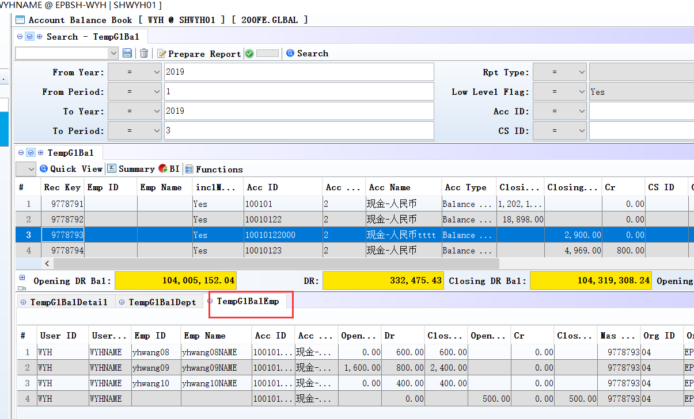

4. Fixes

