EPBrowserRelease Notes
Version 8.80

EPBrowserRelease Notes Version 8.80
Last Revision, 15 April 2019

©Copyright 2018. Enterprise Browser Pte Ltd.
All rights reserved.

No part of this manual may be reproduced in any form or by any means without the express written authorization from EPB. Business forms—which include but are not limited to invoices, checks, sales orders—displayed in this manual are for illustration purposes only and are not to be used for producing actual business forms. Enterprise Browser Pte Ltd. assumes no responsibility.
This document may contain technical inaccuracies or typographical errors and may change without prior notice. Any documentation with respect to EPB software products is provided for informational purposes only and does not extend or modify the limited warranty extended to the licensee of EPB software products.

Enterprise Browser Pte Ltd (EPB)
33Ubi Avenue 3, #07-65, Vertex Tower A, Singapore 408868
Tel: (65)-6509-4065
Fax: (65)-6509-4089

Document Location
EPBSH

Contents
1. Featured 3
2. New Interface 4
3. Enhancements 4
3.1 Privilege 4
3.2 Setting 4
3.2.1 010CA System Settings:Added settings’Age qty1~Age qty13’and’Age value1~ Age value13’.(29133)-880 4
3.2.2 060CG Customer Return:Changed Settings’ Sales Transaction Ref [A] Our Ref [B] Your Ref [C] Our Ref + Your Ref [D] Your Ref + Our Ref [E] Tax Invoice No. [F] Your Ref + Our Ref + Tax Invoice No’ and’ Customer Transaction Ref [A] Our Ref [B] Your Ref [C] Our Ref + Your Ref [D] Your Ref + Our Ref [E] Tax Invoice No. [F] Your Ref + Our Ref + Tax Invoice No’and’Tax Transaction Ref [A] Our Ref [B] Your Ref [C] Our Ref + Your Ref [D] Your Ref + Our Ref [E] Tax Invoice No. [F] Your Ref + Our Ref + Tax Invoice No’.(29083)-880 4
3.2.3 070CC Purchase Order:Changed Setting’ When Net Price and Price Book mismatch [Y] Disallow posting [A] Color Indicating [N] Nil’.(28989)-880 5
3.2.4 090DXC ZPOS:Added setting’ Enable Vip Discount’.(28982)-880 5
3.2.5 800CB Inventory Analysis:Added setting’ Display zero qty and value lines’.(29050)-880 6
3.3 Improve 6
3.3.1 010BB User:Added ‘edit’ function.(29050)-880 6
3.3.2 010BK Alert Enquiry:Added Alert Recoder. (28998)-880 6
3.3.3 020BLB Official Invoice:Added control’ If this invoice is used, is not allowed to Remove’.(29137)-880 7
3.3.4 090CcE Shopping Mall Settlement: Added the Voucher record for Prepaid Card sales and payment.(28846)-880 7
3.3.5 140CE Inventory Issue:Added columns ‘Stk Name’ and ‘Stk Model’ in the transfer from batch interface.(29062)-880 8
3.3.6 140EB Stock Summary :Added columns’Store Cat1 Id’ and ‘Store Cat1 Name’and’Store Cat2 Id’ and ‘Store Cat2 Name’and ’Store Cat3 Id’ and ‘Store Cat3 Name’.(29004)-880 8
3.3.7 150CC Bin Enquiry:Added BI function. (29061)-880 8
3.3.8 110A Projmas: Display the record in ‘ProjExpenses’ table, If proj_id had value in 160AB Module.(28968)-880 9
3.3.9 180BA Work Order:If Status flg is ‘locked’, Edit button doesn't work. (29031)-880 9
3.3.10 200BF GL Transaction:Added function’modify the emp_id’.(29126)-880 9
4. Fixes 10
4.1 Fix: Customer Return copied from DN, if user sort the records first before tick the required line selection record, when execute the transfer, it will still copied the whole items records over to DO. (29134)-880 10

1. Featured

2. New Interface

3. Enhancements

3.1 Privilege

3.2 Setting

3.2.1 010CA System Settings:Added settings’Age qty1~Age qty13’and’Age value1~ Age value13’.(29133)-880
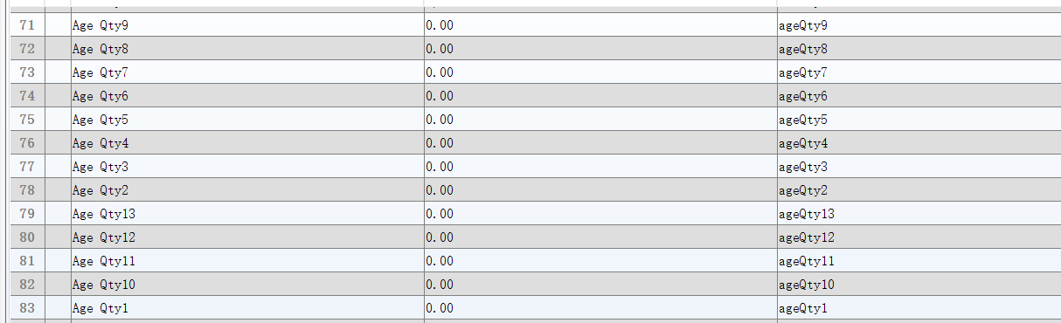
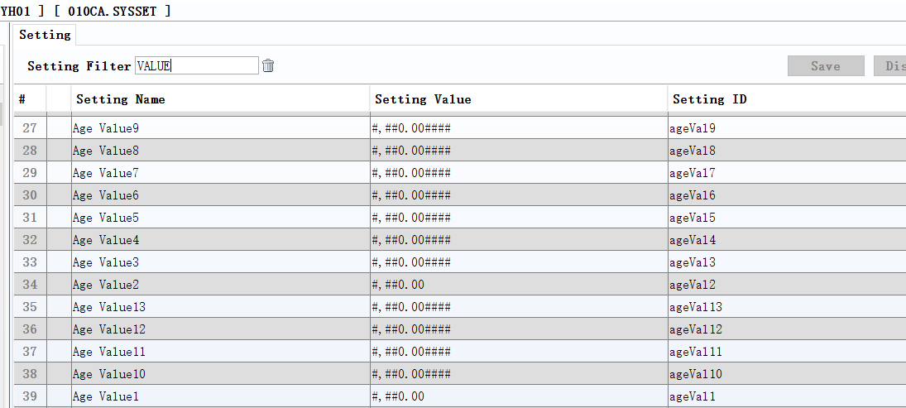
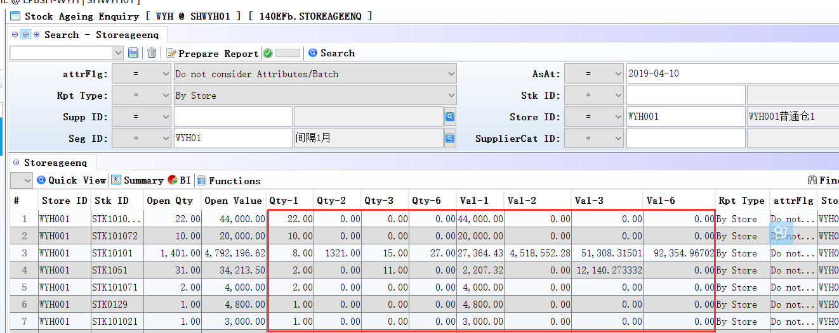

3.2.2 060CG Customer Return:Changed Settings’ Sales Transaction Ref [A] Our Ref [B] Your Ref [C] Our Ref + Your Ref [D] Your Ref + Our Ref [E] Tax Invoice No. [F] Your Ref + Our Ref + Tax Invoice No’ and’ Customer Transaction Ref [A] Our Ref [B] Your Ref [C] Our Ref + Your Ref [D] Your Ref + Our Ref [E] Tax Invoice No. [F] Your Ref + Our Ref + Tax Invoice No’and’Tax Transaction Ref [A] Our Ref [B] Your Ref [C] Our Ref + Your Ref [D] Your Ref + Our Ref [E] Tax Invoice No. [F] Your Ref + Our Ref + Tax Invoice No’.(29083)-880
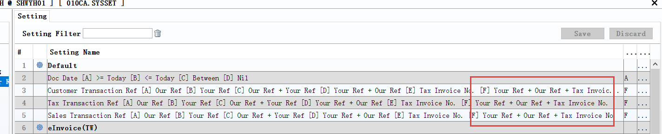
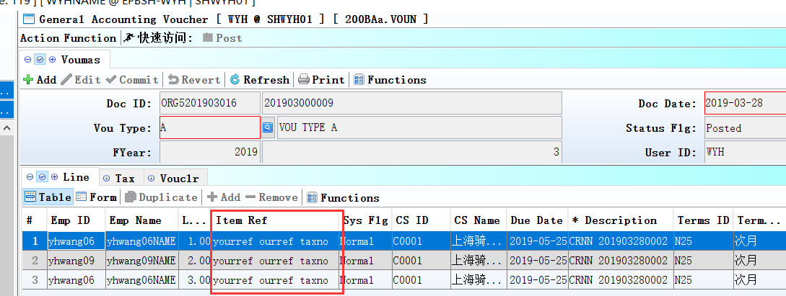

3.2.3 070CC Purchase Order:Changed Setting’ When Net Price and Price Book mismatch [Y] Disallow posting [A] Color Indicating [N] Nil’.(28989)-880
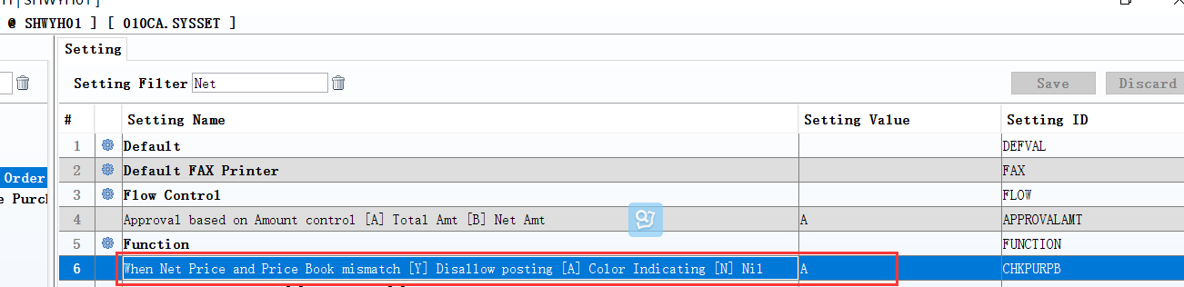
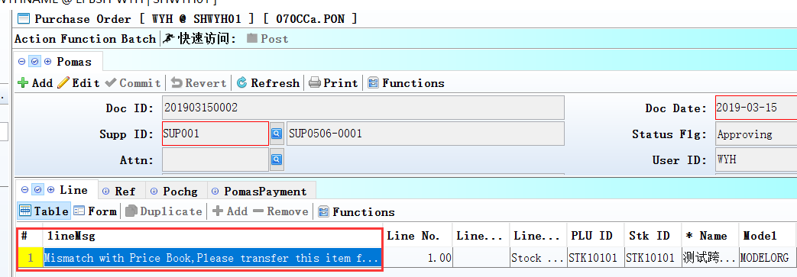

3.2.4 090DXC ZPOS:Added setting’ Enable Vip Discount’.(28982)-880
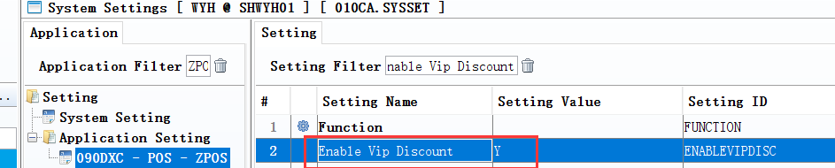

3.2.5 800CB Inventory Analysis:Added setting’ Display zero qty and value lines’.(29050)-880
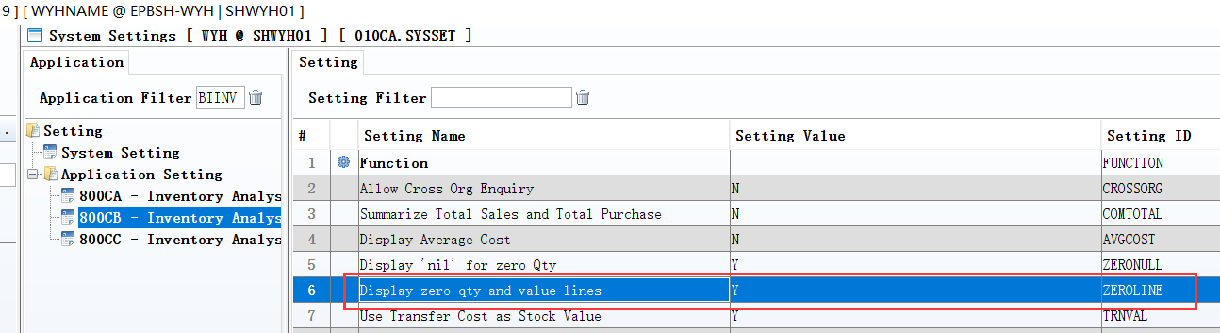
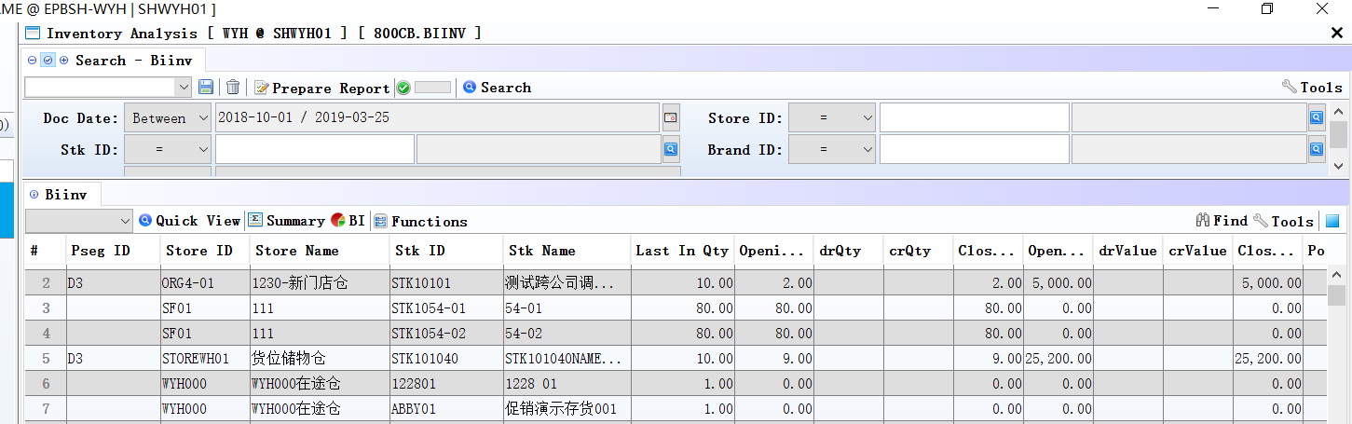

3.3 Improve

3.3.1 010BB User:Added ‘edit’ function.(29050)-880
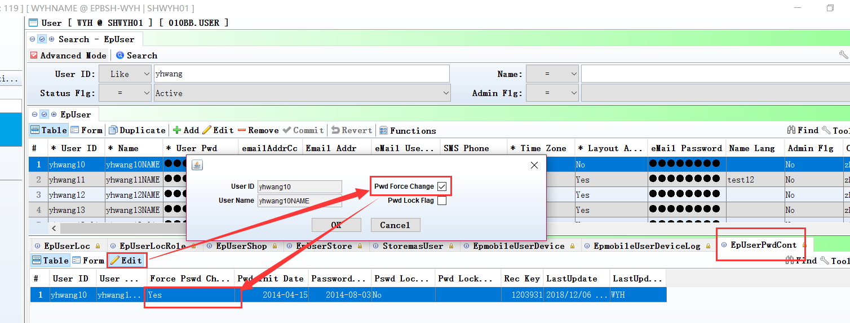
Added function in ‘EpUserPwdCont’ table.

3.3.2 010BK Alert Enquiry:Added Alert Recoder. (28998)-880
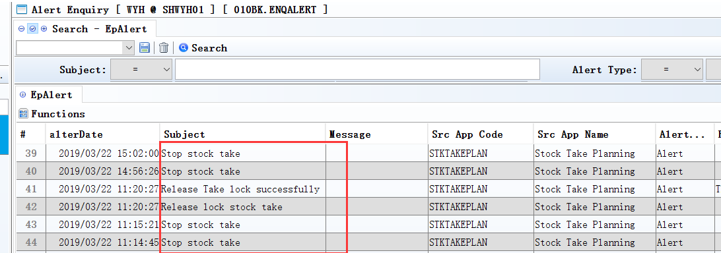
When Click the ‘Release Lock’ and ‘stop’ in 090CbA module,then display record in 010BK module.
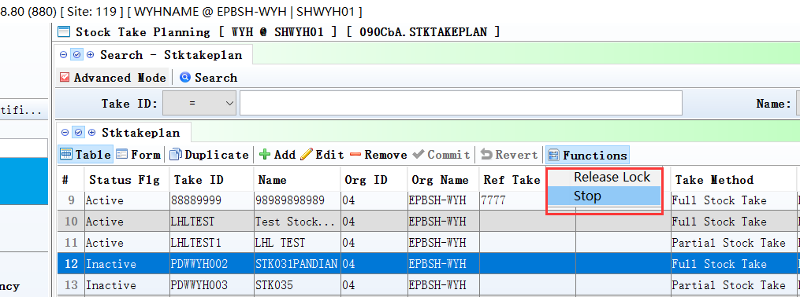

3.3.3 020BLB Official Invoice:Added control’ If this invoice is used, is not allowed to Remove’.(29137)-880
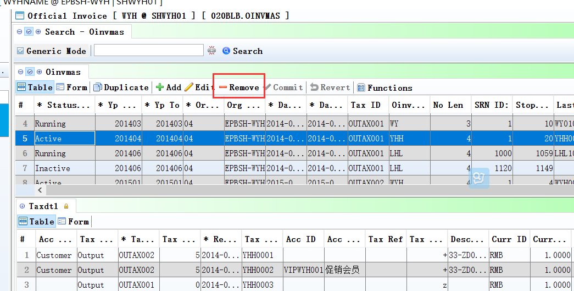

3.3.4 090CcE Shopping Mall Settlement: Added the Voucher record for Prepaid Card sales and payment.(28846)-880
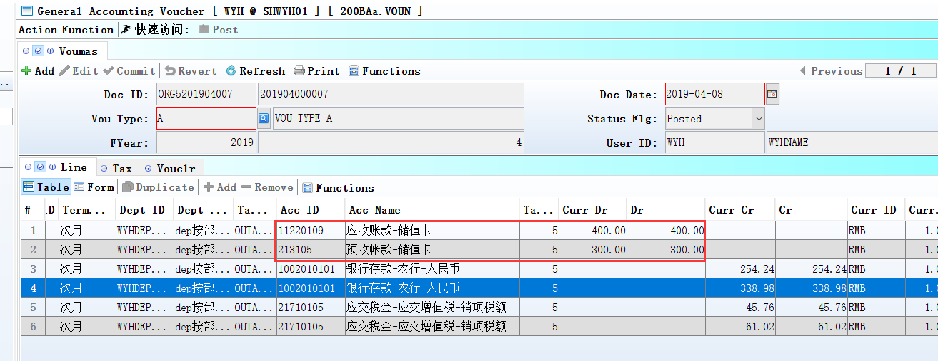

3.3.5 140CE Inventory Issue:Added columns ‘Stk Name’ and ‘Stk Model’ in the transfer from batch interface.(29062)-880
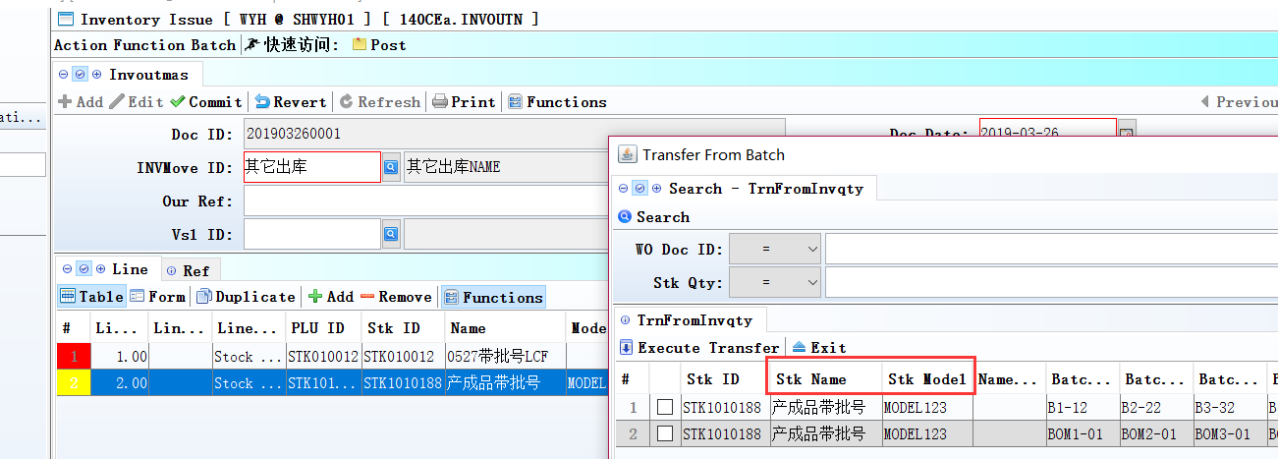

3.3.6 140EB Stock Summary :Added columns’Store Cat1 Id’ and ‘Store Cat1 Name’and’Store Cat2 Id’ and ‘Store Cat2 Name’and ’Store Cat3 Id’ and ‘Store Cat3 Name’.(29004)-880
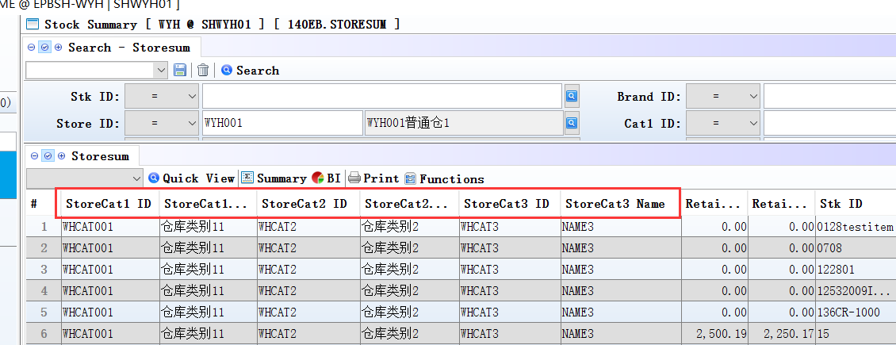
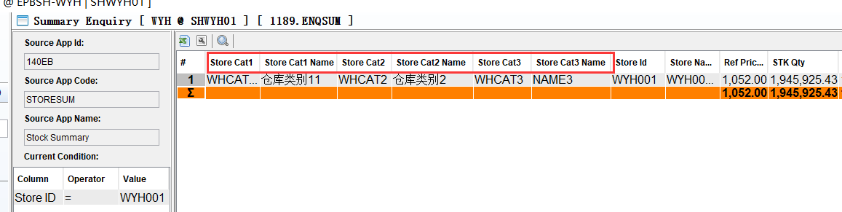

3.3.7 150CC Bin Enquiry:Added BI function. (29061)-880
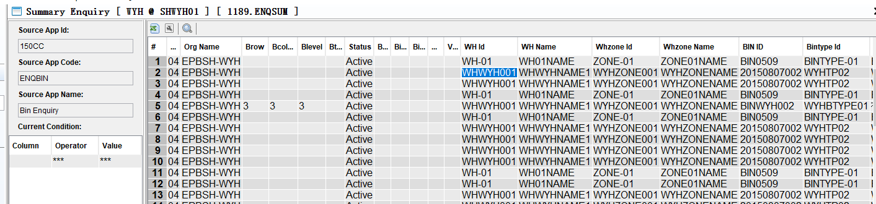

3.3.8 110A Projmas: Display the record in ‘ProjExpenses’ table, If proj_id had value in 160AB Module.(28968)-880
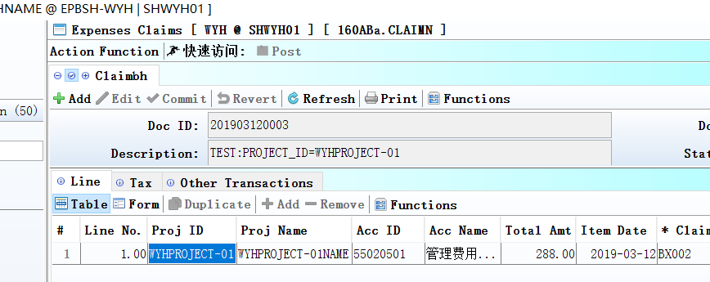
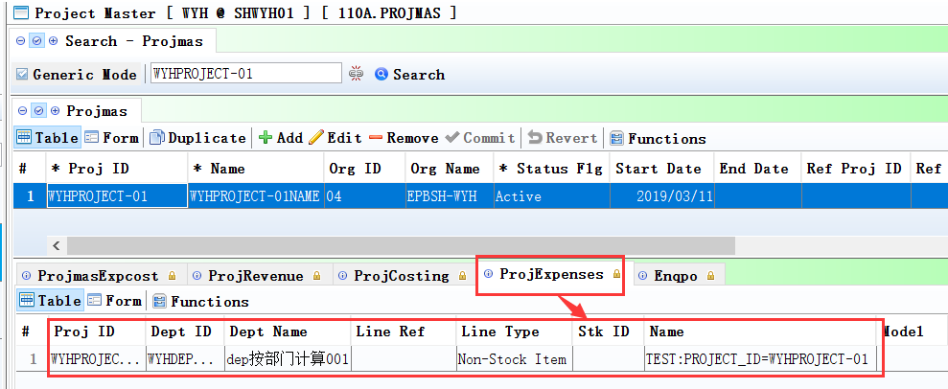

3.3.9 180BA Work Order:If Status flg is ‘locked’, Edit button doesn't work. (29031)-880
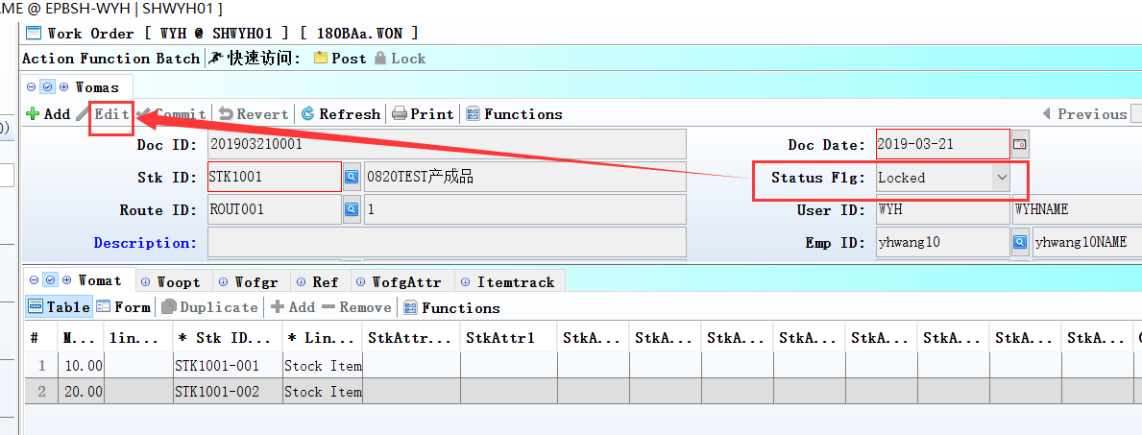

3.3.10 200BF GL Transaction:Added function’modify the emp_id’.(29126)-880
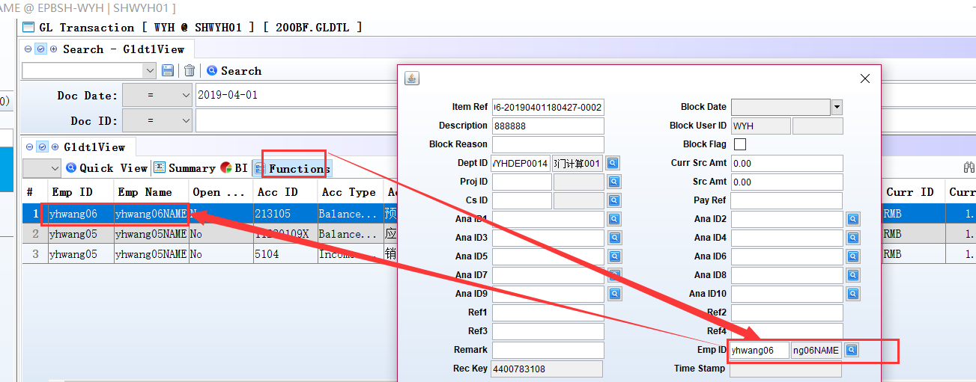
1、200CF\200DF also Added this function ;

2、Note：Only in the edit interface , cannot update to the source documents.

4. Fixes

4.1 Fix: Customer Return copied from DN, if user sort the records first before tick the required line selection record, when execute the transfer, it will still copied the whole items records over to DO. (29134)-880

