EPBrowserRelease Notes
Version 8.81~V8.82

EPBrowserRelease Notes Version 8.81~8.82
Last Revision, 01 June 2019

©Copyright 2018. Enterprise Browser Pte Ltd.
All rights reserved.

No part of this manual may be reproduced in any form or by any means without the express written authorization from EPB. Business forms—which include but are not limited to invoices, checks, sales orders—displayed in this manual are for illustration purposes only and are not to be used for producing actual business forms. Enterprise Browser Pte Ltd. assumes no responsibility.
This document may contain technical inaccuracies or typographical errors and may change without prior notice. Any documentation with respect to EPB software products is provided for informational purposes only and does not extend or modify the limited warranty extended to the licensee of EPB software products.

Enterprise Browser Pte Ltd (EPB)
33Ubi Avenue 3, #07-65, Vertex Tower A, Singapore 408868
Tel: (65)-6509-4065
Fax: (65)-6509-4089

Document Location
EPBSH

Contents
1. Featured 4
2. New Interface 4
3. Enhancements 4
3.1 Privilege 4
3.2 Setting 4
3.2.1 180BA Work Order:Added setting’ Enable manually generate Material Issue Note’。(29195)-881 4
3.2.2 180BD Finished Goods Receive:Added setting’ Enable transferring from WIP’.(29189)-881 4
3.2.3 200CDA AR Receipt Batch:Added setting ’ Cr A/C Type’ ,etc.(29162)-881 5
3.2.4 0021 Qty Detil:Added settings ’ Display Stkqty Info Tab’ etc.(29270)-882 5
3.2.5 070CA Purchase Requisition:Added setting’ Enable transferring from Back Order’.(29296)-882 5
3.2.6 150AE Bin Type:Added setting’ Enable Mixed Item Control’. (29346)-882 5
3.3 Improve 6
3.3.1 060CC Sales Order Change Note:Added columns ’oriGrossMargin’ and ’oriTotalProfit’. (29202)-881 6
3.3.2 060CN Debit Note Request: Drnrline.Tax_Id taken from Stkmas_Org.Tax_Id .(29163)-881 6
3.3.3 060HB Delivery Planning Enquiry:Added column ’Src Doc Date’.(29210)-881 6
3.3.4 140FH Inventory Transfer Enquiry:Added columns ’ SRC_CODE’ and ‘SRC_LOC_ID’ and ‘SRC_DOC_ID’ and ‘SRC_REC_KEY’ and ‘SRC_LINE_REC_KEY’.(29193)881 6
3.3.5 180AF Routing: PreOptNo can choose grpOptNo and optNo.(29159)-881 7
3.3.6 180BNE Work Order Material Enquiry: Added column ’Alt_flg’.(29170)-881 7
3.3.7 190AG Asset Master:Added function ’BI’. (29208)-881 7
3.3.8 090DPOS: When select the customer , show the column'credit limit' (29302)-882 8
3.3.9 140ECB Stock Movement Enquiry:Added column’Name Lang’.(29348)-882 8
3.3.10 140EGb LCM Enquiry:Added colunn’Warranty Duration’. (29334)-882 8
3.3.11 150AD Bin:Added control’ Only allowed to delete the inventory quantity is zero’ (29320)-882 8
4. Fixes 8

1. Featured

2. New Interface

3. Enhancements

3.1 Privilege

3.2 Setting

3.2.1 180BA Work Order:Added setting’ Enable manually generate Material Issue Note’。(29195)-881
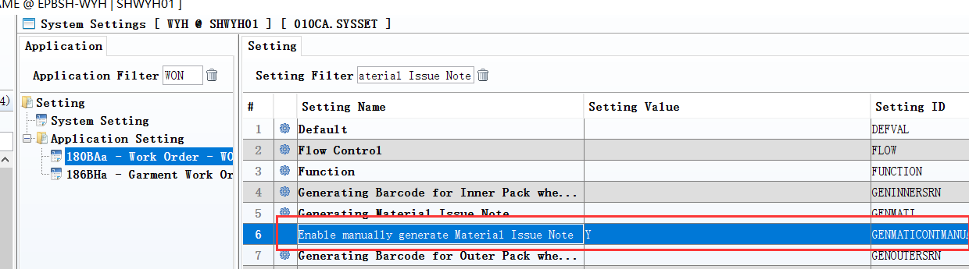
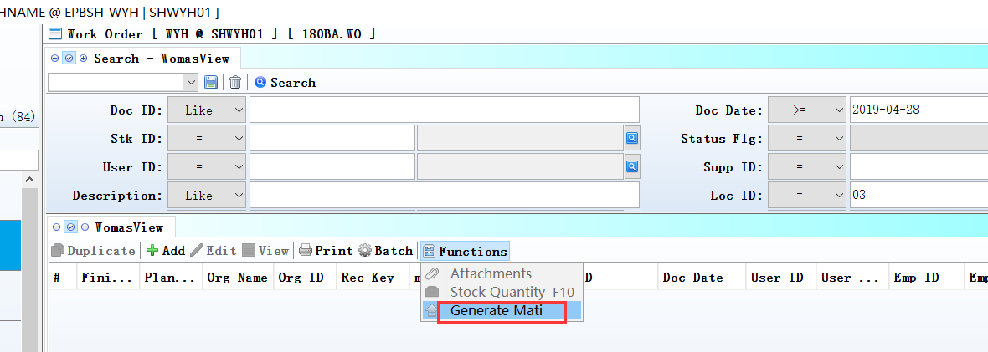
Y:display the button;
N:hide the button.

3.2.2 180BD Finished Goods Receive:Added setting’ Enable transferring from WIP’.(29189)-881
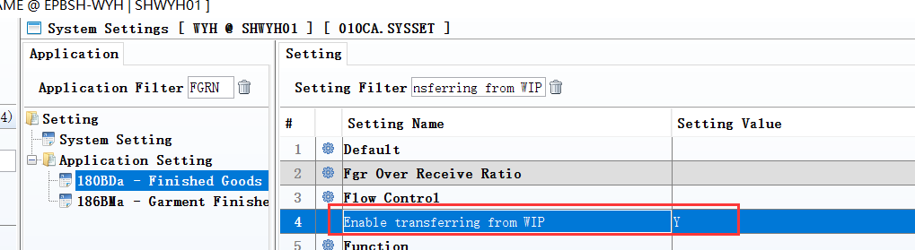

3.2.3 200CDA AR Receipt Batch:Added setting ’ Cr A/C Type’ ,etc.(29162)-881
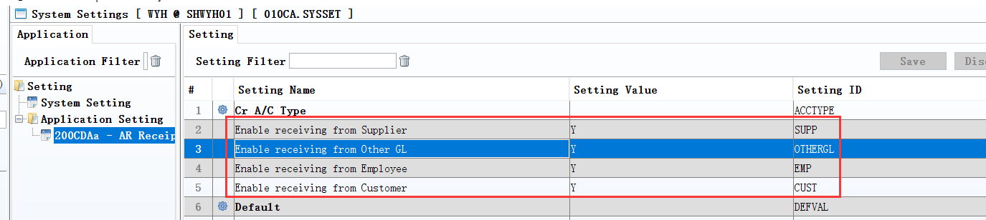
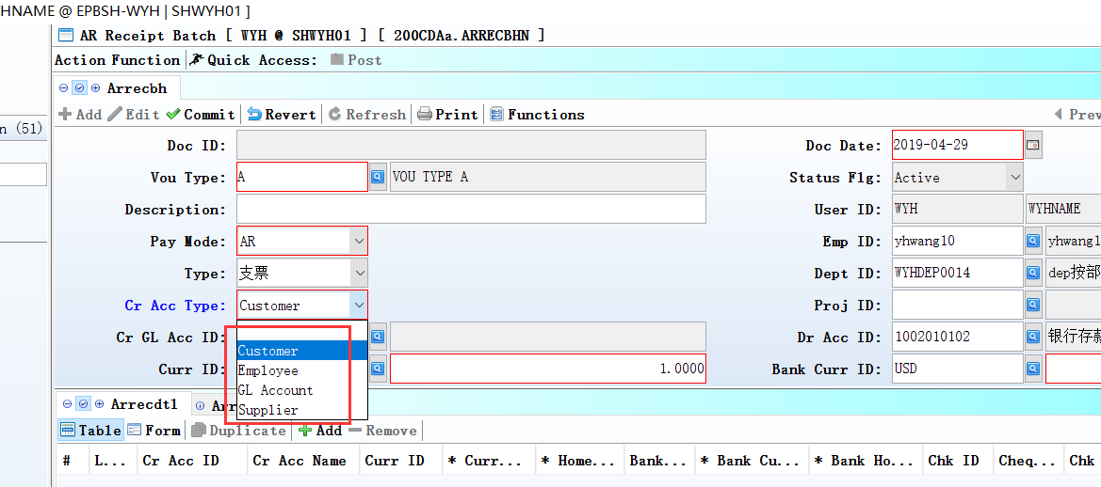

3.2.4 0021 Qty Detil:Added settings ’ Display Stkqty Info Tab’ etc.(29270)-882
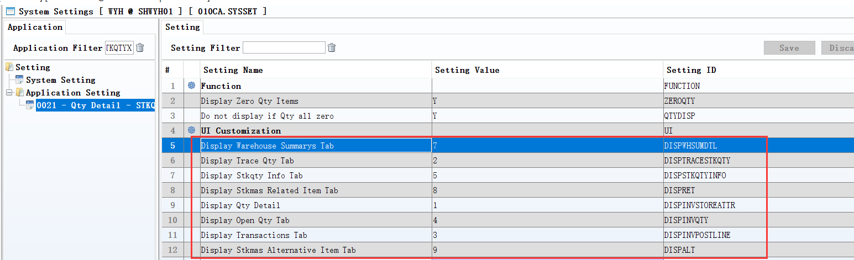
Set to N,
Don’t show the TAB.

3.2.5 070CA Purchase Requisition:Added setting’ Enable transferring from Back Order’.(29296)-882
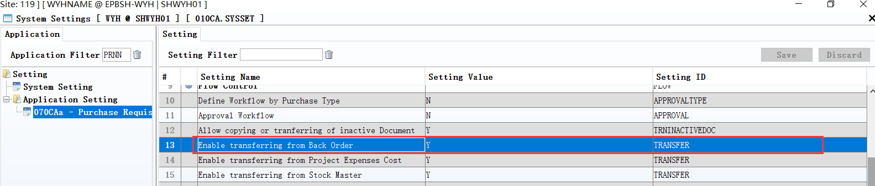

3.2.6 150AE Bin Type:Added setting’ Enable Mixed Item Control’. (29346)-882
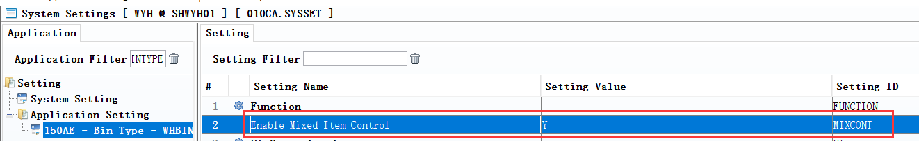

3.3 Improve

3.3.1 060CC Sales Order Change Note:Added columns ’oriGrossMargin’ and ’oriTotalProfit’. (29202)-881
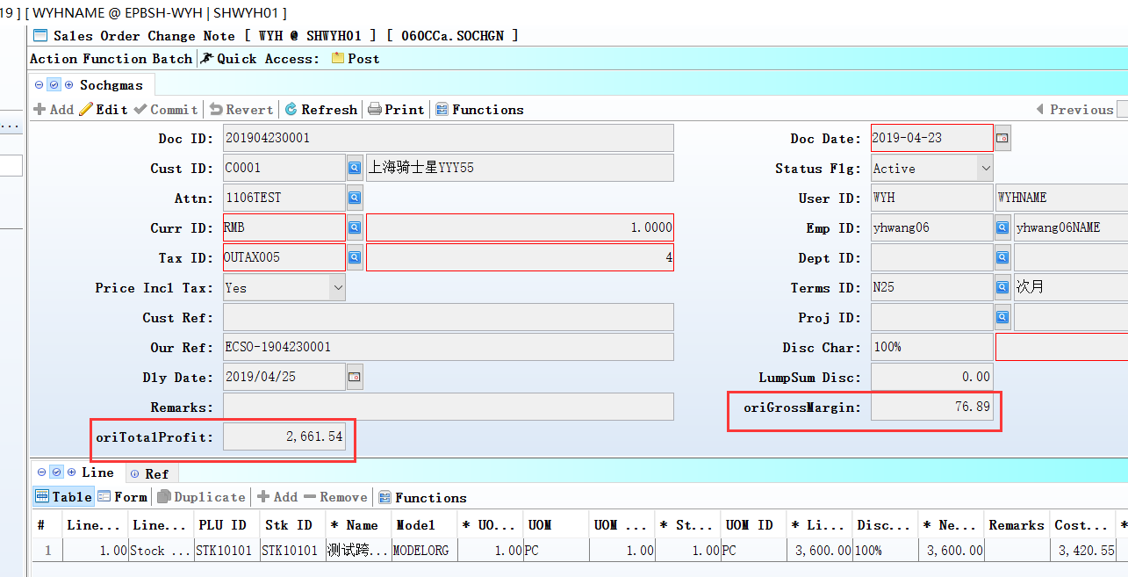

3.3.2 060CN Debit Note Request: Drnrline.Tax_Id taken from Stkmas_Org.Tax_Id .(29163)-881

3.3.3 060HB Delivery Planning Enquiry:Added column ’Src Doc Date’.(29210)-881
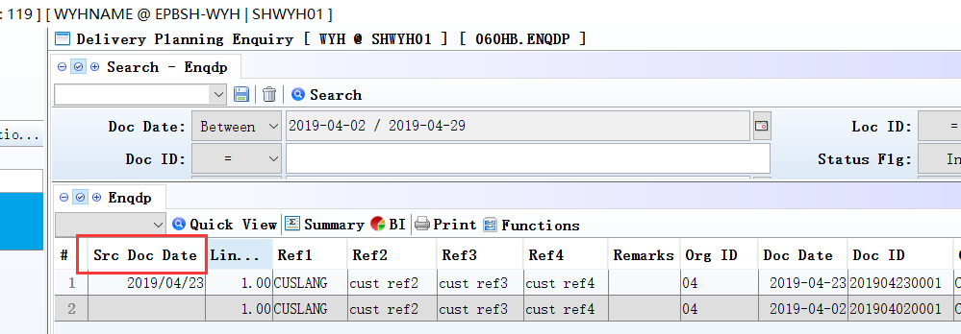

3.3.4 140FH Inventory Transfer Enquiry:Added columns ’ SRC_CODE’ and ‘SRC_LOC_ID’ and ‘SRC_DOC_ID’ and ‘SRC_REC_KEY’ and ‘SRC_LINE_REC_KEY’.(29193)881
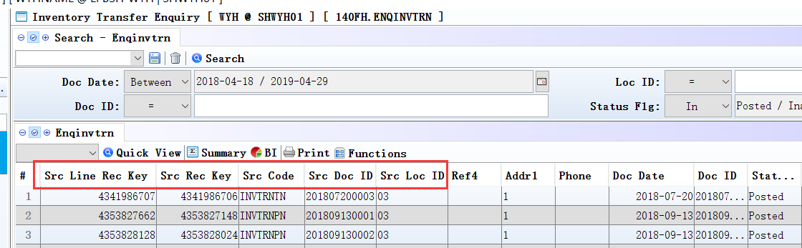
140FD、140FJ、140FC、140FI module added these fields too.

3.3.5 180AF Routing: PreOptNo can choose grpOptNo and optNo.(29159)-881
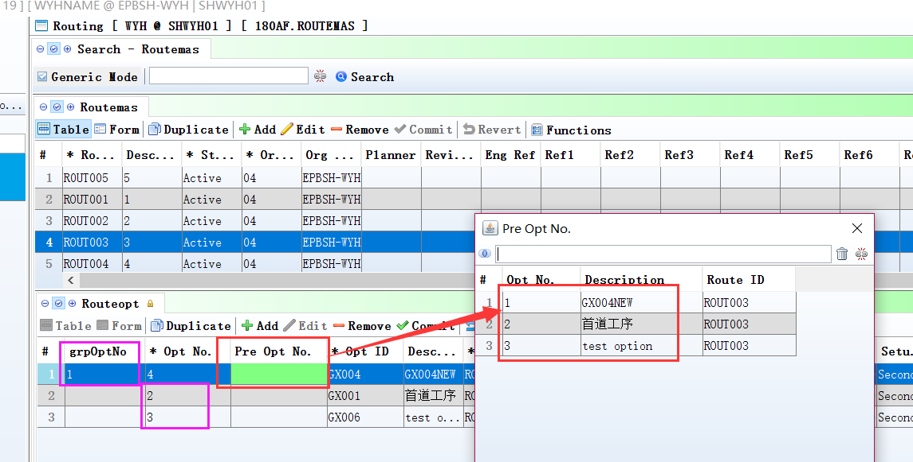
Note:
grpOptNo priority.

3.3.6 180BNE Work Order Material Enquiry: Added column ’Alt_flg’.(29170)-881
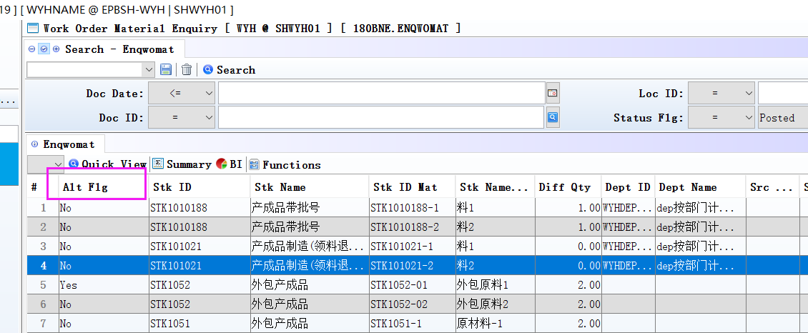

3.3.7 190AG Asset Master:Added function ’BI’. (29208)-881
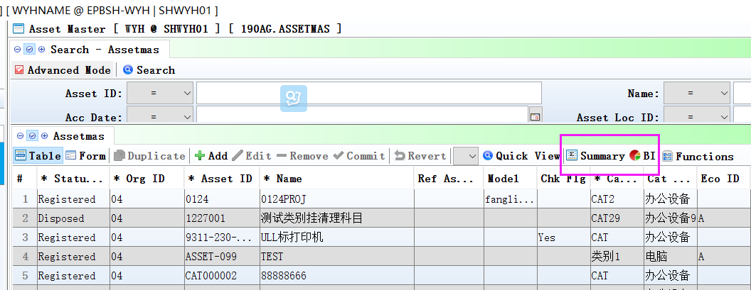

3.3.8 090D POS: When select the customer , show the column'credit limit' (29302)-882
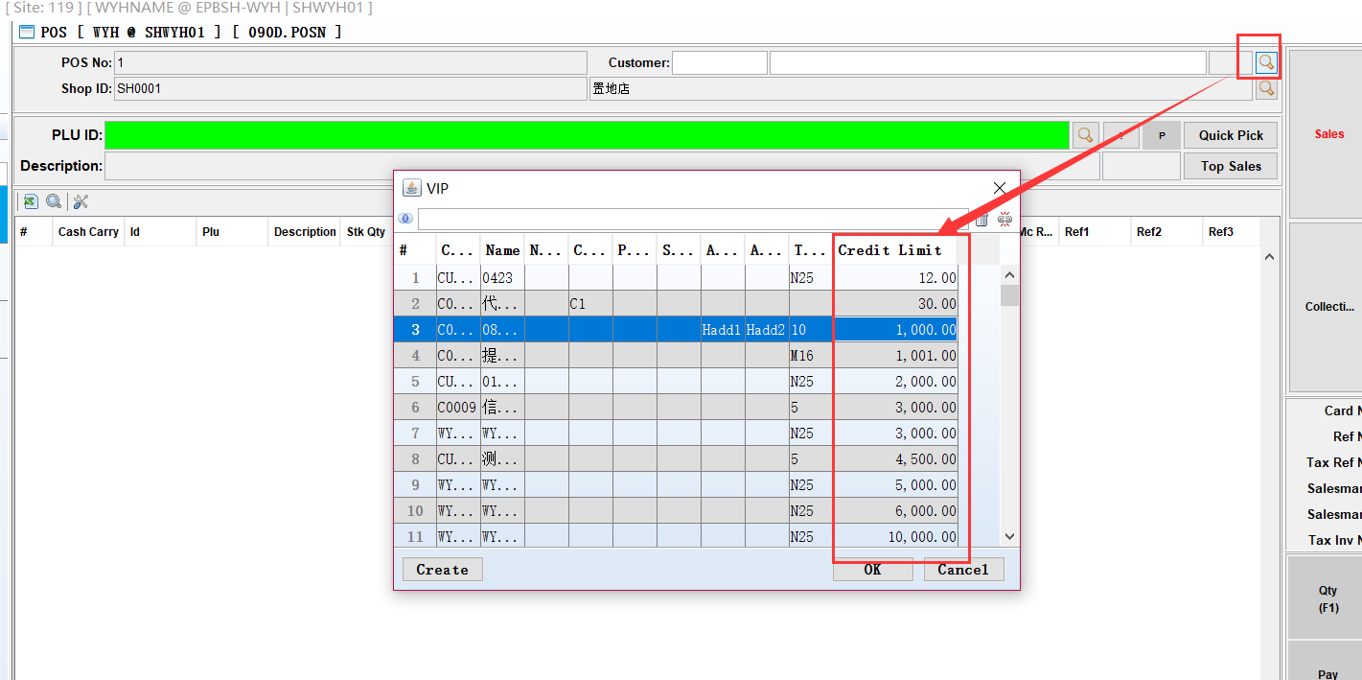

3.3.9 140ECB Stock Movement Enquiry:Added column’Name Lang’.(29348)-882
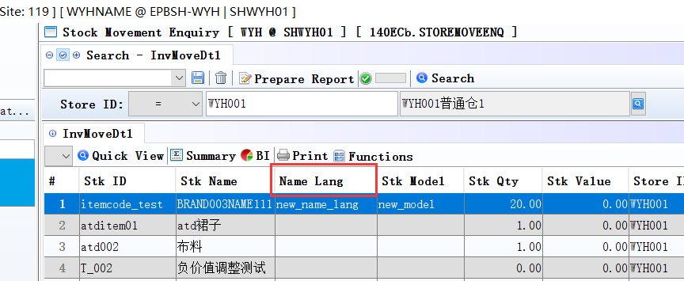

3.3.10 140EGb LCM Enquiry:Added colunn’Warranty Duration’. (29334)-882
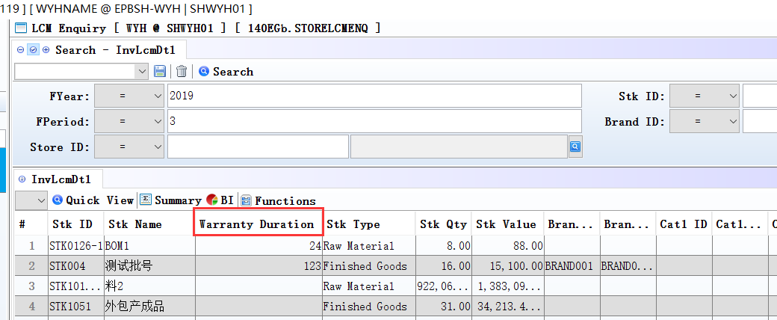

3.3.11 150AD Bin:Added control’ Only allowed to delete the inventory quantity is zero’ (29320)-882

4. Fixes

