EPBrowserRelease Notes
Version 8.83~8.85

EPBrowserRelease Notes Version 8.83~8.85
Last Revision, 28 July 2019

©Copyright 2019. Enterprise Browser Pte Ltd.
All rights reserved.

No part of this manual may be reproduced in any form or by any means without the express written authorization from EPB. Business forms—which include but are not limited to invoices, checks, sales orders—displayed in this manual are for illustration purposes only and are not to be used for producing actual business forms. Enterprise Browser Pte Ltd. assumes no responsibility.
This document may contain technical inaccuracies or typographical errors and may change without prior notice. Any documentation with respect to EPB software products is provided for informational purposes only and does not extend or modify the limited warranty extended to the licensee of EPB software products.

Enterprise Browser Pte Ltd (EPB)
33Ubi Avenue 3, #07-65, Vertex Tower A, Singapore 408868
Tel: (65)-6509-4065
Fax: (65)-6509-4089

Document Location
EPBSH

Contents
1. Featured 3
2. New Interface 4
2.1 Added new module:150CE Warehouse Transfer Request Enquiry.(29606)-884 4
3. Enhancements 4
3.1 Privilege 4
3.2 Setting 4
3.2.1 070HB Purchase Order Enquiry:Added setting'Allow Cross Org Enquiry' .(29411)-883 4
3.2.2 120A Assembly Job:Added setting'Disallow modify Materials info when in LOCK status'. (29527)-883 4
3.2.3 010CA System Settins:Changed the setting'Use MS Outlook to email report [A] Auto [Y] Manual [N] Nil'.(29301)-883 5
3.2.4 800BB Onhand Qty II:Added setting'Allow Cross Org Enquiry'. (29456)-883 5
3.2.5 010CA System Settings:Added setting'Dashboard Message Type [A] Note [B] Report [C] Mail'.(29600)-884 6
3.2.6 140ADC Storage Area:Setting changed'ATD Qty [N] On Hand Qty - Reserved for Delivery Qty [Y] On Hand Qty - Reserve Qty [P] On Hand Qty + Incoming Qty - Reserved for Delivery Qty'. (29595)-884 6
3.2.7 110A Project Master:Added setting'Allow Cross Org Enquiry'.(29493)-885 7
3.2.8 200CA Invoice:Added setting'Disallow posting if related Delivery Order Date is later than Invoice Date'.(29627)-885 7
3.3 Improve 8
3.3.1 090BC~090BI: Added column 'Stk Model' in the table of 'CampaignDetail'. (29403)-883 8
3.3.2 150AB Warehouse: Added column 'Sequence' , 010AE Working location: Added columns 'WH ID' and 'WH Name'.(29453)-883 8
3.3.3 200FE Account Balance Book: Restore query summary subject function.(29362)-883 9
3.3.4 060HC Delivery Order Enquiry:Added columns'Addr1' and 'Addr2' and 'Addr3' and 'Addr4'.(29580)-884 9
3.3.5 050Z My CRM:Adde colunns'LAST_DN_DATE' etc. (29654)-885 9
3.3.6 070BA Stock Item Purchase Price Book:Added colunns'ref1'and'ref2'and'ref3'and'ref4'.(29611)-885 10
3.3.7 180AG BOM:Added f10 function in Bommat table.(29634)-885 10
3.3.8 180DB WIP Enquiry:Added column'WO_SUB_STATUS'.(29655)-885 10
4. Fixes 10

1. Featured

2. New Interface

2.1 Added new module:150CE Warehouse Transfer Request Enquiry.(29606)-884
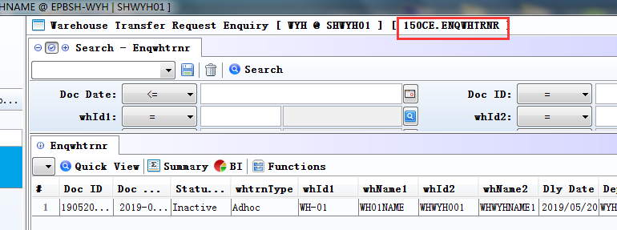

3. Enhancements

3.1 Privilege

3.2 Setting

3.2.1 070HB Purchase Order Enquiry:Added setting'Allow Cross Org Enquiry' .(29411)-883
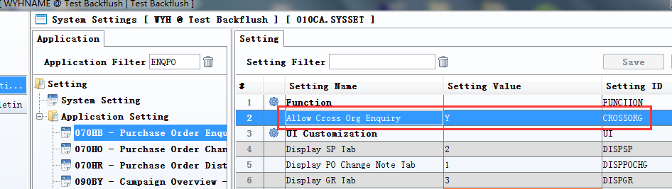

3.2.2 120A Assembly Job:Added setting'Disallow modify Materials info when in LOCK status'. (29527)-883
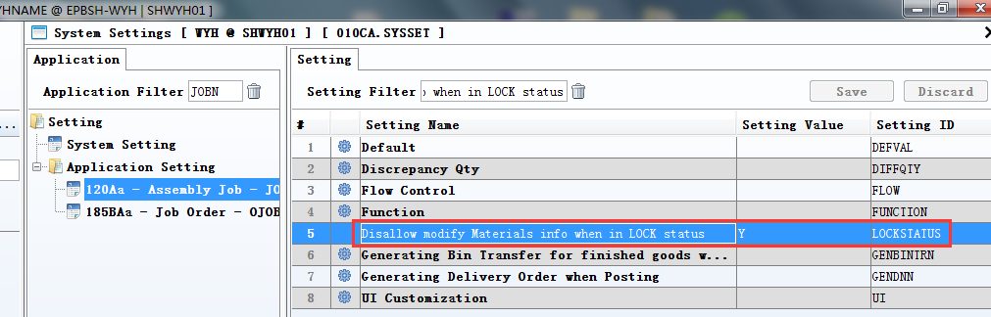
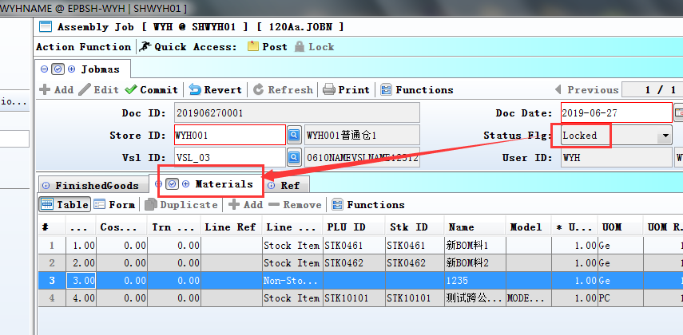
1、Set to Y;
2、Status Flg='Locked';
3、The table of materials can't be edited.

3.2.3 010CA System Settins:Changed the setting'Use MS Outlook to email report [A] Auto [Y] Manual [N] Nil'.(29301)-883
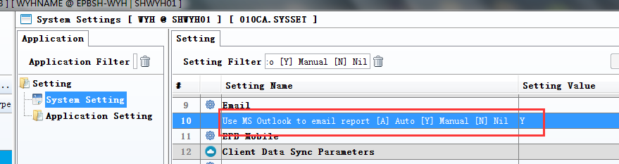
1、set to Y；
When click the bunton of ‘Email’,The interface of ‘OUTLOOK’ will be shown; Can modify the email address.
2、set to A;
Automatically send E-mail.

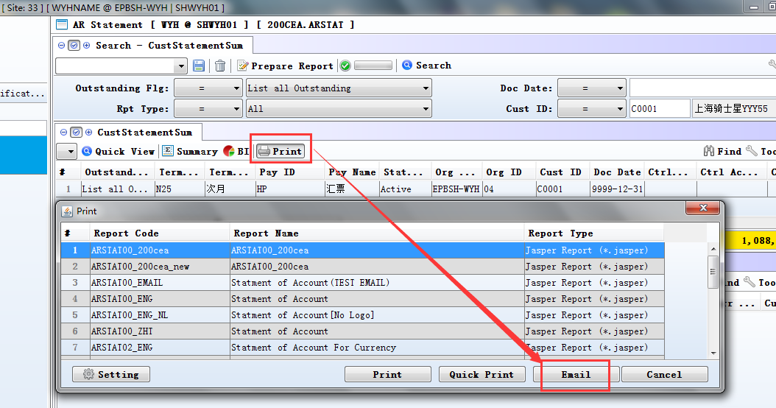

3.2.4 800BB Onhand Qty II:Added setting'Allow Cross Org Enquiry'. (29456)-883
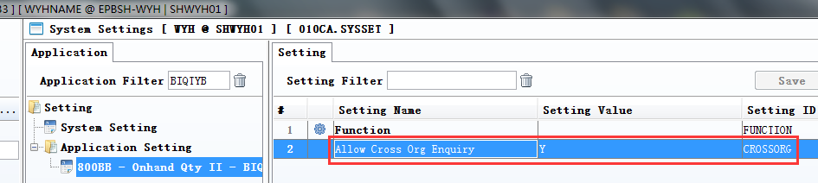
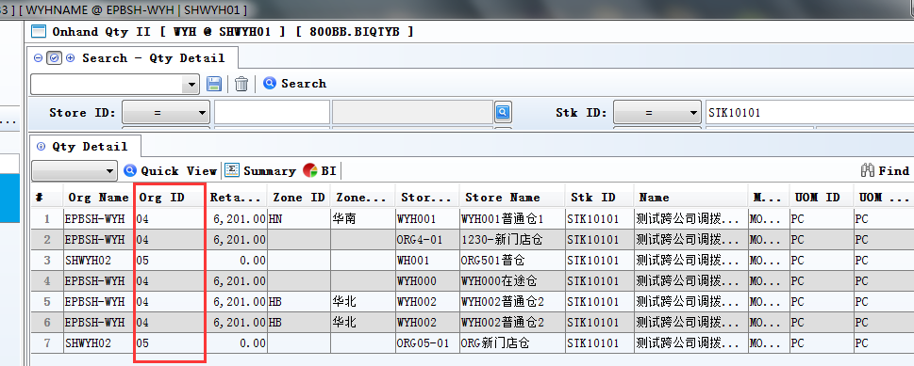

3.2.5 010CA System Settings:Added setting'Dashboard Message Type [A] Note [B] Report [C] Mail'.(29600)-884
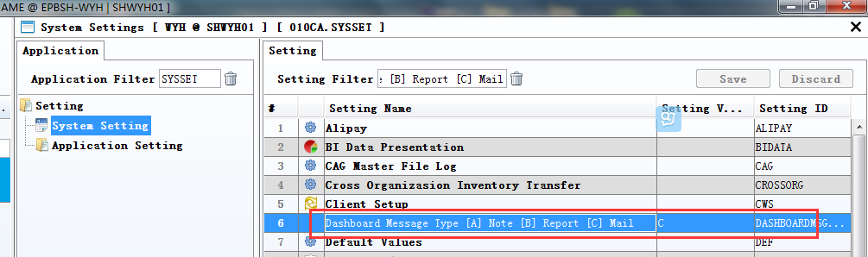
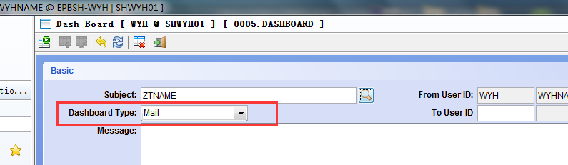
Default value of Dashboard Type according to the system setup.

3.2.6 140ADC Storage Area:Setting changed'ATD Qty [N] On Hand Qty - Reserved for Delivery Qty [Y] On Hand Qty - Reserve Qty [P] On Hand Qty + Incoming Qty - Reserved for Delivery Qty'. (29595)-884
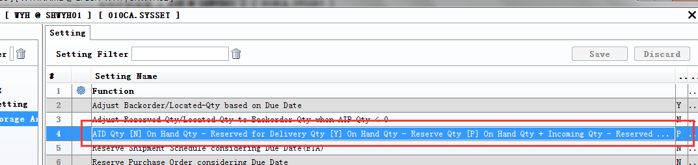
1、Added the setting options:' [P] On Hand Qty + Incoming Qty - Reserved for Delivery Qty ';
2、If set to 'P';
When a purchase order is after Posting，there be generated ‘ATD QTY’.
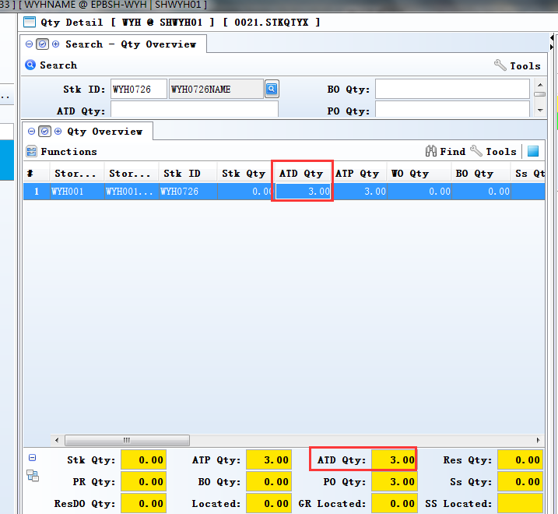

3.2.7 110A Project Master:Added setting'Allow Cross Org Enquiry'.(29493)-885
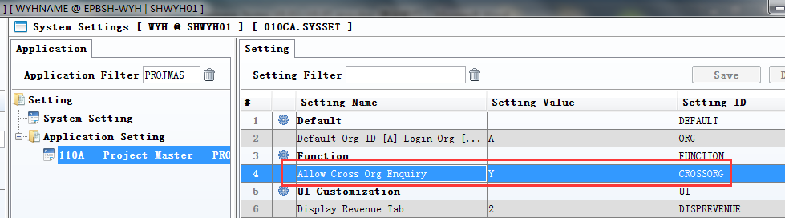
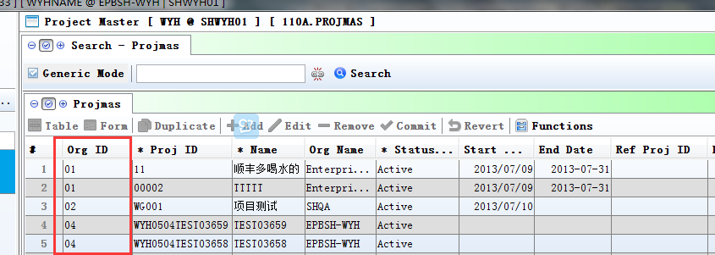

3.2.8 200CA Invoice:Added setting'Disallow posting if related Delivery Order Date is later than Invoice Date'.(29627)-885
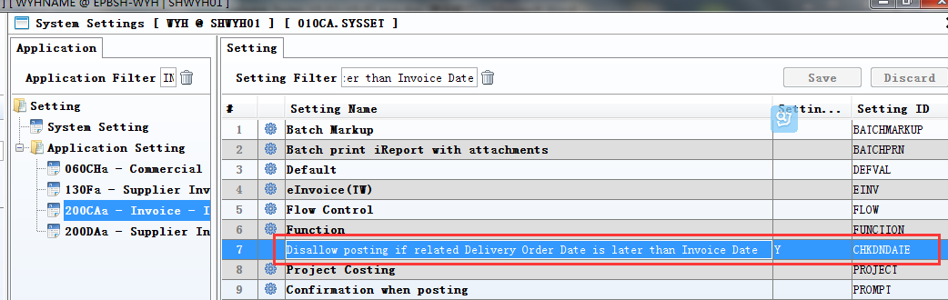
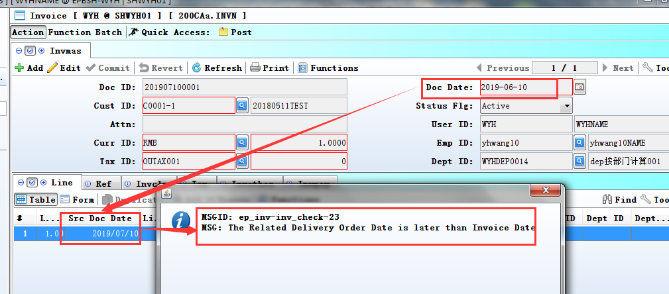

3.3 Improve

3.3.1 090BC~090BI: Added column 'Stk Model' in the table of 'CampaignDetail'. (29403)-883
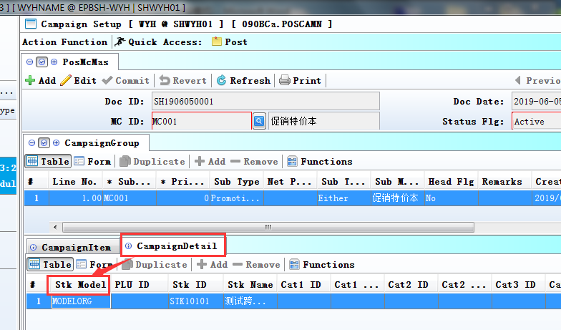

3.3.2 150AB Warehouse: Added column 'Sequence' , 010AE Working location: Added columns 'WH ID' and 'WH Name'.(29453)-883
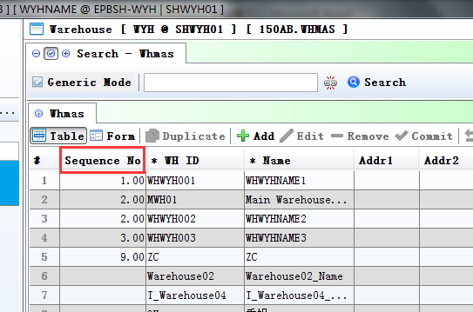
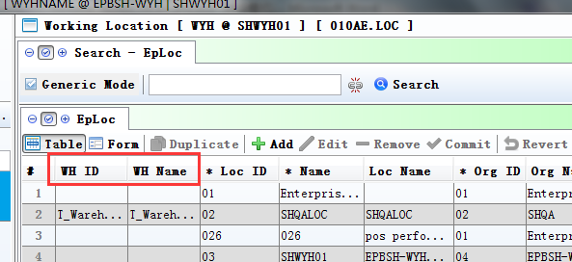

3.3.3 200FE Account Balance Book: Restore query summary subject function.(29362)-883
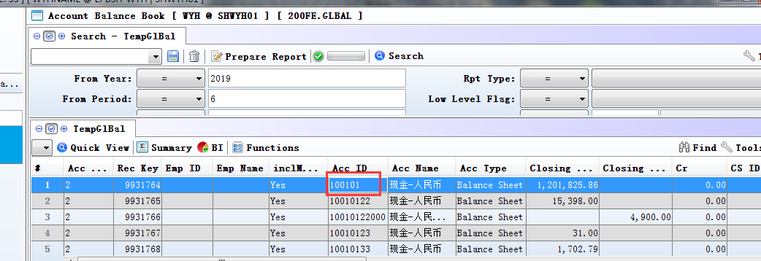

3.3.4 060HC Delivery Order Enquiry:Added columns'Addr1' and 'Addr2' and 'Addr3' and 'Addr4'.(29580)-884
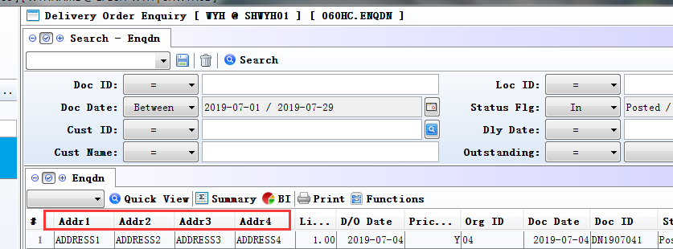

3.3.5 050Z My CRM:Adde colunns'LAST_DN_DATE' etc. (29654)-885
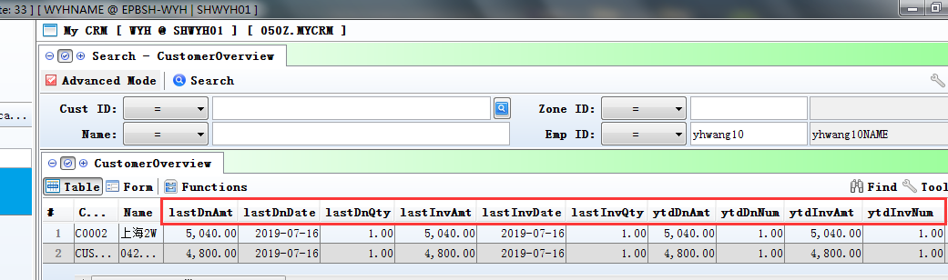

3.3.6 070BA Stock Item Purchase Price Book:Added colunns'ref1'and'ref2'and'ref3'and'ref4'.(29611)-885
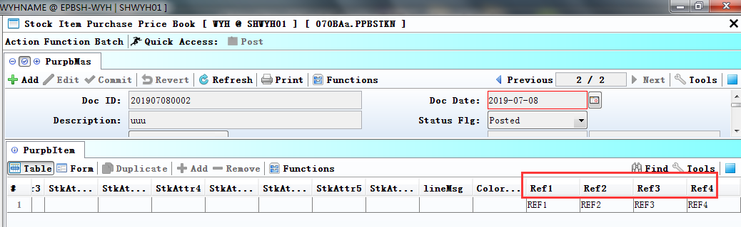

3.3.7 180AG BOM:Added f10 function in Bommat table.(29634)-885
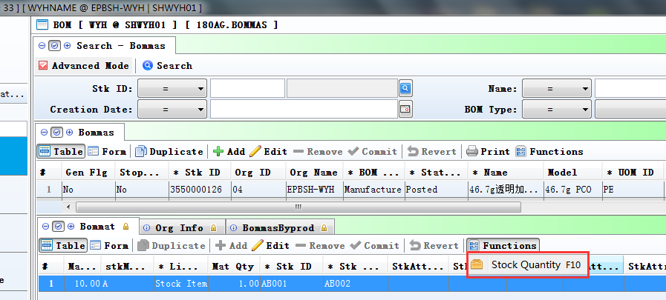

3.3.8 180DB WIP Enquiry:Added column'WO_SUB_STATUS'.(29655)-885
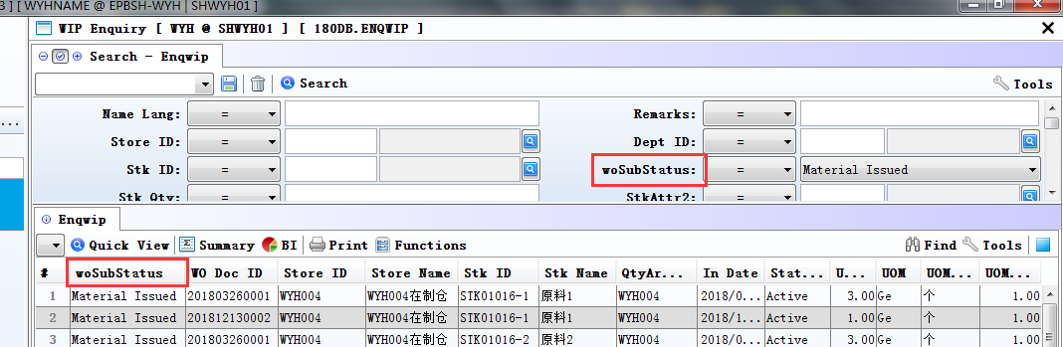

4. Fixes

