EPBrowserRelease Notes
Version 8.86~8.87

EPBrowserRelease Notes Version 8.86~8.87
Last Revision, 10 September 2019

©Copyright 2019. Enterprise Browser Pte Ltd.
All rights reserved.

No part of this manual may be reproduced in any form or by any means without the express written authorization from EPB. Business forms—which include but are not limited to invoices, checks, sales orders—displayed in this manual are for illustration purposes only and are not to be used for producing actual business forms. Enterprise Browser Pte Ltd. assumes no responsibility.
This document may contain technical inaccuracies or typographical errors and may change without prior notice. Any documentation with respect to EPB software products is provided for informational purposes only and does not extend or modify the limited warranty extended to the licensee of EPB software products.

Enterprise Browser Pte Ltd (EPB)
33Ubi Avenue 3, #07-65, Vertex Tower A, Singapore 408868
Tel: (65)-6509-4065
Fax: (65)-6509-4089

Document Location
EPBSH

Contents
1. Featured 4
2. New Interface 4
2.1 Added new module:140FN Goods in Value Adjustment Enquiry. (29900)-887 4
3. Enhancements 4
3.1 Privilege 4
3.2 Setting 5
3.2.1 010CA System Settings:Added setting’ Use [A] RPT FILE NAME + DOC ID + TIMESTAMP [B] DOC ID + TIMESTAMP [C] DOC ID as file name’. (29817)-887 5
3.2.2 010CA System Settings: Setting changed ’All date according to the DateFormat format, all the time according to DateTimeFormat format’.(29802)-887 5
3.3.3 180BE Work Order Reporting:Added setting’ Update ROUTEOPT OPT Time when OPT Time is zero,OPT Time = Hour Used * 60 / Qty’.(29922)-887 5
3.3.4 200CC Debit Note:Added setting‘Enable transferring from Delivery Order’.(29762)-887 6
3.3 Improve 6
3.3.1 090B Campaign module： added columns ’select Flg’、’Pts control Flg’、’Pts From’、’Pts to’; When there are more than a promotion ,in 090D module you can click the F8 then choose one of the promotion.(27696)-886 6
3.3.2 150G Truck Note: added columns’Marking’、’Marking Name’、’Vsl Id’、’Vsl Name’.(29764)-886 7
3.3.3 180BB Material Issue :Added control’ There be prompt when post document，if the store is not in active status’.(29746)-886 8
3.3.4 180BNN Work Order ReportingII Enquiry: Allow editing ‘Cost Id ‘、’ resource id’.(29739)-886 8
3.3.5 060BM Stock Sales Price Book Change:Added column’Emp Id’. (29848)-887 8
3.3.6 090AaH POSVIP:Added function’Purge Lock’. (29804)-887 8
3.3.7 090D POS: The remark take out the different values by promotion campaign .(29831)-887 9
3.3.8 140CL Value Adjustment/140FL Stock Value Adjustment Enquiry: drop column store_id .(29889)-887 9
3.3.9 150G Truck Note: Scan documents added control, there are red alerts if there are repeat documents.(29773)-887 10
3.3.10 180BNN Work Order Reporting II Enquiry:Added delete function. (29788)-887 10
3.3.11 180BNN Work Order Reporting II Enquiry: If there is value in worptlineRecKey,then the edit button is not used.(29830)-887 10
4. Fixes 10

1. Featured

2. New Interface

2.1 Added new module:140FN Goods in Value Adjustment Enquiry. (29900)-887
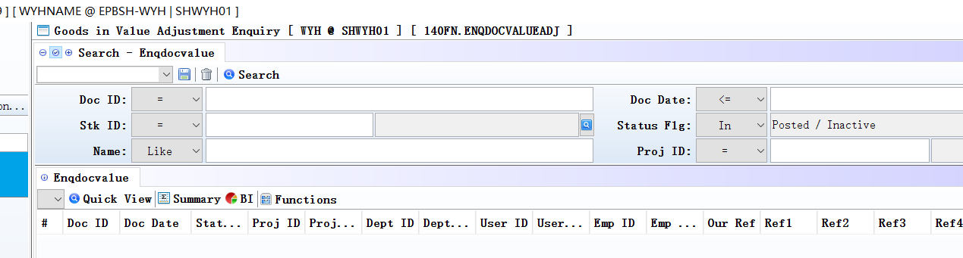

3. Enhancements

3.1 Privilege

3.2 Setting

3.2.1 010CA System Settings:Added setting’ Use [A] RPT FILE NAME + DOC ID + TIMESTAMP [B] DOC ID + TIMESTAMP [C] DOC ID as file name’. (29817)-887
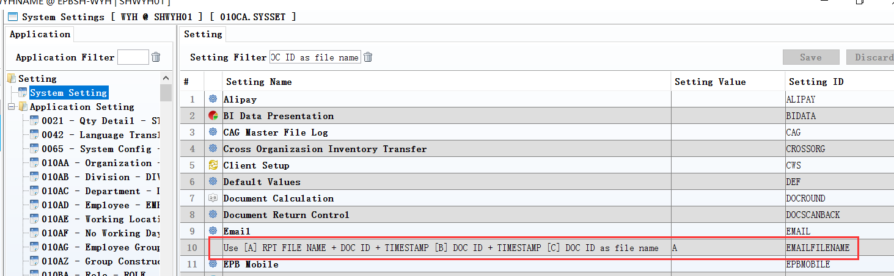
Set to A:
Use ‘RPT FILE NAME + DOC ID + TIMESTAMP’ as the file name for attachment.
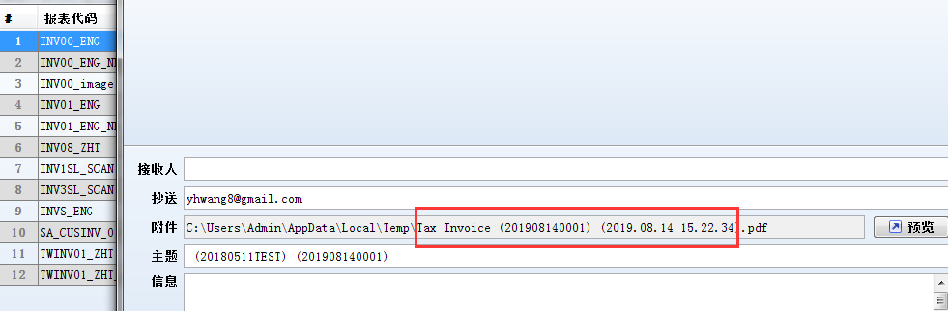

3.2.2 010CA System Settings: Setting changed ’All date according to the DateFormat format, all the time according to DateTimeFormat format’.(29802)-887
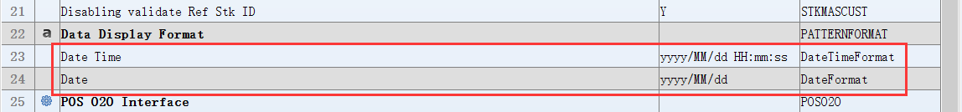

3.3.3 180BE Work Order Reporting:Added setting’ Update ROUTEOPT OPT Time when OPT Time is zero,OPT Time = Hour Used * 60 / Qty’.(29922)-887
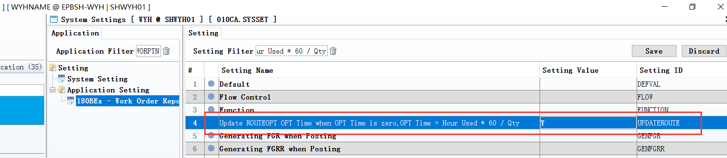
Set to Y:
Update ROUTEOPT OPT Time when OPT Time is zero,OPT Time = Hour Used * 60 / Qty.

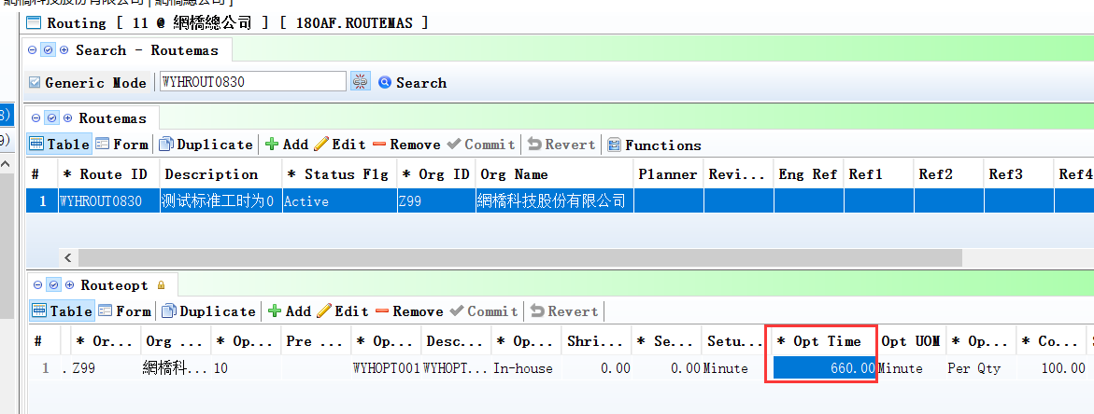

3.3.4 200CC Debit Note:Added setting‘Enable transferring from Delivery Order’.(29762)-887
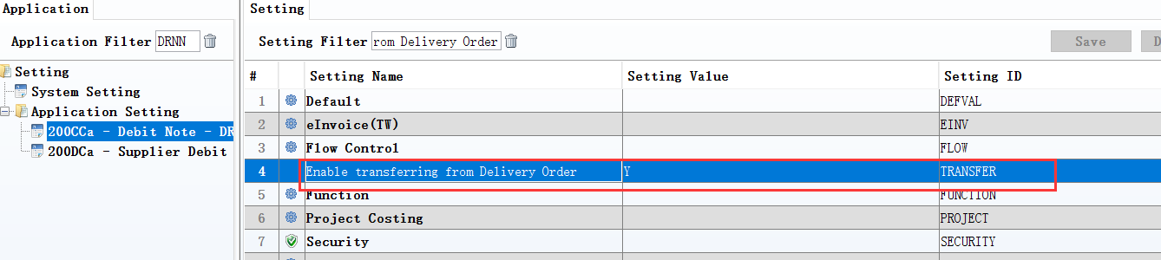

3.3 Improve

3.3.1 090B Campaign module： added columns ’select Flg’、’Pts control Flg’、’Pts From’、’Pts to’; When there are more than a promotion ,in 090D module you can click the F8 then choose one of the promotion.(27696)-886
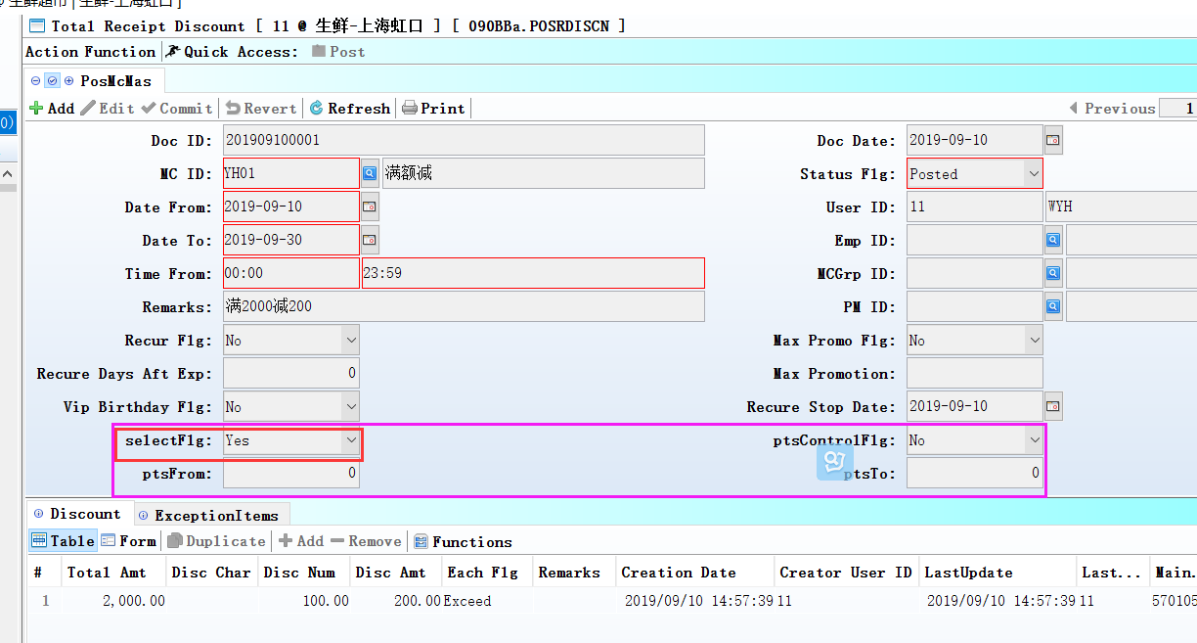
Select Flg=Y；
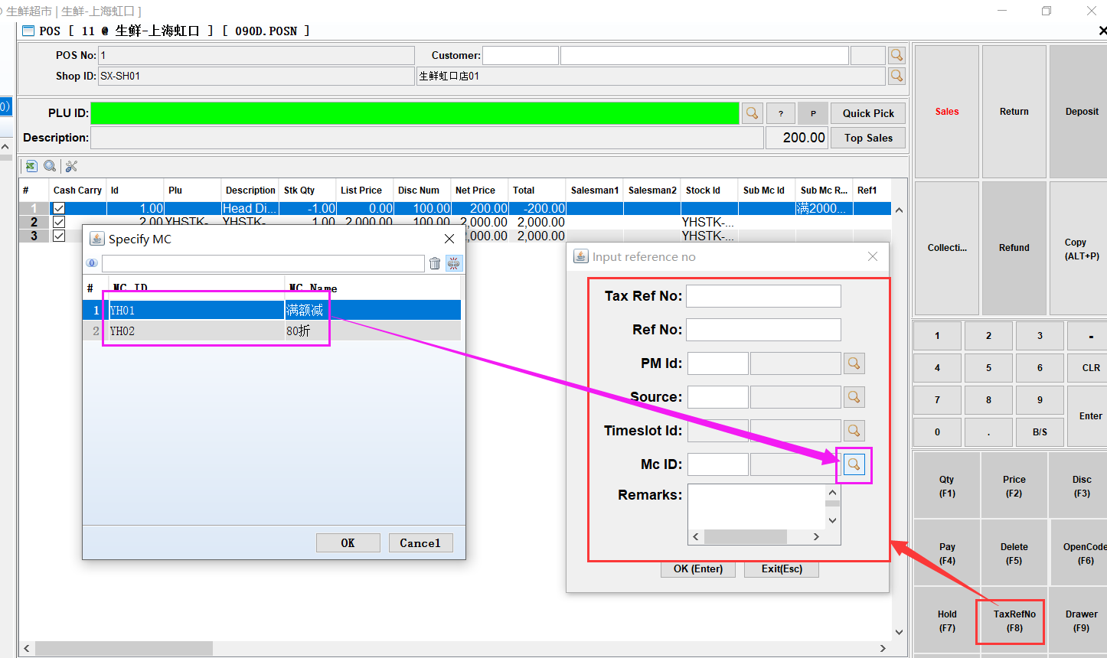
2、Click the F8 to choose one promotion.
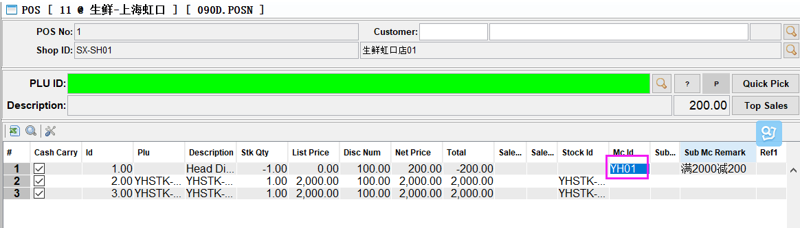

3.3.2 150G Truck Note: added columns’Marking’、’Marking Name’、’Vsl Id’、’Vsl Name’.(29764)-886
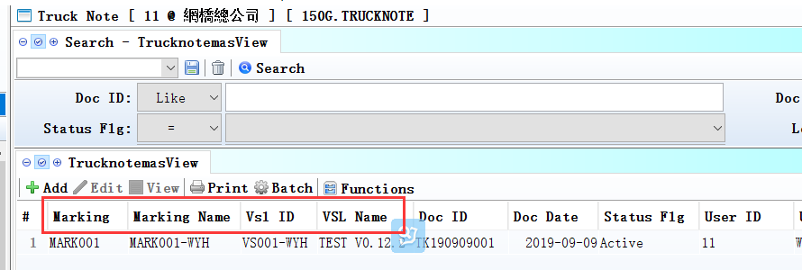

3.3.3 180BB Material Issue :Added control’ There be prompt when post document，if the store is not in active status’.(29746)-886
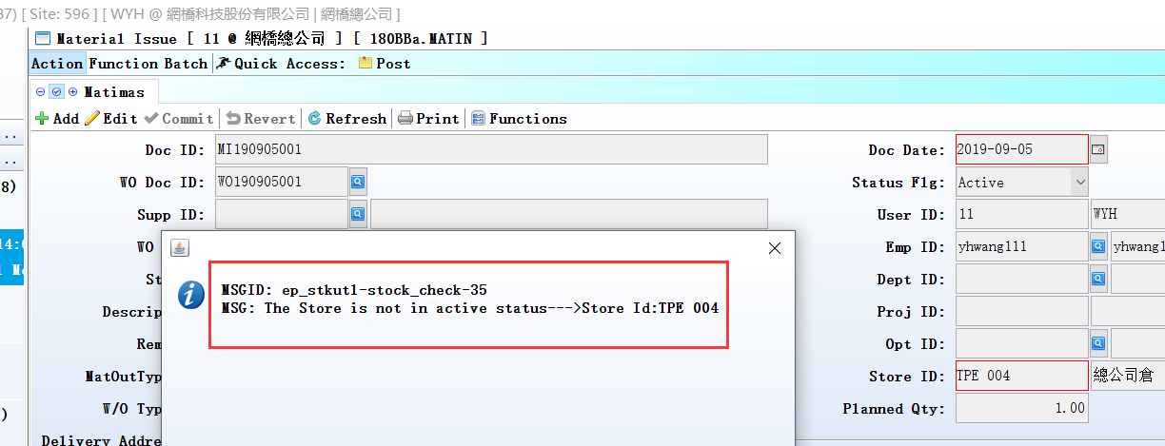

3.3.4 180BNN Work Order ReportingII Enquiry: Allow editing ‘Cost Id ‘、’ resource id’.(29739)-886
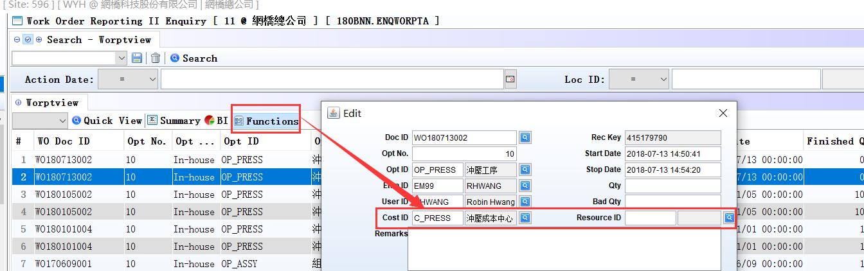

3.3.5 060BM Stock Sales Price Book Change:Added column’Emp Id’. (29848)-887
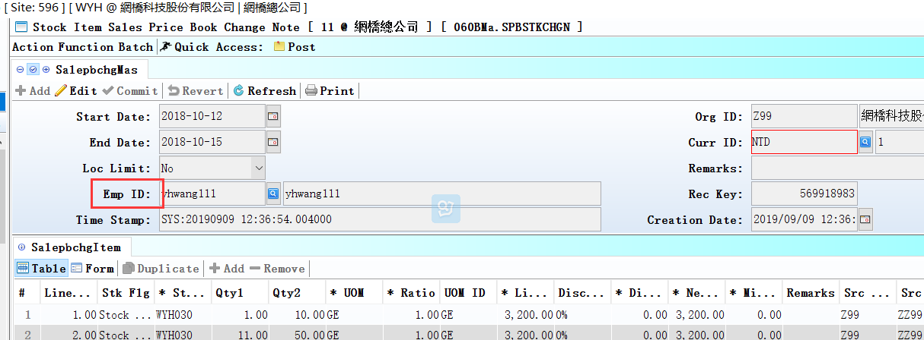

3.3.6 090AaH POSVIP:Added function’Purge Lock’. (29804)-887
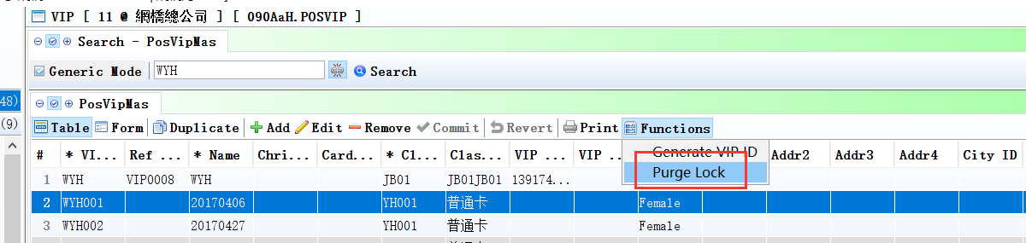
Used to delete points wrong record that due to redeem.

Note: Data to validate!

3.3.7 090D POS: The remark take out the different values by promotion campaign .(29831)-887
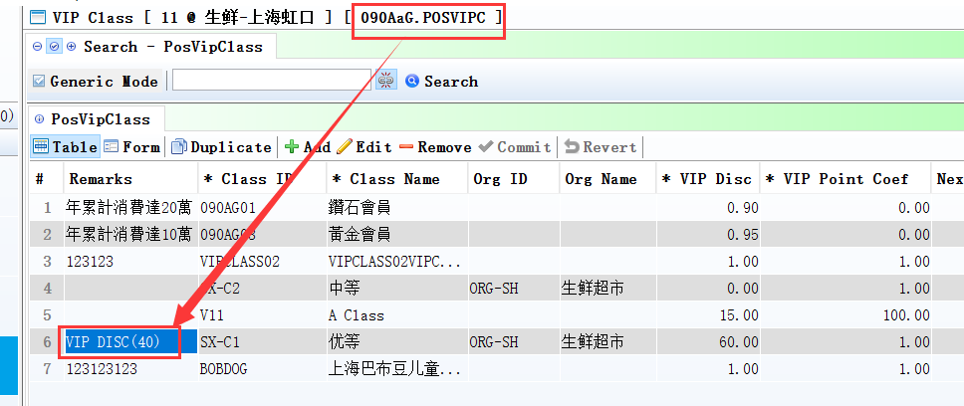
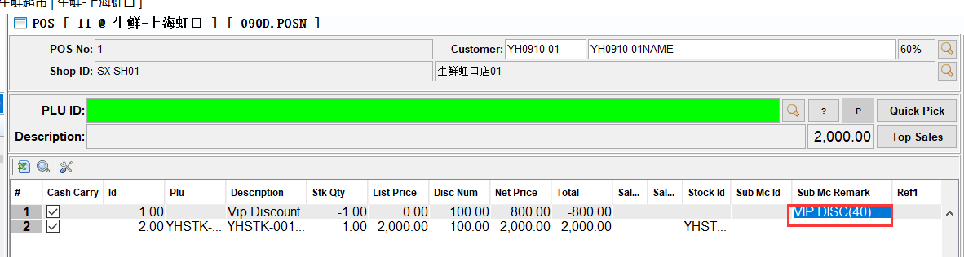
Sub MC Reamark
=pos_vip_class.remark
（Vip Disc）
-----------------------------------------------------------------------------------------------------------------------------------------------------------
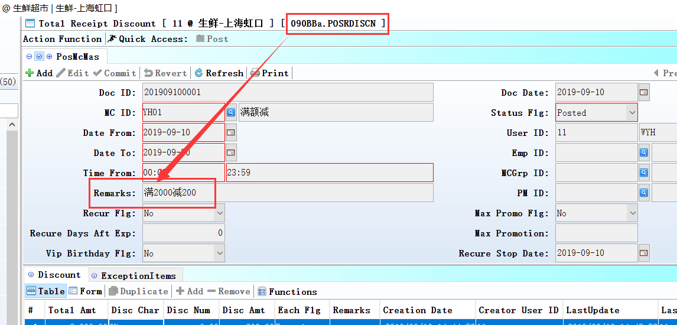
2、Sub MC Reamark
=pos_mc_mas.remark
(head disc)
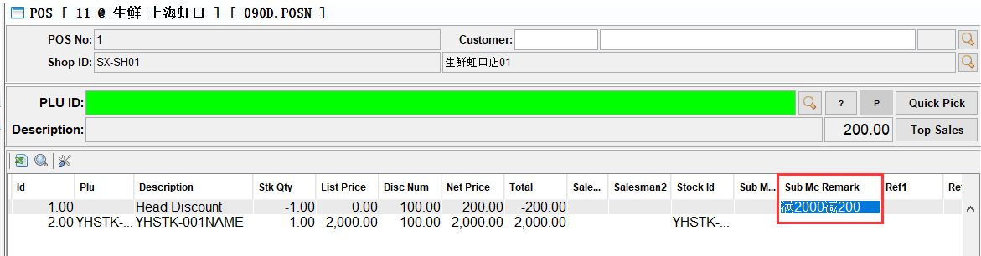

3.3.8 140CL Value Adjustment/140FL Stock Value Adjustment Enquiry: drop column store_id .(29889)-887

3.3.9 150G Truck Note: Scan documents added control, there are red alerts if there are repeat documents.(29773)-887
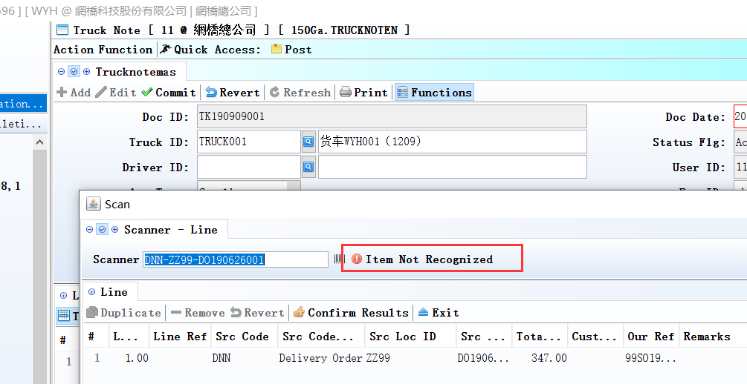

3.3.10 180BNN Work Order Reporting II Enquiry:Added delete function. (29788)-887
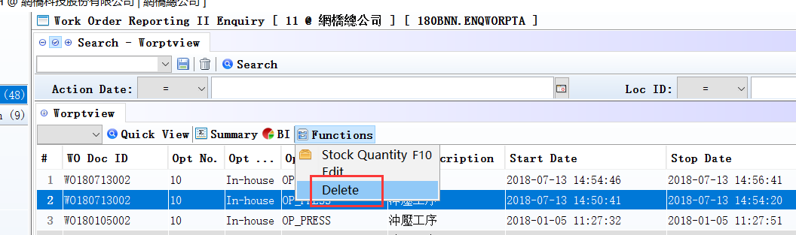

3.3.11 180BNN Work Order Reporting II Enquiry: If there is value in worptlineRecKey,then the edit button is not used.(29830)-887
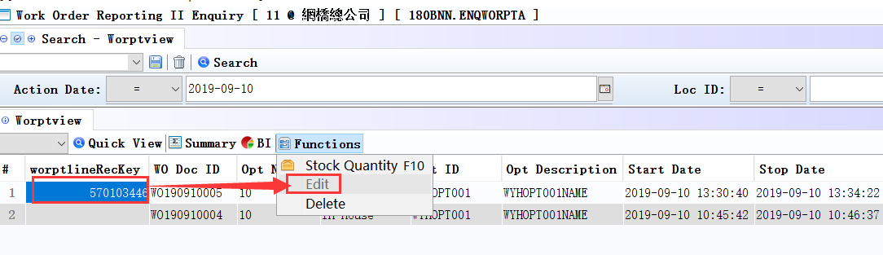

4. Fixes

