EPBrowserRelease Notes
Version 8.90~8.91

EPBrowserRelease Notes Version 8.90~8.91
Last Revision, 19 January 2020

©Copyright 2019. Enterprise Browser Pte Ltd.
All rights reserved.

No part of this manual may be reproduced in any form or by any means without the express written authorization from EPB. Business forms—which include but are not limited to invoices, checks, sales orders—displayed in this manual are for illustration purposes only and are not to be used for producing actual business forms. Enterprise Browser Pte Ltd. assumes no responsibility.
This document may contain technical inaccuracies or typographical errors and may change without prior notice. Any documentation with respect to EPB software products is provided for informational purposes only and does not extend or modify the limited warranty extended to the licensee of EPB software products.

Enterprise Browser Pte Ltd (EPB)
33Ubi Avenue 3, #07-65, Vertex Tower A, Singapore 408868
Tel: (65)-6509-4065
Fax: (65)-6509-4089

Document Location
EPBSH

Contents
1. Featured 4
2. New Interface 4
2.1 Added new module:180CX Forecast Import. (30443)-890 4
2.2 Added new module: 200BY Budget Batch .(30437)-890 4
3. Enhancements 5
3.1 Privilege 5
3.1.1 060BZ Sales Price Book Enquiry added the privilege: Batch Change STK ID.(30445)-890 5
3.1.2 060HA\070HA\WO added the privilege:' Batch Import Due Date ' .(30241)-890 5
3.2 Setting 6
3.2.1 010CA System Settings : added setting 'No of days to keep the POS data history at local DB'. (30399)-890 6
3.2.2 010CA System Settings :added setting:'Automatically create Assembly Job for Finished Goods from Kit, [Y] when POS transaction upload [N] Every Night'.(30375)-890 6
3.2.3 060CH Commercial Invoice :Added setting'Disallow editing of Customer Name'.(30414)-890 6
3.2.4 090D POS :added setting 'Require Colletion Date for Deposit'. (30439)-890 7
3.2.5 180BNN Work Order Reporting II Enquiry: Added setting'Disallow edit Inactive W/O Reporting'.(30352)-890 7
3.2.6 010CA System Settings:Added setting'No of days to keep shell log'. (30658)-891 7
3.2.7 050C Opportunity:Added setting' Enable Cross ORG enquiry '.(30504)-891 8
3.2.8 200CA Invoice:Added setting'Enable transferring from ML Billing'. (29868)-891 8
.3 Improve 9
3.3.1 060CE Delivery Order:Added function'Apply last Price to net price'. (30374)-890 9
3.3.2 070HC Shipment Planning Enquiry:Added columns'Acc ID'and'Acc Name'. (30380)-890 9
3.3.3 090CDB Shopping Voucher:Added columns'IssueShop Id'and'IssueShopName'.(30440)-890 9
3.3.4 140BE Kit Items:Added column'autoAssembleFlg'. (30375)-890 10
3.3.5 160AB Expenses Claims :Added column'approving_amt'. (30435)-890 10
3.3.6 180BA Work Order:Added column'Opt UOM' . (30365)-890 10
3.3.7 180BNF Work Order Operation Enquiry:Added columns'Cost Id' and 'Cost Description' . (30449)-890 10
3.3.8 060HA Sales Order Enquiry:Added columns'dodatelaterthandlydate'and'dpdatelaterthandlydate'.(30608)-891 11
3.3.9 060IA Triangle Trading Setup:Added columns'Def Store ID' and'Def Store Name'.(30671)-891 11
3.3.10 070CB Request for Quotation:Added columns''.(30664)-891 11
3.3.11 090CaC Item Enquiry:Added function'edit ref1~ref4'. (30549)-891 12
3.3.12 090D POS :added column'POS DATE'. (30561)-891 12
3.3.13 140EB Stock Summary:Added column'LAST_UNIT_COST'. (30625)-891 12
3.3.14 180BE Work Order Reporting:Added function' HrsUsed retain the decimal digits according to the Settings '. '30648'-891 13
3.3.15 190CA Asset Enquiry:Added columns'New Dept Name'and'New Emp Name'.(30581)-891 13
3.3.16 200FD Tax Transaction:Added function'Creator_User_Id allows selection'. (30649)-891 13
3.3.17 800FA Sales Analysis:Added column'Ref Stk Id'.(30559)-891 14
3.3.18 800FA Sales Analysis:Added columns'Ref Cust Id'and'Ref Cust Name'.(30650)-891 14
4. Fixes 14

1. Featured

2. New Interface

2.1 Added new module:180CX Forecast Import. (30443)-890
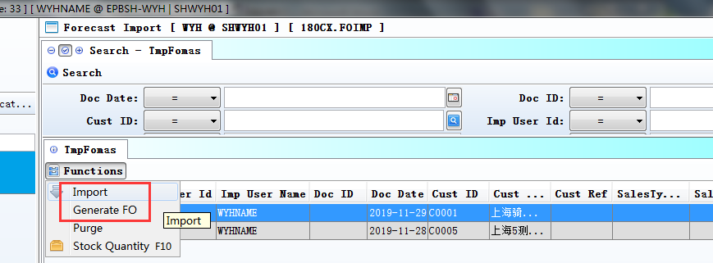
1、Import；
2、Generate FO.

2.2 Added new module: 200BY Budget Batch .(30437)-890
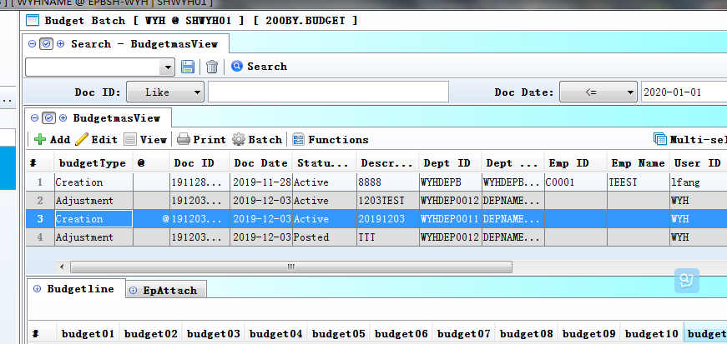

3. Enhancements

3.1 Privilege

3.1.1 060BZ Sales Price Book Enquiry added the privilege: Batch Change STK ID.(30445)-890
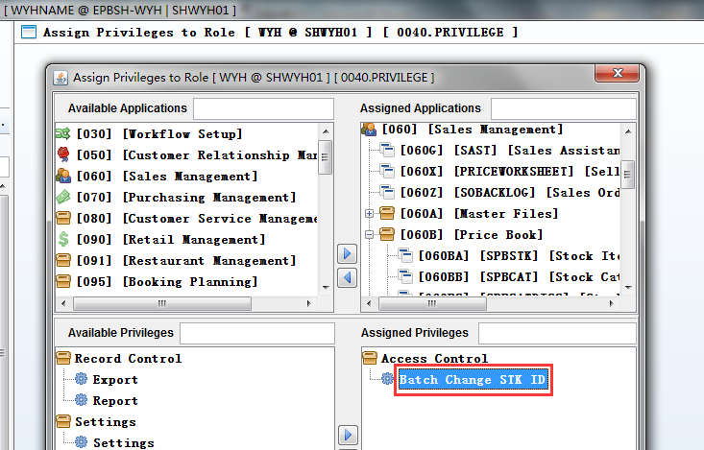
If user isn't Admin,and haven't the privilege,then can't modify the stock code.

3.1.2 060HA\070HA\WO added the privilege:' Batch Import Due Date ' .(30241)-890
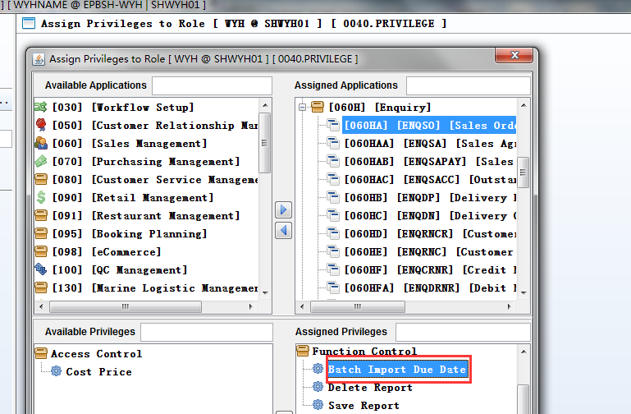
NOTE:
1)In ENQSO/ENQPO:
start_date is null，DUE_DATE=COM_DLY_DATE!!!
2)In WO:LINE NO is null
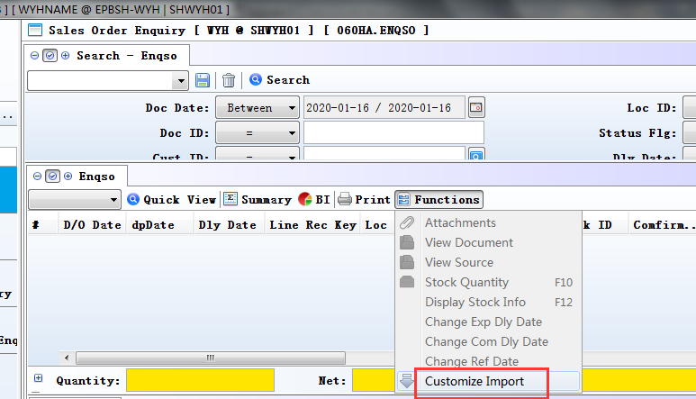

3.2 Setting

3.2.1 010CA System Settings : added setting 'No of days to keep the POS data history at local DB'. (30399)-890
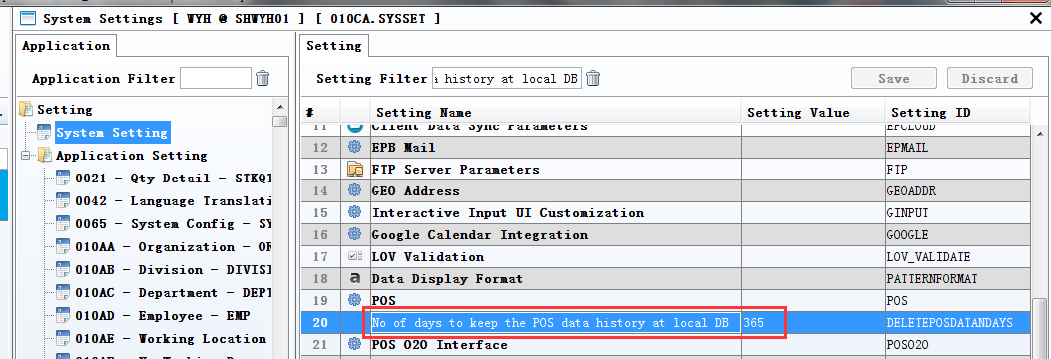
1、DELETEPOSDATANDAYS =365;
2、DELETEPOSDATA =Y.

For example,090CA Can query data within a year.

3.2.2 010CA System Settings :added setting:'Automatically create Assembly Job for Finished Goods from Kit, [Y] when POS transaction upload [N] Every Night'.(30375)-890
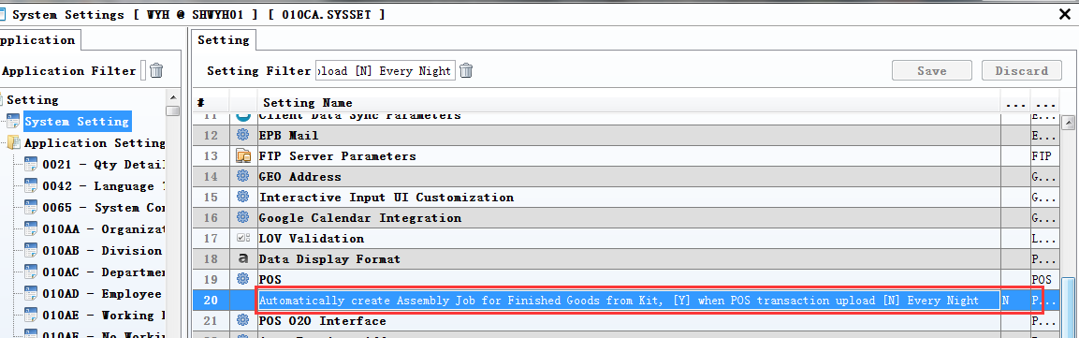
Y: When POS transaction upload，Automatically create Assembly Job for Finished Goods from Kit;
N: Every Night，Summary create Assembly Job for Finished Goods from Kit.

3.2.3 060CH Commercial Invoice :Added setting'Disallow editing of Customer Name'.(30414)-890
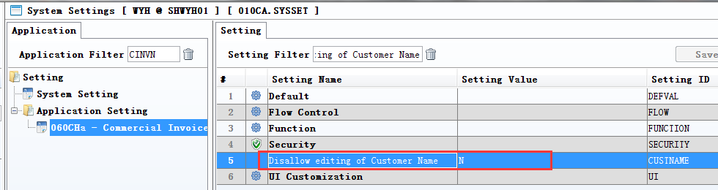
Set to N: allow editing of Customer Name.

3.2.4 090D POS :added setting 'Require Colletion Date for Deposit'. (30439)-890
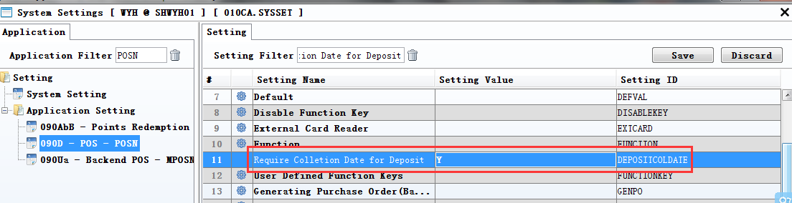
Set to Y: Can choose the Colletion Date.
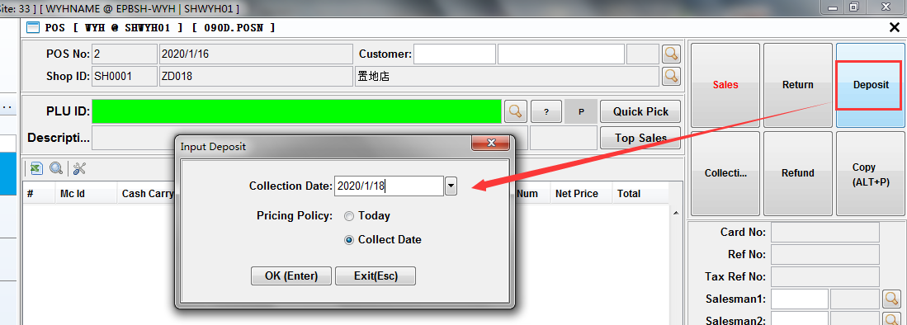

3.2.5 180BNN Work Order Reporting II Enquiry: Added setting'Disallow edit Inactive W/O Reporting'.(30352)-890
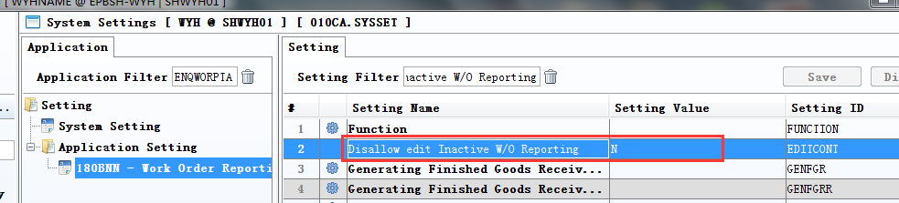

3.2.6 010CA System Settings:Added setting'No of days to keep shell log'. (30658)-891
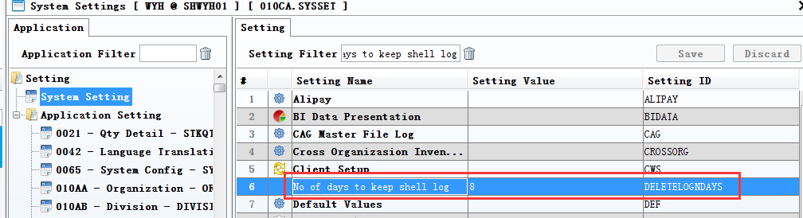
1、Set number of days:
2、'D: \ EPBrowser \ EPBSHN \ Shell \ log'
This directory is reserved for a few days of the log files

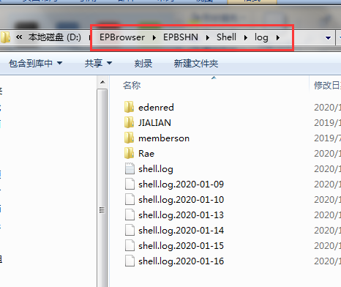

3.2.7 050C Opportunity:Added setting' Enable Cross ORG enquiry '.(30504)-891
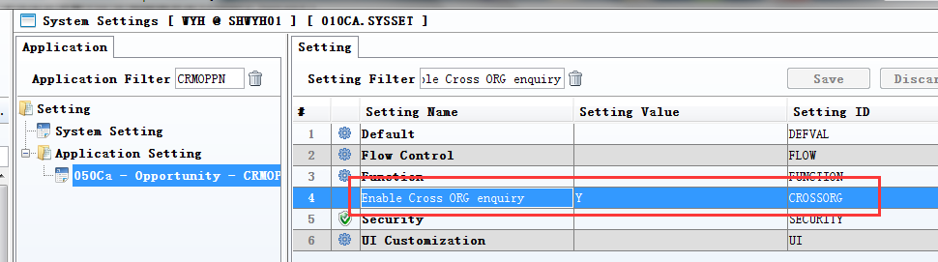

3.2.8 200CA Invoice:Added setting'Enable transferring from ML Billing'. (29868)-891
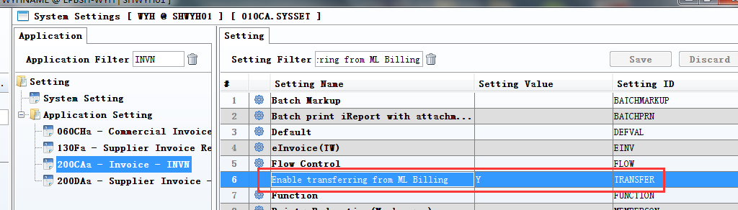
Set to Y:

Enable transferring from ML Billing.
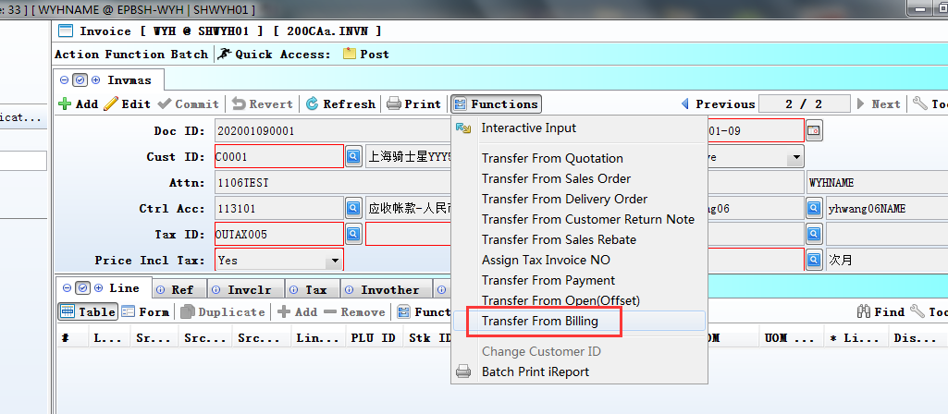

.3 Improve

3.3.1 060CE Delivery Order:Added function'Apply last Price to net price'. (30374)-890
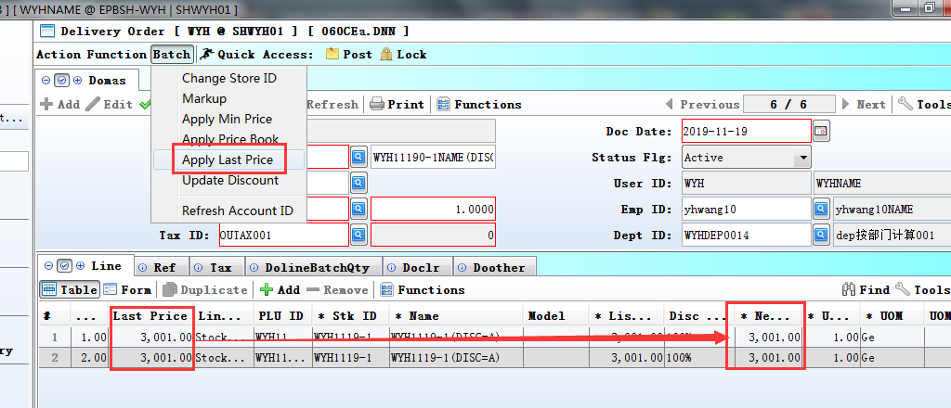

3.3.2 070HC Shipment Planning Enquiry:Added columns'Acc ID'and'Acc Name'. (30380)-890
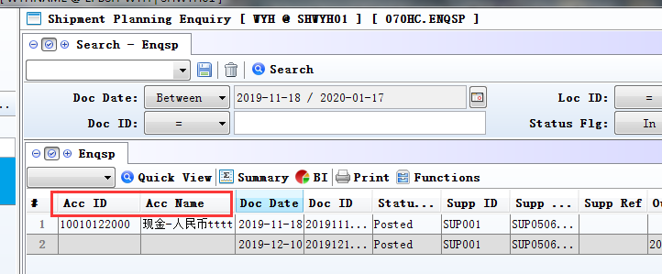

3.3.3 090CDB Shopping Voucher:Added columns'IssueShop Id'and'IssueShopName'.(30440)-890
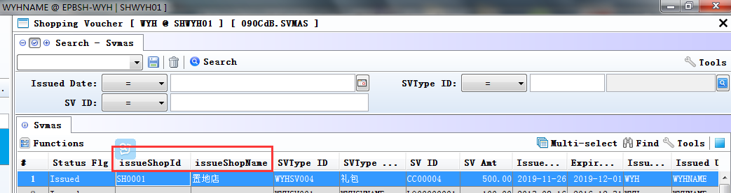

3.3.4 140BE Kit Items:Added column'autoAssembleFlg'. (30375)-890
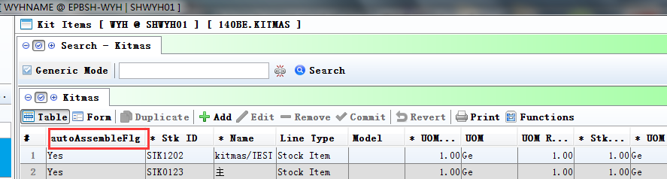

3.3.5 160AB Expenses Claims :Added column'approving_amt'. (30435)-890
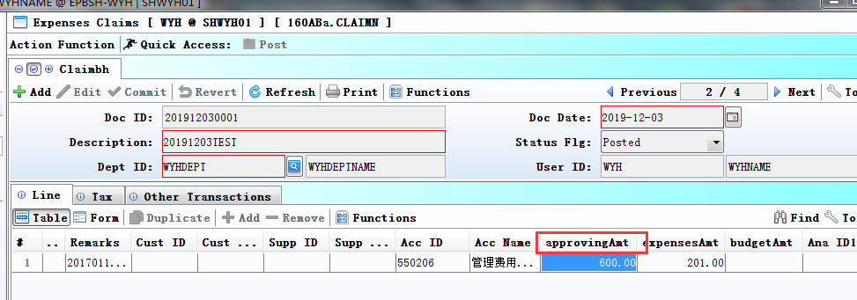

3.3.6 180BA Work Order:Added column'Opt UOM' . (30365)-890
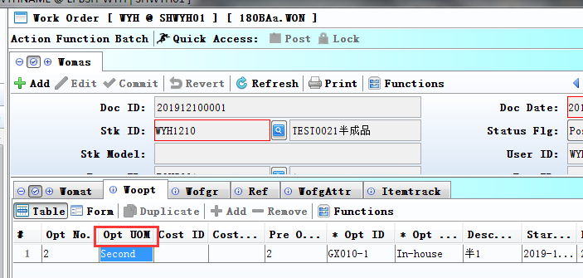

3.3.7 180BNF Work Order Operation Enquiry:Added columns'Cost Id' and 'Cost Description' . (30449)-890
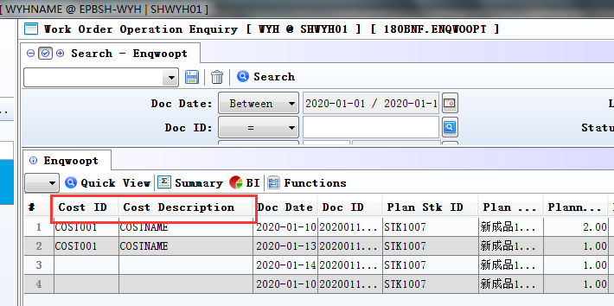

3.3.8 060HA Sales Order Enquiry:Added columns'dodatelaterthandlydate'and'dpdatelaterthandlydate'.(30608)-891
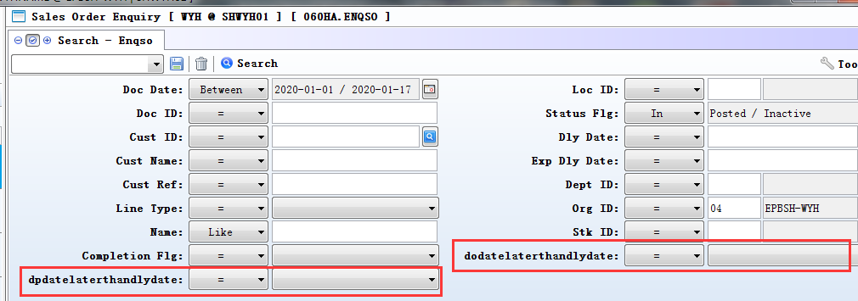

3.3.9 060IA Triangle Trading Setup:Added columns'Def Store ID' and'Def Store Name'.(30671)-891
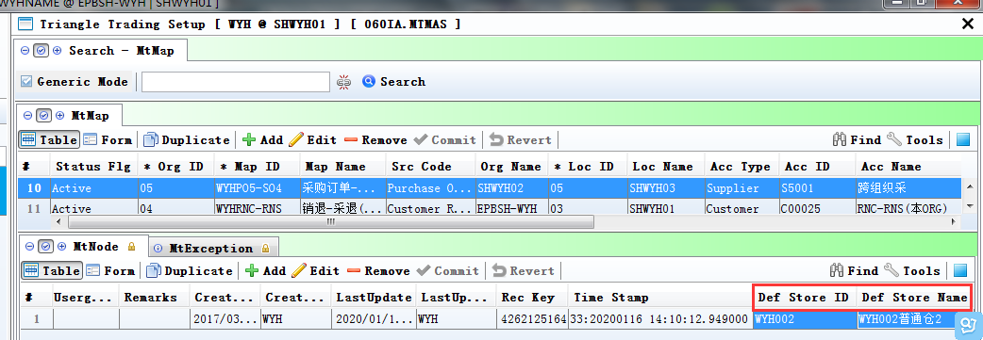
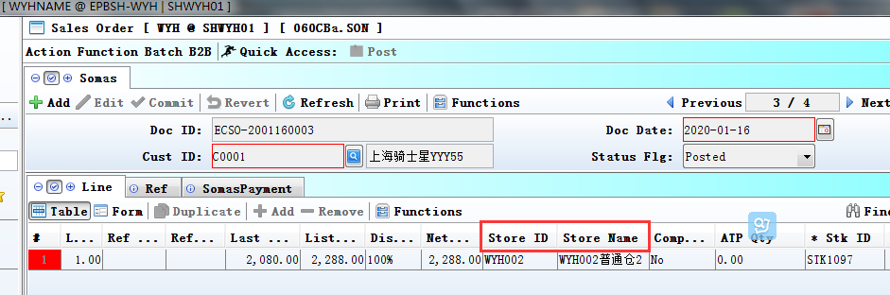

3.3.10 070CB Request for Quotation:Added columns''.(30664)-891
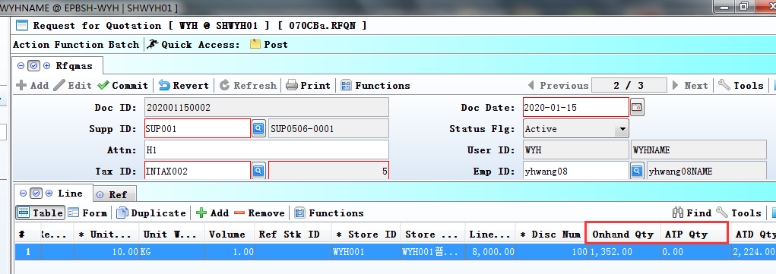

3.3.11 090CaC Item Enquiry:Added function'edit ref1~ref4'. (30549)-891
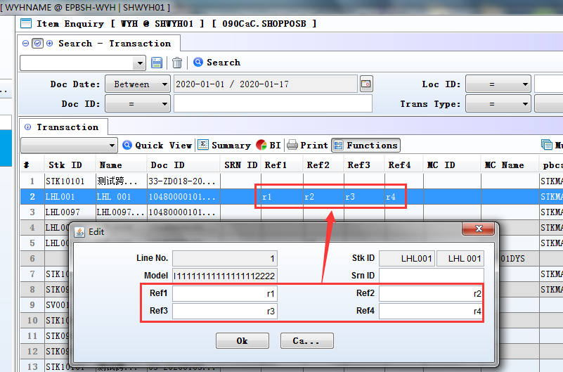

3.3.12 090D POS :added column'POS DATE'. (30561)-891
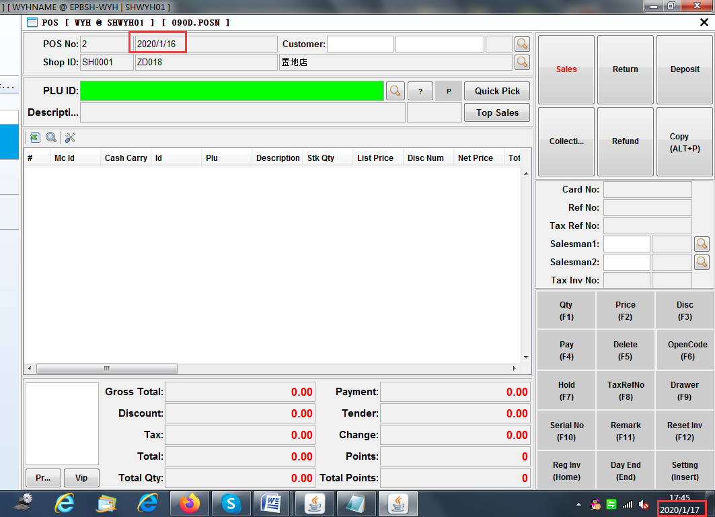

3.3.13 140EB Stock Summary:Added column'LAST_UNIT_COST'. (30625)-891
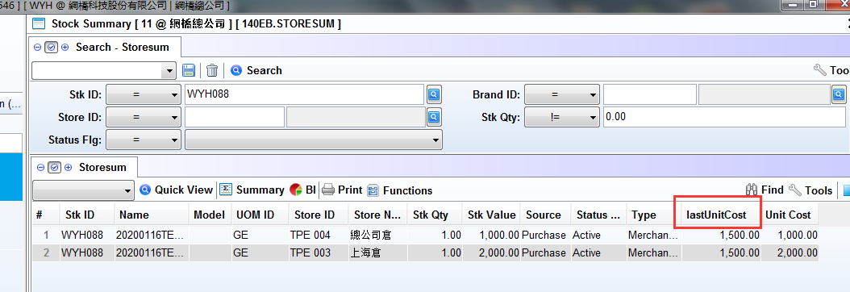

3.3.14 180BE Work Order Reporting:Added function' HrsUsed retain the decimal digits according to the Settings '. '30648'-891
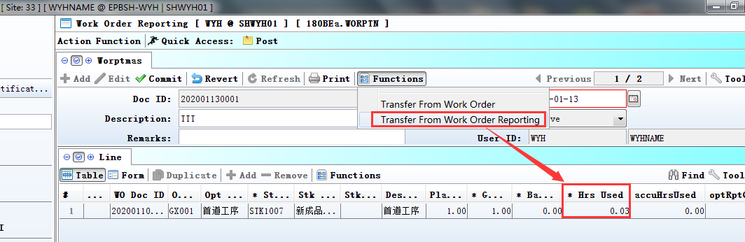
When Transer From Work Order Reporting,
'HrsUsed' retain the decimal digits according to the System Settings.

3.3.15 190CA Asset Enquiry:Added columns'New Dept Name'and'New Emp Name'.(30581)-891
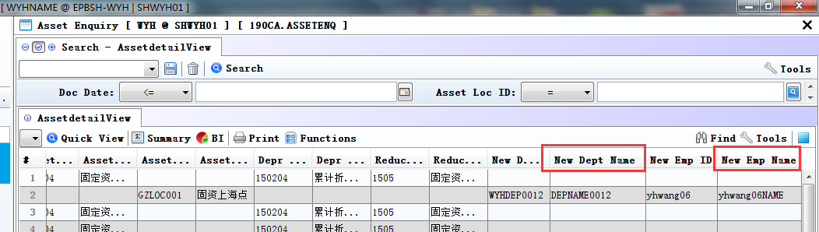

3.3.16 200FD Tax Transaction:Added function'Creator_User_Id allows selection'. (30649)-891
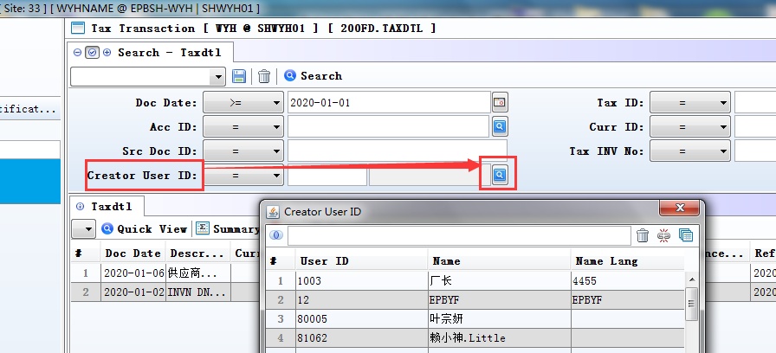

3.3.17 800FA Sales Analysis:Added column'Ref Stk Id'.(30559)-891
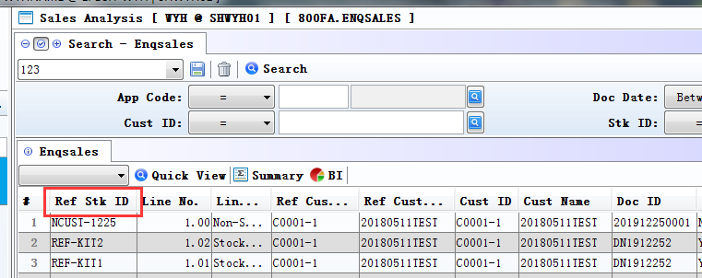

3.3.18 800FA Sales Analysis:Added columns'Ref Cust Id'and'Ref Cust Name'.(30650)-891
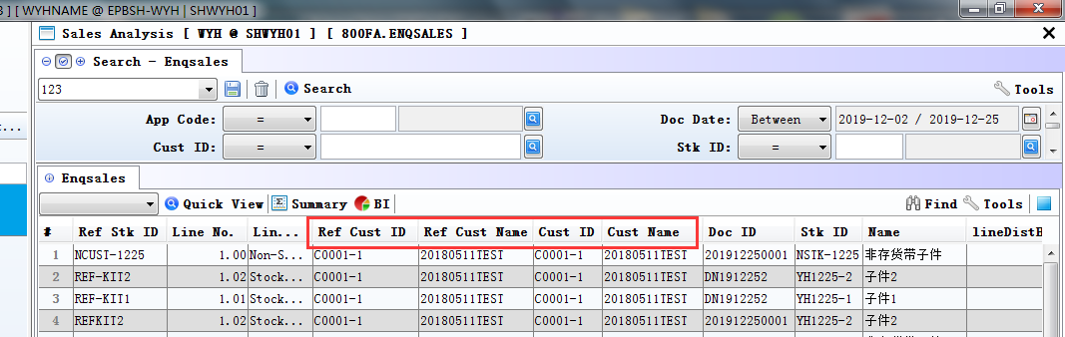
ref_cus_id=pos_shop_mas.cust_id
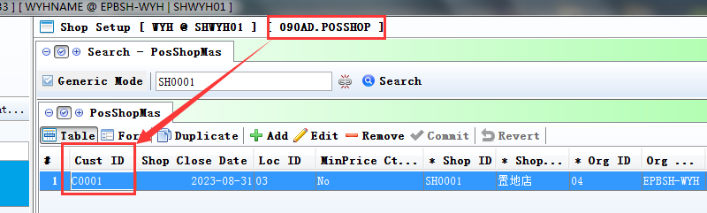

4. Fixes

