EPBrowserRelease Notes
Version 8.92

EPBrowserRelease Notes Version 8.92
Last Revision, 27 February 2020

©Copyright 2020. Enterprise Browser Pte Ltd.
All rights reserved.

No part of this manual may be reproduced in any form or by any means without the express written authorization from EPB. Business forms—which include but are not limited to invoices, checks, sales orders—displayed in this manual are for illustration purposes only and are not to be used for producing actual business forms. Enterprise Browser Pte Ltd. assumes no responsibility.
This document may contain technical inaccuracies or typographical errors and may change without prior notice. Any documentation with respect to EPB software products is provided for informational purposes only and does not extend or modify the limited warranty extended to the licensee of EPB software products.

Enterprise Browser Pte Ltd (EPB)
33Ubi Avenue 3, #07-65, Vertex Tower A, Singapore 408868
Tel: (65)-6509-4065
Fax: (65)-6509-4089

Document Location
EPBSH

Contents
1. Featured 3
2. New Interface 4
2.1 Added new module：140ADBd Store Category 4~140ADBh Store Category 8.(30717)-892 4
3. Enhancements 4
3.1 Privilege 4
3.2 Setting 4
3.2.1 Deleted setting’ Resequence by Dr’ in 200BA module,Added setting’ Voucher resequence by Dr’ in 160AB module etc.(30752)-892 4
3.2.2 010AA Organization: Retail Net Price Logic, setting adjustment .(30693)-892 5
3.2.3 060CE Delivery Order: Added setting’ Transaction Flag’.(30700)-892 5
3.2.4 070CC Purchase Order:Added setting’ Disallow undo posting if ATD minus’. (30771)-892 6
3.2.5 140CH Inventory Transfer Issue:Added setting’ Disallow posting if related Transfer Requisition not reserved’.(30739)-892 6
3.3 Improve 7
3.3.1 Added function: The user can select attachment download path .(30772)-892 7
3.3.2 060CB Sales Order :Added column ‘MPS_QTY’ in the'Generate MPS' interface. (30757)-892 7
3.3.3 090H Shop Replenishment:Added cloumn’ MAIN_STORE_ATD_QTY’.(30747)-892 7
3.3.4 200FCA Bank Book:Added columns’ana Id 1’、’ana Id2’...’ana Id 10’.(30735)-892 8
3.3.5 200FD Tax Transaction:Added column’ FIRST_LINE_DESCRIPTION’ .(30759)-892 8
3.3.6 800CB Inventory Analysis:Added column’ STK_TYPE’. (30708)-892 8
4. Fixes 8

1. Featured

2. New Interface

2.1 Added new module：140ADBd Store Category 4~140ADBh Store Category 8.(30717)-892
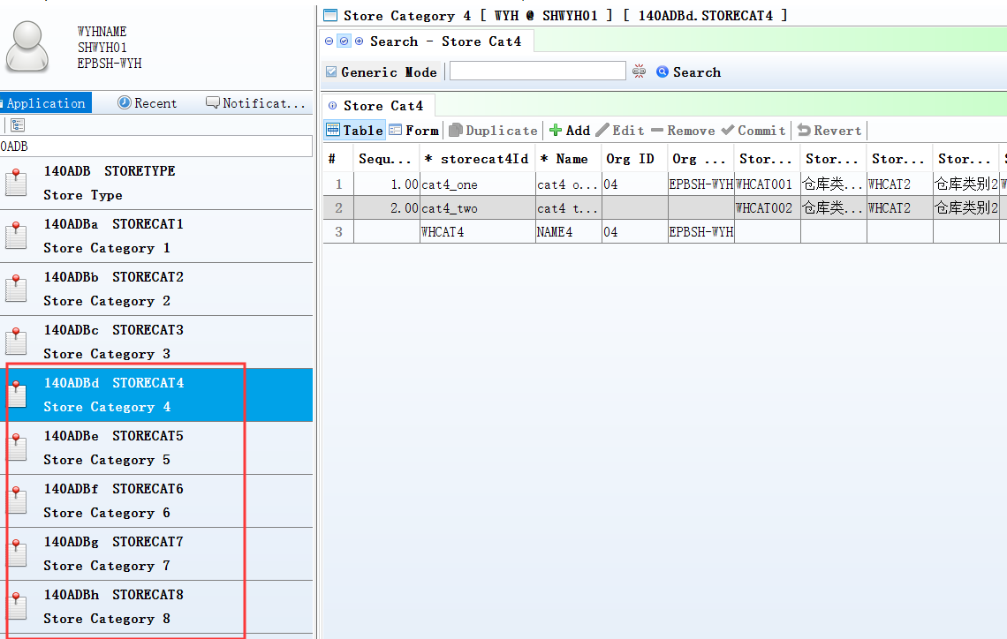
In 140ADBd~140ADBh defined;
In Storemas defined store _category;
It can query store_category in 800CB module etc.
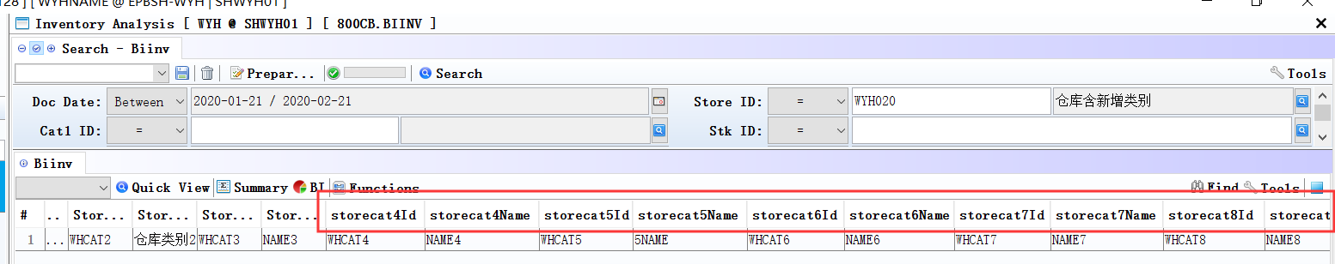

3. Enhancements

3.1 Privilege

3.2 Setting

3.2.1 Deleted setting’ Resequence by Dr’ in 200BA module,Added setting’ Voucher resequence by Dr’ in 160AB module etc.(30752)-892
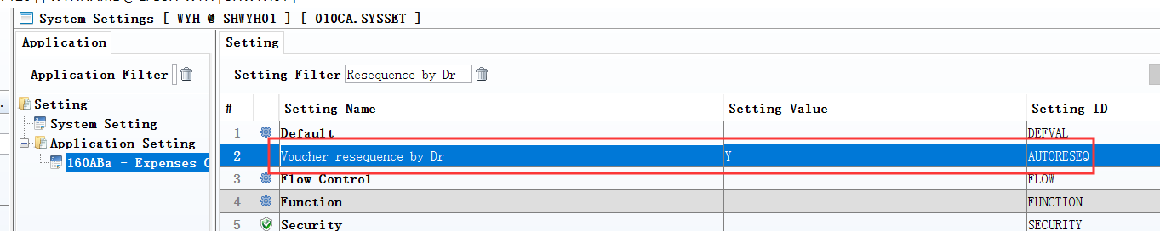
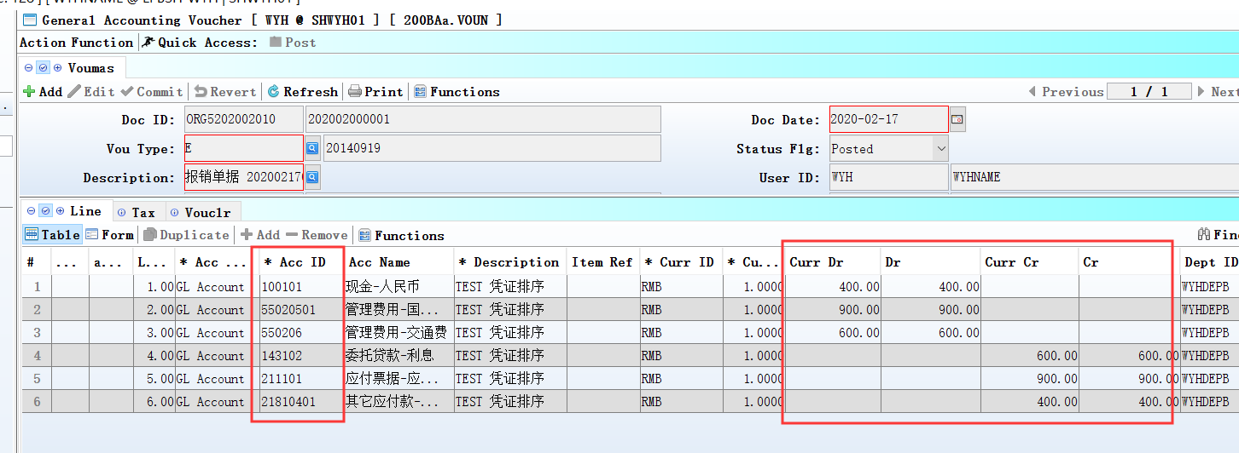
Set to ‘Y’: Display entries debit first then credit ,and then according to the accounting subject to sort in voucher module.

Set to ‘N’: Display entries according to the item of number in voucher module.

3.2.2 010AA Organization: Retail Net Price Logic, setting adjustment .(30693)-892
Retail Net Price Logic include six Settings:
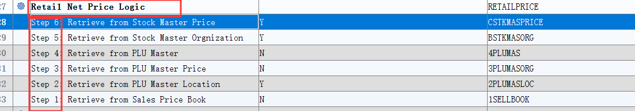
Note:
- Step 6: Retrieve from Stock Master Price= Y (Others set to N)
Retail Net Price is STKMAS.retail_net_price, not is STKMAS_PRICE.retail_net_price, in 090D module.
- Step 6: Retrieve from Stock Master Price= Y
Step 5: Retrieve from Stock Master Orgnization =Y
(Others set to N)
Retail Net Price is STKMAS_PRICE.retail_net_price in 090D module.

3.2.3 060CE Delivery Order: Added setting’ Transaction Flag’.(30700)-892
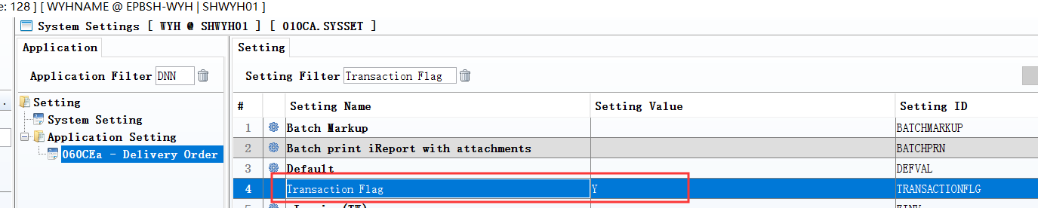
Set to Y: Added a new document, Transaction Flag default is Y;
Set to N: Transaction Flag default is N.

When the Transaction Flag default is Y, Display entries by line in voucher.
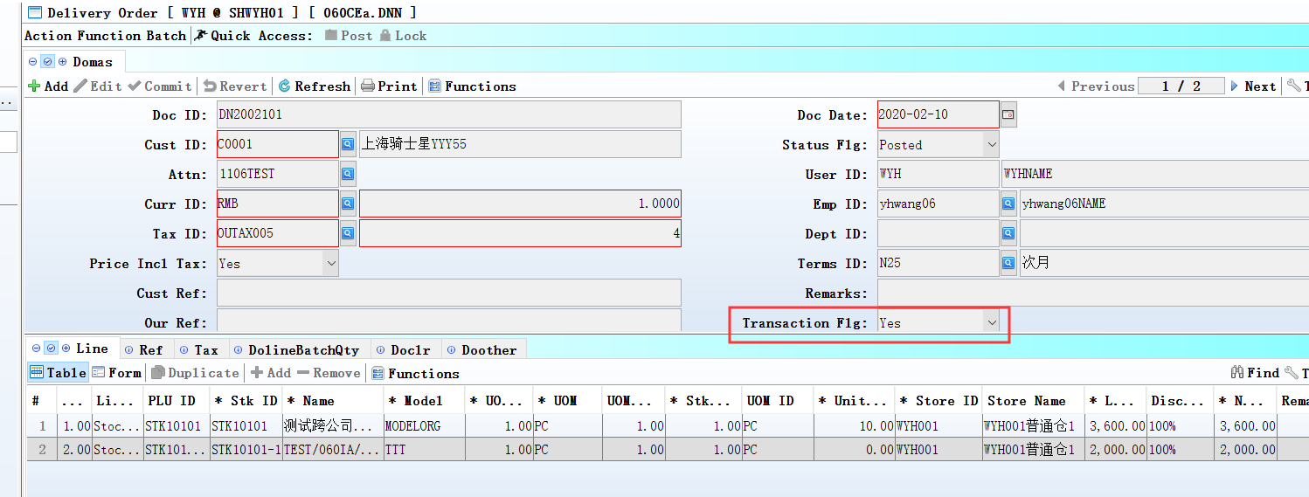
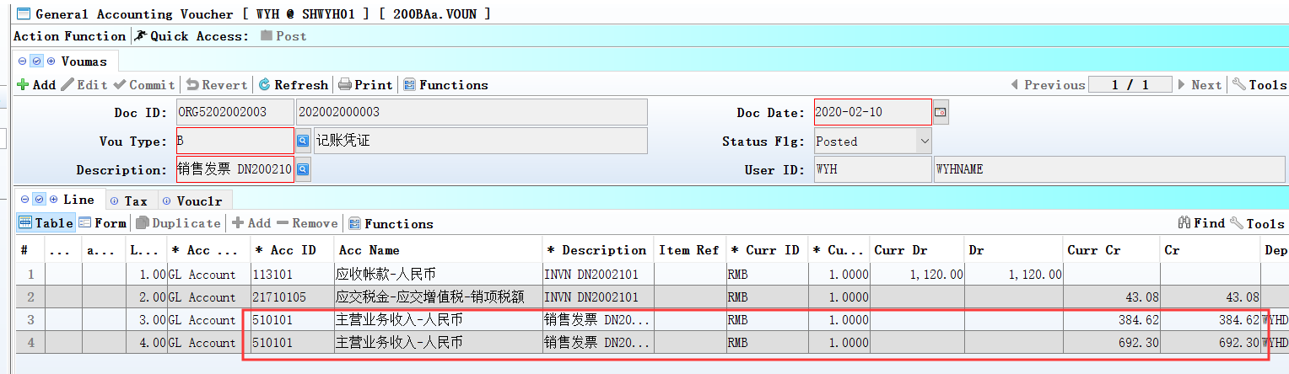

3.2.4 070CC Purchase Order:Added setting’ Disallow undo posting if ATD minus’. (30771)-892
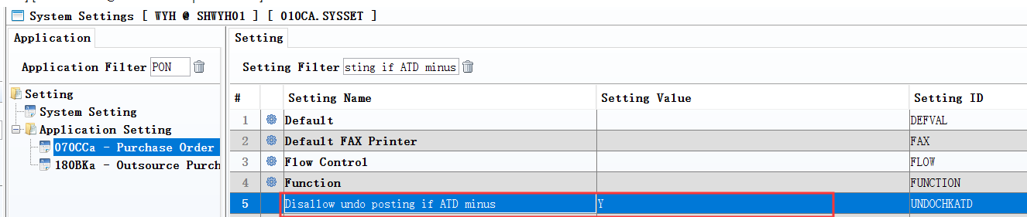

3.2.5 140CH Inventory Transfer Issue:Added setting’ Disallow posting if related Transfer Requisition not reserved’.(30739)-892
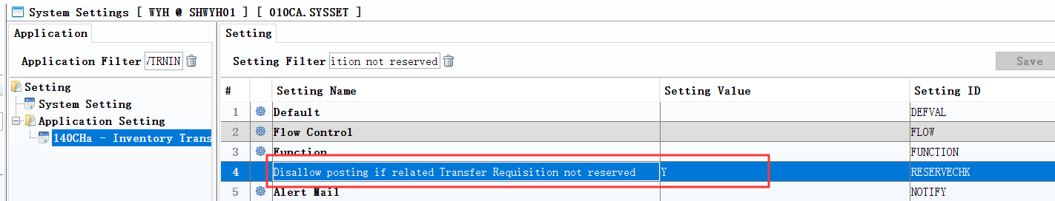
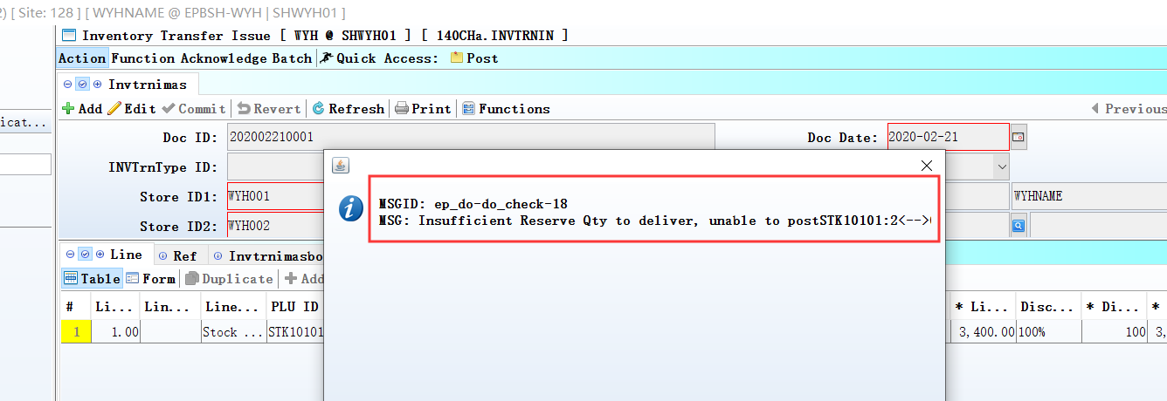

3.3 Improve

3.3.1 Added function: The user can select attachment download path .(30772)-892
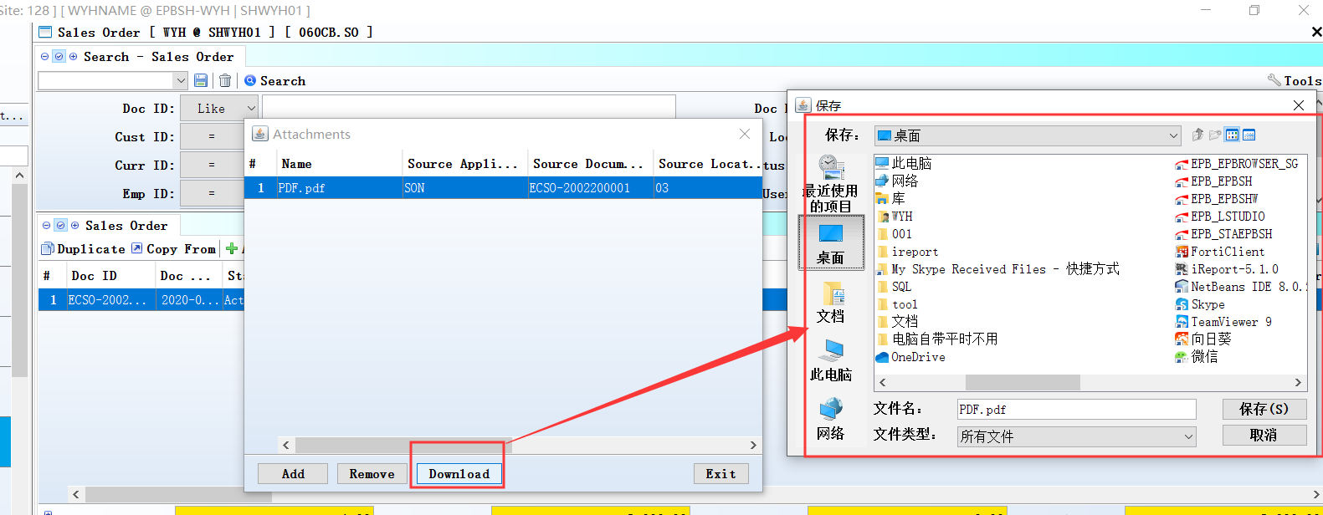

3.3.2 060CB Sales Order :Added column ‘MPS_QTY’ in the'Generate MPS' interface. (30757)-892
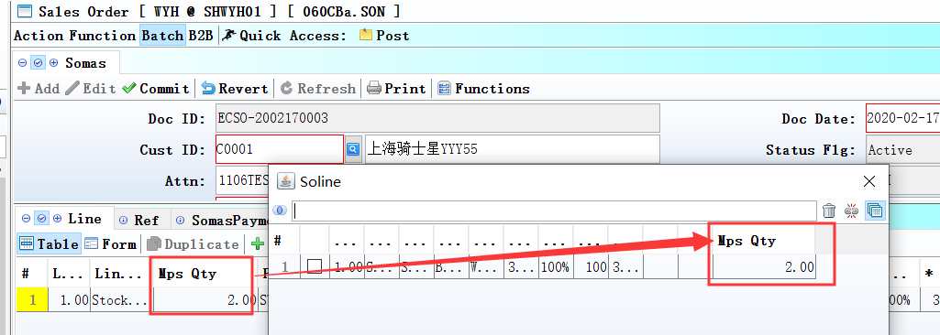

3.3.3 090H Shop Replenishment:Added cloumn’ MAIN_STORE_ATD_QTY’.(30747)-892
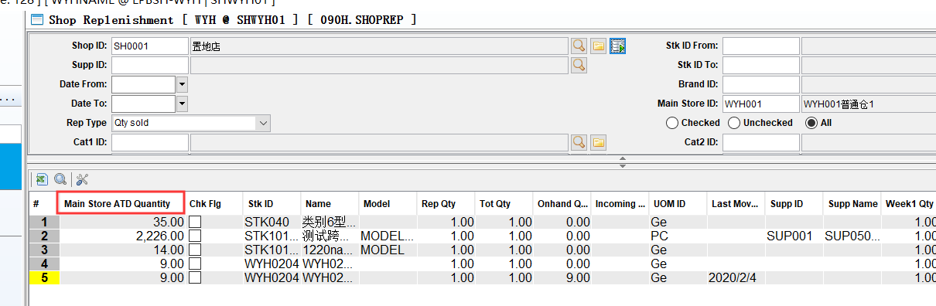

3.3.4 200FCA Bank Book:Added columns’ana Id 1’、’ana Id2’...’ana Id 10’.(30735)-892
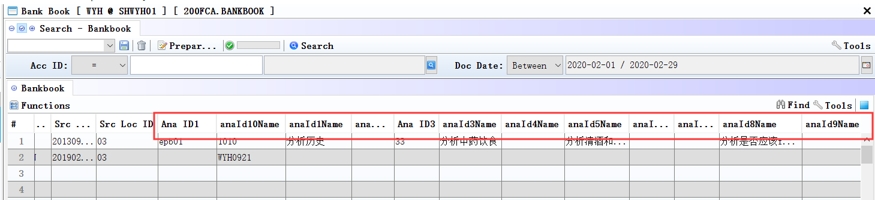

3.3.5 200FD Tax Transaction:Added column’ FIRST_LINE_DESCRIPTION’ .(30759)-892
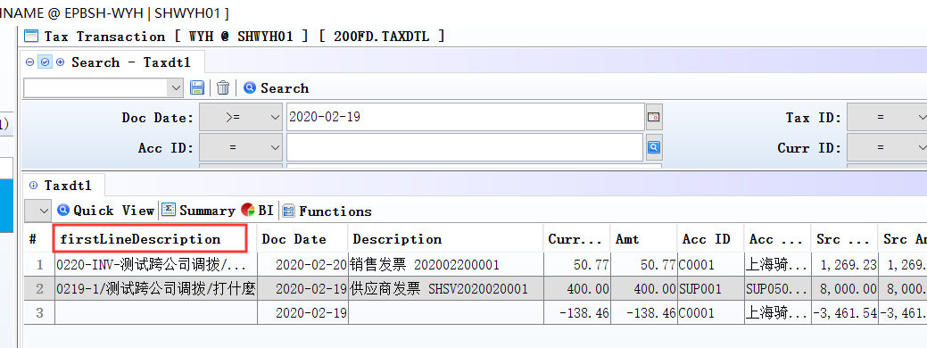

3.3.6 800CB Inventory Analysis:Added column’ STK_TYPE’. (30708)-892
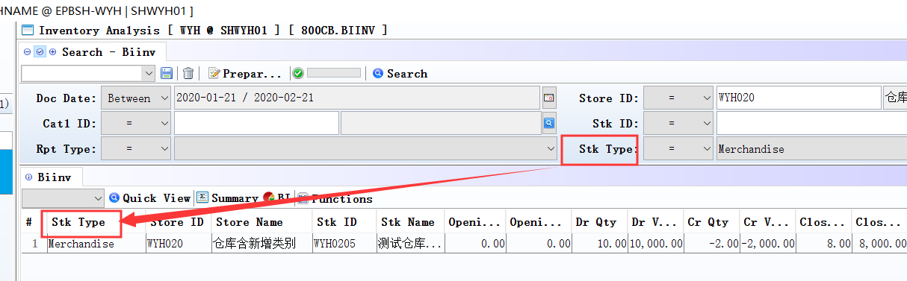

4. Fixes

