EPBrowserRelease Notes
Version 8.93~8.94

EPBrowserRelease Notes Version 8.93~8.94
Last Revision, 18 May 2020

©Copyright 2020. Enterprise Browser Pte Ltd.
All rights reserved.

No part of this manual may be reproduced in any form or by any means without the express written authorization from EPB. Business forms—which include but are not limited to invoices, checks, sales orders—displayed in this manual are for illustration purposes only and are not to be used for producing actual business forms. Enterprise Browser Pte Ltd. assumes no responsibility.
This document may contain technical inaccuracies or typographical errors and may change without prior notice. Any documentation with respect to EPB software products is provided for informational purposes only and does not extend or modify the limited warranty extended to the licensee of EPB software products.

Enterprise Browser Pte Ltd (EPB)
33Ubi Avenue 3, #07-65, Vertex Tower A, Singapore 408868
Tel: (65)-6509-4065
Fax: (65)-6509-4089

Document Location
EPBSH

Contents
1. Featured 4
2. New Interface 4
2.1 Added 098AM module: (31019)-894 4
3. Enhancements 4
3.1 Privilege 4
3.2 Setting 4
3.2.1 140BE Kit Items:Added setting’ Default Org ID [A] Login Org [B] Nil’. (30875)-893 4
3.2.2 200CA Invoice :Added setting ‘Bring over Customer Master Ref 1..4 to INV when validate Cust ID’.(30871)-893 4
3.2.3 060CE Delivery Order:Added setting’ Update status to inactive when amount received[Bypass Sales Invoice’.(29786)-894 5
3.2.4 010CA Added setting’ Automatically archive inventory data older then n years’. (30932)-894 5
3.2.5 090D POSN Added setting’ Use Price book,Campaign,VIP Discount if available’.(31101)-894 5
3.2.6 180BD Finished Goods Receive: Added setting’ Display WIP Tab'; and delete setting’ Enable transferring from WIP’.(30962)-894 5
3.3 Improve 6
3.3.1 070CS Consignment Settlement:Added column’YYYYMM’. (30850)-893 6
3.3.2 090D POS: Added the control ‘When inputed two different points for items, click on the pay of button, there will be prompt’. (30874)-893 6
3.3.3 140EFB Stock Ageing Enquiry:Improved ‘USER submited data in ORG1 first, and then submited data in ORG2, return ORG1, don't need to resubmit can query to the data’ . (30873)-893 6
3.3.4 180BND Work Order Finished Goods Enquiry: Added columns’ ’MAT_READY_DATE’、’SUB_STATUS’、’MATERIAL_STATUS’、’SALESCAT1_ID’、’SRC_DOC_DATE’ , etc. ‘ .(30847\30853)-893 6
3.3.5 200FK Open Item Account Balance:Added ‘Emp_Id’ query condition.(30801)-893 7
3.3.6 Delete 090H module . (30877)-893 7
3.3.7 060BZ Sales Price Book Enquiry:Added .(30909)-894 7
3.3.8 090AaZ VIP Statistics：Added column’Age’.(30812)-894 7
3.3.9 090AN Added Sub_table:ECSKUEC.(31009)-894 8
3.3.10 060CBA Sales Agreement:Added function’ Credit can also include the amount of sales agreement’. (30990)-894 8
3.3.11 090D POSN, ecorder get tax rates from STKMAS_ORG. (31105)-894 8
3.3.12 140ADC Storage Area:Added column ‘HAVE_TRANSACTIONS.(30931)-894 8
3.3.13 140ED Stock Transaction: BI Added columns’’.(30946)-894? 9
3.3.14 140EJE Stock Value Summary(Exclude WIP):BI added ‘TO_FYEAR’ and ‘TO_FPERIOD’.(30982)-894 9
3.3.15 200BD Bank Reconciliation:Added column ‘reverseFlg’。 (30899)-894 9
3.3.16 090D POSN:Added function’ different shop to collection’.(27009)-894 10
4. Fixes 10

1. Featured

2. New Interface

2.1 Added 098AM module: (31019)-894
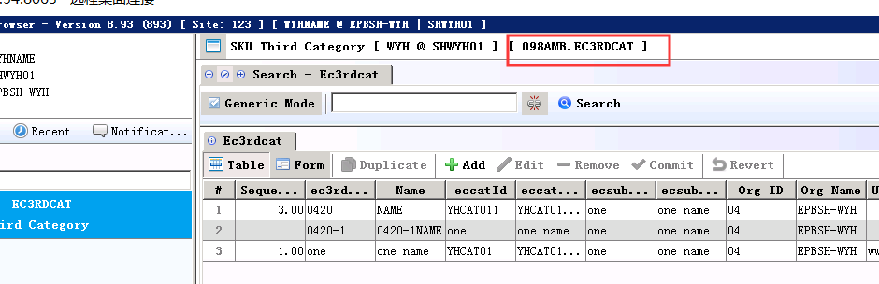

3. Enhancements

3.1 Privilege

3.2 Setting

3.2.1 140BE Kit Items:Added setting’ Default Org ID [A] Login Org [B] Nil’. (30875)-893
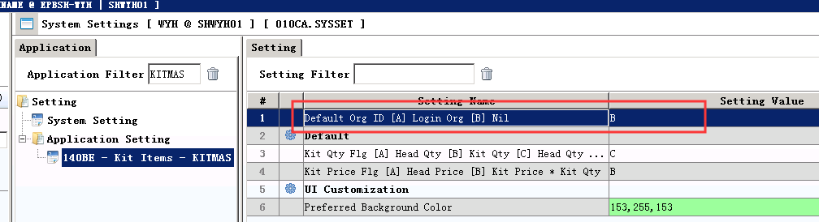

3.2.2 200CA Invoice :Added setting ‘Bring over Customer Master Ref 1..4 to INV when validate Cust ID’.(30871)-893
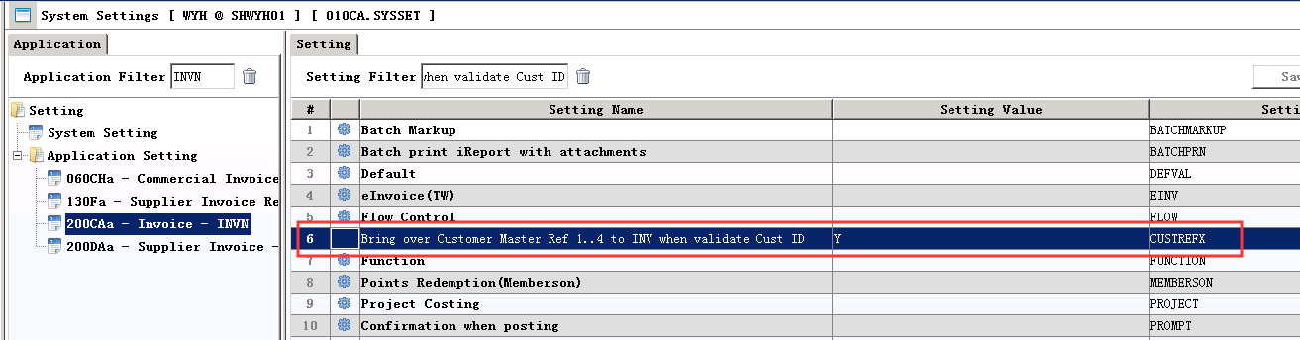

3.2.3 060CE Delivery Order:Added setting’ Update status to inactive when amount received[Bypass Sales Invoice’.(29786)-894
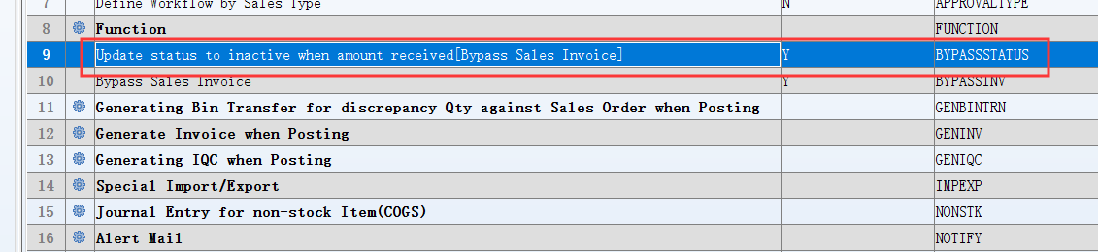
Set to Y, Update status to inactive when amount received.
Set to N, Don't update the status when the amount received.

3.2.4 010CA Added setting’ Automatically archive inventory data older then n years’. (30932)-894
N=3,then system will automatically backup, remain pass 3 years inventory data
For example: 2020 - 3 = 2017, asat 2016/12/31 have a summary data .

3.2.5 090D POSN Added setting’ Use Price book,Campaign,VIP Discount if available’.(31101)-894
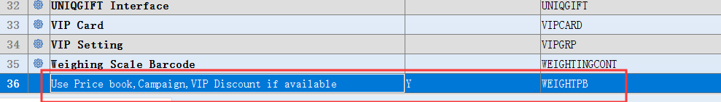
Set to Y: Use Price book,Campaign,VIP Discount if available.

3.2.6 180BD Finished Goods Receive: Added setting’ Display WIP Tab'; and delete setting’ Enable transferring from WIP’.(30962)-894
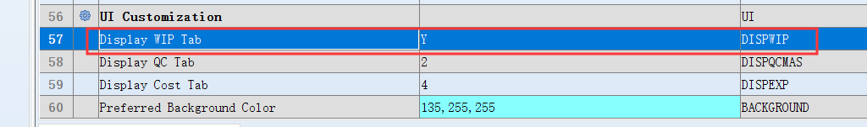

3.3 Improve

3.3.1 070CS Consignment Settlement:Added column’YYYYMM’. (30850)-893
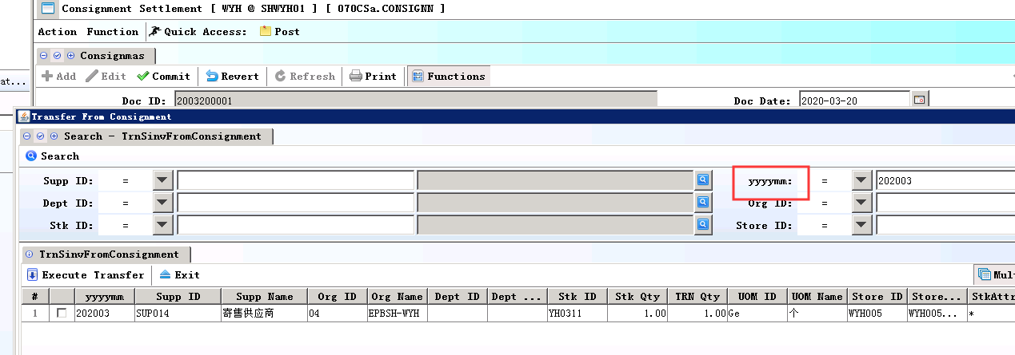

3.3.2 090D POS: Added the control ‘When inputed two different points for items, click on the pay of button, there will be prompt’. (30874)-893
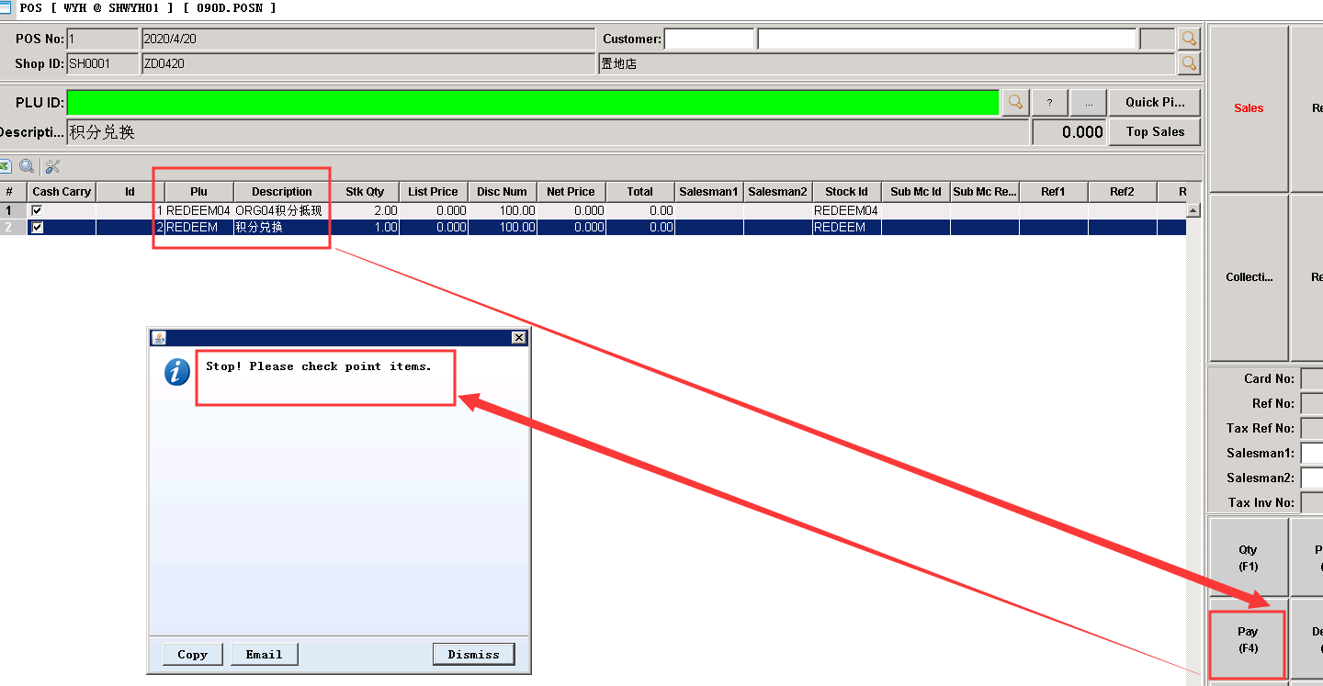

3.3.3 140EFB Stock Ageing Enquiry:Improved ‘USER submited data in ORG1 first, and then submited data in ORG2, return ORG1, don't need to resubmit can query to the data’ . (30873)-893

3.3.4 180BND Work Order Finished Goods Enquiry: Added columns’ ’MAT_READY_DATE’、’SUB_STATUS’、’MATERIAL_STATUS’、’SALESCAT1_ID’、’SRC_DOC_DATE’ , etc. ‘ .(30847\30853)-893
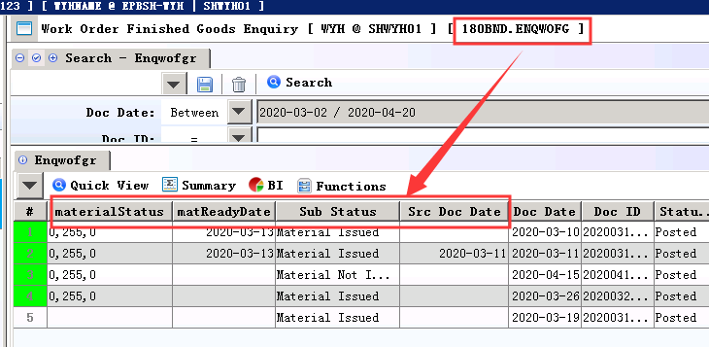

3.3.5 200FK Open Item Account Balance:Added ‘Emp_Id’ query condition.(30801)-893
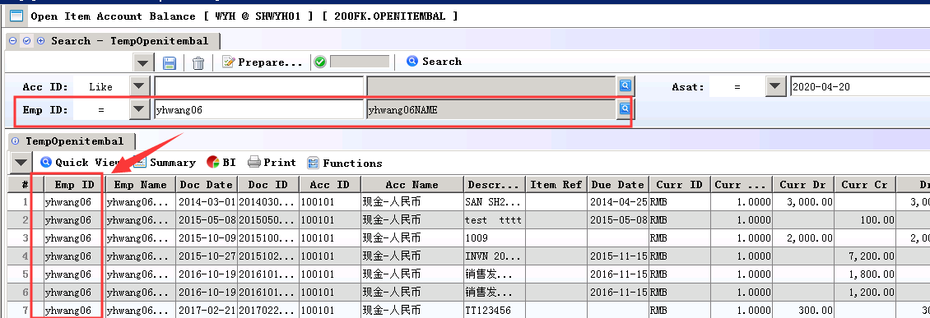

3.3.6 Delete 090H module . (30877)-893

3.3.7 060BZ Sales Price Book Enquiry:Added .(30909)-894
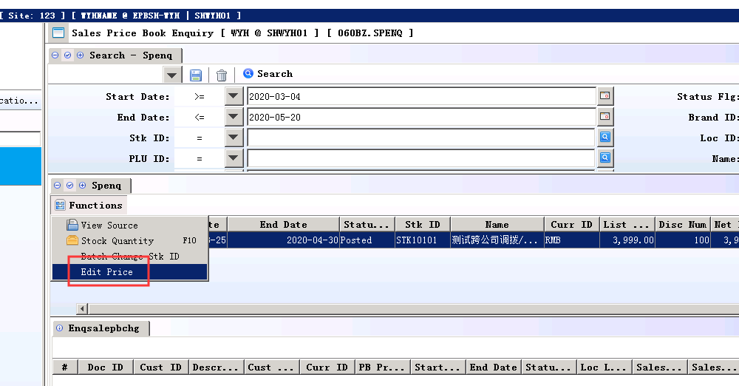
Setting: Enable Edit Price=Y;
Allow to edit the net price.

Note：
Only allowed to change the price that the discount is 0 and 100.
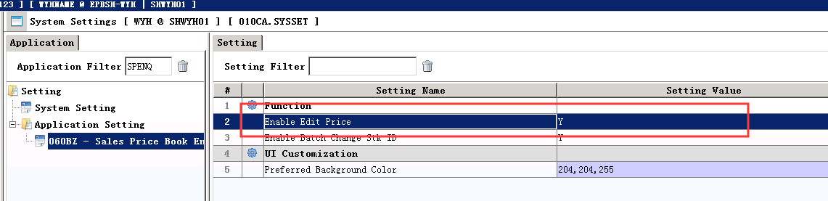

3.3.8 090AaZ VIP Statistics：Added column’Age’.(30812)-894
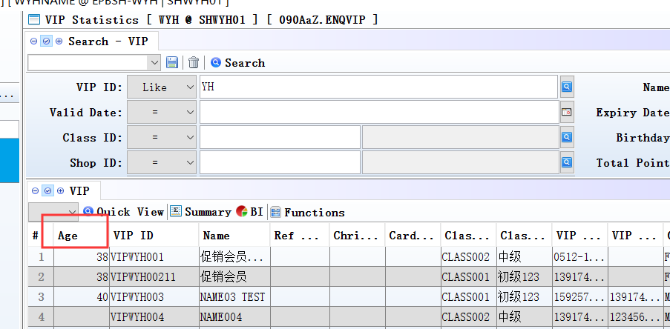

3.3.9 090AN Added Sub_table:ECSKUEC.(31009)-894
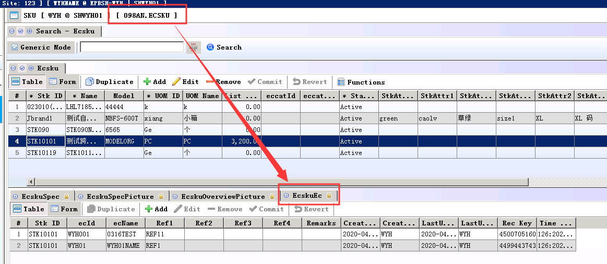

3.3.10 060CBA Sales Agreement:Added function’ Credit can also include the amount of sales agreement’. (30990)-894
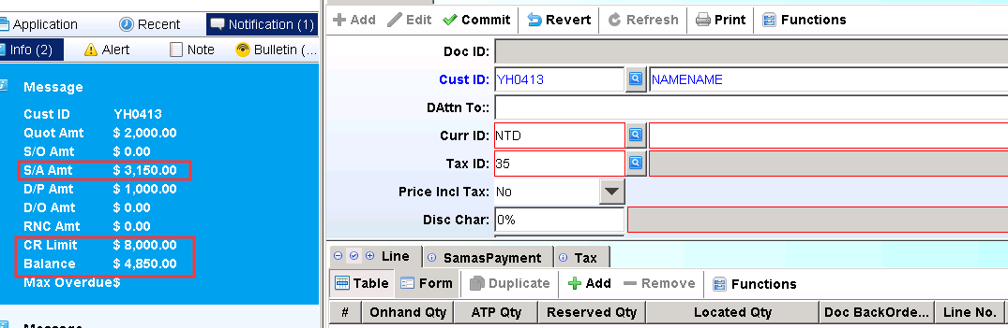
Note：1) 020BF：Setting’ Include Outstanding S/A when calculating Credit Limit’=Y;

3.3.11 090D POSN, ecorder get tax rates from STKMAS_ORG. (31105)-894
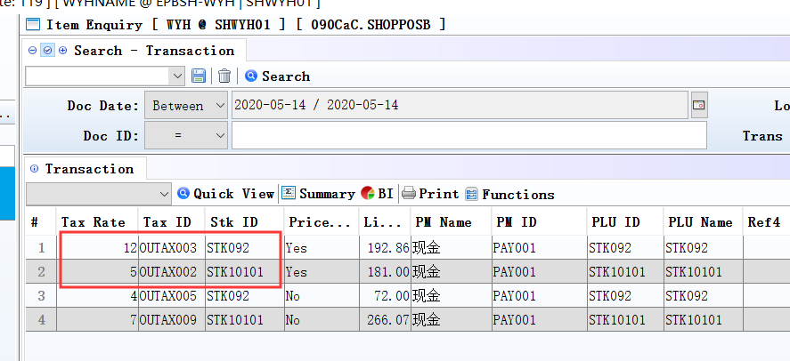
So that different STK_ID take different tax rates.

3.3.12 140ADC Storage Area:Added column ‘HAVE_TRANSACTIONS.(30931)-894
Default is ‘N’

When there have stock in and out of the deal ，It is 'Y'.

If have whpostline, then not allowed to change ‘def_wh_id’ and ‘def_whbin_id’ .

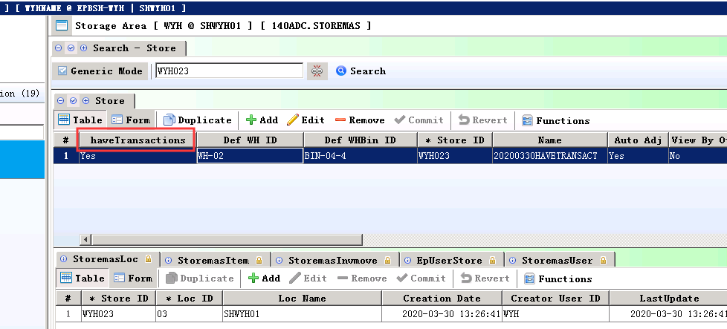

3.3.13 140ED Stock Transaction: BI Added columns’ customercatId’ .etc .(30946)-894
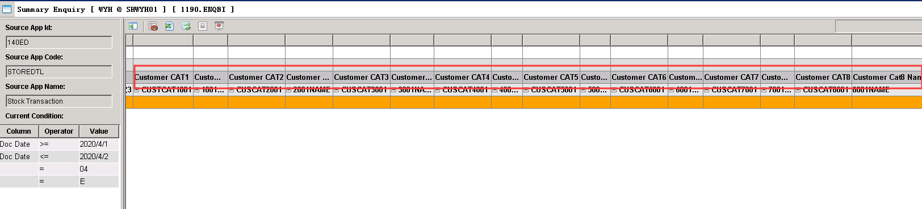

3.3.14 140EJE Stock Value Summary(Exclude WIP):BI added ‘TO_FYEAR’ and ‘TO_FPERIOD’.(30982)-894
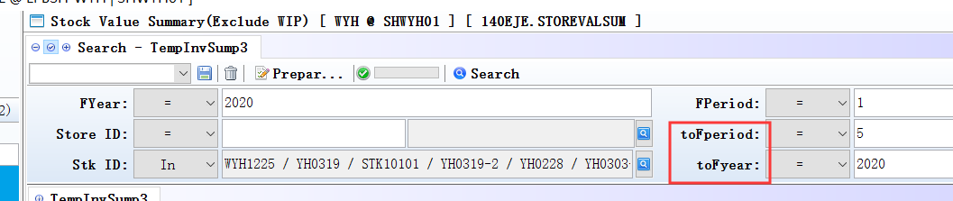
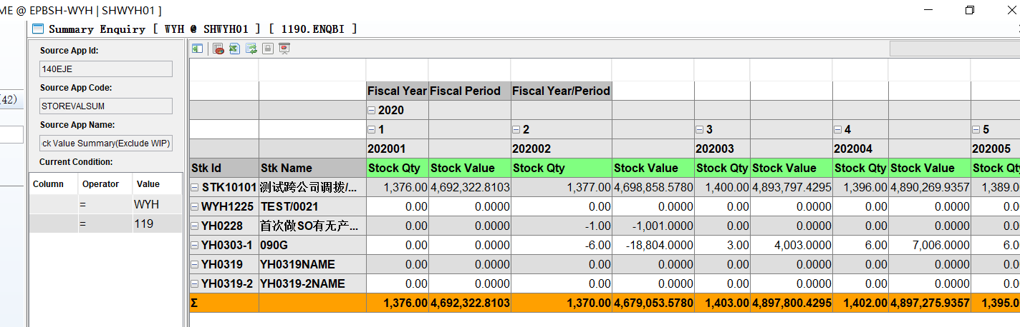
BI report can show different inventory quantity and value by period.

3.3.15 200BD Bank Reconciliation:Added column ‘reverseFlg’。 (30899)-894
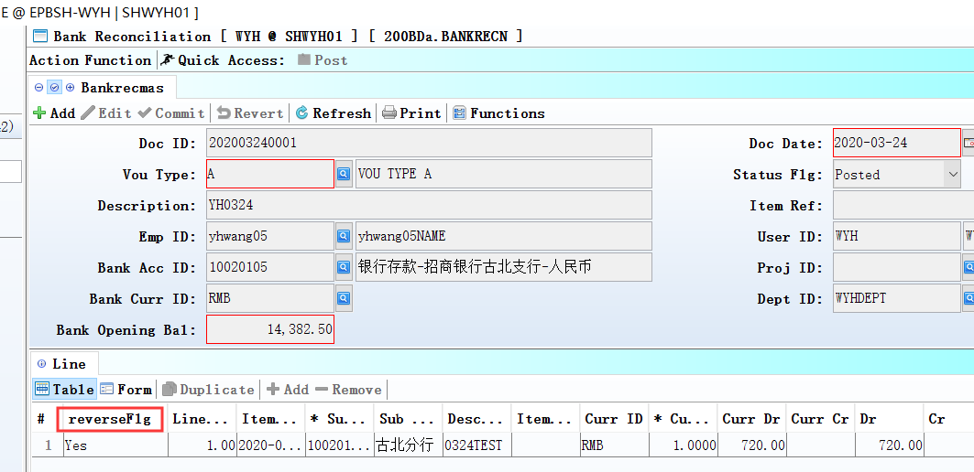
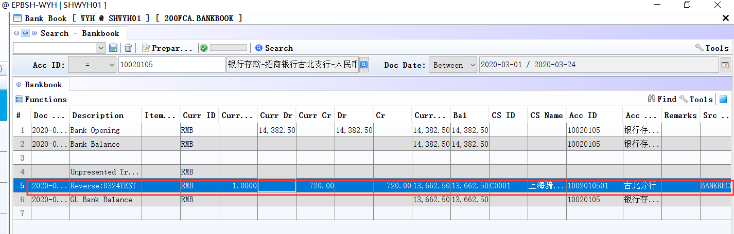
Set to Y, means this transaction rejected by bank，system will reverse this transaction related voucher, NRIN or NPOUT。

3.3.16 090D POSN:Added function’ different shop to collection’.(27009)-894
Shop A :Deposit , Shop B: Deposit collection

4. Fixes

