EPBrowserRelease Notes
Version 8.95

EPBrowserRelease Notes Version 8.95
Last Revision, 22 June 2020

©Copyright 2020. Enterprise Browser Pte Ltd.
All rights reserved.

No part of this manual may be reproduced in any form or by any means without the express written authorization from EPB. Business forms—which include but are not limited to invoices, checks, sales orders—displayed in this manual are for illustration purposes only and are not to be used for producing actual business forms. Enterprise Browser Pte Ltd. assumes no responsibility.
This document may contain technical inaccuracies or typographical errors and may change without prior notice. Any documentation with respect to EPB software products is provided for informational purposes only and does not extend or modify the limited warranty extended to the licensee of EPB software products.

Enterprise Browser Pte Ltd (EPB)
33Ubi Avenue 3, #07-65, Vertex Tower A, Singapore 408868
Tel: (65)-6509-4065
Fax: (65)-6509-4089

Document Location
EPBSH

Contents
1. Featured 4
2. New Interface 4
2.1 Added new module：090BK , (31223)-895 4
3. Enhancements 4
3.1 Privilege 4
3.1.1 140EB Stock Summary：added privieges ‘Display Customer’ and ‘Display Supplier’.(31195)-895 4
3.1.2 M005/M008：added privieges ‘View Shop Sales’ and ‘View Sales’.(31204)-895 5
3.1.3 060BZ Sales Price Book Enquiry:Added priviege ‘Batch Change STK ID’. (30445)-895 5
3.2 Setting 6
3.2.1 060CI Credit Note Request:changed setting’ CRN Type [A] Return [B] Discount [C] Credit Tax Only [D] Cancelled’. (31062)-895 6
3.2.2 200DA Supplier Invoice:Changed setting’ Disallow posting if related Goods Receive/Supplier Retuen/Oursource Goods Receive Date is later than Supplier Invoice Date’.(31136)-895 6
3.3 Improve 6
3.3.1 If the email attachment under the FTP path has been deleted, Then forward will have remind information.(31181)-895 6
3.3.2 0065 String requited distribute that does not affect the client interface.(31171)-895 7
3.3.3 030E Business Logic Checklist：Added CHK30 ‘Check changing default Sales Manager in QUOT/SO’.(31247)-895 7
3.3.4 060HC Delivery Order Enquiry:Added columns ’ PUR_ACC_ID’ and ‘PUR_CURR_ID’ and ‘PUR_CURR_RATE’ and ‘PUR_PRICE’ .(31278)-895 8
3.3.5 All campaign/price assign function.(31280)-895 8
3.3.6 800AB Shop Revenue Analysis:Added column ‘Remarks’.(31177)-895 8
3.3.7 800DA Distribution Analysis:Added function ‘View Source’.(31221)-895 9
3.3.8 800DA Distribution Analysis:Added columns ’Term_ID’ and ‘Terms_Name’.(31265)-895 9
3.3.9 060CBA Sales Agreement:Added function’ get campaign price and PB price’.(31015)-895 9
4. Fixes 9

1. Featured

2. New Interface

2.1 Added new module：090BK , (31223)-895
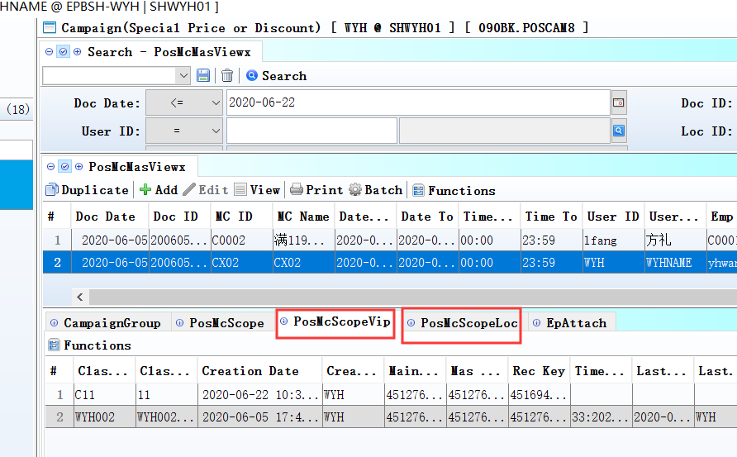
The special price book applies only to retail ;
Applies only to assign 'loc_id' and ‘class_id’.

3. Enhancements

3.1 Privilege

3.1.1 140EB Stock Summary：added privieges ‘Display Customer’ and ‘Display Supplier’.(31195)-895
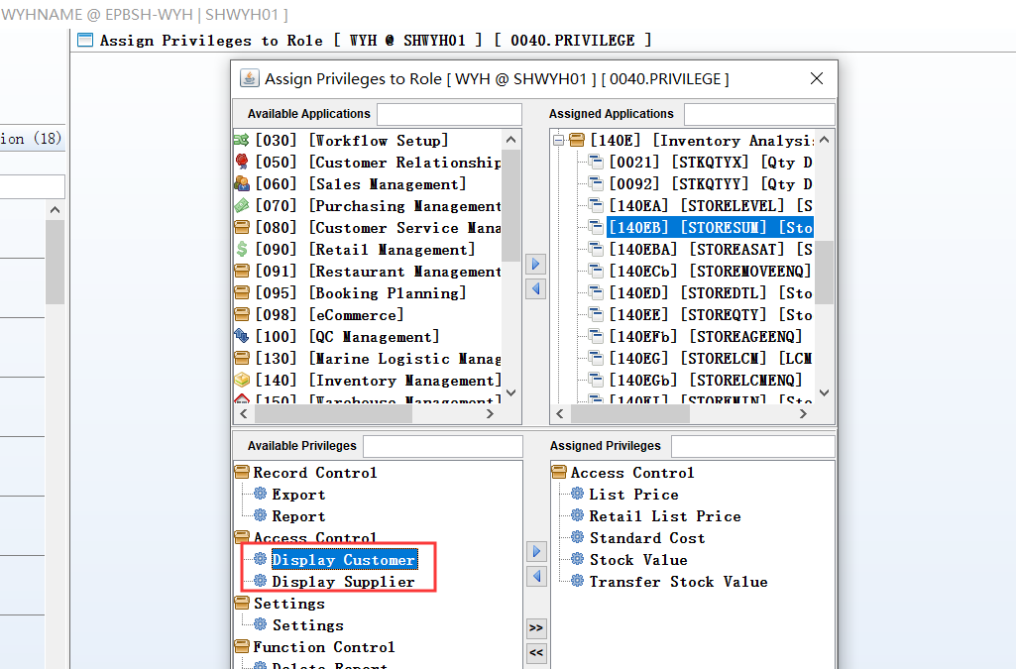
140ED Stock Transaction ：added the function too.

3.1.2 M005/M008：added privieges ‘View Shop Sales’ and ‘View Sales’.(31204)-895
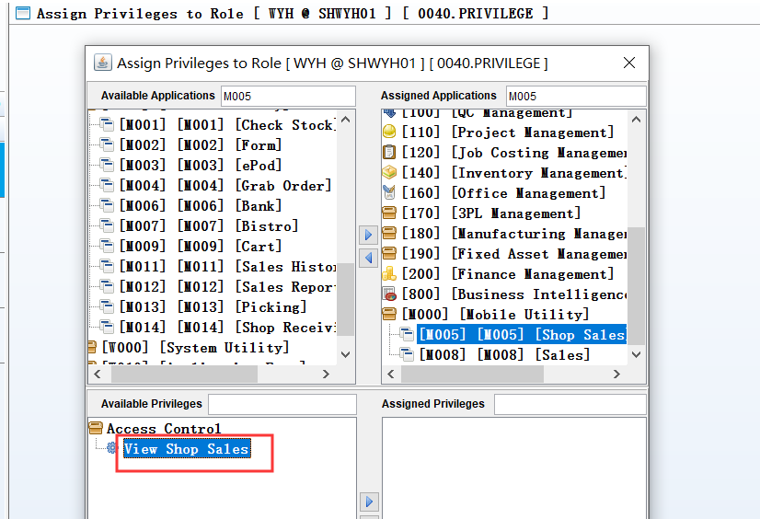
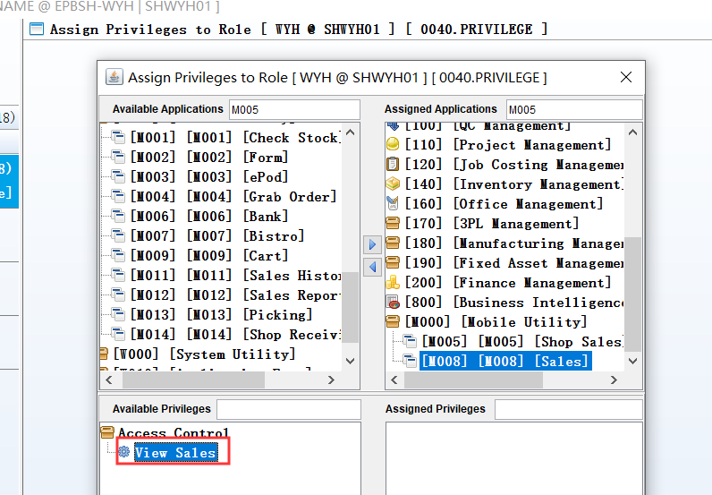

3.1.3 060BZ Sales Price Book Enquiry:Added priviege ‘Batch Change STK ID’. (30445)-895
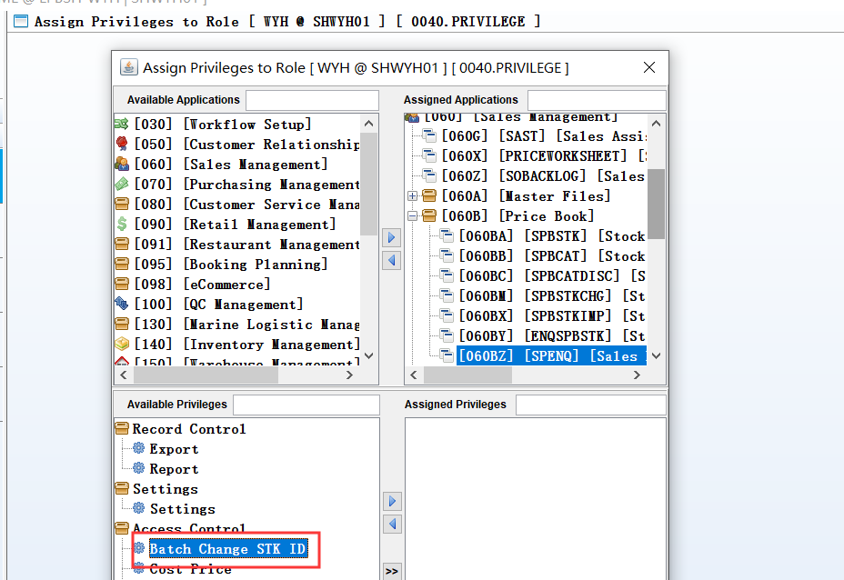

3.2 Setting

3.2.1 060CI Credit Note Request:changed setting’ CRN Type [A] Return [B] Discount [C] Credit Tax Only [D] Cancelled’. (31062)-895
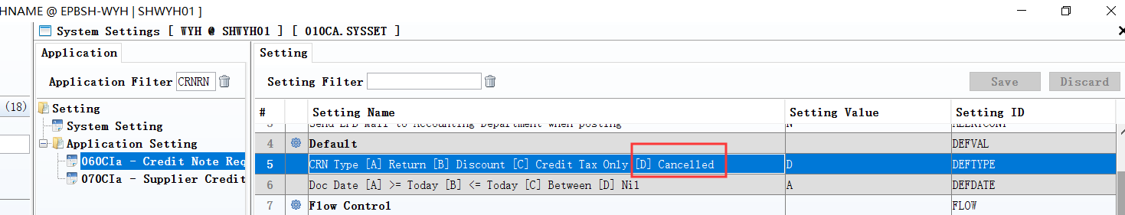
Added default type ‘D’.

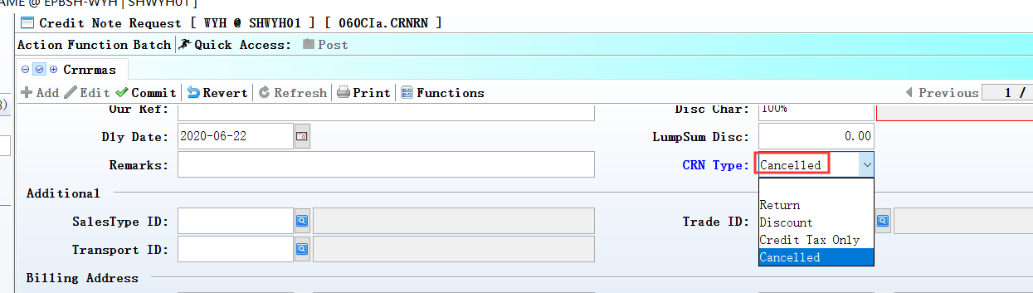

3.2.2 200DA Supplier Invoice:Changed setting’ Disallow posting if related Goods Receive/Supplier Retuen/Oursource Goods Receive Date is later than Supplier Invoice Date’.(31136)-895
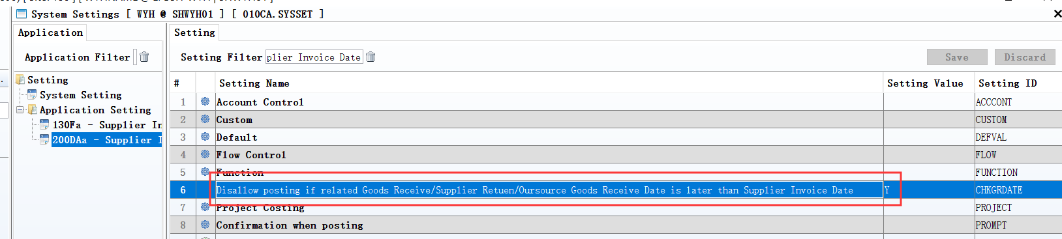
Added control for Supplier Retuen/Oursource Goods Receive

3.3 Improve

3.3.1 If the email attachment under the FTP path has been deleted, Then forward will have remind information.(31181)-895
Wait for …

3.3.2 0065 String requited distribute that does not affect the client interface.(31171)-895
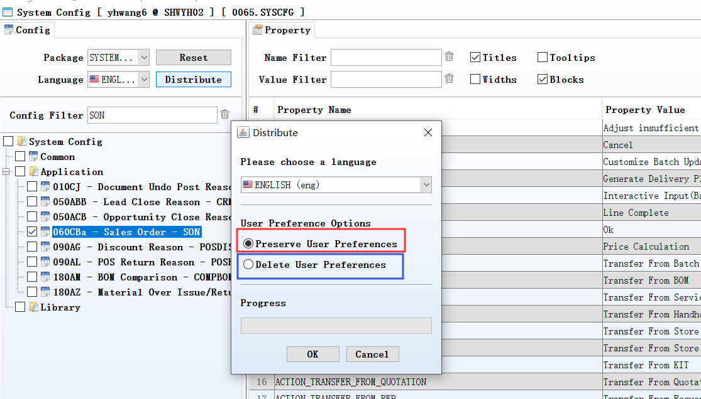
1、
Go to 0065.syscfg->ticked app code->Click 'Distribute'->ticked 'Preserve User Preferences'->Click 'OK' - (Keep the client interface)

2、Go to 0065.syscfg->ticked app code->Click 'Distribute'->ticked 'Delete User Preferences'->Click 'OK'-（Remove the client interface）

3.3.3 030E Business Logic Checklist：Added CHK30 ‘Check changing default Sales Manager in QUOT/SO’.(31247)-895
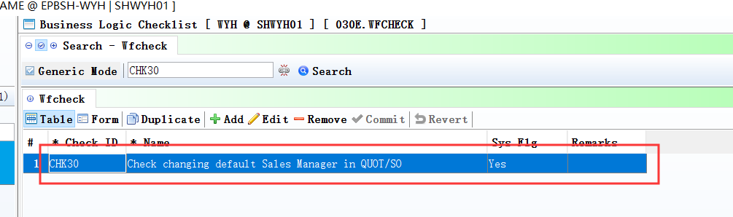
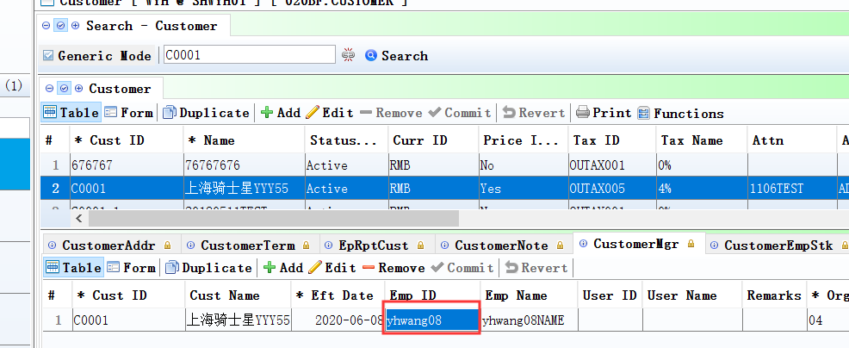
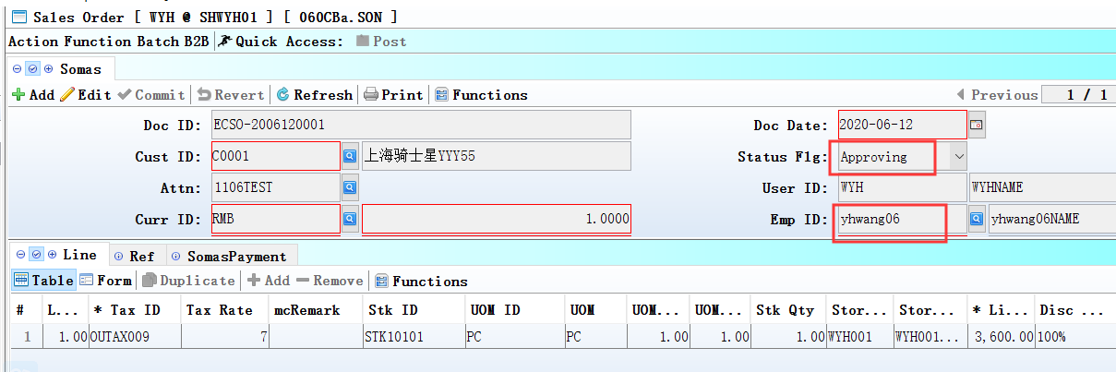
Yhwang08<>yhwang06,

trigger the workflow.

3.3.4 060HC Delivery Order Enquiry:Added columns ’ PUR_ACC_ID’ and ‘PUR_CURR_ID’ and ‘PUR_CURR_RATE’ and ‘PUR_PRICE’ .(31278)-895
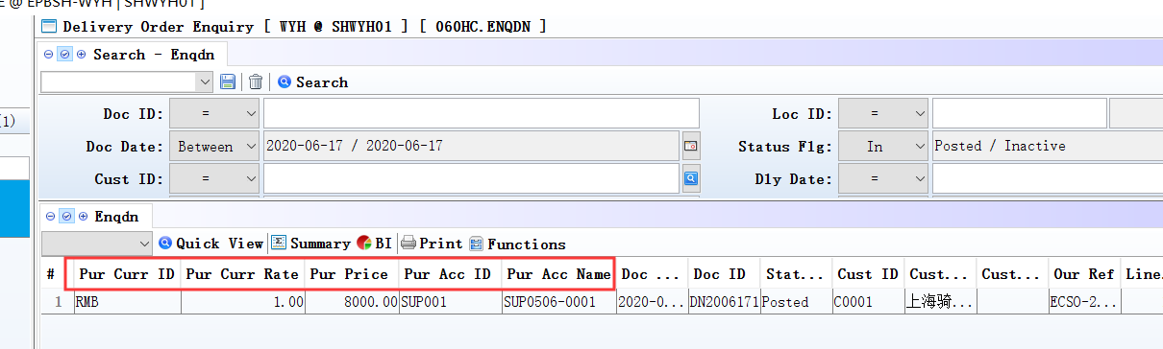

3.3.5 All campaign/price assign function.(31280)-895
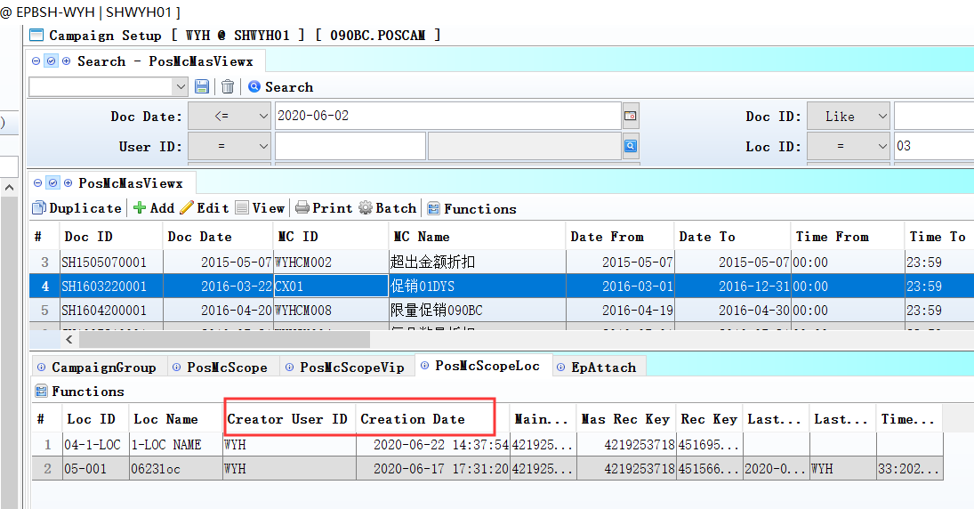
Assign a new record, create_date and create_user_Id will not overwrite the original already assigned records.

3.3.6 800AB Shop Revenue Analysis:Added column ‘Remarks’.(31177)-895
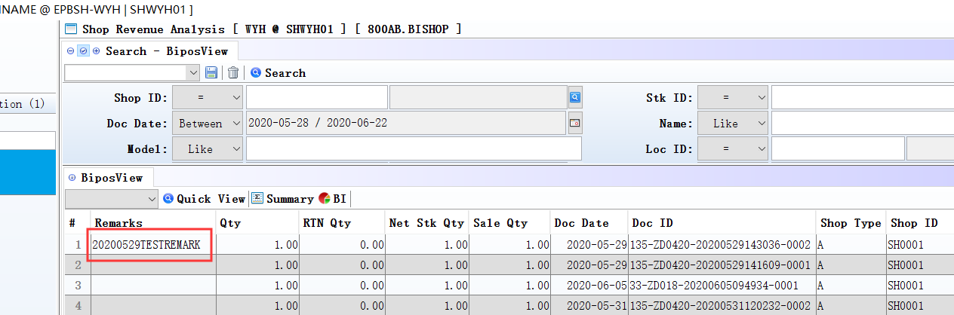

3.3.7 800DA Distribution Analysis:Added function ‘View Source’.(31221)-895
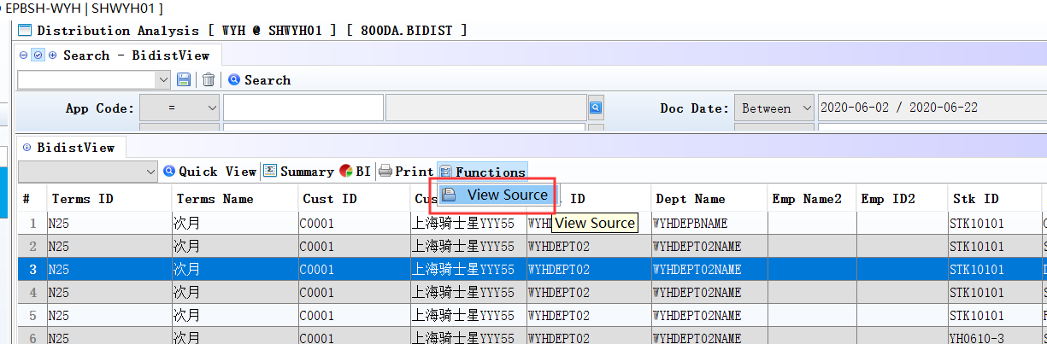

3.3.8 800DA Distribution Analysis:Added columns ’Term_ID’ and ‘Terms_Name’.(31265)-895
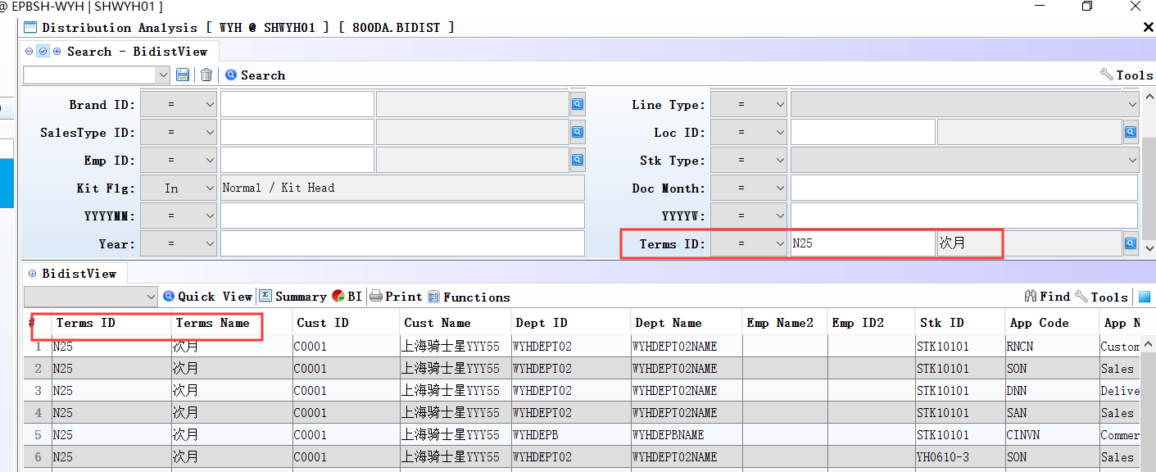

3.3.9 060CBA Sales Agreement:Added function’ get campaign price and PB price’.(31015)-895
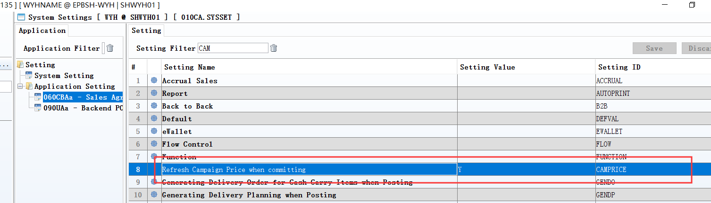
Refresh Campaign Price when committing=Y

4. Fixes

