EPBrowserRelease Notes
Version 8.96

EPBrowserRelease Notes Version 8.96
Last Revision, 20 July 2020

©Copyright 2020. Enterprise Browser Pte Ltd.
All rights reserved.

No part of this manual may be reproduced in any form or by any means without the express written authorization from EPB. Business forms—which include but are not limited to invoices, checks, sales orders—displayed in this manual are for illustration purposes only and are not to be used for producing actual business forms. Enterprise Browser Pte Ltd. assumes no responsibility.
This document may contain technical inaccuracies or typographical errors and may change without prior notice. Any documentation with respect to EPB software products is provided for informational purposes only and does not extend or modify the limited warranty extended to the licensee of EPB software products.

Enterprise Browser Pte Ltd (EPB)
33Ubi Avenue 3, #07-65, Vertex Tower A, Singapore 408868
Tel: (65)-6509-4065
Fax: (65)-6509-4089

Document Location
EPBSH

Contents
1. Featured 3
2. New Interface 3
2.1 Added new module： 3
3. Enhancements 4
3.1 Privilege 4
3.1.1 140UA Unicode：added privilege ‘edit’. (31378)-896 4
3.2 Setting 4
3.2.1 140BA Stock Items:Added setting'Enable Barcode1/Barcode2 Unique Control'. (31340)-896 4
3.2.2 140BA Stock Items: Added setting ' STK ID access control by stkmas_loc'.(31370)-896 4
3.3 Improve 5
3.3.1 060HK Sales Quotation Enquiry:Added column'COPY_COUNTS'.(31364)-896 5
3.3.2 070CC Purchade Order:Added function'last price overwrite pur price'.(31329)-896 5
3.3.3 090CaE Day-end Closing Enquiry:Added 'Increase the multiselect function'.(31387)-896 5
3.3.4 140FC Inventory Transfer Request Enquiry:Added column 'INVTRNTRET_QTY'. (31331)-896 6
3.3.5 140UA Unicode:Added column'remark'.(31378)-896 6
3.3.6 150G Truck Note:Added function'TRANSFER FROM INVTRNI' ;170AF :added column'ZONE_ID' .(31335)-896 6
3.3.7 160BB Leave Application:Added columns 'LEAVE_DAYS' and'LEAVE_BALANCE'.(31328)-896 7
3.3.8 200FX Financial Report II Setup:Added column'underline'.(31354)-896 7
4. Fixes 8

1. Featured

2. New Interface

2.1 Added new module：

3. Enhancements

3.1 Privilege

3.1.1 140UA Unicode：added privilege ‘edit’. (31378)-896
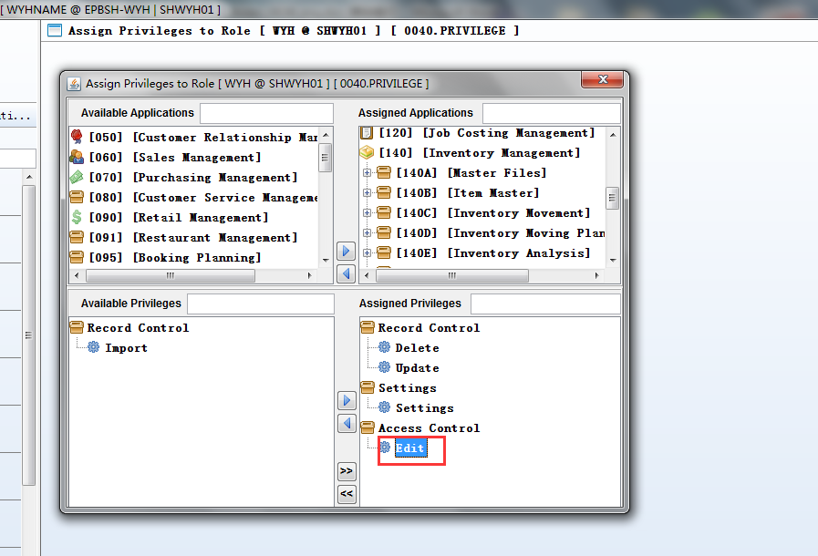
Added remark of edit by privilege.

3.2 Setting

3.2.1 140BA Stock Items:Added setting'Enable Barcode1/Barcode2 Unique Control'. (31340)-896
Set to Y, Check barcode1or barcode2 uniqueness;

Set to N, not check.
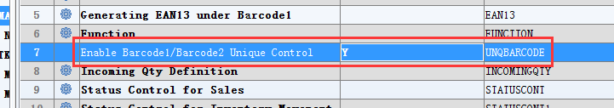

3.2.2 140BA Stock Items: Added setting ' STK ID access control by stkmas_loc'.(31370)-896
Set to Y, STK ID access control by stkmas_loc;

Set to N, To maintain the original.
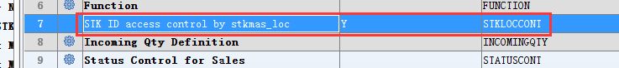

3.3 Improve

3.3.1 060HK Sales Quotation Enquiry:Added column'COPY_COUNTS'.(31364)-896
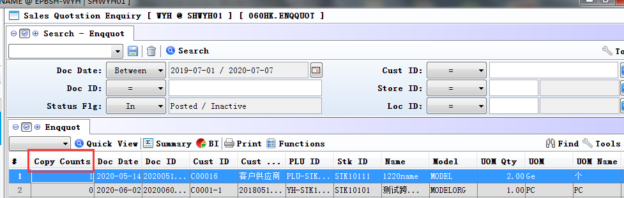

3.3.2 070CC Purchade Order:Added function'last price overwrite pur price'.(31329)-896
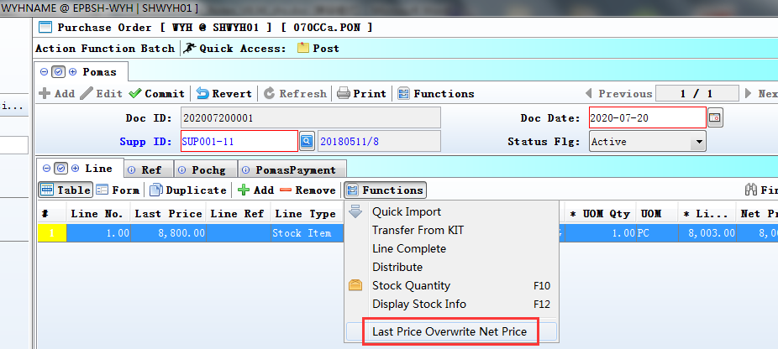
1) Key the item and save;
2)click'last price overwrite pur price'.

3.3.3 090CaE Day-end Closing Enquiry:Added 'Increase the multiselect function'.(31387)-896
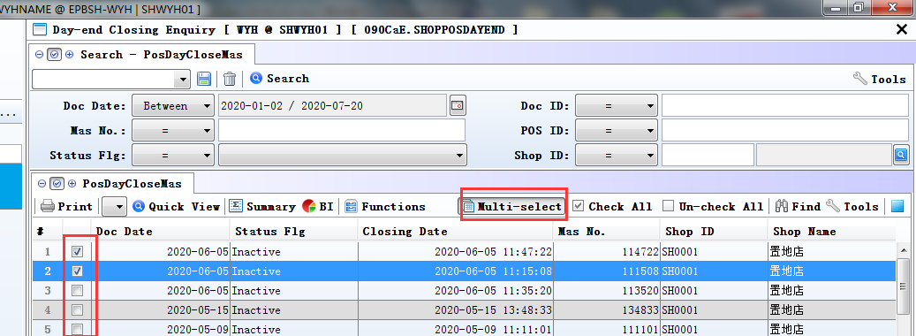

3.3.4 140FC Inventory Transfer Request Enquiry:Added column 'INVTRNTRET_QTY'. (31331)-896
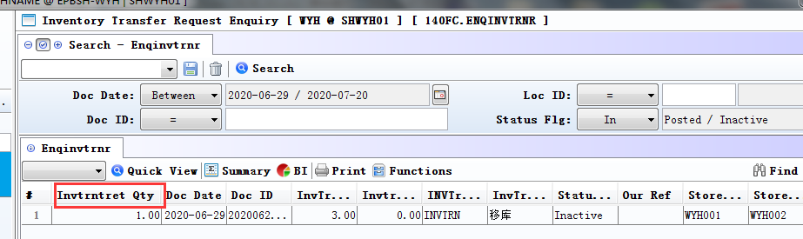
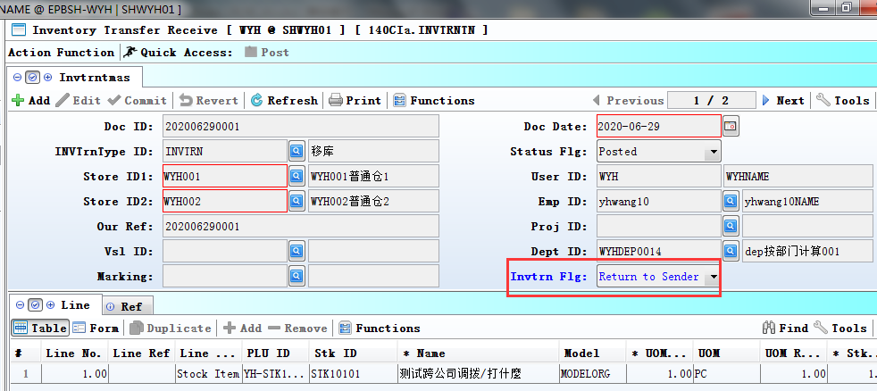
in invtrnt module:
if invtrn_flg = receive,it will update invtrnt_qty;

if invtrn_flg = return to sender,it will update invtrnret_qty.

3.3.5 140UA Unicode:Added column'remark'.(31378)-896
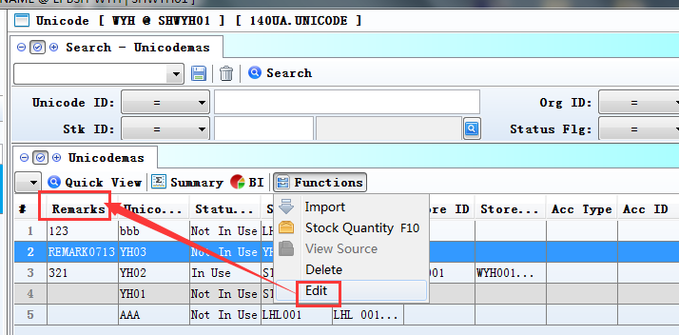

3.3.6 150G Truck Note:Added function'TRANSFER FROM INVTRNI' ;170AF :added column'ZONE_ID' .(31335)-896
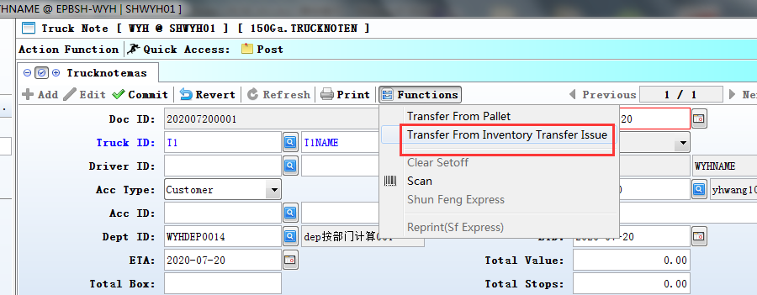
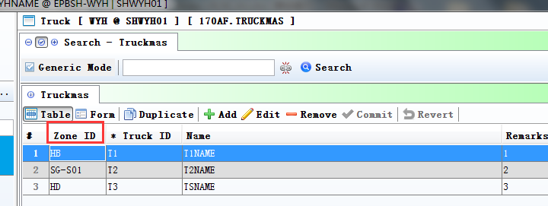

3.3.7 160BB Leave Application:Added columns 'LEAVE_DAYS' and'LEAVE_BALANCE'.(31328)-896
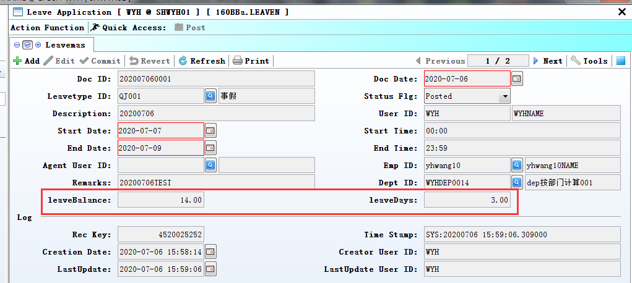
LEAVE_BALANCE=(Adjust in) - ( Annual Leave(and other leave)).
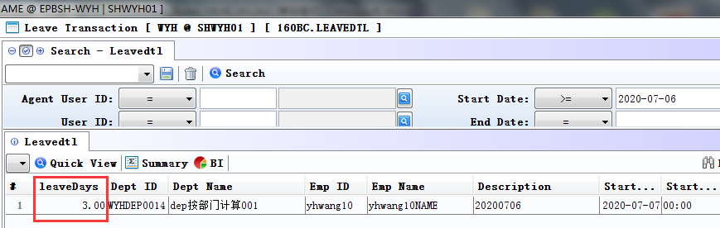
160BC:Added column 'leaveDays'.

3.3.8 200FX Financial Report II Setup:Added column'underline'.(31354)-896
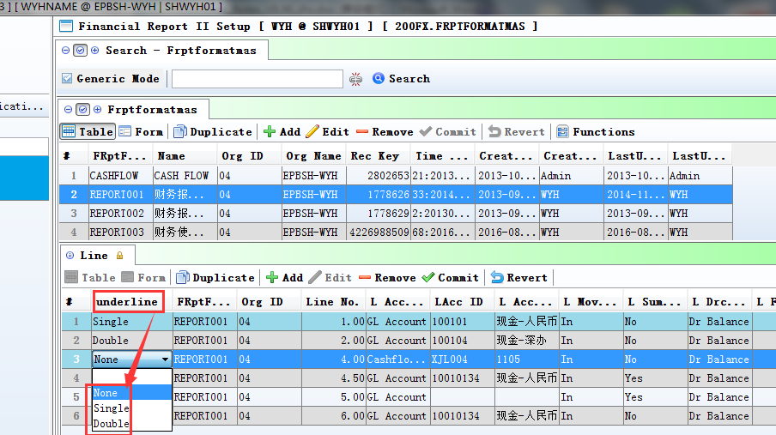
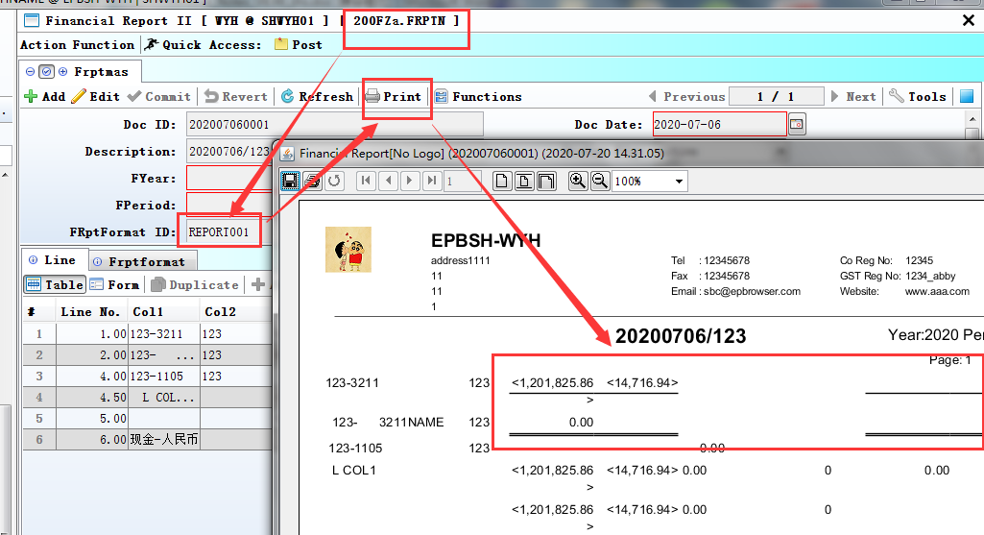

4. Fixes

