EPBrowserRelease Notes
Version 8.97

EPBrowserRelease Notes Version 8.97
Last Revision, 24 August 2020

©Copyright 2020. Enterprise Browser Pte Ltd.
All rights reserved.

No part of this manual may be reproduced in any form or by any means without the express written authorization from EPB. Business forms—which include but are not limited to invoices, checks, sales orders—displayed in this manual are for illustration purposes only and are not to be used for producing actual business forms. Enterprise Browser Pte Ltd. assumes no responsibility.
This document may contain technical inaccuracies or typographical errors and may change without prior notice. Any documentation with respect to EPB software products is provided for informational purposes only and does not extend or modify the limited warranty extended to the licensee of EPB software products.

Enterprise Browser Pte Ltd (EPB)
33Ubi Avenue 3, #07-65, Vertex Tower A, Singapore 408868
Tel: (65)-6509-4065
Fax: (65)-6509-4089

Document Location
EPBSH

Contents
1. Featured 3
2. New Interface 4
3. Enhancements 4
3.1 Privilege 4
3.2 Setting 4
3.2.1 120A Assembly Job:Added setting'Disallow posting if ATD minus'.(31569)-897 4
3.2.2 140CJ Stock Take:Added setting'Enable Stock Take Card'.(31480)-897 4
3.2.3 200DD :Added setting' Acceptable Rounding Variance '.(31510)-897 5
3.3 Improve 5
3.3.1 030E Business Logic Checklist:Changed CHECK 26'Check SO/PO Term ID is not as same as master Term Id'. (31547)-897 5
3.3.2 090CaA Receipt Enquiry:Added column'masCollectionDate'.(31547)-896 6
3.3.3 180BNN Work Order Reporting II Enquiry:Added function'allowed to edit 'remark''.(31495)-897 6
3.3.4 180DF BOM List:Added column'Opt Description' .(31453)-897 7
3.3.5 200CA Invoice:Added column 'src_doc_date'. (31412)-897 7
3.3.6 200FK Open Item Account Balance:Added the column of Query conditions 'Due_Date' .(31435)-897 7
4. Fixes 7

1. Featured

2. New Interface

3. Enhancements

3.1 Privilege

3.2 Setting

3.2.1 120A Assembly Job:Added setting'Disallow posting if ATD minus'.(31569)-897
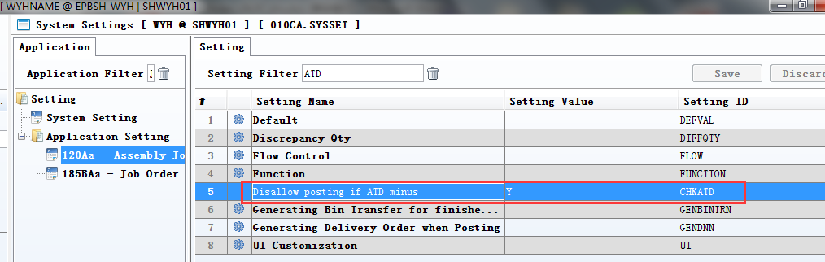
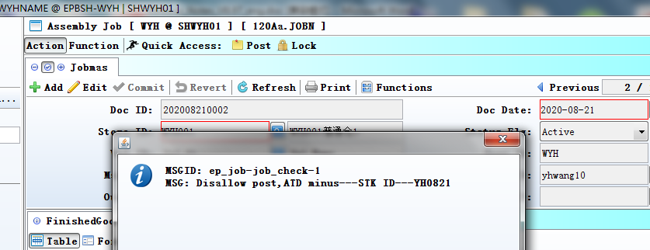

3.2.2 140CJ Stock Take:Added setting'Enable Stock Take Card'.(31480)-897
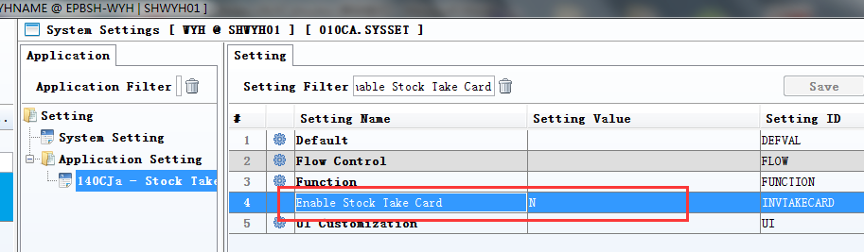

3.2.3 200DD :Added setting' Acceptable Rounding Variance '.(31510)-897
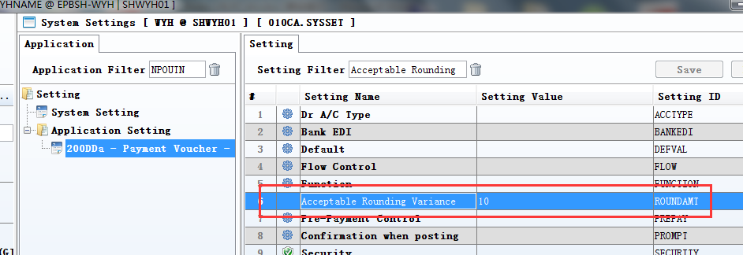
Set variance:
(Home amt-Bank Home Amt) < variance,allow POST;
(Home amt-Bank Home Amt) >variance,don't allow POST.
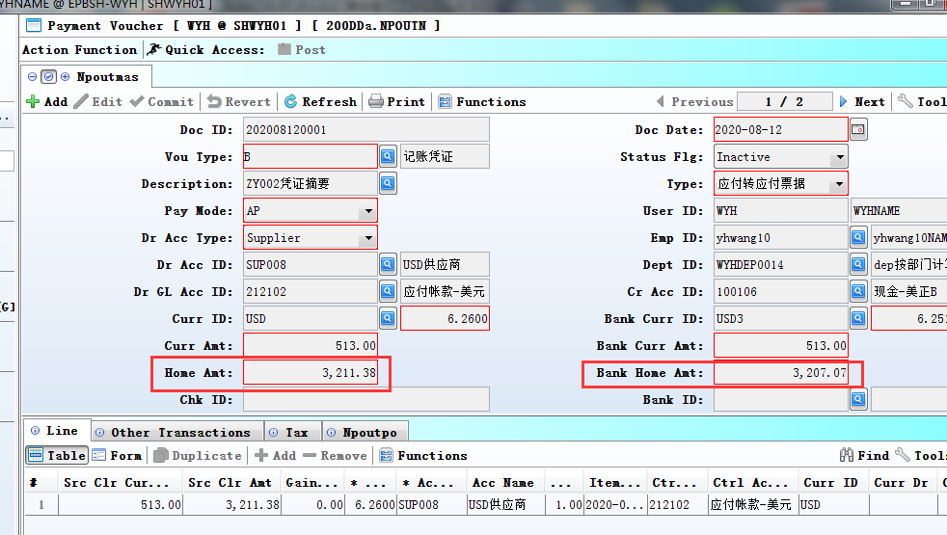

3.3 Improve

3.3.1 030E Business Logic Checklist:Changed CHECK 26'Check SO/PO Term ID is not as same as master Term Id'. (31547)-897
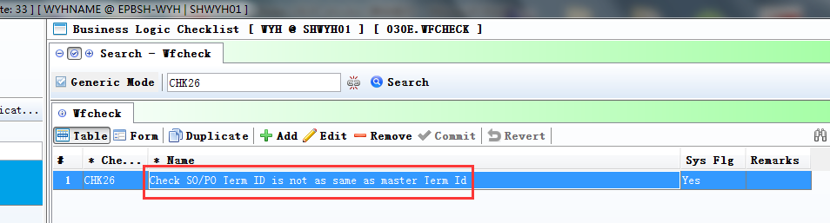
Added to check:
SO Term Id .
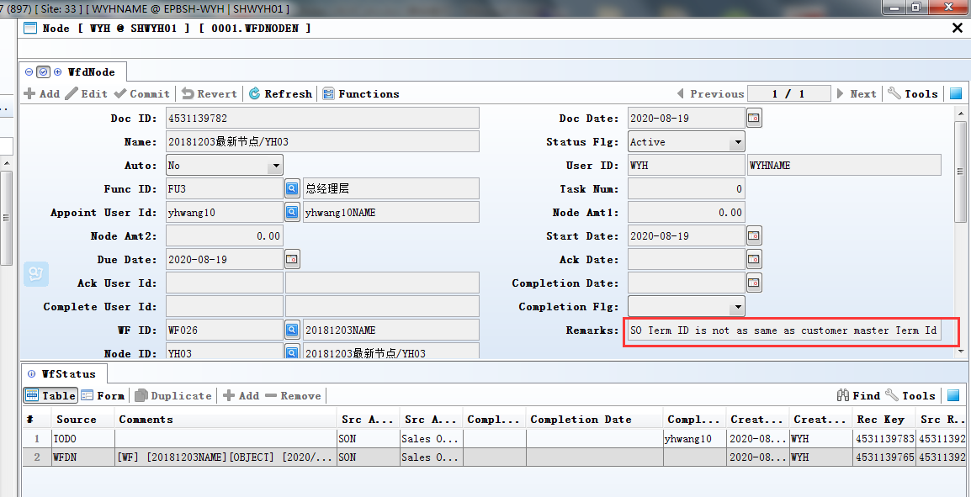

3.3.2 090CaA Receipt Enquiry:Added column'masCollectionDate'.(31547)-896
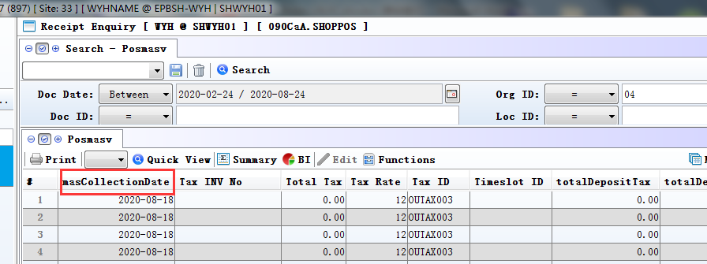

3.3.3 180BNN Work Order Reporting II Enquiry:Added function'allowed to edit 'remark''.(31495)-897
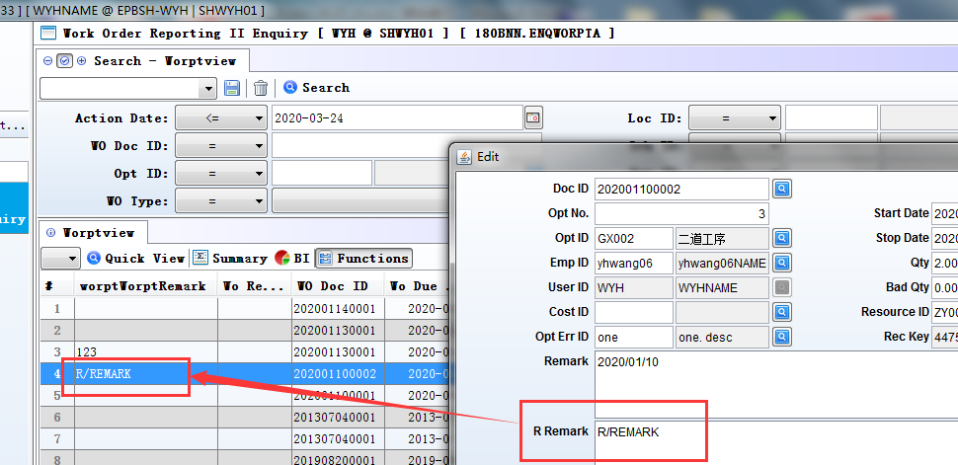

3.3.4 180DF BOM List:Added column'Opt Description' .(31453)-897
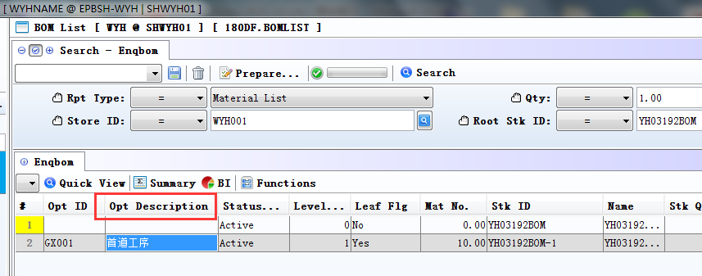

3.3.5 200CA Invoice:Added column 'src_doc_date'. (31412)-897
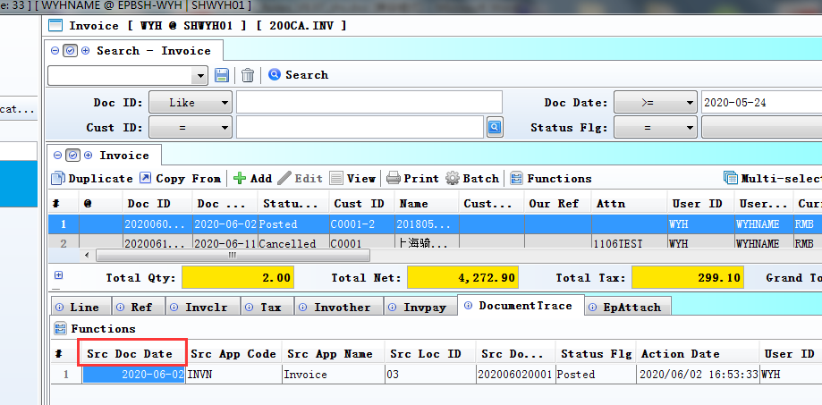

3.3.6 200FK Open Item Account Balance:Added the column of Query conditions 'Due_Date' .(31435)-897
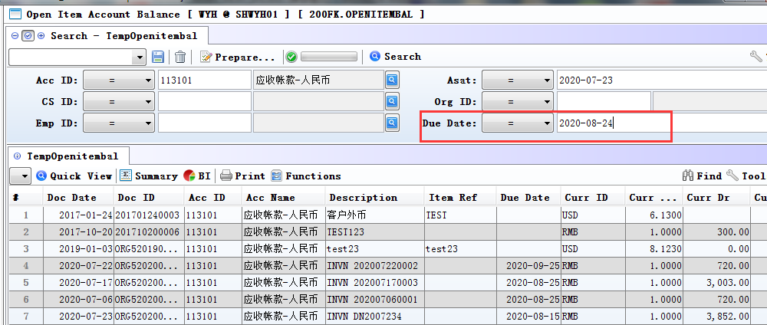

4. Fixes

