EPBrowserRelease Notes
Version 8.98~8.99

EPBrowserRelease Notes Version 8.97
Last Revision, 26 October 2020

©Copyright 2020. Enterprise Browser Pte Ltd.
All rights reserved.

No part of this manual may be reproduced in any form or by any means without the express written authorization from EPB. Business forms—which include but are not limited to invoices, checks, sales orders—displayed in this manual are for illustration purposes only and are not to be used for producing actual business forms. Enterprise Browser Pte Ltd. assumes no responsibility.
This document may contain technical inaccuracies or typographical errors and may change without prior notice. Any documentation with respect to EPB software products is provided for informational purposes only and does not extend or modify the limited warranty extended to the licensee of EPB software products.

Enterprise Browser Pte Ltd (EPB)
33Ubi Avenue 3, #07-65, Vertex Tower A, Singapore 408868
Tel: (65)-6509-4065
Fax: (65)-6509-4089

Document Location
EPBSH

Contents
1. Featured 4
2. New Interface 4
2.1 Added new module: 190BI-Asset Split.(31828)-899 4
3. Enhancements 4
3.1 Privilege 4
3.1.1 070DHZA My Procurement Overview: Added privilege'STKVALUE' And 'TRNSTKVALUE '. (31627)-898 4
3.2 Setting 5
3.2.1 140CF Inventory Transfer:Added setting'Enable transferring from RFID Cart'.(31589)-898 5
3.2.2 140CF Inventory Transfer:Added setting'Keep Our Ref when copying from Source Document '.(31712)-899 5
3.3 Improve 5
3.3.1 060HK Sales Qutotation Enquiry:Added columns.(31571)-898 5
3.3.2 150K Cycle Count(Warehouse Bin): Added columns 'BRAND_ID' and 'CAT1_ID' and 'CAT2_ID' and 'CAT3_ID' and 'CAT4_ID' and 'CAT5_ID' and 'CAT6_ID' and 'CAT7_ID' and 'CAT8_ID' in the transfer from Warehouse of screen.(31661)-898 6
3.3.3 180DA Sales Order Backlog Tracing:Added BI funcion.(31690)-898 6
3.3.4 060CH Commercial Invoice:Attn Added lov . (31807)-899 7
3.3.5 200DDA AP Payment Batch:Added Email report,the report name is' APPAYBH03_EMAIL '. (31793-)899 7
3.3.6 210B Multi-Org Consolidation:Added column 'ORI_ORG_ID' and'ORI_ORG_NAME'. (31766)-899 8
3.3.7 In GINPUT screen, display intransit store .(31838)-899 8
4. Fixes 8

1. Featured

2. New Interface

2.1 Added new module: 190BI-Asset Split.(31828)-899
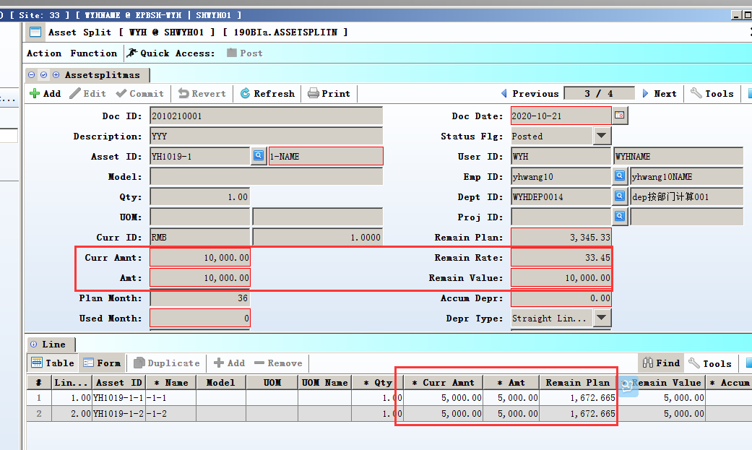

3. Enhancements

3.1 Privilege

3.1.1 070DHZA My Procurement Overview: Added privilege'STKVALUE' And 'TRNSTKVALUE '. (31627)-898
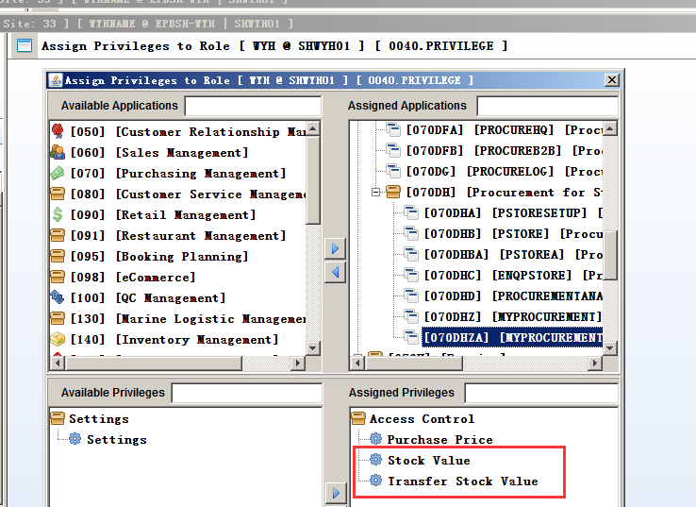

3.2 Setting

3.2.1 140CF Inventory Transfer:Added setting'Enable transferring from RFID Cart'.(31589)-898
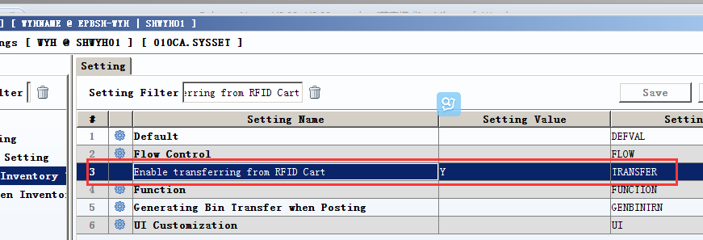

3.2.2 140CF Inventory Transfer:Added setting'Keep Our Ref when copying from Source Document '.(31712)-899
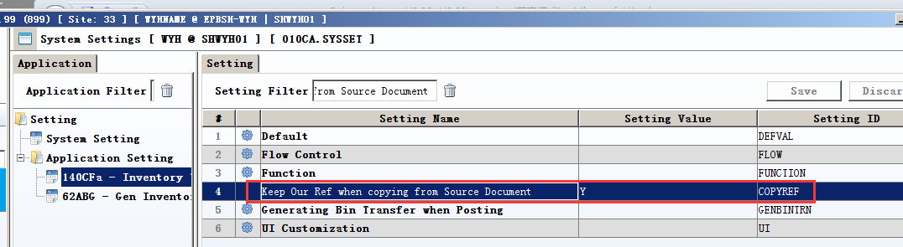
140CGA Inventory Transfer Planning;
140CH Inventory Transfer Issue;
140CI Inventory Transfer Receive ;
-----Added the same setting.

3.3 Improve

3.3.1 060HK Sales Qutotation Enquiry:Added columns.(31571)-898
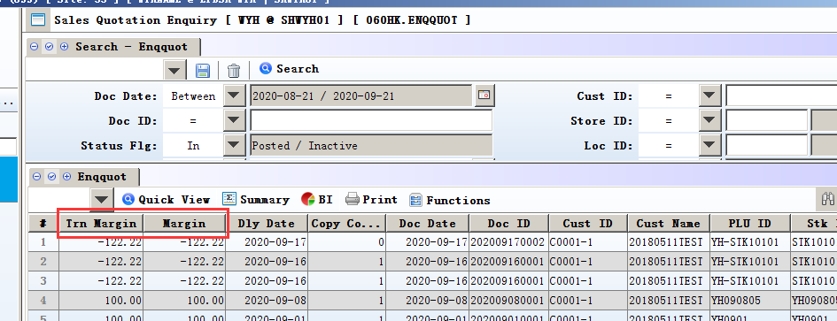

3.3.2 150K Cycle Count(Warehouse Bin): Added columns 'BRAND_ID' and 'CAT1_ID' and 'CAT2_ID' and 'CAT3_ID' and 'CAT4_ID' and 'CAT5_ID' and 'CAT6_ID' and 'CAT7_ID' and 'CAT8_ID' in the transfer from Warehouse of screen.(31661)-898
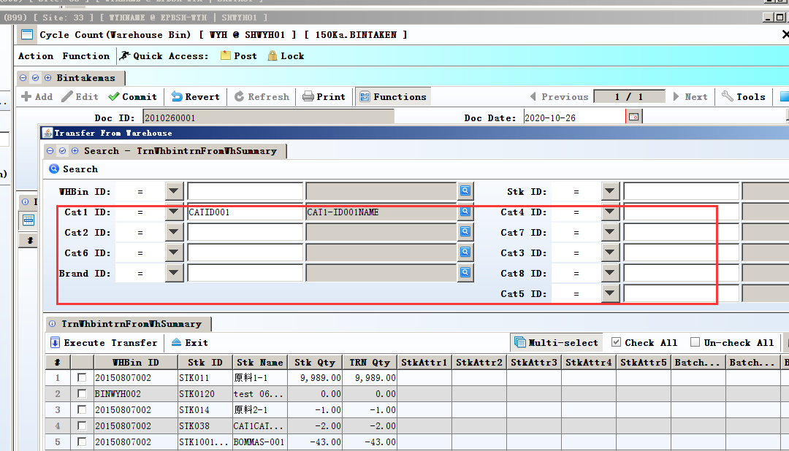

3.3.3 180DA Sales Order Backlog Tracing:Added BI funcion.(31690)-898
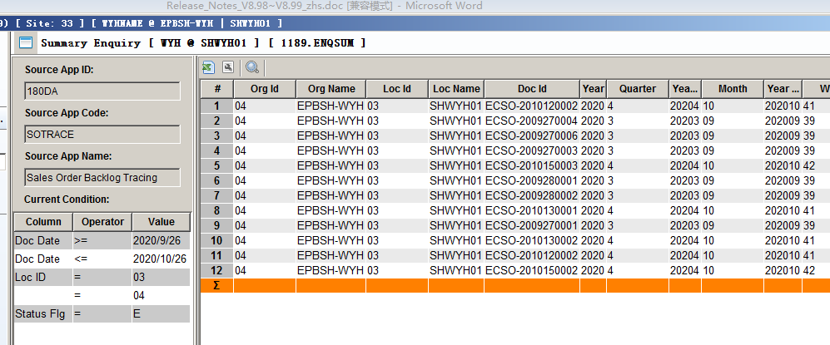

3.3.4 060CH Commercial Invoice:Attn Added lov . (31807)-899
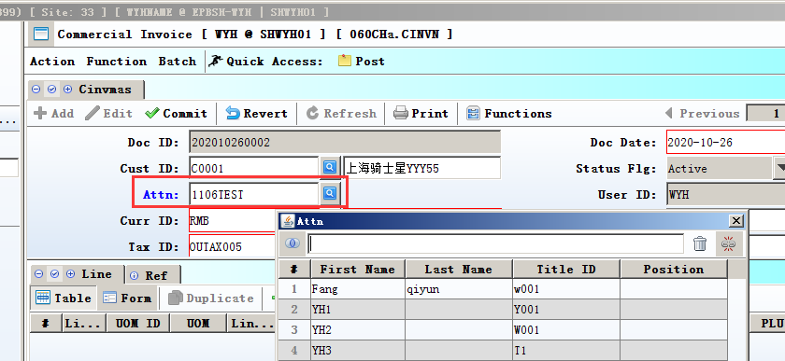
DattnTo can bring out DPhone and DFaxd automatically;

if DPhone and DFaxd are null,then ignore.

3.3.5 200DDA AP Payment Batch:Added Email report,the report name is' APPAYBH03_EMAIL '. (31793-)899
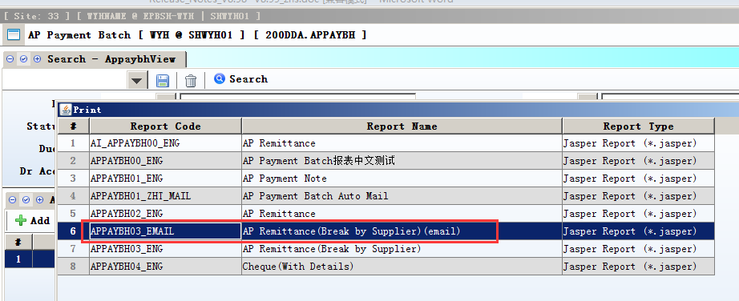
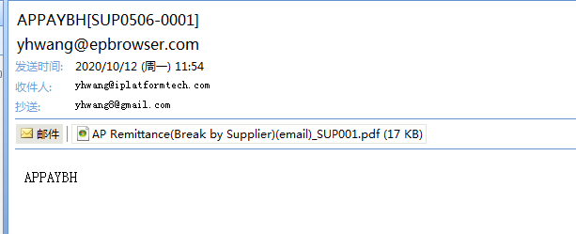

3.3.6 210B Multi-Org Consolidation:Added column 'ORI_ORG_ID' and'ORI_ORG_NAME'. (31766)-899
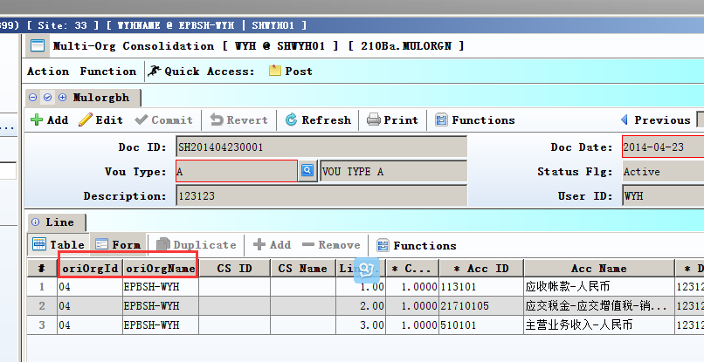

3.3.7 In GINPUT screen, display intransit store .(31838)-899
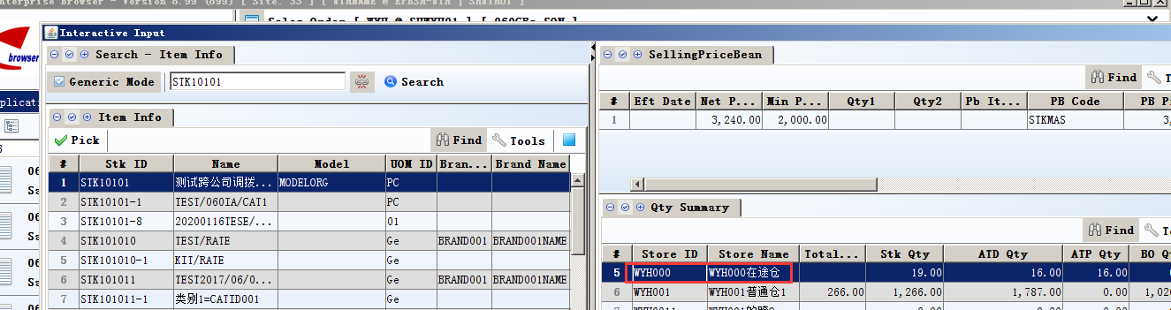

4. Fixes

