EPBrowserRelease Notes
Version 9.00

EPBrowserRelease Notes Version 9.00
Last Revision, 30 November 2020

©Copyright 2020. Enterprise Browser Pte Ltd.
All rights reserved.

No part of this manual may be reproduced in any form or by any means without the express written authorization from EPB. Business forms—which include but are not limited to invoices, checks, sales orders—displayed in this manual are for illustration purposes only and are not to be used for producing actual business forms. Enterprise Browser Pte Ltd. assumes no responsibility.
This document may contain technical inaccuracies or typographical errors and may change without prior notice. Any documentation with respect to EPB software products is provided for informational purposes only and does not extend or modify the limited warranty extended to the licensee of EPB software products.

Enterprise Browser Pte Ltd (EPB)
33Ubi Avenue 3, #07-65, Vertex Tower A, Singapore 408868
Tel: (65)-6509-4065
Fax: (65)-6509-4089

Document Location
EPBSH

Contents
1. Featured 4
2. New Interface 4
2.1 Added new module: 090BL Campaign([Combine]Special Price or Discount).(31841)-900 4
2.2 Added new module:090BP Max Redeem Points Setup.(31969)-900 4
2.3 Added new module:150CCA Bin Summary As At. (32043)-900 5
3. Enhancements 5
3.1 Privilege 5
3.2 Setting 5
3.2.1 060CB Sales Order:Added setting'Carry over header remark when generating'. (32029)-900 5
3.2.2 060CM Packing List:Added setting'Enable copying Document Head from Commercial invoice'(31982)-900 6
3.2.3 100B QC Note:Added setting' Enable Edit QC Process ID '. (32030)-900 6
3.2.4 140BA Stock Items:Added settings'Send EPB Force Message when item qty below min level'. (31966)-900 6
3.2.5 140CD Inventory Issue Request:Added setting'Generating Stock Issue when Posting' . (31963)-900 7
3.2.6 160BB Leave Application:Added settings'Leave Type ID'.(31944)-900 8
3.2.7 160DA Application Form Setup:Added settings'Update Document Date using Posting Date' and 'Set Form Status to Active when rejected'. (31960)(31962)-900 8
3.2.8 180BAA Work Order Change Note:Added setting'Allow update WO Type when posting'.(31929)-900 8
3.2.9 180BD Finished Goods Receive:Added settting'Send EPB Force Message when FGR posted'. (31965)-900 9
3.2.10 App added setting ' Allow Cross Org Enquiry '.(31923)-900 9
3.3 Improve 9
3.3.1 020BI Supplier Added columns:KEY1~KEY6 in the tabel 'EpEditlog'(31933)-900 9
3.3.2 060CB Sales Order:Added function'Update Header Tax To Line'.(31984)-900 10
3.2.3 090CaC Item Enquiry:Added column'Total Sales2(without Deposit) ' in BI. (31925)-900 10
3.2.4 090CdB Shopping Voucher:Added column'phone'.(31972)-900 10
3.2.5 090Cdb Shopping Voucher :Added function' Generate Voucher by Customer '. (32008)-900 11
3.3.6 090D Added control : Different shops are not allowed to call the 'Collection' at the same time (31922)-900 11
3.2.7 Added Function: SV_ID binding STK_ID (31968)-900 12
3.2.8 140DE Inventory Transfer Planning:Added function'config'.(31967)-900 12
3.2.9 140DE Inventory Transfer Planning :Added columns:REF1~REF32.(31971)-900 13
3.2.10 140EB Stock Summary:Added column'STK_NAME'.(31885)-900 13
3.3.11 140ED Stock Transaction:Added column'Our ref' .(31938)-900 13
3.3.12 140CG Inventory Transfer Request :Added colunns:'ANA_ID1'~'ANA_ID10'.(31914)-900 14
3.3.13 180AG BOM:Added function 'Material List'. (32005)-900 14
3.3.14 200CEB AR Ageing:Added column 'VOU_DOC_ID'. (31998)-900 15
4. Fixes 15

1. Featured

2. New Interface

2.1 Added new module: 090BL Campaign([Combine]Special Price or Discount).(31841)-900
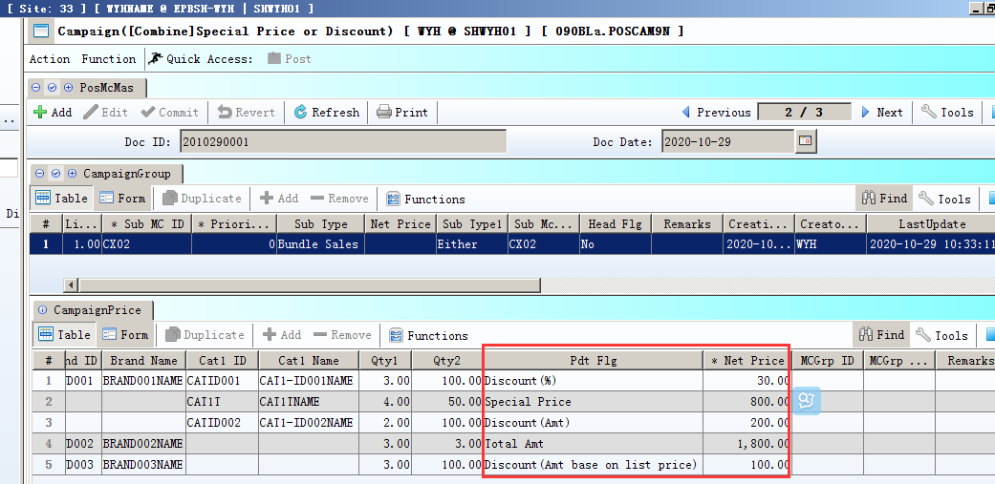
Multiple promotions are defined in a document

2.2 Added new module:090BP Max Redeem Points Setup.(31969)-900
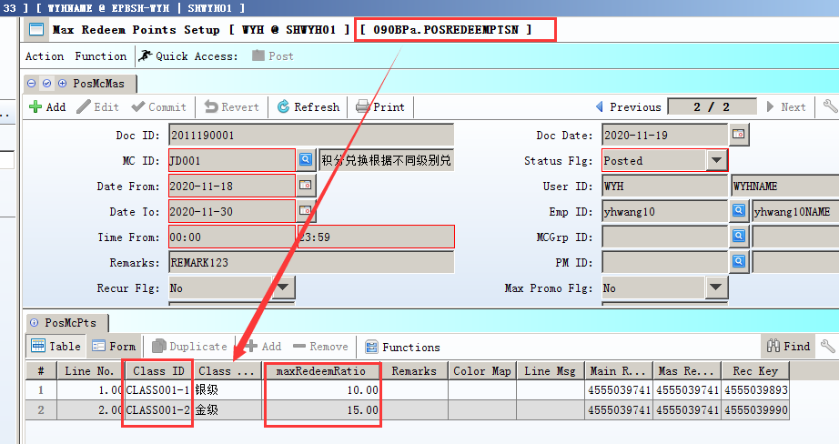
1)090BP: define the maxRedeemRatio and
date range;

For example:
Class_ID=ClASS001-1, maxRedeemRatio=10;
Class_ID=ClASS001-2, maxRedeemRatio=15.
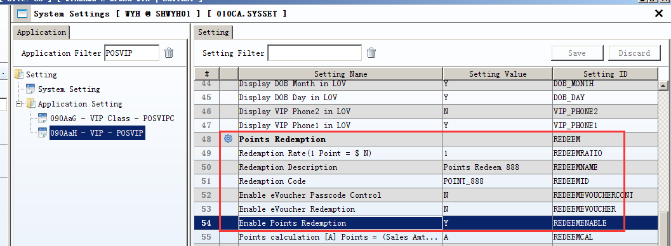
2)090AaH:setting:
Redemption Rate(1 Point = $ N)=1;
Redemption Code=POINT_888;
Redemption Description=Points Redeem 888;
Enable Points Redemption=Y.
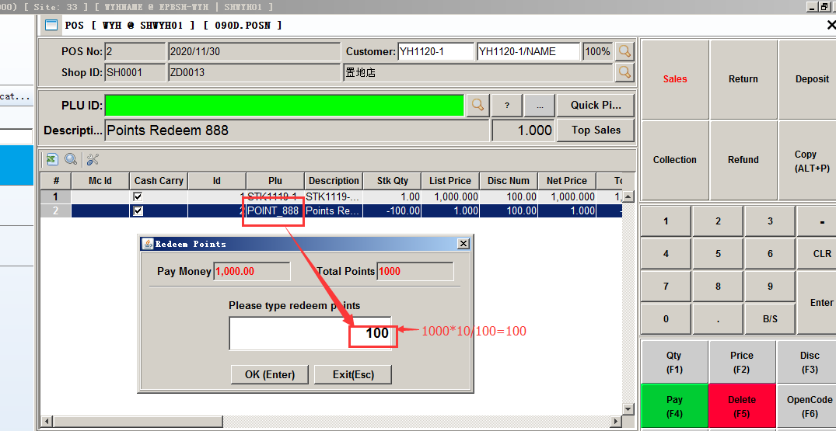
3) When input the Redemption_code , then click the F4,pop-up interface automatic display the redeem points.

2.3 Added new module:150CCA Bin Summary As At. (32043)-900
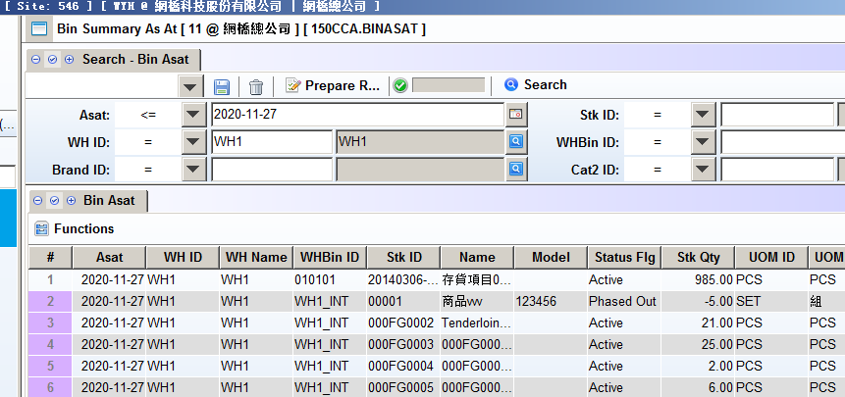

3. Enhancements

3.1 Privilege

3.2 Setting

3.2.1 060CB Sales Order:Added setting'Carry over header remark when generating'. (32029)-900
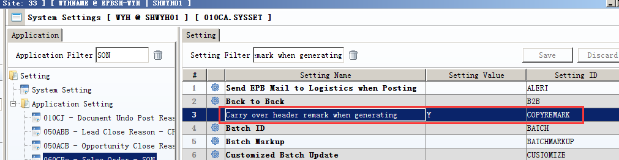
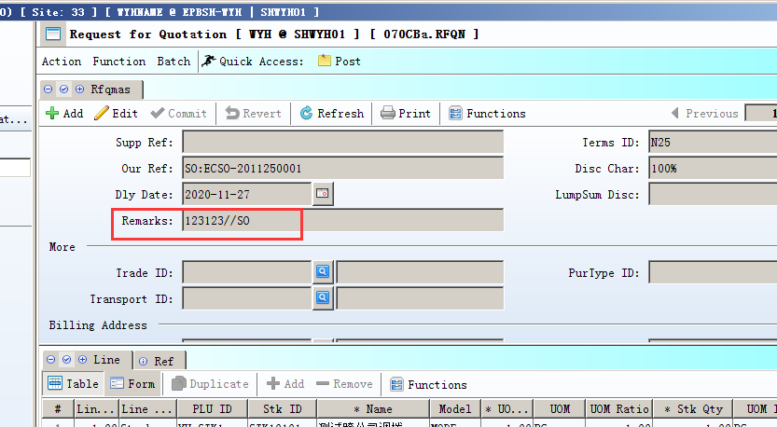

3.2.2 060CM Packing List:Added setting'Enable copying Document Head from Commercial invoice'(31982)-900
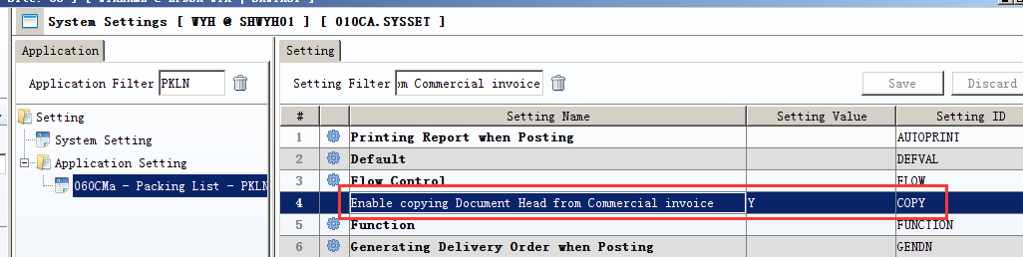

3.2.3 100B QC Note:Added setting' Enable Edit QC Process ID '. (32030)-900
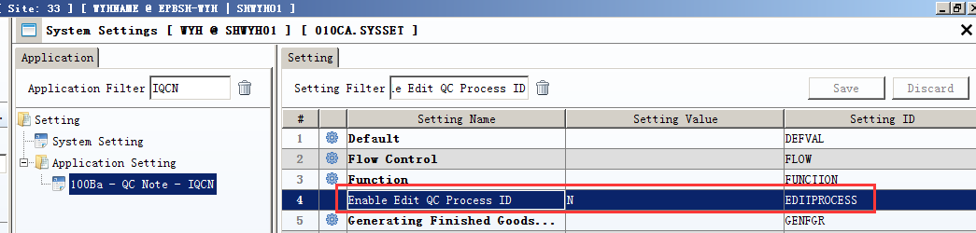
Set to Y,enable edit QC process ID.

3.2.4 140BA Stock Items:Added settings'Send EPB Force Message when item qty below min level'. (31966)-900
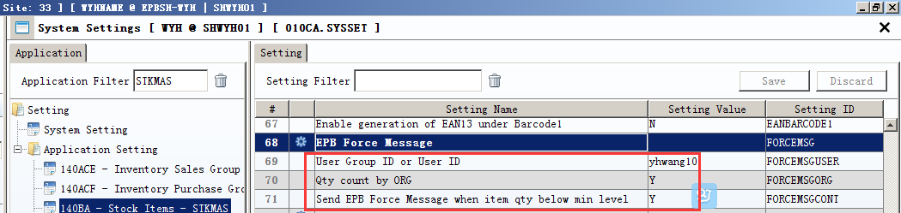
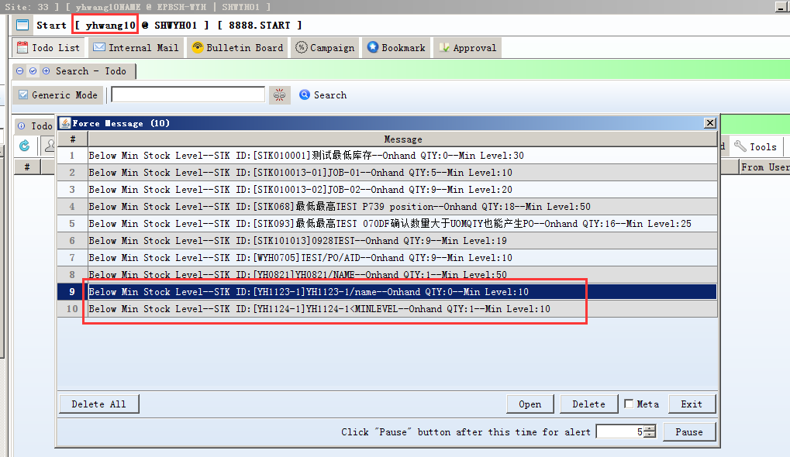

3.2.5 140CD Inventory Issue Request:Added setting'Generating Stock Issue when Posting' . (31963)-900
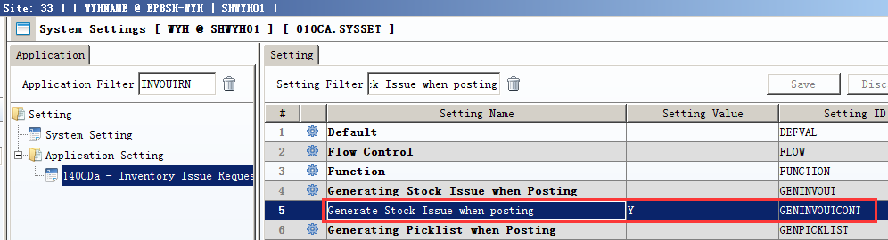
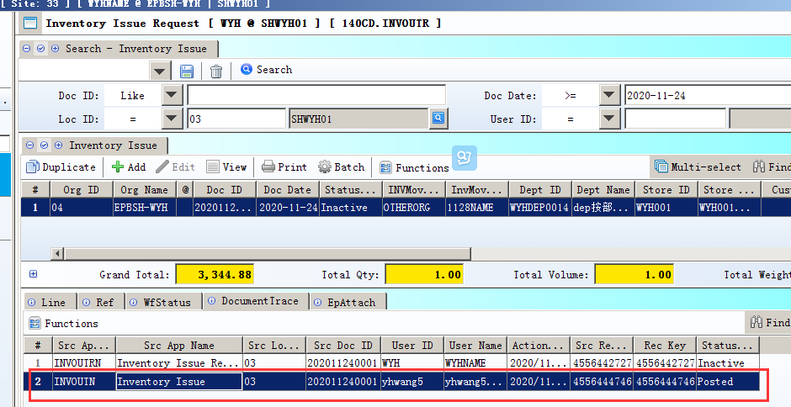

3.2.6 160BB Leave Application:Added settings'Leave Type ID'.(31944)-900
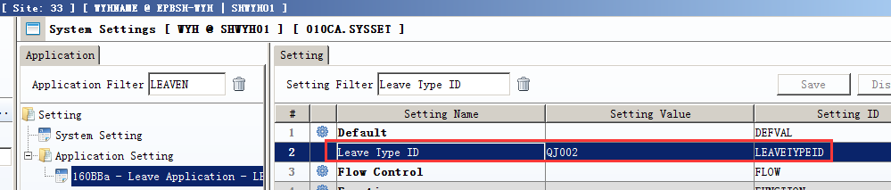
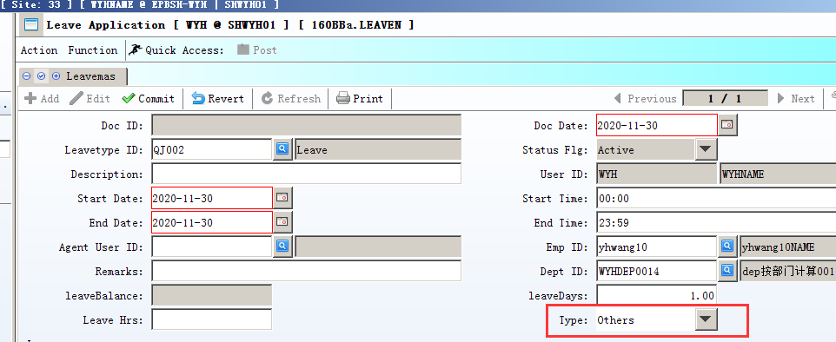

3.2.7 160DA Application Form Setup:Added settings'Update Document Date using Posting Date' and 'Set Form Status to Active when rejected'. (31960)(31962)-900
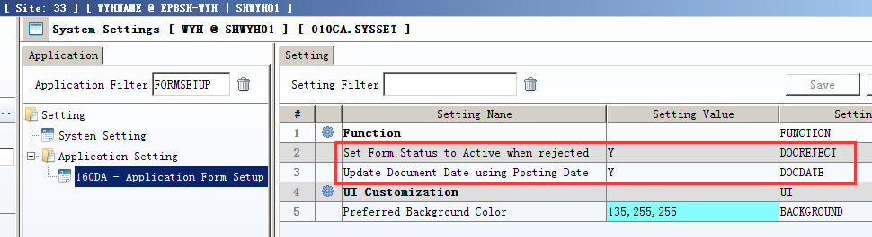

3.2.8 180BAA Work Order Change Note:Added setting'Allow update WO Type when posting'.(31929)-900
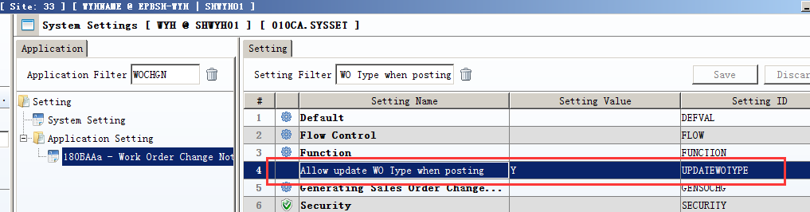

3.2.9 180BD Finished Goods Receive:Added settting'Send EPB Force Message when FGR posted'. (31965)-900
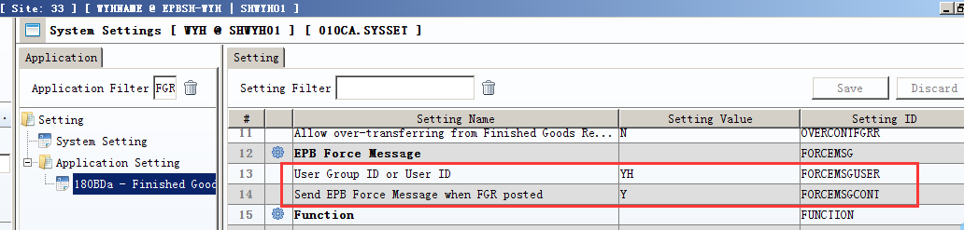

3.2.10 App added setting ' Allow Cross Org Enquiry '.(31923)-900
Note: 1) if the app setting = Y, then can across the organization.
2) if the app setting = N, then the system settig = Y, so can still across the organization,
if the app setting = N, and the system settig = N, cannot across the organization.

3.3 Improve

3.3.1 020BI Supplier Added columns:KEY1~KEY6 in the tabel 'EpEditlog'(31933)-900
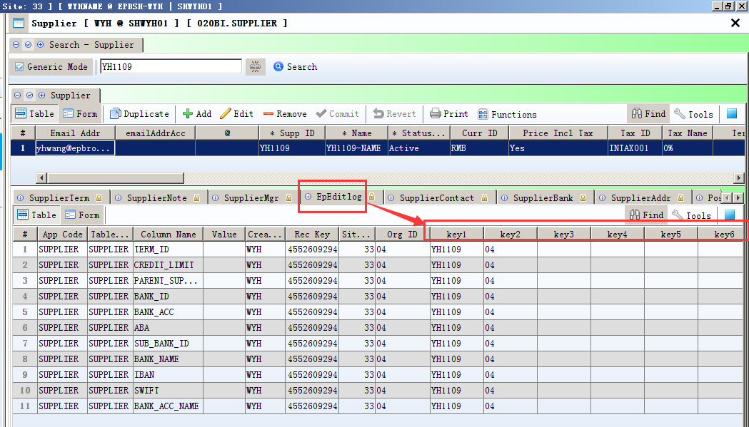
KEY1=SUPP_ID

3.3.2 060CB Sales Order:Added function'Update Header Tax To Line'.(31984)-900
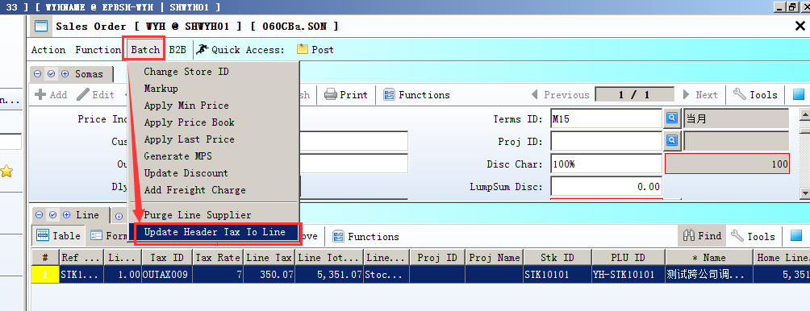

3.2.3 090CaC Item Enquiry:Added column'Total Sales2(without Deposit) ' in BI. (31925)-900
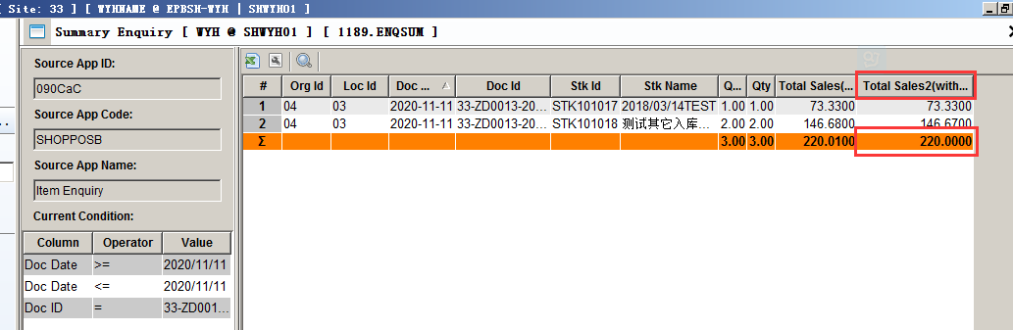

3.2.4 090CdB Shopping Voucher:Added column'phone'.(31972)-900
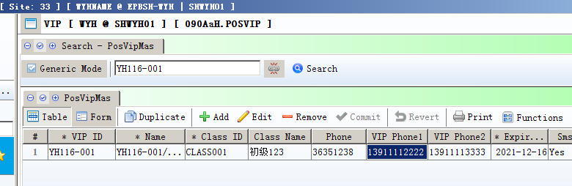
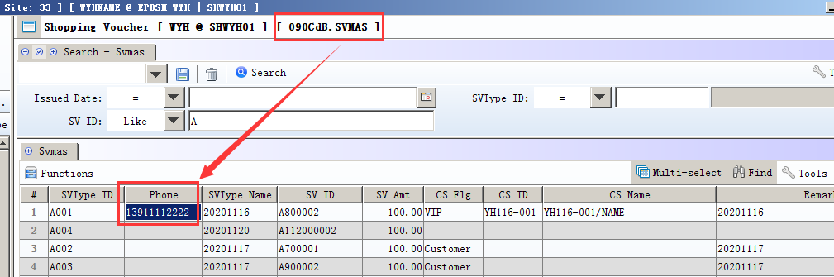

3.2.5 090Cdb Shopping Voucher :Added function' Generate Voucher by Customer '. (32008)-900
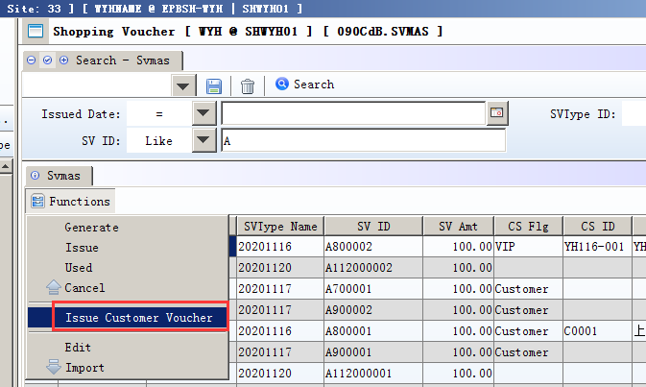

3.3.6 090D Added control : Different shops are not allowed to call the 'Collection' at the same time (31922)-900
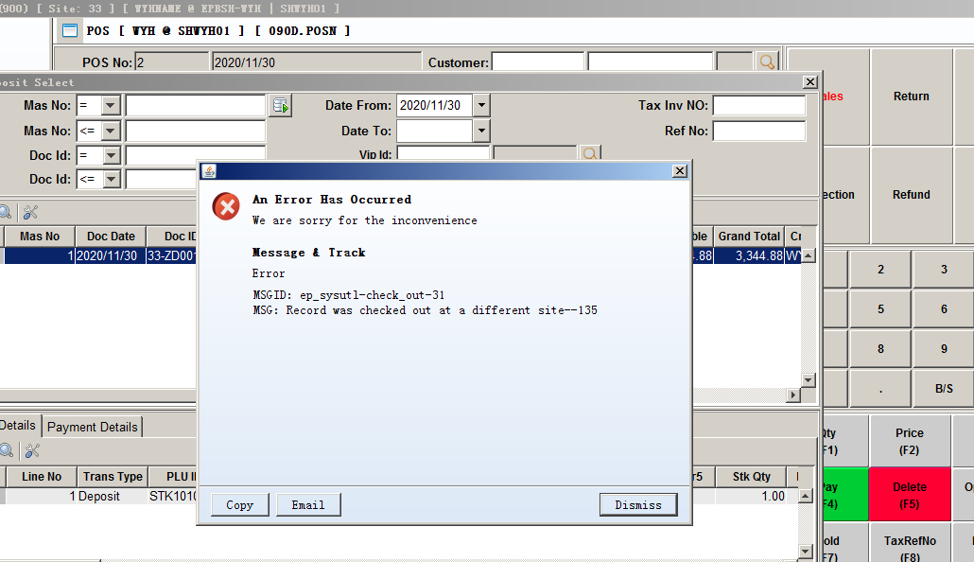

3.2.7 Added Function: SV_ID binding STK_ID (31968)-900
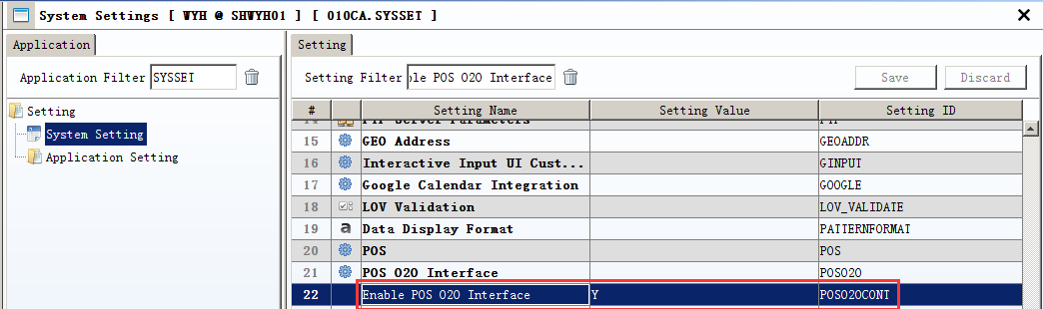
1) 010CA:seting
Enable POS O2O Interface=Y

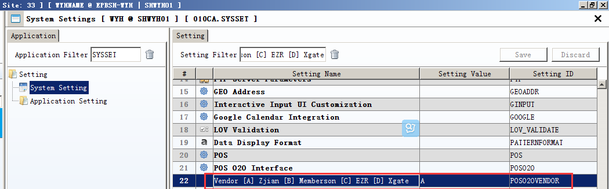
2) 010CA:setting:
Vendor [A] Zjian [B] Memberson [C] EZR [D] Xgate=A
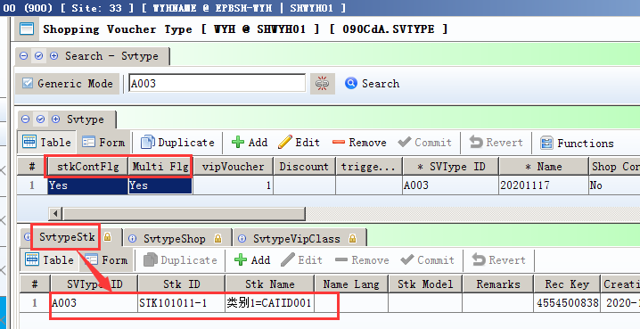
3) 090CdA:
3.1) Multi Flg=Y;
3.2) stkContFlg=Y;
3.3) SvTypeStk binding STK_ID
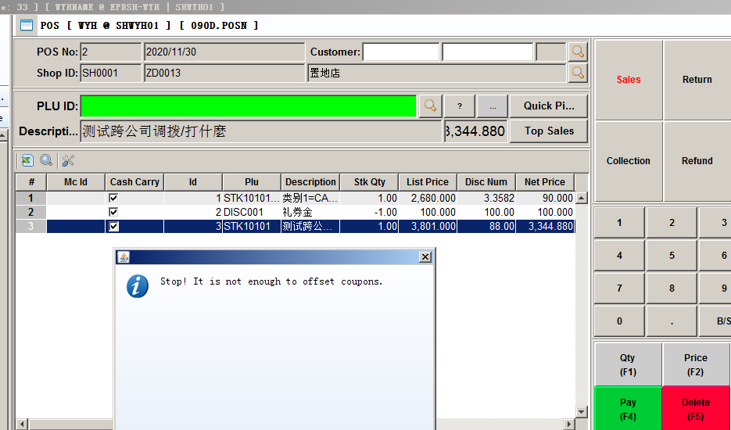
4)sv_id= A900002,must use to scan, can't use to PAY4!

3.2.8 140DE Inventory Transfer Planning:Added function'config'.(31967)-900
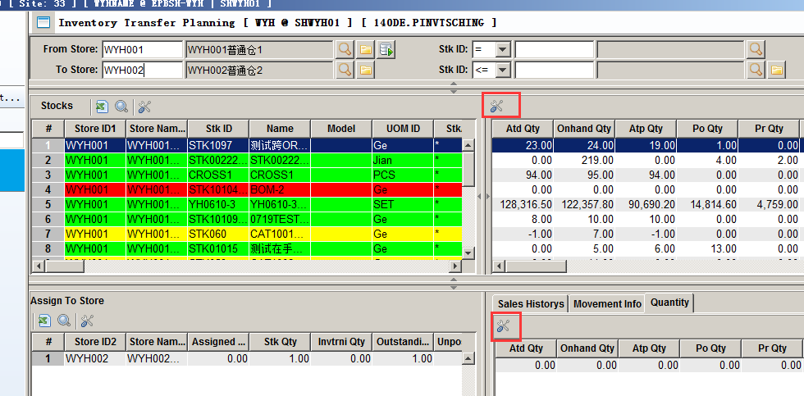

3.2.9 140DE Inventory Transfer Planning :Added columns:REF1~REF32.(31971)-900
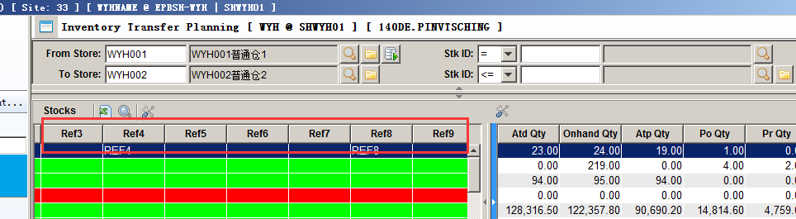

3.2.10 140EB Stock Summary:Added column'STK_NAME'.(31885)-900
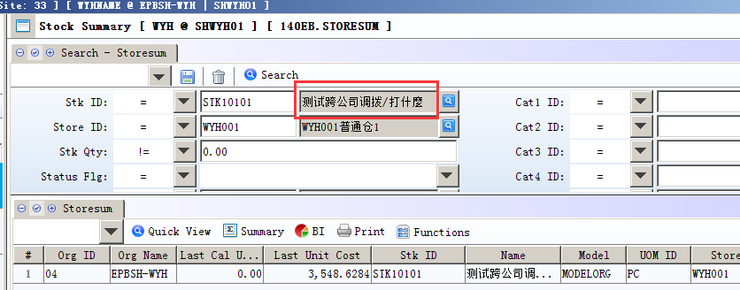

3.3.11 140ED Stock Transaction:Added column'Our ref' .(31938)-900
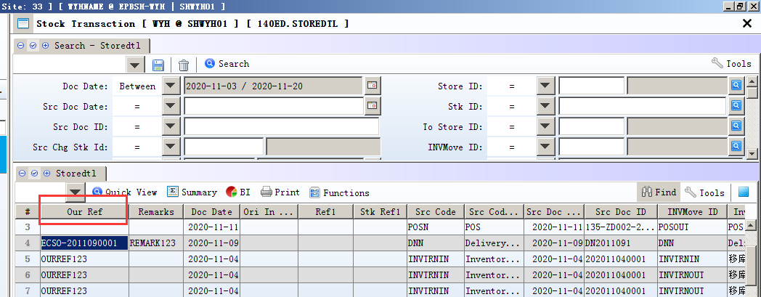

3.3.12 140CG Inventory Transfer Request :Added colunns:'ANA_ID1'~'ANA_ID10'.(31914)-900
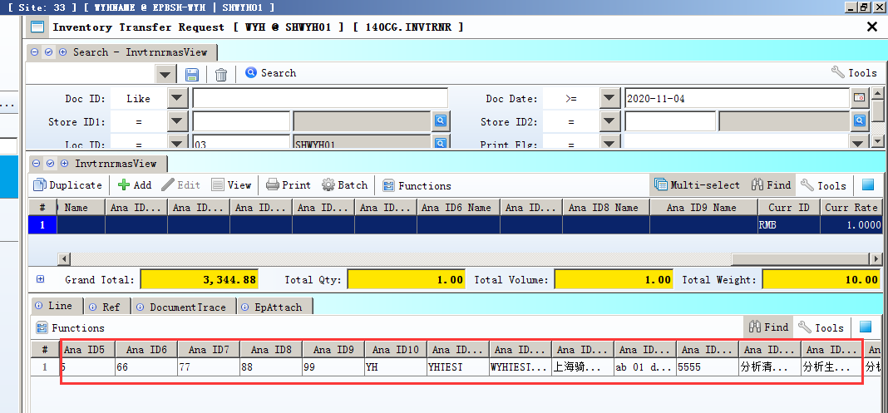
Only the detail line

3.3.13 180AG BOM:Added function 'Material List'. (32005)-900
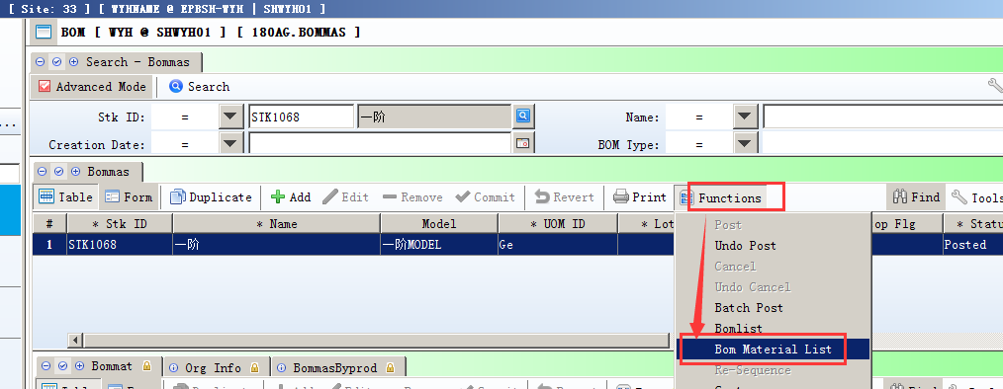
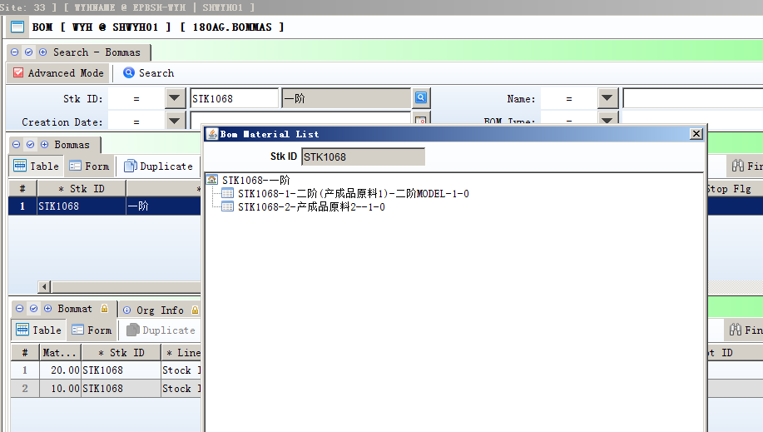

3.3.14 200CEB AR Ageing:Added column 'VOU_DOC_ID'. (31998)-900
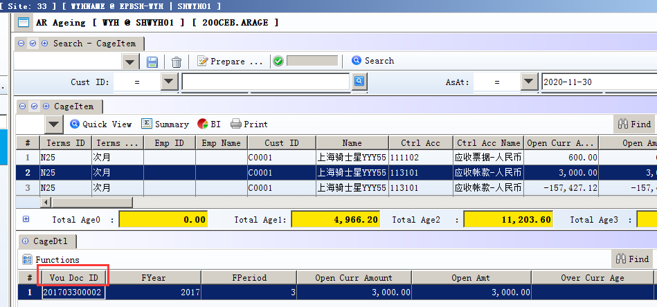

4. Fixes

