EPBrowserRelease Notes
Version 9.01

EPBrowserRelease Notes Version 9.01
Last Revision, 28 December 2020

©Copyright 2020. Enterprise Browser Pte Ltd.
All rights reserved.

No part of this manual may be reproduced in any form or by any means without the express written authorization from EPB. Business forms—which include but are not limited to invoices, checks, sales orders—displayed in this manual are for illustration purposes only and are not to be used for producing actual business forms. Enterprise Browser Pte Ltd. assumes no responsibility.
This document may contain technical inaccuracies or typographical errors and may change without prior notice. Any documentation with respect to EPB software products is provided for informational purposes only and does not extend or modify the limited warranty extended to the licensee of EPB software products.

Enterprise Browser Pte Ltd (EPB)
33Ubi Avenue 3, #07-65, Vertex Tower A, Singapore 408868
Tel: (65)-6509-4065
Fax: (65)-6509-4089

Document Location
EPBSH

Contents
1. Featured 4
2. New Interface 4
3. Enhancements 4
3.1 Privilege 4
3.2 Setting 4
3.2.1 010AA Organization:Added setting'Retrieve from Stock Master(STKMAS_LOC)'.(32134)-901 4
3.2.2 060CBA Sales Agreemen:Added setting'Enable Change Price Privilege'. (32105)-901 4
3.2.3 140EA stock level:Added setting' Send EPB Force Message when item qty below min level(Location Default Store '.(32109)-901 5
3.2.4 200DDB General Interbank Recurring Order(GIRO):Added setting'GIRO File Type [DBS] [CITI] [OCBC] [UOB]'. (32045)-901 5
3.3 Improve 6
3.3.1 020BC Terms:Added column 'type'. (32142)-901 6
3.3.2 140ADC Storage Area:Added column'minLevelAlert'. (31966)-901 6
3.3.3 060CB Sales Order:Added control' Active documents are not allowed to generate the MPS '.(32066)-891 6
3.3.4 140CG Inventory Transfer Request:Added function'When inputting CUS_ID, automatically get the address information from the customer_mas' .(32047)-901 7
3.3.5 150G Truck Note: Added function'when transfer from pkl by cust_id'.32063)-901 7
3.3.6 180BNN Work order Reporting II Enquiry: Added columm'supp_id' and 'supp_name'. (32050)-901 7
4. Fixes 7

1. Featured

2. New Interface

3. Enhancements

3.1 Privilege

3.2 Setting

3.2.1 010AA Organization:Added setting'Retrieve from Stock Master(STKMAS_LOC)'.(32134)-901
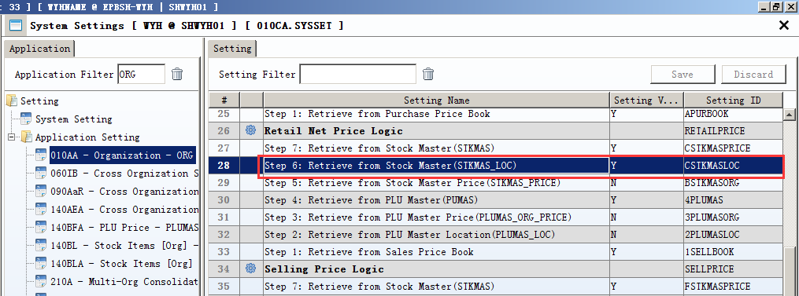

3.2.2 060CBA Sales Agreemen:Added setting'Enable Change Price Privilege'. (32105)-901
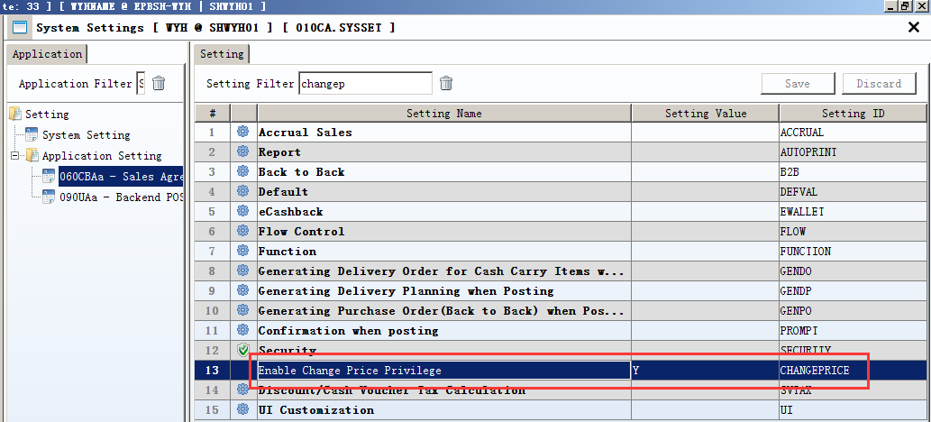
Set to Y, Didn't assign 'modify prices' privilege, If not the administrator, is not allowed to modify the price.
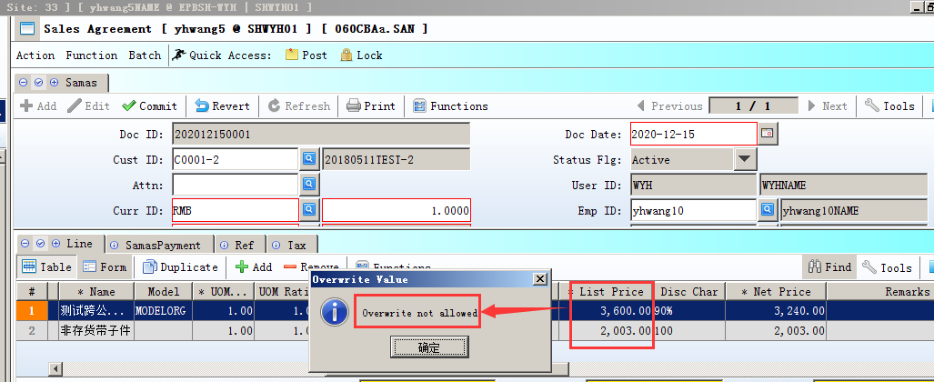

3.2.3 140EA stock level:Added setting' Send EPB Force Message when item qty below min level(Location Default Store '.(32109)-901
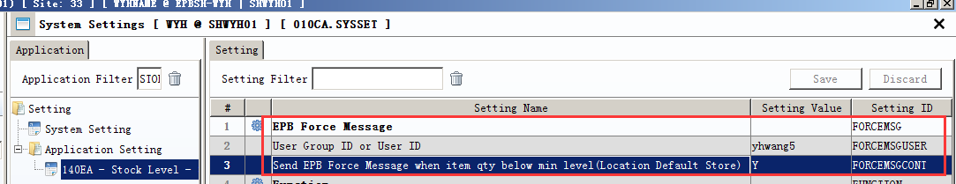
Set to Y, When item qty below min level, will send information to the specified user.

3.2.4 200DDB General Interbank Recurring Order(GIRO):Added setting'GIRO File Type [DBS] [CITI] [OCBC] [UOB]'. (32045)-901
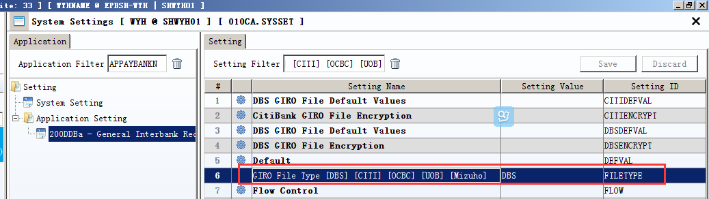

3.3 Improve

3.3.1 020BC Terms:Added column 'type'. (32142)-901
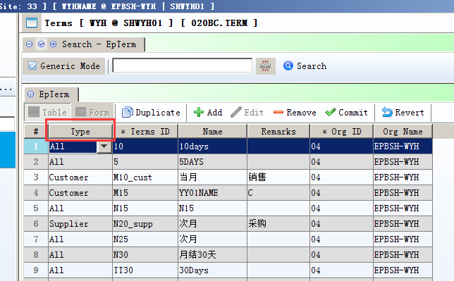
When create new document,term_id matching according to type.

3.3.2 140ADC Storage Area:Added column'minLevelAlert'. (31966)-901
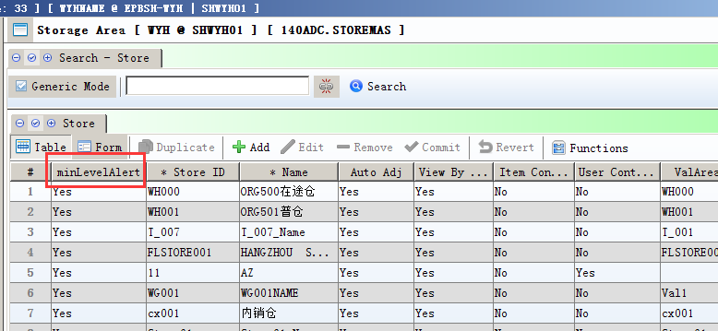
Set to Y, the warehouse calculate the quantity;
Set to N, the warehouse don't calculate the quantity.
(By MINLEVEL trigger message)

3.3.3 060CB Sales Order:Added control' Active documents are not allowed to generate the MPS '.(32066)-891
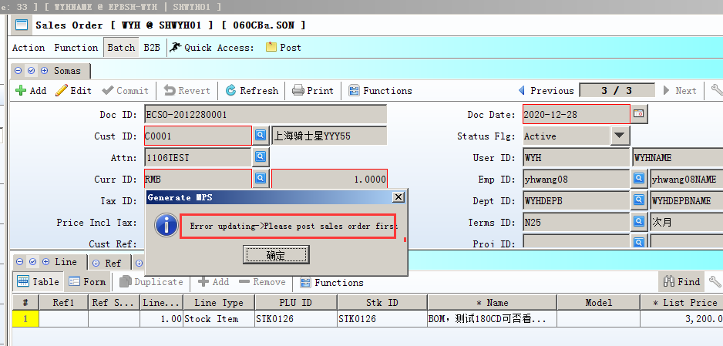

3.3.4 140CG Inventory Transfer Request:Added function'When inputting CUS_ID, automatically get the address information from the customer_mas' .(32047)-901
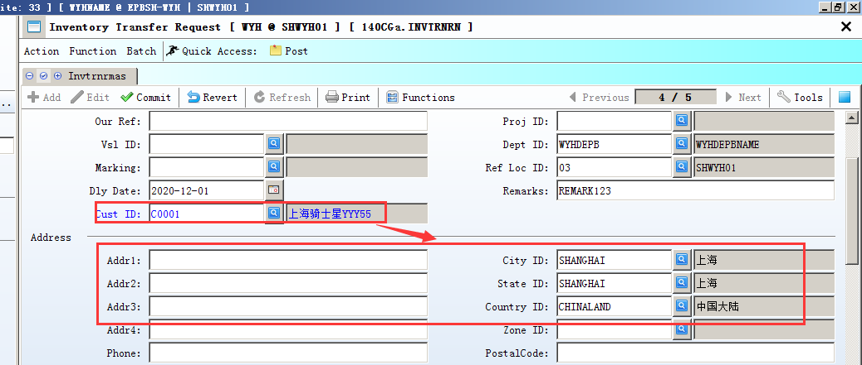

3.3.5 150G Truck Note: Added function'when transfer from pkl by cust_id'.32063)-901

3.3.6 180BNN Work order Reporting II Enquiry: Added columm'supp_id' and 'supp_name'. (32050)-901
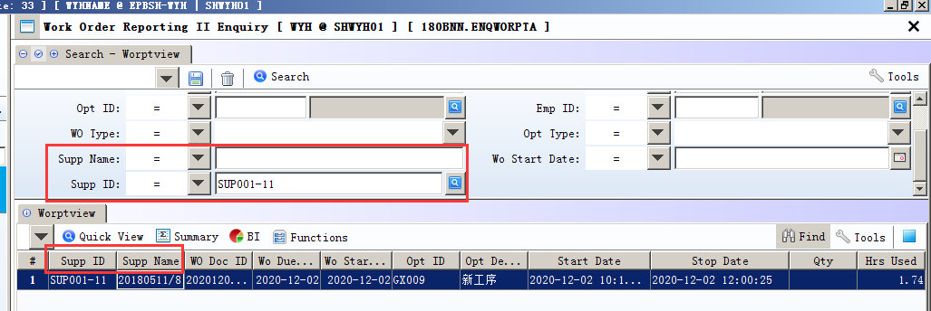

4. Fixes

