EPBrowserRelease Notes
Version 9.02

EPBrowserRelease Notes Version 9.02
Last Revision, 1 February 2021

©Copyright 2021. Enterprise Browser Pte Ltd.
All rights reserved.

No part of this manual may be reproduced in any form or by any means without the express written authorization from EPB. Business forms—which include but are not limited to invoices, checks, sales orders—displayed in this manual are for illustration purposes only and are not to be used for producing actual business forms. Enterprise Browser Pte Ltd. assumes no responsibility.
This document may contain technical inaccuracies or typographical errors and may change without prior notice. Any documentation with respect to EPB software products is provided for informational purposes only and does not extend or modify the limited warranty extended to the licensee of EPB software products.

Enterprise Browser Pte Ltd (EPB)
33Ubi Avenue 3, #07-65, Vertex Tower A, Singapore 408868
Tel: (65)-6509-4065
Fax: (65)-6509-4089

Document Location
EPBSH

Contents
1. Featured 4
2. New Interface 4
2.1 Added new module:140BIA Stock Item Attribute. (32234)-902 4
3. Enhancements 4
3.1 Privilege 4
3.2 Setting 4
3.2.1 090H Shop Replenishment:Added setting'Replenishment include non-stock items'. (32206)-902 4
3.2.2 140CH Inventory Transfer Issue:Added setting'Disallow posting if item without code'.(32264)-902 5
3.2.3 180BA Work Order:Added setting'WO Opt Uom [S] Second [M] Minute [H] Hour'.(32219)-902 5
3.3 Improve 6
3.3.1 00 LOV Added a button 'restore factory settings'. (32248)-902 6
3.3.2 010AA Organization:added column'xcurrId',020BA Currency:added column'xcurrRate';200BA General Accounting Voucher:added columns'xcr' and 'xdr' and 'xcurrRate' and 'xsrcAmt'.(32254)-902 6
3.3.3 050M Sales Activities:Added column'EMAIL_ADDR'. (32214)-902 7
3.3.4 060BZ Sales Price Book Enquiry: Added column'create_date'.(32181)-902 7
3.3.5 090CaC Item Enquiry:Added column' create_date ' .(32155)-902 7
3.3.6 140CJ Added the 'InvtakelineBatch' table.(31480)-902 8
3.3.7 140EBA Stock Summary As At:Added column'source'.(32216)-902 8
3.3.8 180BNE Work Order Material Enquiry:Added columns'CUS_ID' and 'CUS_NAME'.(32272)-902 8
3.3.9 200ANA Budget Enquiry:Added the table'BudgetApproving'.(32205)-902 9
3.3.10 800AB Shop Revenue Analysis:Added column'create_date'.(32159)-902 9
4. Fixes 9

1. Featured

2. New Interface

2.1 Added new module:140BIA Stock Item Attribute. (32234)-902
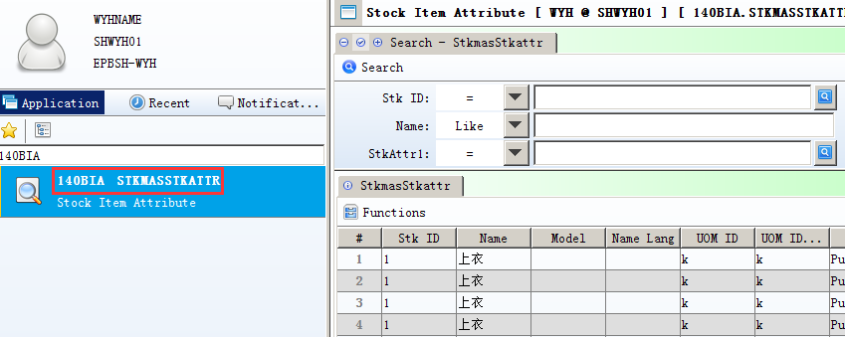

3. Enhancements

3.1 Privilege

3.2 Setting

3.2.1 090H Shop Replenishment:Added setting'Replenishment include non-stock items'. (32206)-902
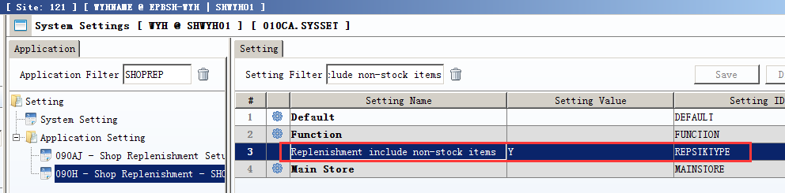
1,SET TO Y: Replenishment include non-stock items;
2,SET TO N:
Replenishment don't include non-stock items.

3.2.2 140CH Inventory Transfer Issue:Added setting'Disallow posting if item without code'.(32264)-902
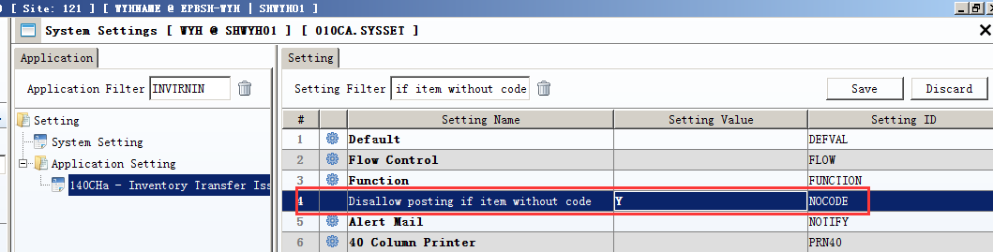
140CF:Added the same setting.
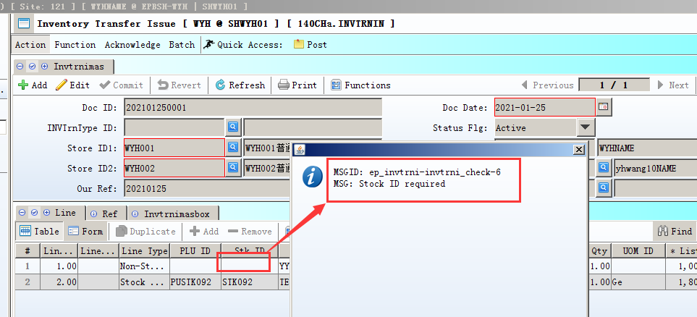
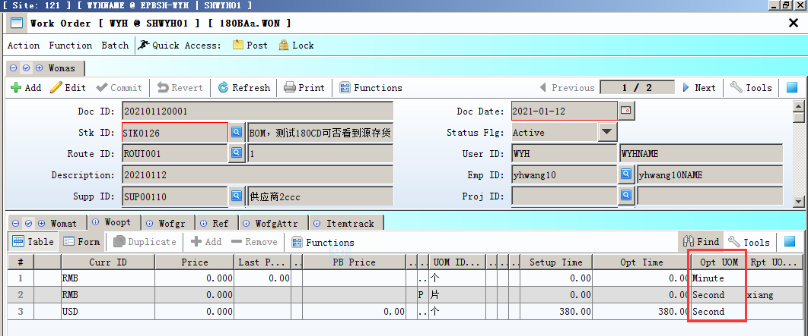

3.2.3 180BA Work Order:Added setting'WO Opt Uom [S] Second [M] Minute [H] Hour'.(32219)-902
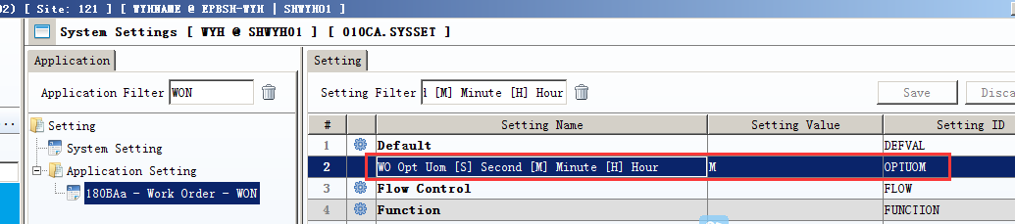

3.3 Improve

3.3.1 00 LOV Added a button 'restore factory settings'. (32248)-902
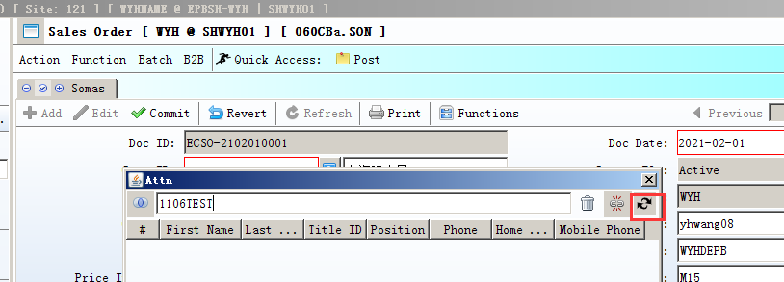
1,LOV add a button to delete property

2, After perform this action, to log in again.

3.3.2 010AA Organization:added column'xcurrId',020BA Currency:added column'xcurrRate';200BA General Accounting Voucher:added columns'xcr' and 'xdr' and 'xcurrRate' and 'xsrcAmt'.(32254)-902
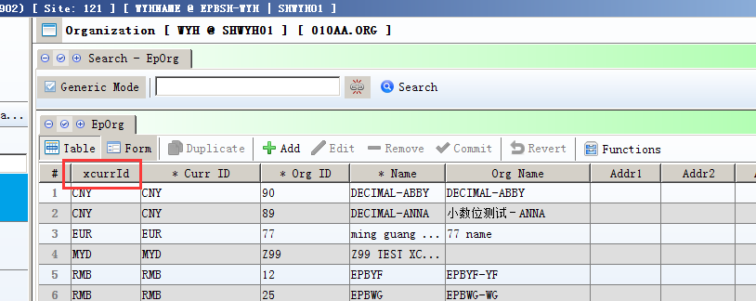
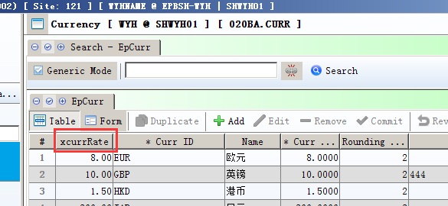
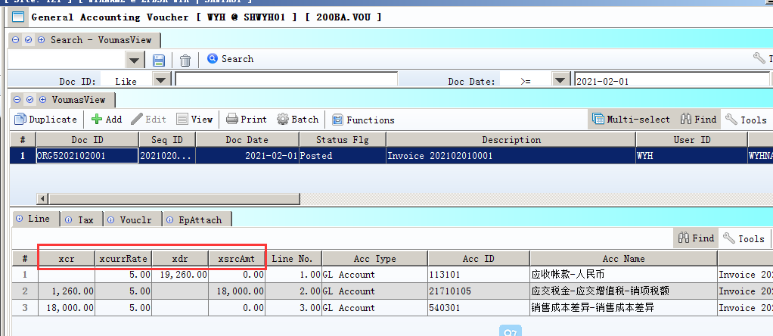

3.3.3 050M Sales Activities:Added column'EMAIL_ADDR'. (32214)-902
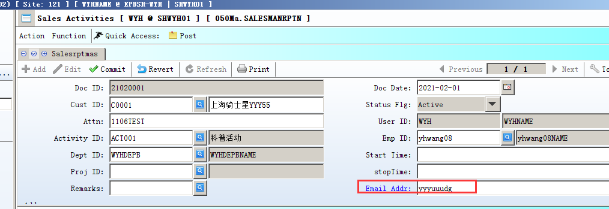

3.3.4 060BZ Sales Price Book Enquiry: Added column'create_date'.(32181)-902
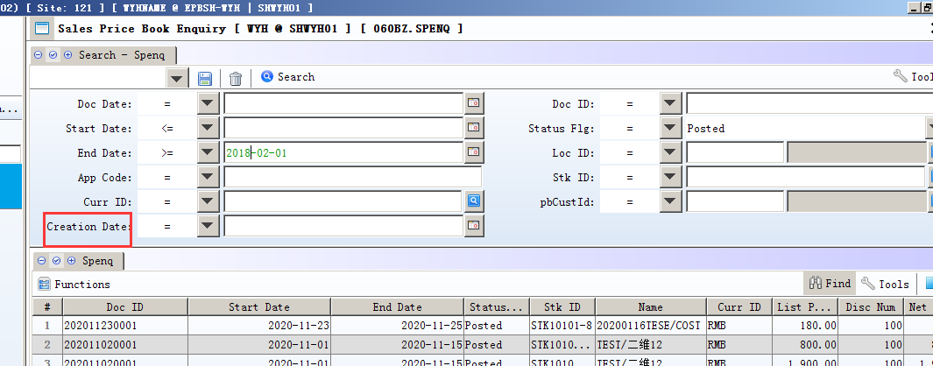

3.3.5 090CaC Item Enquiry:Added column' create_date ' .(32155)-902
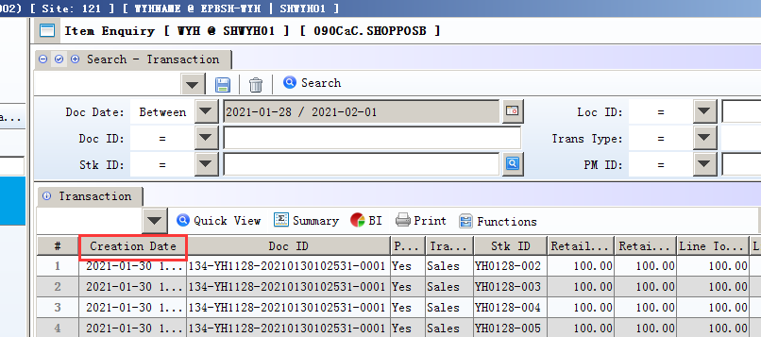

3.3.6 140CJ Added the 'InvtakelineBatch' table.(31480)-902
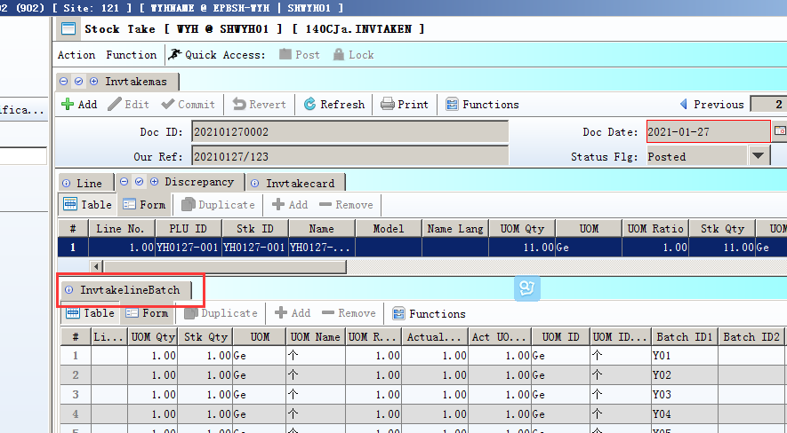
Adjust differences qty of the batch stock.

3.3.7 140EBA Stock Summary As At:Added column'source'.(32216)-902
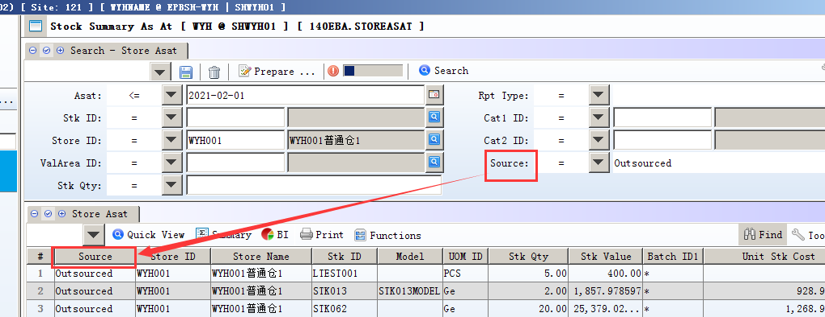

3.3.8 180BNE Work Order Material Enquiry:Added columns'CUS_ID' and 'CUS_NAME'.(32272)-902
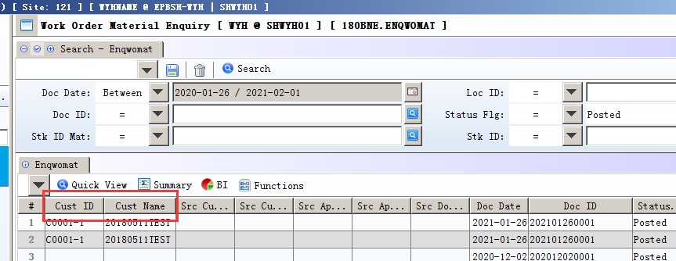

3.3.9 200ANA Budget Enquiry:Added the table'BudgetApproving'.(32205)-902
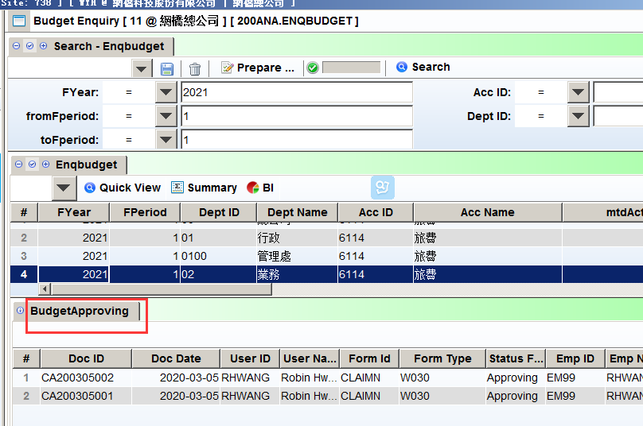

3.3.10 800AB Shop Revenue Analysis:Added column'create_date'.(32159)-902
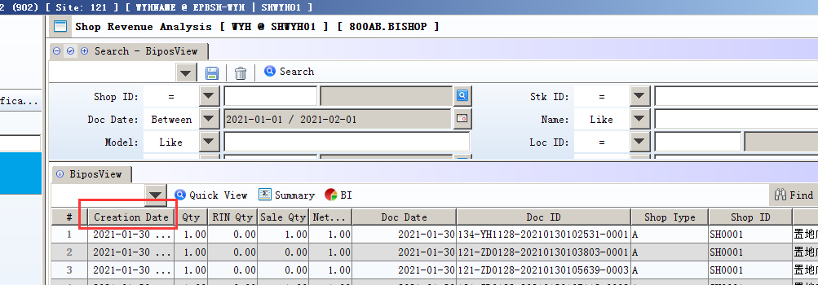

4. Fixes

