EPBrowserRelease Notes
Version 9.03~9.04

EPBrowserRelease Notes Version 9.03~9.04
Last Revision, 19 April 2021

©Copyright 2021. Enterprise Browser Pte Ltd.
All rights reserved.

No part of this manual may be reproduced in any form or by any means without the express written authorization from EPB. Business forms—which include but are not limited to invoices, checks, sales orders—displayed in this manual are for illustration purposes only and are not to be used for producing actual business forms. Enterprise Browser Pte Ltd. assumes no responsibility.
This document may contain technical inaccuracies or typographical errors and may change without prior notice. Any documentation with respect to EPB software products is provided for informational purposes only and does not extend or modify the limited warranty extended to the licensee of EPB software products.

Enterprise Browser Pte Ltd (EPB)
33Ubi Avenue 3, #07-65, Vertex Tower A, Singapore 408868
Tel: (65)-6509-4065
Fax: (65)-6509-4089

Document Location
EPBSH

Contents
1. Featured 4
2. New Interface 4
2.1 Add module for In-House Certificate Enquiry(32525)-904 4
2.2 MTC Management 4
3. Enhancements 5
3.1 Privilege 5
3.2 Setting 5
3.2.1 010CA: New system setting “ Delivery Timeslot LOV using [A] DELIVERY_TIMESLOT [B] EC_TIMESLOT_POSTALCODE” for restrict delivery postal code zone.(32358)-903 5
3.2.2 060CA/060CB:new setting of pre-post control of over credit limit(32387)-903 5
3.2.3 070CC: Add new setting to keep “Our Ref” field when copying from source document such as RFQ(32357)-903 6
3.2.4 090CdB: Add new setting 'Update Status to Expired After Expiry Date' (32355)-903 6
3.2.5 010CA:Add security control to verified password when viewing or editing PDF report print out from EPB system. When the setting value is N, no password is need to view or edit the PDF report. 6
3.2.6 070CC PO add function of sending epb mail to designated user when the supplier account is over supplier credit limit (32522)-904 7
3.2.7 070CE New setting to prohibited edit “Term Id” in SPN, DGN,RNSRN, RNSN,SINVN (32551)-904 7
3.2.8 090D New setting to “Post prevent inventory transaction to current period when POS transaction period closed”. (32549)-904 8
3.3 Improve 8
3.3.1 START: Approval Tab add Marking & Marking Name fields. (32554)-904 8
3.3.2 020BF Customer add Timeslot field(32474)-904 8
3.3.3 110E Add “fixPeriod” field to constraint query result merely to list G/L transaction posted in this period. (21596)-904 9
3.3.4 140BS & Stock Level Tab of 140BA add “Stk Model” field to display stock model when defining Stock level(32558)-904 9
3.3.5 140EA Stock Level add query criteria “Name Lang” (32555)-904 10
3.3.6 160AZ Expenses Claims Enquiry add column Ref1~Ref4,LineRef1~LineRef4,OurRef as criteria as well as query result(including BI report) (32542)-904 10
3.3.7 180BT Inhouse Test Certificate add “Exp Date” both as criteria and query result 10
4. Fixes 10

1. Featured

2. New Interface

2.1 Add module for In-House Certificate Enquiry(32525)-904
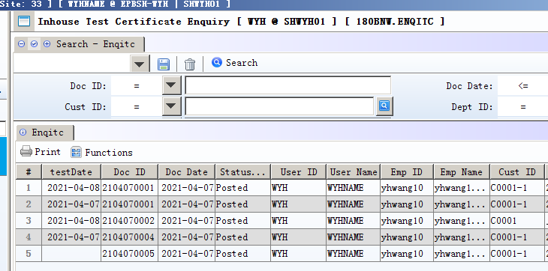

2.2 MTC Management
【180BU】 Add MTC document for mill test certification (32443)-904
【180BV】 Add MTCIMP module for batch import MTC and Generate MTC document after import(32443)-904. setting：'Purge imported data after generating' should be “Y “to avoid generating redundant MTC document.
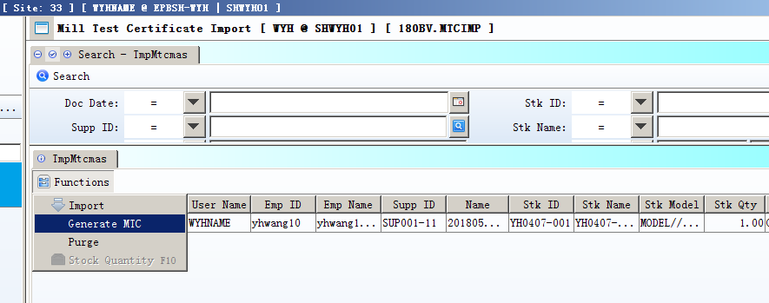

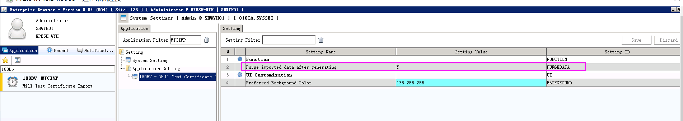

3. Enhancements

3.1 Privilege

3.2 Setting

3.2.1 010CA: New system setting “ Delivery Timeslot LOV using [A] DELIVERY_TIMESLOT [B] EC_TIMESLOT_POSTALCODE” for restrict delivery postal code zone.(32358)-903
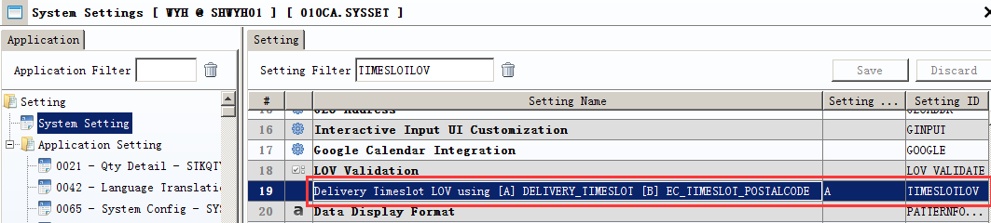

3.2.2 060CA/060CB:new setting of pre-post control of over credit limit(32387)-903
When the setting Value is “Y”, if this account is over credit limit, dialog box pops up when Post the document. User can click Y button to continue or N to deny the post action.
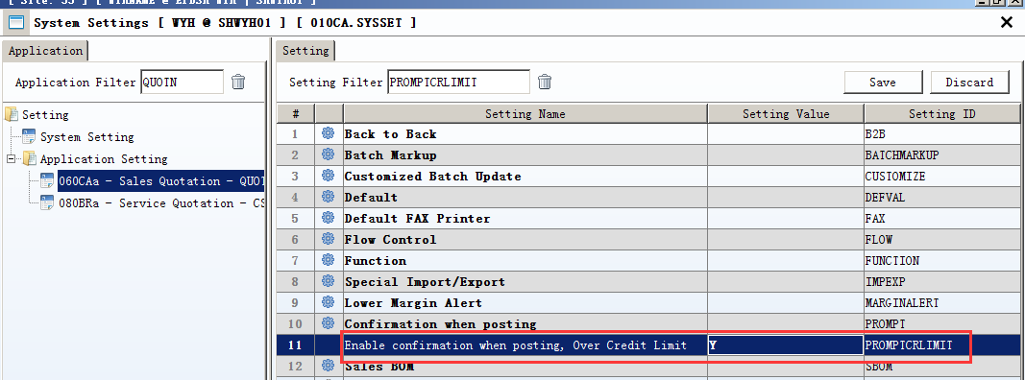
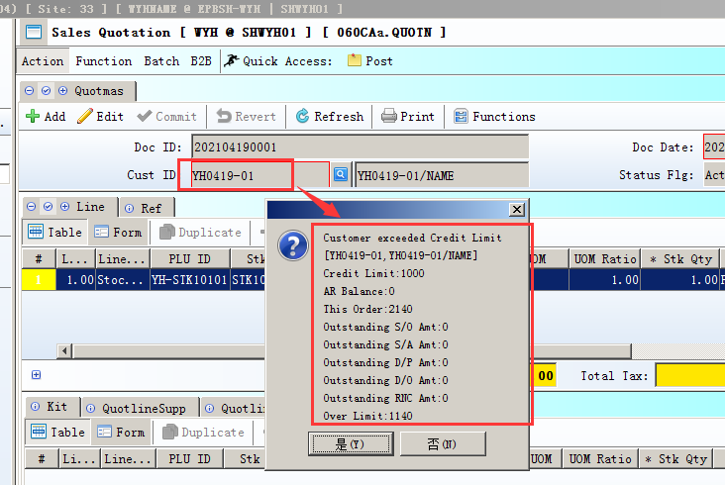

3.2.3 070CC: Add new setting to keep “Our Ref” field when copying from source document such as RFQ(32357)-903
When the setting Value is “N”, “source doc id”+ “our reference” will be put in “our reference” of PO doc.
When the setting Value is “Y”, only “our reference” will be put in “our reference” of PO doc.
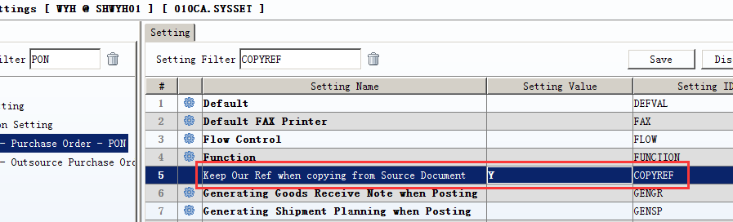

3.2.4 090CdB: Add new setting 'Update Status to Expired After Expiry Date' (32355)-903
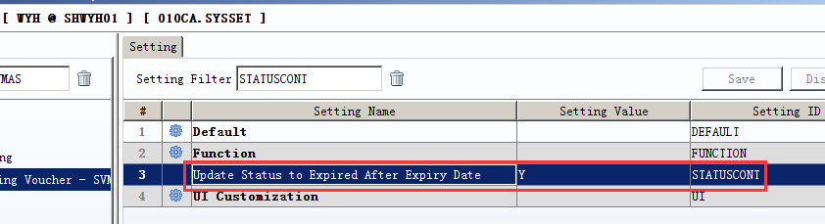

3.2.5 010CA:Add security control to verified password when viewing or editing PDF report print out from EPB system. When the setting value is N, no password is need to view or edit the PDF report.
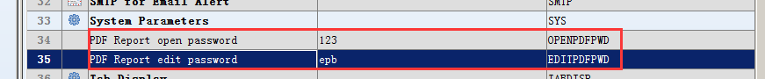
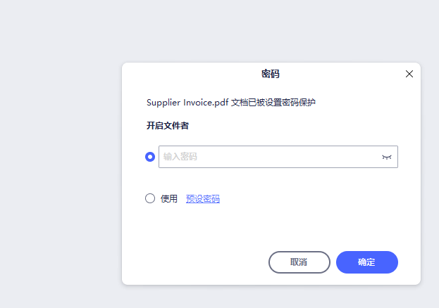
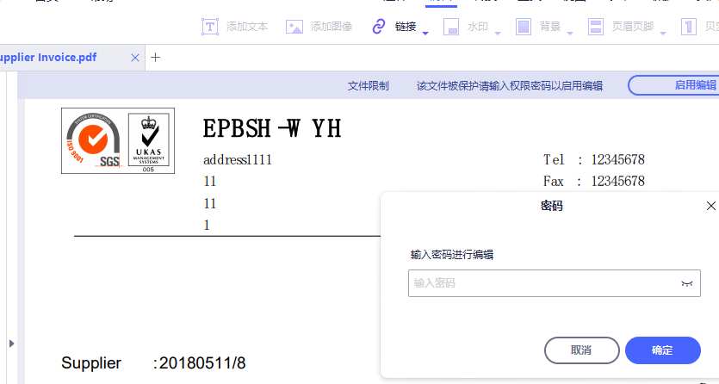

3.2.6 070CC PO add function of sending epb mail to designated user when the supplier account is over supplier credit limit (32522)-904
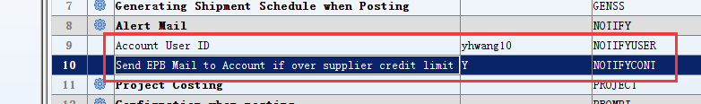
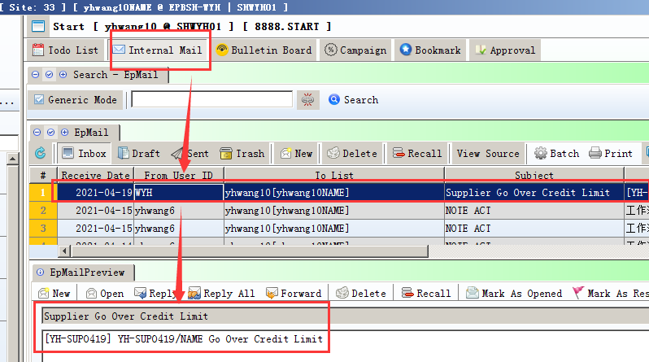

3.2.7 070CE New setting to prohibited edit “Term Id” in SPN, DGN,RNSRN, RNSN,SINVN (32551)-904
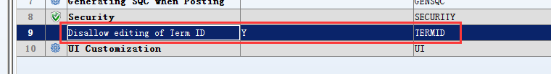

3.2.8 090D New setting to “Post prevent inventory transaction to current period when POS transaction period closed”. (32549)-904
Set the Setting valued as “N”to validate the control.

3.3 Improve

3.3.1 START: Approval Tab add Marking & Marking Name fields. (32554)-904
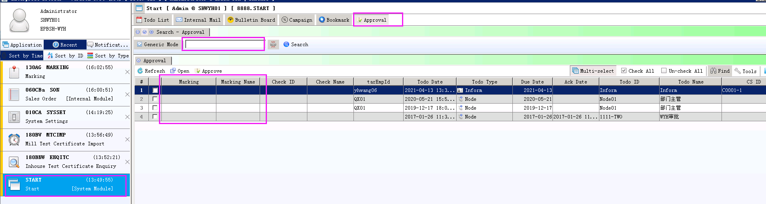

3.3.2 020BF Customer add Timeslot field(32474)-904
Timeslot of this customer will be carried out as default in following document such as sa/so/sochg/dp/do once defined in Customer. Timeslot of CustomerAddr will be carried out as default only when the Delivery Address is selected in sa/so/sochg/dp/do.
Timeslot must be defined in 060AI previously wrapped to Delivery Zone.
Timeframe is bound with Timeslot in 060AI and can not be edited otherwise.

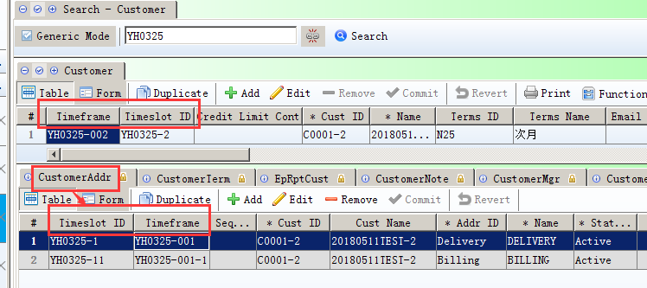
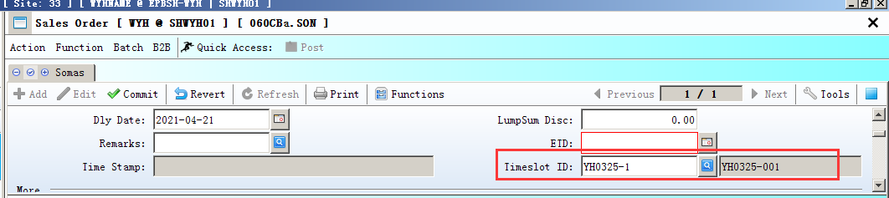

3.3.3 110E Add “fixPeriod” field to constraint query result merely to list G/L transaction posted in this period. (21596)-904
Set fixPeriod as “Yes” to effect the constraint.
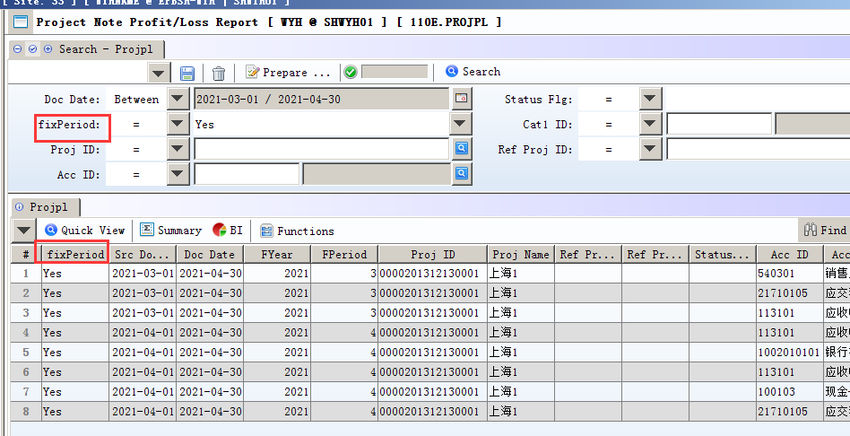

3.3.4 140BS & Stock Level Tab of 140BA add “Stk Model” field to display stock model when defining Stock level(32558)-904
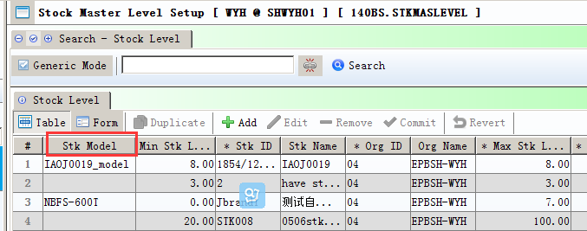

3.3.5 140EA Stock Level add query criteria “Name Lang” (32555)-904
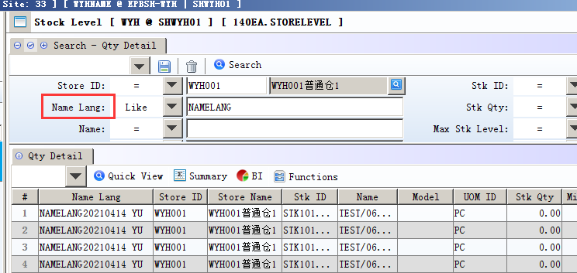

3.3.6 160AZ Expenses Claims Enquiry add column Ref1~Ref4,LineRef1~LineRef4,OurRef as criteria as well as query result(including BI report) (32542)-904

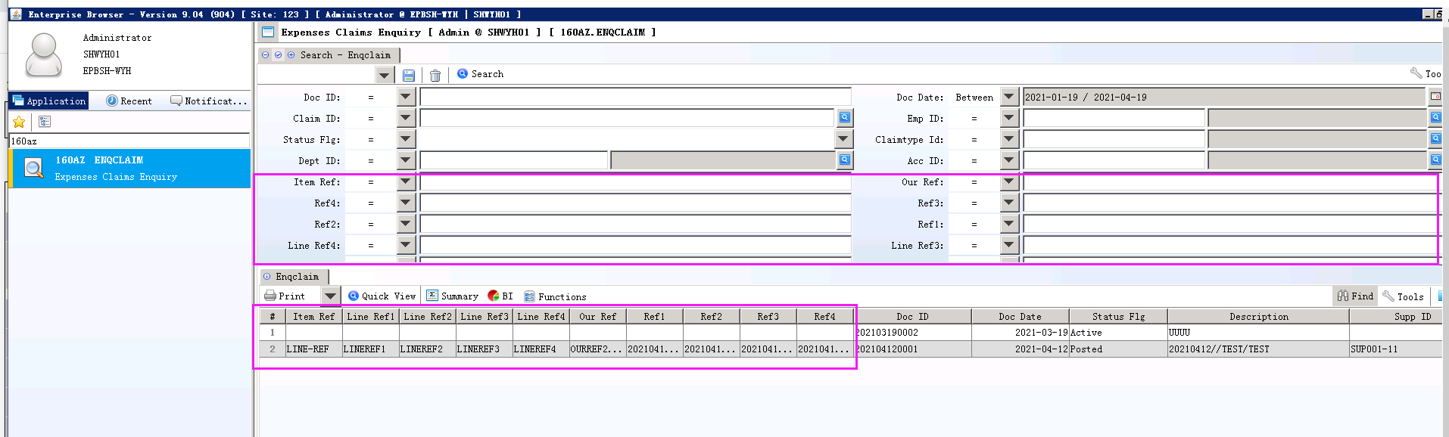

3.3.7 180BT Inhouse Test Certificate add “Exp Date” both as criteria and query result
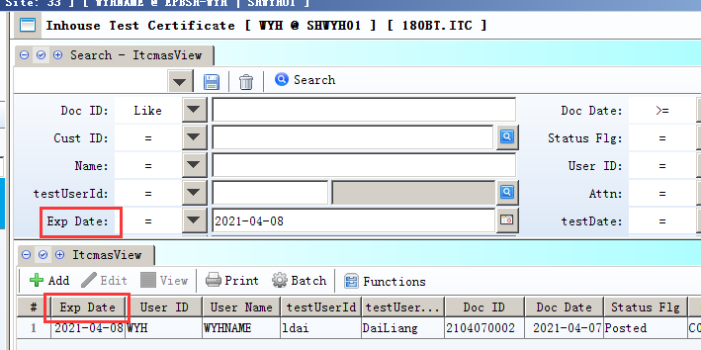

4. Fixes

