EPBrowserRelease Notes
Version 9.05~9.06

EPBrowserRelease Notes Version 9.05~9.06
Last Revision, 7 June 2021

©Copyright 2021. Enterprise Browser Pte Ltd.
All rights reserved.

No part of this manual may be reproduced in any form or by any means without the express written authorization from EPB. Business forms—which include but are not limited to invoices, checks, sales orders—displayed in this manual are for illustration purposes only and are not to be used for producing actual business forms. Enterprise Browser Pte Ltd. assumes no responsibility.
This document may contain technical inaccuracies or typographical errors and may change without prior notice. Any documentation with respect to EPB software products is provided for informational purposes only and does not extend or modify the limited warranty extended to the licensee of EPB software products.

Enterprise Browser Pte Ltd (EPB)
33Ubi Avenue 3, #07-65, Vertex Tower A, Singapore 408868
Tel: (65)-6509-4065
Fax: (65)-6509-4089

Document Location
EPBSH

Contents
1. Featured 4
2. New Interface 4
2.1 Add new module 010BS Personal Data Protection Act Control.(32557)-906 4
2.2 Add SKU management 4
3. Enhancements 5
3.1 Privilege 5
3.2 Setting 5
3.2.1 060CA.QUOT Add new setting: Allow modification of billing address/BILLADDR.(32642)-906 5
3.2.2 180BBMaterial Issue add setting 'Transfer From Invqty’.(32596)-905 6
3.2.3 180BFA.Batch Generate Work Order add new setting: ’Allow over -transferring from sales Agreement’.(32638)-906 6
3.2.4 200CD.Official Receipt /200DD.Payment Voucher add setting ‘Separate Gain/Loss transactions’.(32592)-906 7
3.2.5 200DP.AP Accrual add setting'Inventory ACC ID'.(32650)-906 8
3.3 Improve 8
3.3.1 Not validate Bank id and Sub Bank id in SupplierBank tab of SUPPLIER with 200EAB.BANKMAS. (32690)-906 8
3.3.2 070CF.Good Receive enable distribute tariff amount according HS code in 140BA.STKMAS.(32595)-906 9
3.3.3 9
3.3.4 Add familyVip_id/Self8_id in VIP lov of POSN.(32681)-906 9
3.3.5 090U/090UA Type delete Trans Type 'deposit'/'refund'.(32639)-906 10
3.3.6 140EK.ENQBO BI report add Attribute 1/Attribute 1 Name~ Attribute 5/Attribute 5 Name.(32677)-906 10
3.3.7 180BA.Work Order/180BAA.Work Order Change Note add Material qty zero control.(32641)-906 10
3.3.8 190BF.Value Adjust add function: Transfer From Supplier Credit Note.(32672)-906 11
3.3.9 200AP Official Receipt Type Setup add Org ID and Org Name.(32648)-906 11
3.3.10 200AQ module is deleted and payment type change to be defined in 020BJ Payment Type.(32691)-906 11
3.3.11 Other Transaction tab of 200DDA AP Payment Batch add 'Swift' field to keep bank swift code.(32685)-906 13
3.3.12 Lov of Aanalysis code 10 in all modules selected from 200AK Cash Flow ID.(15375)-906 13
4. Fixes 13

1. Featured

2. New Interface

2.1 Add new module 010BS Personal Data Protection Act Control.(32557)-906
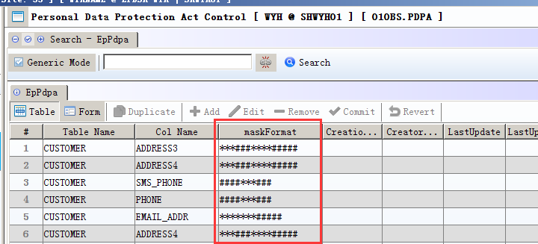
1)rules of maskFormat:
Mask format is made up with * and #. The character will be displayed as * when the mask code is * while the character will be displayed normally when the code is a #.
If the last bit of maskFormat is *, all subsequent character will following the masking rule of *, which means replacing character with *.
On the same time, if the last bit of maskFormat is #, all subsequent character will following the masking rule of #, which means displaying its original character.
2)Column with mask format must obey user privilege of the master data module;
3)010CA. SYSSET add a new setting to enable this module 010BS.PDPA working;
exec create_sys_setting('PDPA','Enable Personal Data Protection Act Control','N','SYS','C','N','N')=Y
4)If a Role has ‘Access’ privilege of 010BS.PDPA, the user can view original value of the masked field.
5) If a Role has ‘Export’ privilege of 010BS.PDPA, the user can export original value of the masked field.
6) If a Role do not have ‘Access’ privilege of 010BS.PDPA, the masked field will not be displayed in BI report.
Note: Exporting log will recorded in file named EP_PDPA_EXPORT_LOG and it can only be exported from server.

2.2 Add SKU management
140BU.SKU Master module is created to define unique stk id + stkattr1 id(Color id) + stkattr2 id(Size id).
The difference between SKU and PLU:
Stk id with specific stkattr1 id and stkattr2 id may map to several PLU while only can map to one SKU.

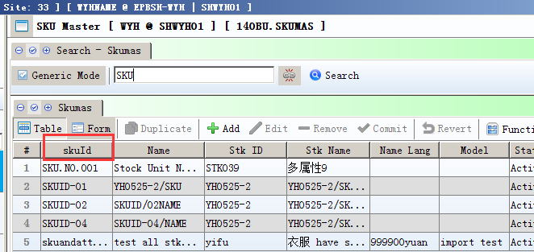
- Sale price and Retail Price in transaction can be retrieved from SKU price by Application setting of 010.ORG
- Special price by stock category or brand defined in Price Book and Campaign can be set as according stk category/brand or sku category/brand in 010CA.System Setting (Campaign/Price Book, Category/Brand define in [A] STKMAS [B] SKUMAS)

3. Enhancements

3.1 Privilege

3.2 Setting

3.2.1 060CA.QUOT Add new setting: Allow modification of billing address/BILLADDR.(32642)-906
In previous version, bill address cannot be edit when system setting “Allow modification of billing address/BILLADDR” is ‘N’. From EPB version 906, user can modify(re-select) bill address in active Quotation document when this setting value is ‘Y’.

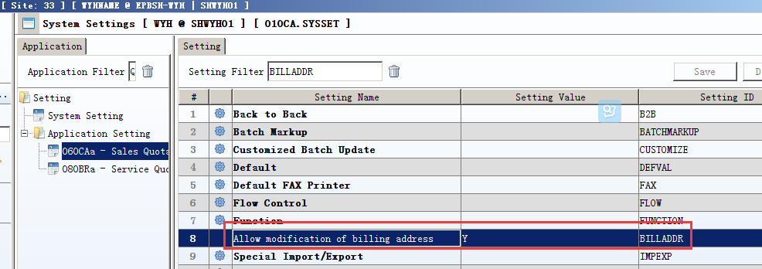
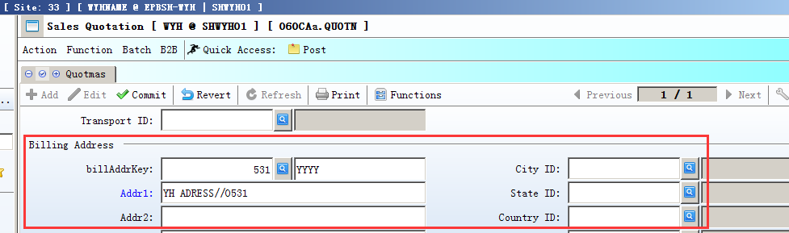

3.2.2 180BBMaterial Issue add setting 'Transfer From Invqty’.(32596)-905
When this setting is Y, user can issue material from inventory other than Work Order.
Several setting in Material Issue should be set as following to enable transferring material from Invqty:
- Allow over-transferring from Work Order Material Y OVERCONTWOMAT
- Allow over-transferring from Material Requisition Y OVERCONTMATIR
- Enable transferring from Material Issue Request N TRANSFER
- Automatically create work order material when material issue posting Y AUTOMAT

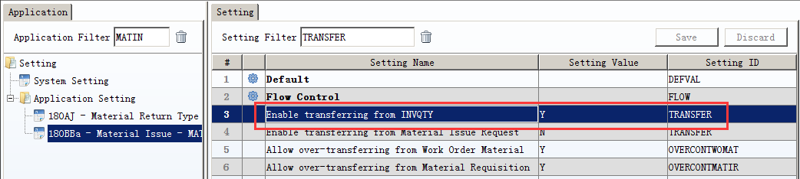
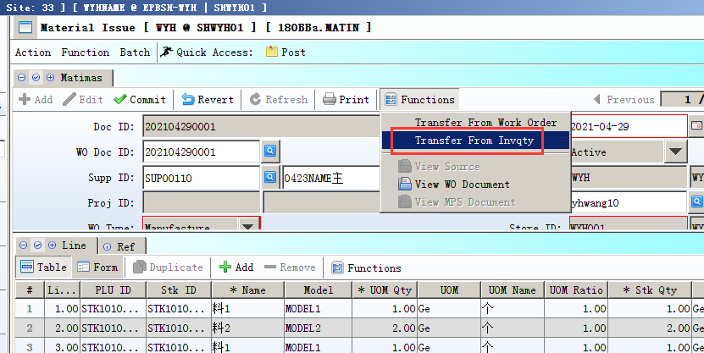

3.2.3 180BFA.Batch Generate Work Order add new setting: ’Allow over -transferring from sales Agreement’.(32638)-906
When the setting valued is Y, system will control Plan Qty must be transferred from Sales Agreement and can’t be edit to a bigger quantity. This setting is used to constrain user from generating WO items redundantly.
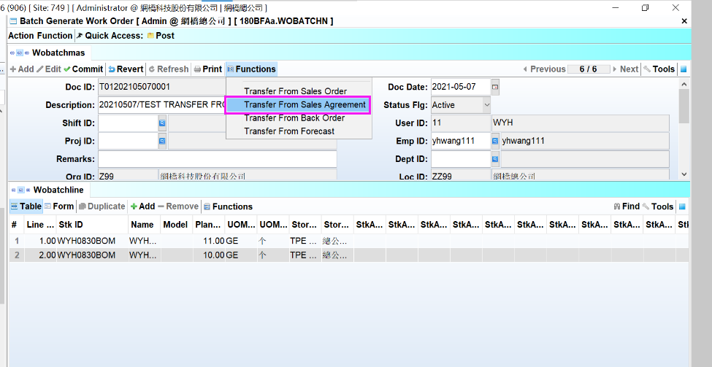
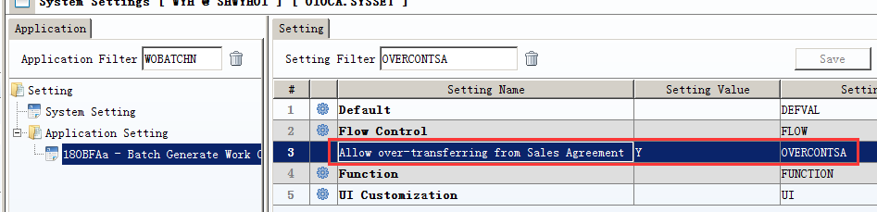

3.2.4 200CD.Official Receipt /200DD.Payment Voucher add setting ‘Separate Gain/Loss transactions’.(32592)-906
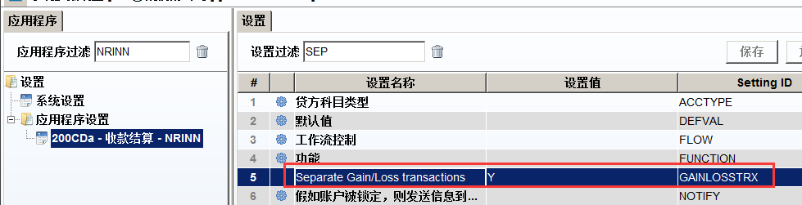
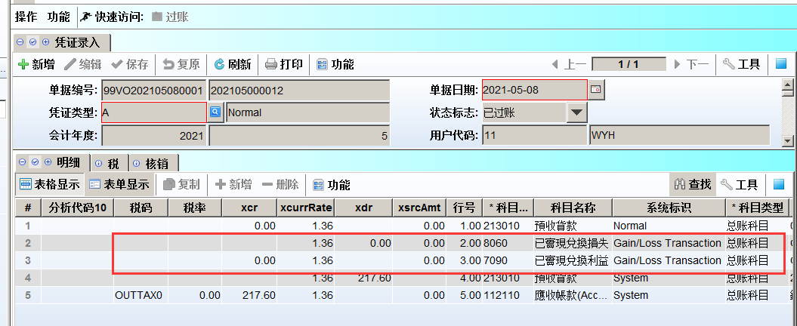

3.2.5 200DP.AP Accrual add setting'Inventory ACC ID'.(32650)-906
This setting is used to define a temporary account when user don’ t wish recording cost of goods in transit into normal inventory account. This temporary account balance will be reversed to zero in the reversed AP Accrual document generated at the first day of next period.
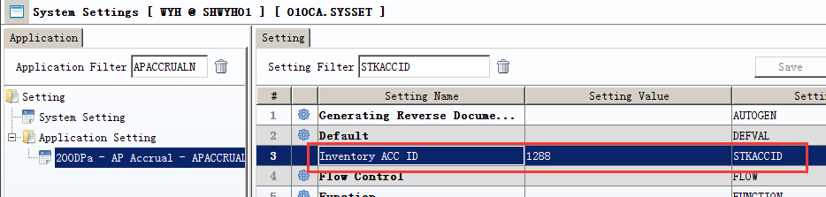

3.3 Improve

3.3.1 Not validate Bank id and Sub Bank id in SupplierBank tab of SUPPLIER with 200EAB.BANKMAS. (32690)-906
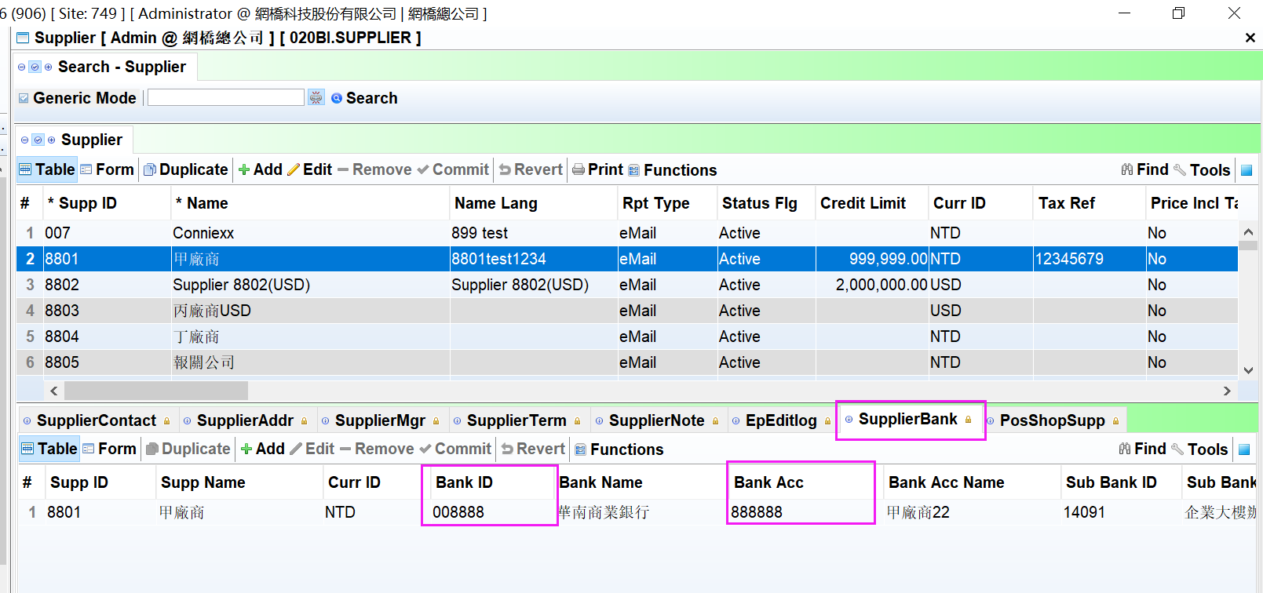
User can input Bank ID and Sub Bank ID without maintain them in 200EAB previously.
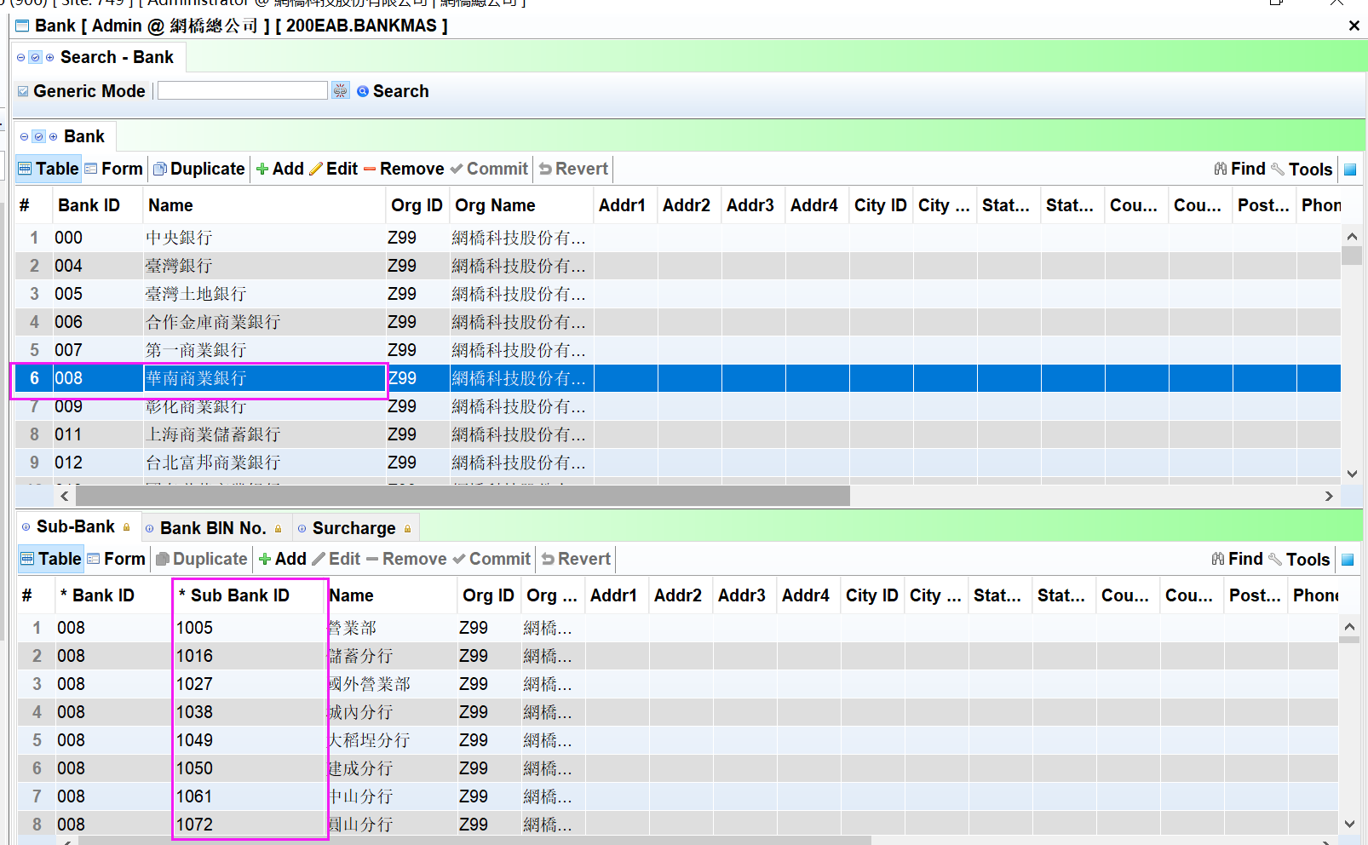

3.3.2 070CF.Good Receive enable distribute tariff amount according HS code in 140BA.STKMAS.(32595)-906
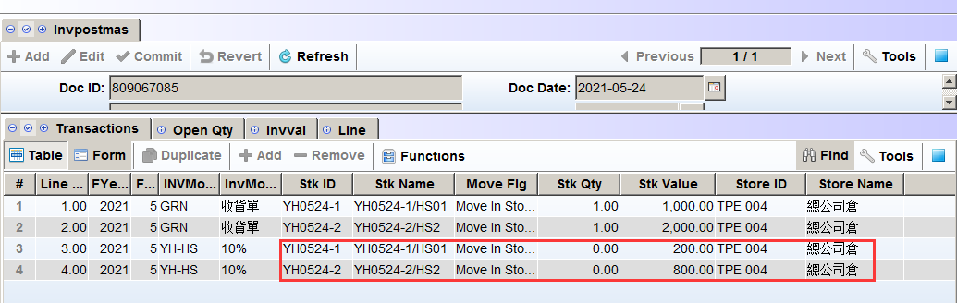

3.3.3 SA 090AaZ.ENQVIP add first shop name of the VIP field. (32681)-906
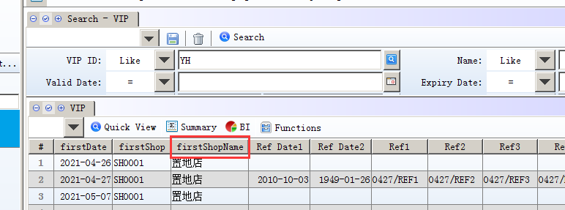

3.3.4 Add familyVip_id/Self8_id in VIP lov of POSN.(32681)-906
Self8_id is the relationship between the family VIP and current VIP.
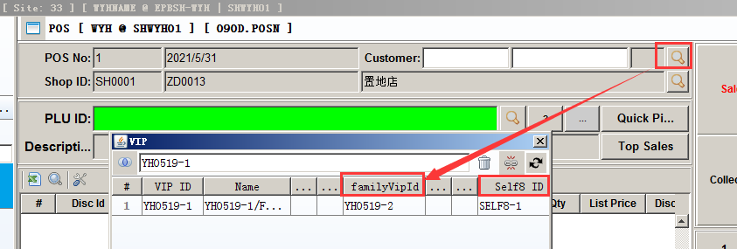

3.3.5 090U/090UA Type delete Trans Type 'deposit'/'refund'.(32639)-906
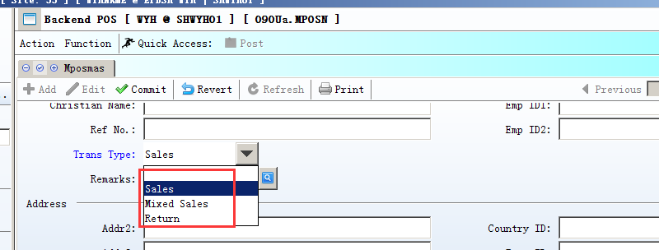

3.3.6 140EK.ENQBO BI report add Attribute 1/Attribute 1 Name~ Attribute 5/Attribute 5 Name.(32677)-906
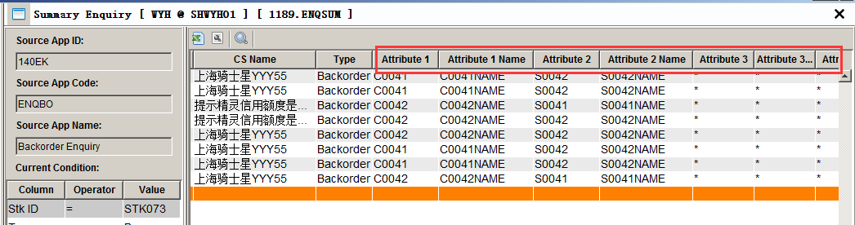

3.3.7 180BA.Work Order/180BAA.Work Order Change Note add Material qty zero control.(32641)-906
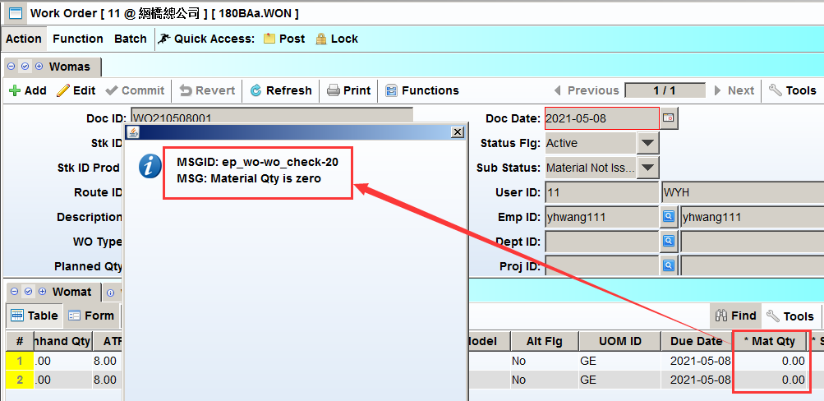

3.3.8 190BF.Value Adjust add function: Transfer From Supplier Credit Note.(32672)-906
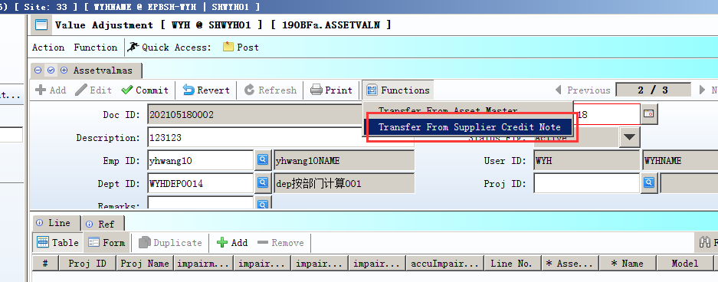
Note: Batch_id1 of item must be the same as asset id.

3.3.9 200AP Official Receipt Type Setup add Org ID and Org Name.(32648)-906
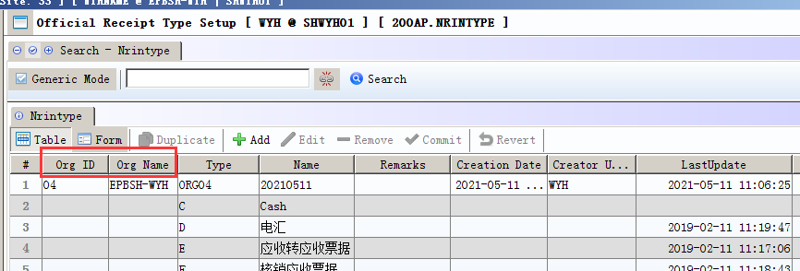

3.3.10 200AQ module is deleted and payment type change to be defined in 020BJ Payment Type.(32691)-906

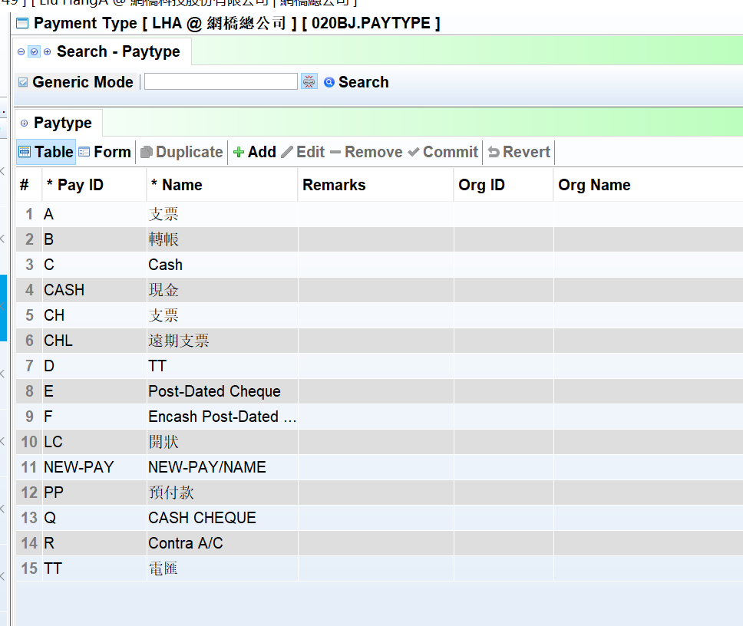

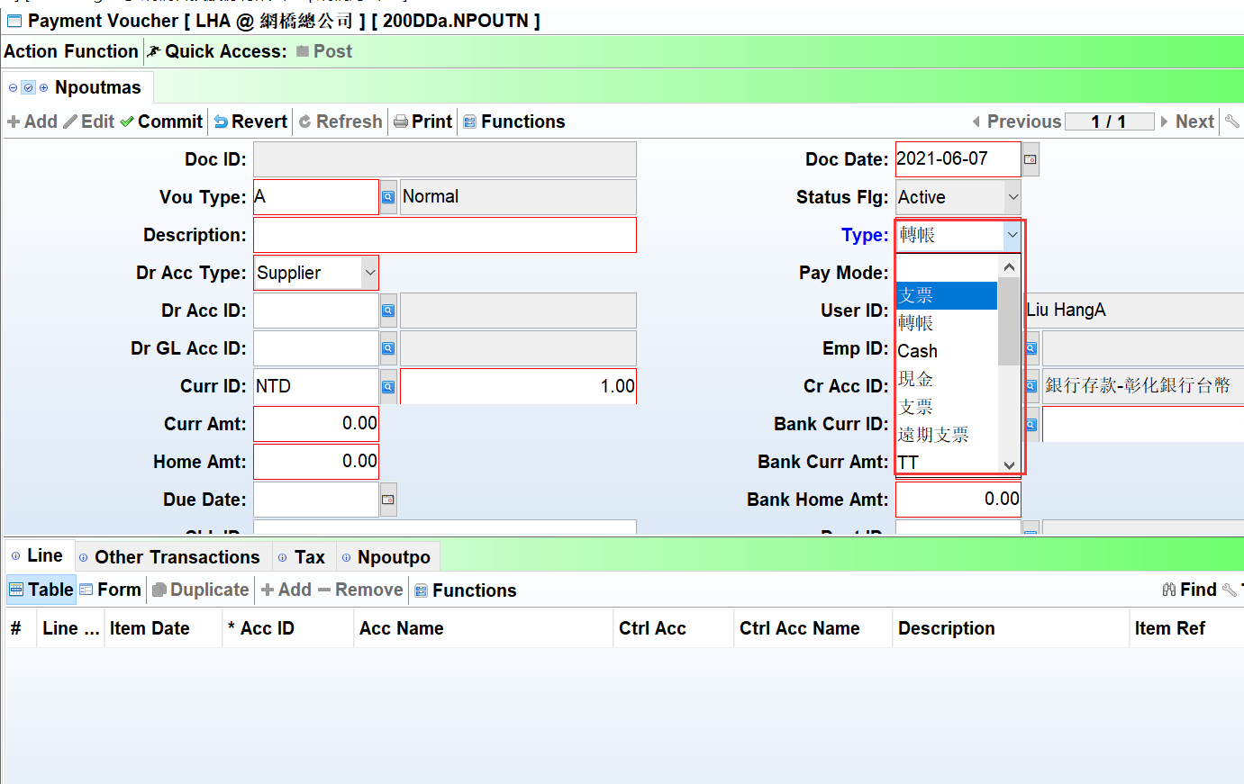

3.3.11 Other Transaction tab of 200DDA AP Payment Batch add 'Swift' field to keep bank swift code.(32685)-906
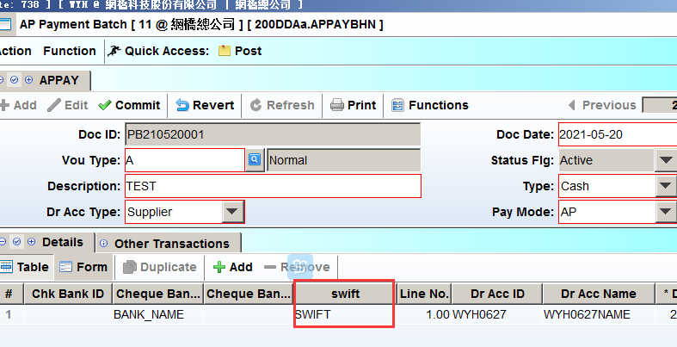

3.3.12 Lov of Aanalysis code 10 in all modules selected from 200AK Cash Flow ID.(15375)-906
Other Analysis code1~9 lov selected from 200AC. G/L Analysis Code.
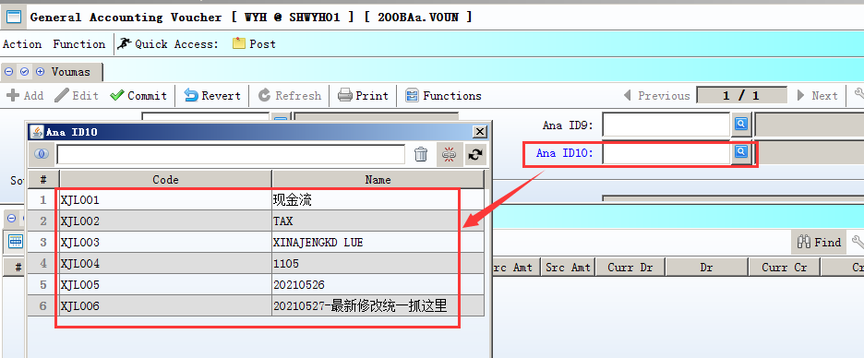

4. Fixes

