EPBrowserRelease Notes
Version 9.07~9.08

EPBrowserRelease Notes Version 9.07~9.08
Last Revision, 16 August 2021

©Copyright 2021. Enterprise Browser Pte Ltd.
All rights reserved.

No part of this manual may be reproduced in any form or by any means without the express written authorization from EPB. Business forms—which include but are not limited to invoices, checks, sales orders—displayed in this manual are for illustration purposes only and are not to be used for producing actual business forms. Enterprise Browser Pte Ltd. assumes no responsibility.
This document may contain technical inaccuracies or typographical errors and may change without prior notice. Any documentation with respect to EPB software products is provided for informational purposes only and does not extend or modify the limited warranty extended to the licensee of EPB software products.

Enterprise Browser Pte Ltd (EPB)
33Ubi Avenue 3, #07-65, Vertex Tower A, Singapore 408868
Tel: (65)-6509-4065
Fax: (65)-6509-4089

Document Location
EPBSH

Contents
1. Featured 4
2. New Interface 4
2.1 Add module 900AG.G1R7 to edit/import STKMAS/Attribute1/Attribute2(32929)-908 4
3. Enhancements 4
3.1 Privilege 4
3.2 Setting 5
3.2.1 060G Sales Assistant add tabs of PO history and Inventory Cost.(32816)-907 5
3.2.2 090AaH module add setting to verify VIP email format.(32857)-908 6
3.2.3 160CB Miscilance Note add three settings :(32845)-908 7
3.3 Improve 7
3.3.1 070CC add Pb Remark field to identify line remark of the Price Book.(32795)-907 7
3.3.2 190A.Asset Master add picture of the asset. (32738)-907 7
3.3.3 180BA.WO/180BF.WPS add ‘Min Order Qty’ to display Min Order Qty in 140EA.Stk Level .(32793)-907 8
3.3.4 CrmoppContact tab of 050C.CRMOPP can be edited when doc in Posted status.(32890)-908 9
3.3.5 060CI.Credit Note Request add Tax tab.(32962)-908 9
3.3.6 Add new application to set foreign price according home currency price range.(32889)-908 (Customized function) 10
3.3.7 090UA.MPOSAN prevent Post the document in inventory shortage.(31338)-908 11
3.3.8 110A.PROJMAS add Cust ID and Cust Name fields.(32956)-908 11
3.3.9 180BNE.ENQWOMAT add Material_Status and Sub_Status fields.(32946)-908 11
3.3.10 180BNX.ENQOSPB change log add User Id/User Name/Doc Date fields.(32968)-908 12
3.3.11 190BFa.ASSETVALN add functions of “Transfer From Supplier Invoice”.(32877)-908 12
3.3.12 200CXD.ENQINVCRN add Ana ID1~ Ana ID 10 fields.(32918)-908 13
4. Fixes 13

1. Featured

2. New Interface

2.1 Add module 900AG.G1R7 to edit/import STKMAS/Attribute1/Attribute2(32929)-908
User can apply this module to prevent user from deleting stk id which is permitted in STKMAS.
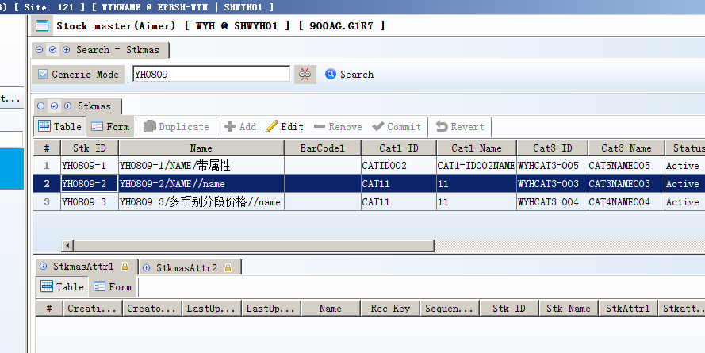

3. Enhancements

3.1 Privilege
3.1.1 All modules in EPB add privilege to control 'Print' /'BI'/'Attach' .
If user can’t perform 'Print' /'BI'/'Attach' after upgrading to 907, please check the role’s privilege and add correspondent privilege.
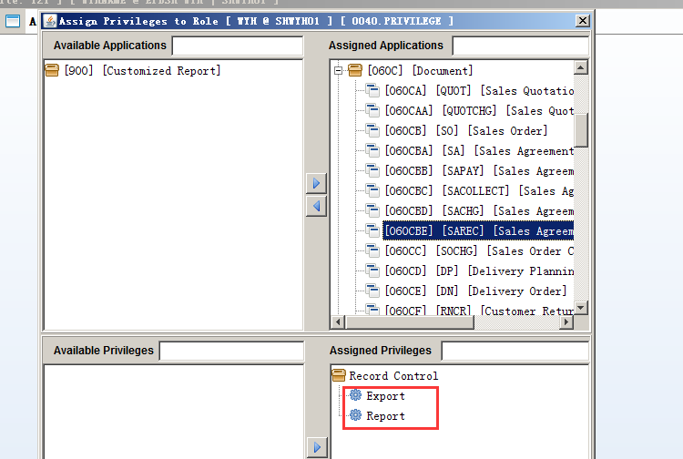

3.2 Setting

3.2.1 060G Sales Assistant add tabs of PO history and Inventory Cost.(32816)-907
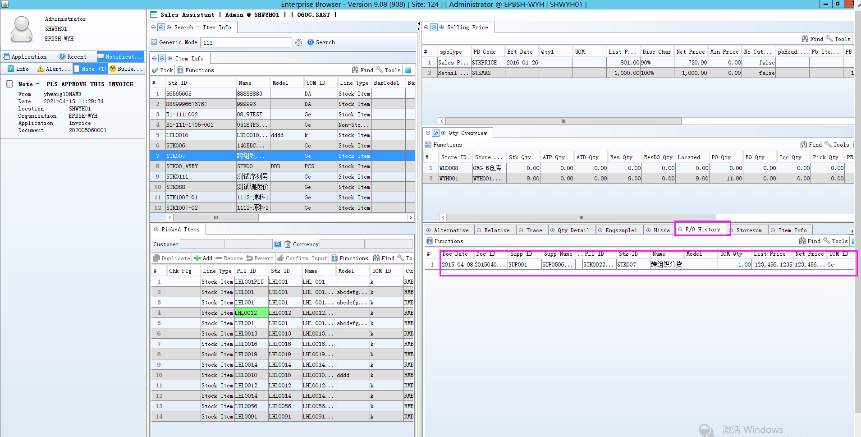
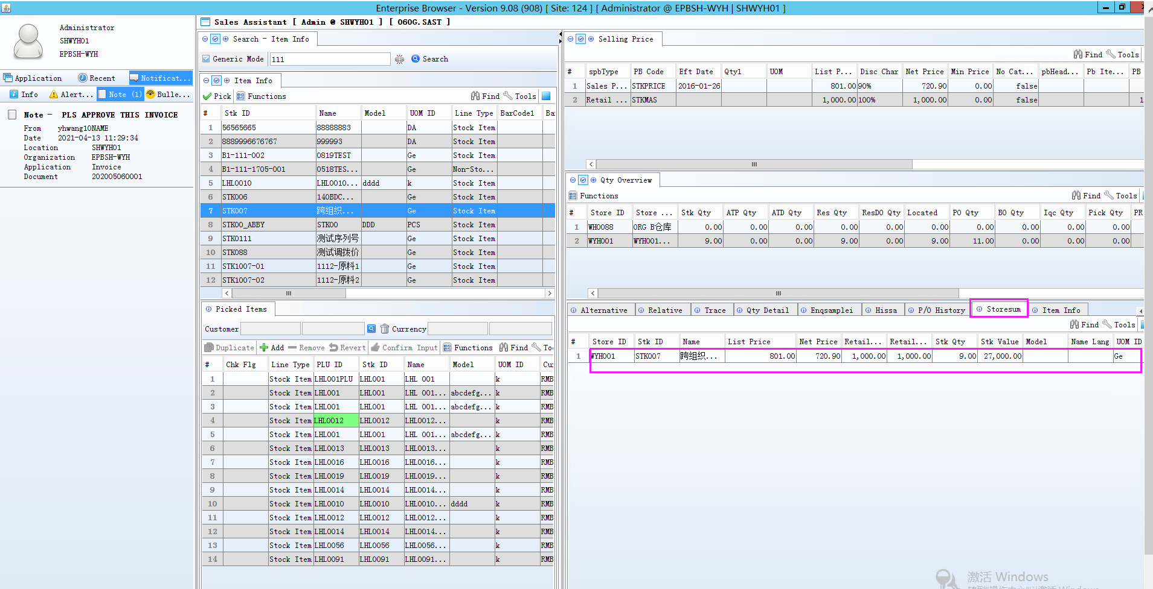
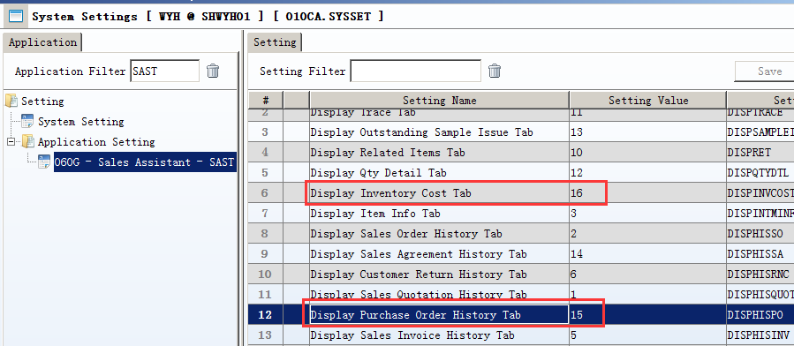

3.2.2 090AaH module add setting to verify VIP email format.(32857)-908
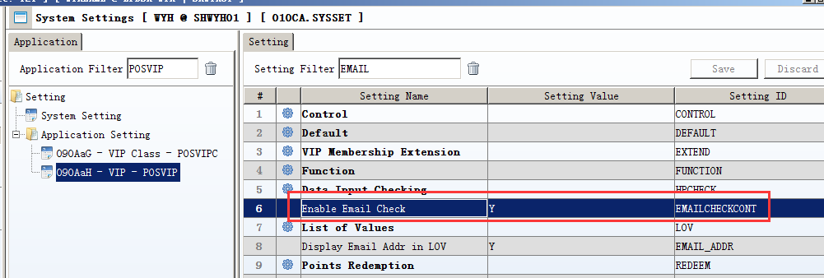

3.2.3 160CB Miscilance Note add three settings :(32845)-908
4. Define workflow by Misc Type.
11. Enable User access control.
10. User access control by [A] by Dept [B] by Emp Group
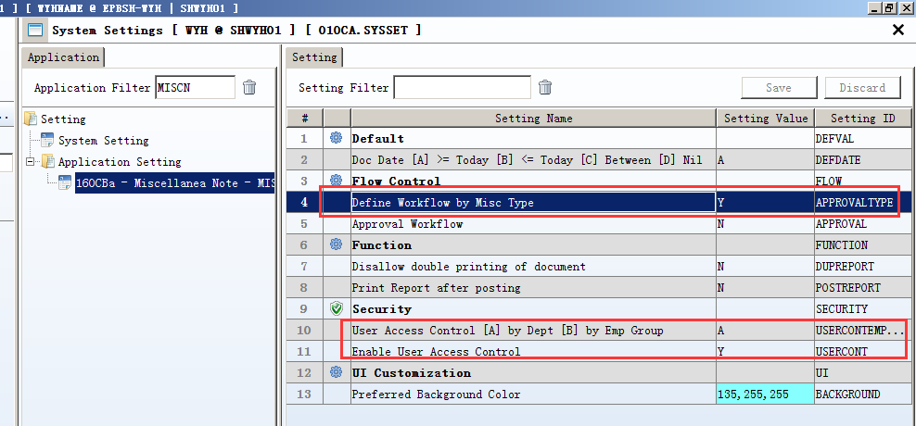

3.3 Improve

3.3.1 070CC add Pb Remark field to identify line remark of the Price Book.(32795)-907
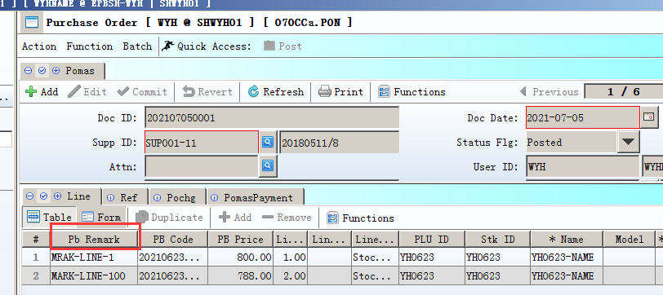
Document Tabs changed:
Grline，GrlineKit，Poline，PolineKit，Prline，Rfqline，RfqlineKit，Sinvline，SinvlineKit，Spline，SplineKit，Consignline，Pochgline，Rnsline，RnslineKit，
Rnsrline，RnsrlineKit，Scrnline，ScrnlineKit，Scrnrline，ScrnrlineKit，Sdrnline，SdrnlineKit，Sdrnrline，SdrnrlineKit，Sqcline，Ssline，

Enqconsign,Enqgr,Enqgrrns,Enqpo,Enqpr,Enqrfq,Enqrns,Enqrnsr,Enqscrn,Enqscrnr,Enqsdrn,Enqsinv,Enqsinvscrn, Enqsp

3.3.2 190A.Asset Master add picture of the asset. (32738)-907
Add picture files named same as Asset Id can display the image when moving cursor to the item. Purple color of # field indicating this Asset has related image.
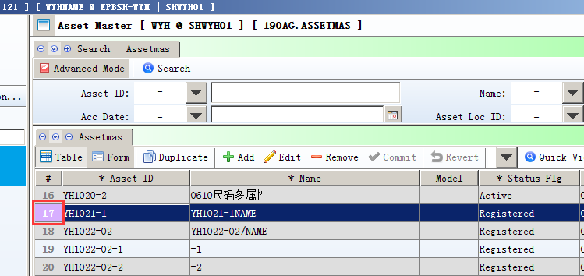

3.3.3 180BA.WO/180BF.WPS add ‘Min Order Qty’ to display Min Order Qty in 140EA.Stk Level .(32793)-907
It is a reference qty when user creating a WO/WPS.
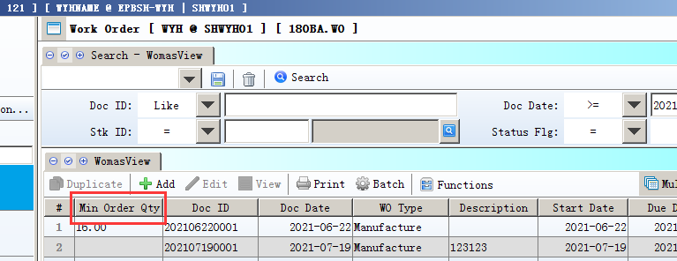

3.3.4 CrmoppContact tab of 050C.CRMOPP can be edited when doc in Posted status.(32890)-908
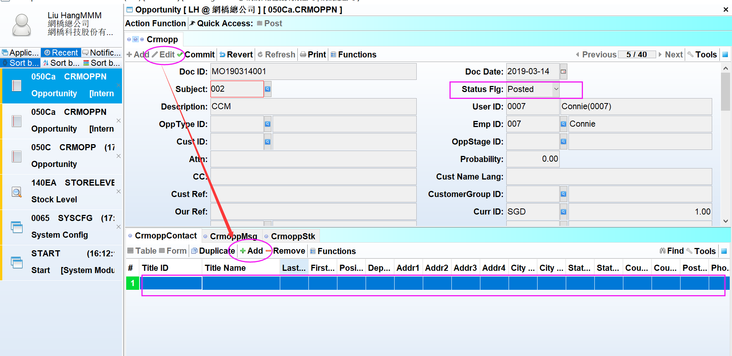

3.3.5 060CI.Credit Note Request add Tax tab.(32962)-908
This tab can be carried to 200CB.Credit Note when creating new Credit Note by “Copy from CRNR”.
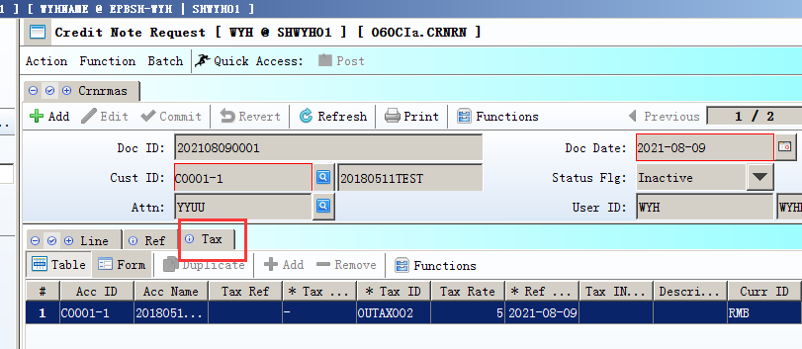

3.3.6 Add new application to set foreign price according home currency price range.(32889)-908 (Customized function)
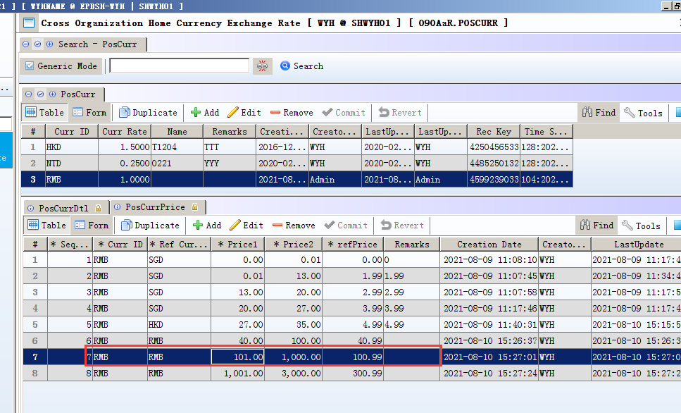

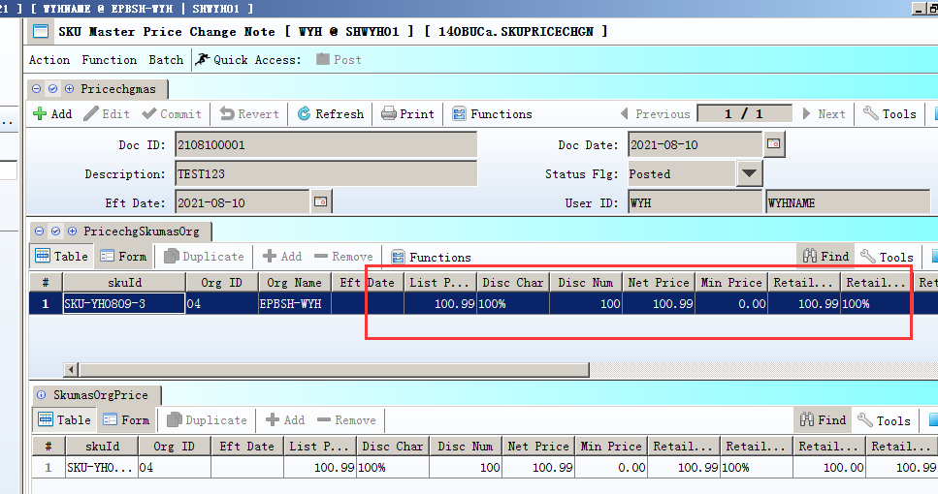
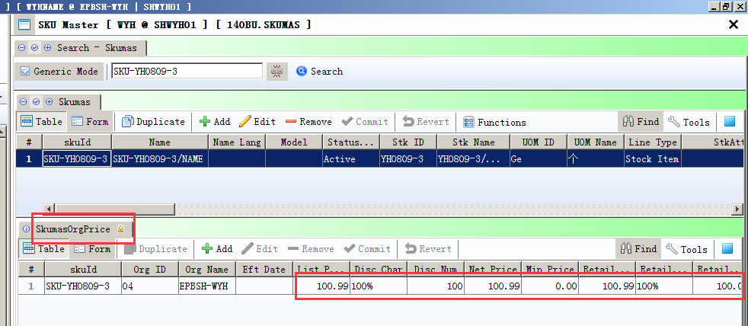

3.3.7 090UA.MPOSAN prevent Post the document in inventory shortage.(31338)-908
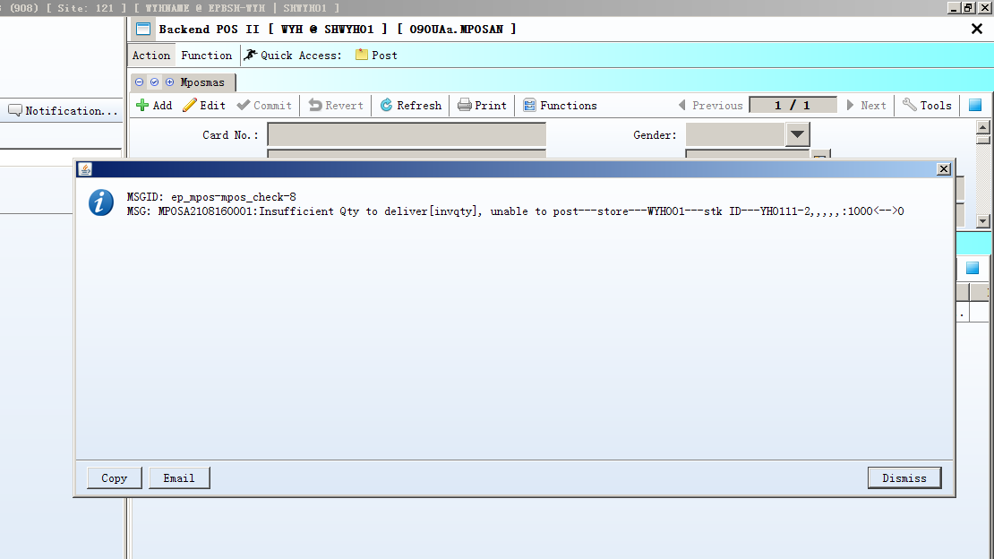

3.3.8 110A.PROJMAS add Cust ID and Cust Name fields.(32956)-908
This enables user listing customer in BI report query by project .
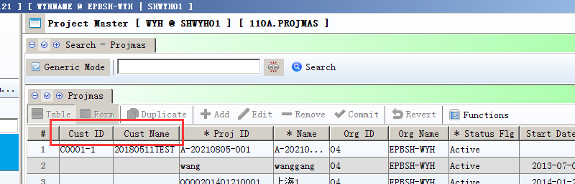

3.3.9 180BNE.ENQWOMAT add Material_Status and Sub_Status fields.(32946)-908
These two Fields are get from WO and will be applied in BI report.

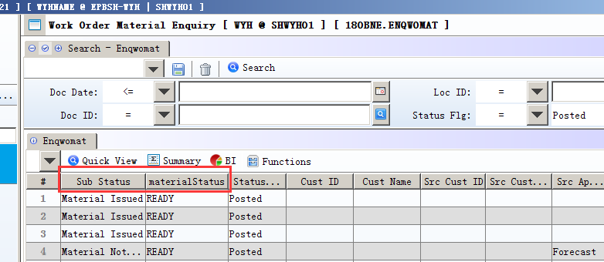

3.3.10 180BNX.ENQOSPB change log add User Id/User Name/Doc Date fields.(32968)-908
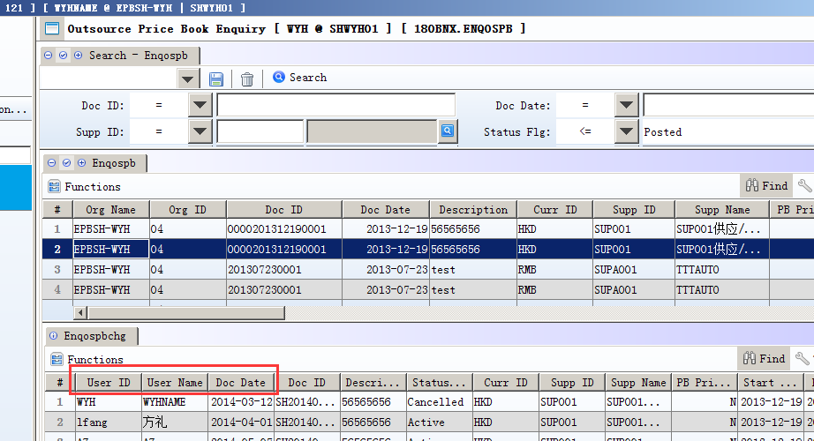

3.3.11 190BFa.ASSETVALN add functions of “Transfer From Supplier Invoice”.(32877)-908
SRN_id in SINV line should not be null.
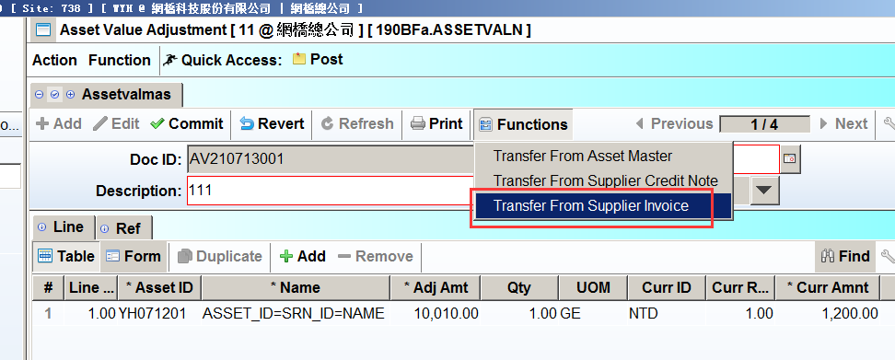

3.3.12 200CXD.ENQINVCRN add Ana ID1~ Ana ID 10 fields.(32918)-908
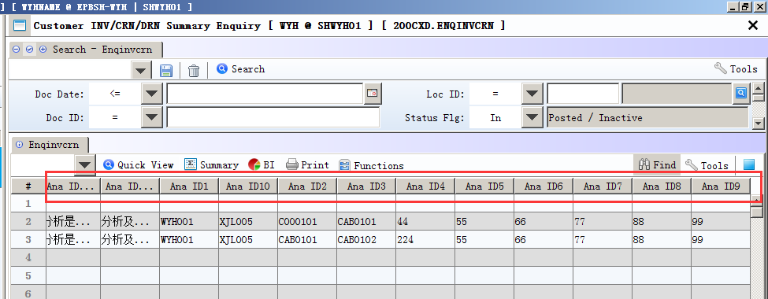

Fixes
end

